Written Plan for SCA in Schools - Full Version
Cardiac Emergency Response Plan
Name of School District
This Cardiac Emergency Response Plan is adopted by (insert name of school/school district) effective (insert date). This plan was reviewed and approved by medical and legal counsel for (insert name of school/school district) on (insert date).
A cardiac emergency requires immediate action. Cardiac emergencies may arise as a result of a Sudden Cardiac Arrest (SCA) or a heart attack, but can have other causes. SCA occurs when the electrical impulses of the heart malfunction resulting in sudden death.
Signs of Sudden Cardiac Arrest can include one or more of the following:
- Not moving, unresponsive or unconscious, or
- Not breathing normally (i.e., may have irregular breathing, gasping or gurgling or may not be breathing at all), or
- Seizure or convulsion-like activity.
Note: Those who collapse shortly after being struck in the chest by a firm projectile/direct hit may have SCA from commotio cordis.

The Cardiac Emergency Response Plan of (insert name of school/school district) shall be as follows:
- Developing a Cardiac Emergency Response Team
- The Cardiac Emergency Response Team shall be comprised of those individuals who have current CPR/AED certification. It will include the school nurse, coaches, and others within the school. It should also include an administrator and office staff who can call 9-1-1 and direct EMS to the location of the SCA.
- Members of the Cardiac Emergency Response Team are identified in the “Cardiac Emergency Response Team” attachment, to be updated yearly and as needed to remain current. One of the members shall be designated as the Cardiac Emergency Response Team Coordinator.
- All members of the Cardiac Emergency Response Team shall receive and maintain nationally recognized training, which includes a certification card with an expiration date of not more than 2 years.
- As many other staff members as reasonably practicable shall receive training.

- Activation of Cardiac Emergency Response Team during an identified cardiac emergency
(a) The members of the Cardiac Emergency Response Team shall be notified immediately when a cardiac emergency is suspected.
(b) The Protocol for responding to a cardiac emergency is described in Section 8 (below) and in the “Protocol for Posting” attachment.

- Automated external defibrillators (AEDs) – placement and maintenance

- Minimum recommended number of AEDs for (insert name of school/school district):
- Inside school building – The number of AEDs shall be sufficient to enable the school staff or another person to retrieve an AED and deliver it to any location within the school building, ideally within 2 minutes of being notified of a possible cardiac emergency.
- Outside the school building on school grounds / athletic fields – The number of AEDs, either stationary or in the possession of an on-site athletic trainer, coach, or other qualified person, shall be sufficient to enable the delivery of an AED to any location outside of the school (on school grounds) including any athletic field, ideally within 2 minutes of being notified of a possible cardiac emergency.
- Back-up AEDs – One or more AEDs shall be held in reserve for use as a replacement for any AED which may be out-of-service for maintenance or other issues. The back-up AED(s) should also be available for use by the school’s athletic teams or other groups traveling to off-site locations.
- (insert name of school/school district) will regularly check and maintain each school-owned AED in accordance with the AED’s operating manual and maintain a log of the maintenance activity. The school shall designate a person who will be responsible for verifying equipment readiness and for maintaining maintenance activity.
- Additional Resuscitation Equipment: A resuscitation kit shall be connected to the AED carry case. The kit shall contain latex-free gloves, razor, scissors, towel antiseptic wipes and a CPR barrier mask.
- AEDs shall not be locked in an office or stored in a location that is not easily and quickly accessible at all times.
- AEDs shall be readily accessible for use in responding to a cardiac emergency, during both school-day activities and after-school activities, in accordance with this Plan. Each AED shall have one set of defibrillator electrodes connected to the device and one spare set. All AEDs should have clear AED signage so as to be easily identified. Locations of the AEDs are to be listed in the “Cardiac Emergency Response Team” attachment and in the “Protocol for Posting” attachment.

- Communication of this Plan throughout the school campus

- The Cardiac Emergency Response Protocol shall be posted as follows:
  - In each classroom, cafeteria, restroom, health room, faculty break room and in all school offices.
  - Adjacent to each AED.
  - Adjacent to each school telephone.
  - In the gym, near the swimming pool, and in all other indoor locations where athletic activities take place.
  - At other strategic school campus locations, including outdoor physical education and athletic areas.
  - Attached to all portable AEDs.
- The Cardiac Emergency Response Protocol shall be distributed to:
  - All staff and administrators at the start of each school year, with updates distributed as made.
  - All Health Services staff including the school nurse, health room assistants and self-care assistants.
  - All athletic directors, coaches, and applicable advisors at the start of each school year and as applicable at the start of the season for each activity, with updates distributed as made.
- Results and recommendations from Cardiac Emergency Response Drills performed during the school year shall be communicated to all staff and administrative personnel. See paragraph 5(b) below.
- A copy of this Cardiac Emergency Response Plan shall be provided to any organization using the school. A signed acknowledgment of the receipt of this Plan and the Protocol by any outside organization using the school shall be kept in the school office. School administration and any outside organization using the school shall agree upon a modified Cardiac Emergency Response Plan. The modified Plan shall take into consideration the nature and extent of the use and shall meet the spirit and intent of this Plan which is to ensure that preparations are made to enable a quick and effective response to a cardiac emergency on school property.

- Training in Cardiopulmonary Resuscitation (CPR) and AED Use

- Staff Training:
- In addition to the school nurse, a sufficient number of staff shall be trained in cardiopulmonary resuscitation (CPR) and in the use of an AED to enable (insert name of school/school district) to carry out this Plan. (It is recommended that at a minimum, at least 10% of staff, 50% of coaches, and 50% of physical education staff should have current CPR/AED certification.) Training shall be renewed at least every two years. The school shall designate the person responsible for coordinating staff training as well as the medical contact for school based AEDs, if available.
- Training shall be provided by an instructor, who may be a school staff member, currently certified by a nationally-recognized organization to conform to current American Heart Association guidelines for teaching CPR and/or Emergency Cardiac Care (ECC).
- Training may be traditional classroom, on-line or blended instruction but should include cognitive learning, hands-on practice and testing.
(b) Cardiac Emergency Response Drills:
Cardiac Emergency Response Drills are an essential component of this Plan. (Insert name of school) shall perform a minimum of 2 successful Cardiac Emergency Response Drills each school year with the participation of athletic trainers, athletic training students, team and consulting physicians, school nurses, coaches, campus safety officials and other targeted responders. A successful Cardiac Emergency Response Drill is defined as full and successful completion of the Drill in 5 minutes or less. (Insert name of school/school district) shall prepare and maintain a Cardiac Emergency Response Drill Report for each Drill. (See “Conducting Drills” attachment.) These reports shall be maintained for a minimum of 5 years with other safety documents. The reports shall include an evaluation of the Drill and shall include recommendations for the modification of the CERP if needed. (It is suggested that the school / school district consider incorporating the use of students in the Drills.)

- Local Emergency Medical Services (EMS) integration with the school/school district’s plan

- (insert name of school/school district) shall provide a copy of this Plan to local emergency response and dispatch agencies (e.g., the 9-1-1 response system), which may include local police and fire departments and local Emergency Medical Services (EMS).
- The development and implementation of the Cardiac Emergency Response Plan shall be coordinated with the local EMS Agency, campus safety officials, on-site first responders, administrators, athletic trainers, school nurses and other members of the school and/or community medical team.
- (Insert name of school/school district) shall work with local emergency response agencies to 1) coordinate this Plan with the local emergency response system and 2) to inform local emergency response system of the number and location of on-site AEDs.

- Annual review and evaluation of the Plan

(insert name of school/school district) shall conduct an annual internal review of the school/school district’s Plan. The annual review should focus on ways to improve the schools response process, to include:

- A post-event review following an event. This includes review of existing school-based documentation for any identified cardiac emergency that occurred on the school campus or at any off-campus school-sanctioned function. The school shall designate the person who will be responsible for establishing the documentation process.
Post-event documentation and action shall include the following:
- A contact list of individuals to be notified in case of a cardiac emergency.
- Determine the procedures for the release of information regarding the cardiac emergency.
- Date, time and location of the cardiac emergency and the steps taken to respond to the cardiac emergency.
- The identification of the person(s) who responded to the emergency.
- The outcome of the cardiac emergency. This shall include but not be limited to a summary of the presumed medical condition of the person who experienced the cardiac emergency to the extent that the information is publicly available. Personal identifiers should not be collected unless the information is publicly available.
- An evaluation of whether the Plan was sufficient to enable an appropriate response to the specific cardiac emergency. The review shall include recommendations for improvements in the Plan and in its implementation if the Plan was not optimally suited for the specific incident. The post-event review may include discussions with medical personnel (ideally through the school’s medical counsel) to help in the debriefing process and to address any concerns regarding on-site medical management and coordination.
- An evaluation of the debriefing process for responders and post-event support. This shall include the identification of aftercare services including aftercare services and crisis counselors.
- A review of the documentation for all Cardiac Emergency Response Drills performed during the school year. Consider pre-established Drill report forms to be completed by all responders.
- A determination, at least annually, as to whether or not additions, changes or modifications to the Plan are needed. Reasons for a change in the Plan may result from a change in established guidelines, an internal review following an actual cardiac emergency, or from changes in school facilities, equipment, processes, technology, administration, or personnel.

- Protocol for School Cardiac Emergency Responders
(School Name)
Cardiac Emergency Response Team PROTOCOL For All Schools
Sudden cardiac arrest events can vary greatly. Faculty, staff and Cardiac Emergency Response Team (CERT) members must be prepared to perform the duties outlined below. Immediate action is crucial in order to successfully respond to a cardiac emergency. Consideration should be given to obtaining on-site ambulance coverage for high-risk athletic events. The school should also identify the closest appropriate medical facility that is equipped in advanced cardiac care.
Follow these steps in responding to a suspected cardiac emergency:

(a) Recognize the following signs of sudden cardiac arrest and take action in the event of one or more of the following:
- The person is not moving, or is unresponsive, or appears to be unconscious.
- The person is not breathing normally (has irregular breaths, gasping or gurgling, or is not breathing at all).
- The person appears to be having a seizure or is experiencing convulsion-like activity. (Cardiac arrest victims commonly appear to be having convulsions).
- Note: If the person received a blunt blow to the chest, this can cause cardiac arrest, a condition called commotio cordis. The person may have the signs of cardiac arrest described above and is treated the same.

(b) Facilitate immediate access to professional medical help:
- Call 9-1-1 as soon as you suspect a sudden cardiac arrest. Provide the school address, cross streets, and patient condition. Remain on the phone with 9-1-1. (Bring your mobile phone to the patient’s side, if possible.) Give the exact location and provide the recommended route for ambulances to enter and exit. Facilitate access to the victim for arriving Emergency Medical Service (EMS) personnel.
- Immediately contact the members of the Cardiac Emergency Response Team.
  - Give the exact location of the emergency. (“Mr. /Ms. ___ Classroom, Room # ___, gym, football field, cafeteria, etc.”). Be sure to let EMS know which door to enter. Assign someone to go to that door to wait for and flag down EMS responders and escort them to the exact location of the patient.
- If you are a CERT member, proceed immediately to the scene of the cardiac emergency.
  - The closest team member should retrieve the automated external defibrillator (AED) en route to the scene and leave the AED cabinet door open; the alarm typically signals the AED was taken for use.
  - Acquire AED supplies such as scissors, a razor and a towel and consider an extra set of AED pads.

(c) Start CPR:
- Begin continuous chest compressions and have someone retrieve the AED.
- Here’s how:
  - Press hard and fast in center of chest. Goal is 100 compressions per minute. (Faster than once per second, but slower than twice per second.)
  - Use 2 hands: The heel of one hand and the other hand on top (or one hand for children under 8 years old), pushing to a depth of 2 inches (or 1/3rd the depth of the chest for children under 8 years old.
  - Follow the 9-1-1 dispatcher’s instructions, if provided.

- Use the nearest AED:
- When the AED is brought to the patient’s side, press the power-on button, and attach the pads to the patient as shown in the diagram on the pads. Then follow the AED’s audio and visual instructions. If the person needs to be shocked to restore a normal heart rhythm, the AED will deliver one or more shocks.
  - Note: The AED will only deliver shocks if needed; if no shock is needed, no shock will be delivered.
- Continue CPR until the patient is responsive or a professional responder arrives and takes over.

- Transition care to EMS:
- Transition care to EMS upon arrival so that they can provide advanced life support.

- Action to be taken by Office / Administrative Staff:
- Confirm the exact location and the condition of the patient.
- Activate the Cardiac Emergency Response Team and give the exact location if not already done.
- Confirm that the Cardiac Emergency Response Team has responded.
- Confirm that 9-1-1 was called. If not, call 9-1-1 immediately.
- Assign a staff member to direct EMS to the scene.
- Perform “Crowd Control” – directing others away from the scene.
- Notify other staff: school nurse, athletic trainer, athletic director, etc.
- Ensure that medical coverage continues to be provided at the athletic event if on-site medical staff accompanies the victim to the hospital.
- Consider delaying class dismissal, recess, or other changes to facilitate CPR and EMS functions.
- Designate people to cover the duties of the CPR responders.
- Copy the patient’s emergency information for EMS.
- Notify the patient’s emergency contact (parent/guardian, spouse, etc.).
- Notify staff and students when to return to the normal schedule.
- Contact school district administration.

Building Location Information

School Name & Address ______________________________________________________________

School Emergency Phone# Insert #s for school-hours & after-hours, may be office during school hours______

Cross Streets ______________________________________________________________________

AED Location ______________________________ AED Location __________________________

AED Location ______________________________ AED Location __________________________

AED Location ______________________________ AED Location __________________________

(School District Name)
CARDIAC EMERGENCY RESPONSE TEAM PROTOCOL

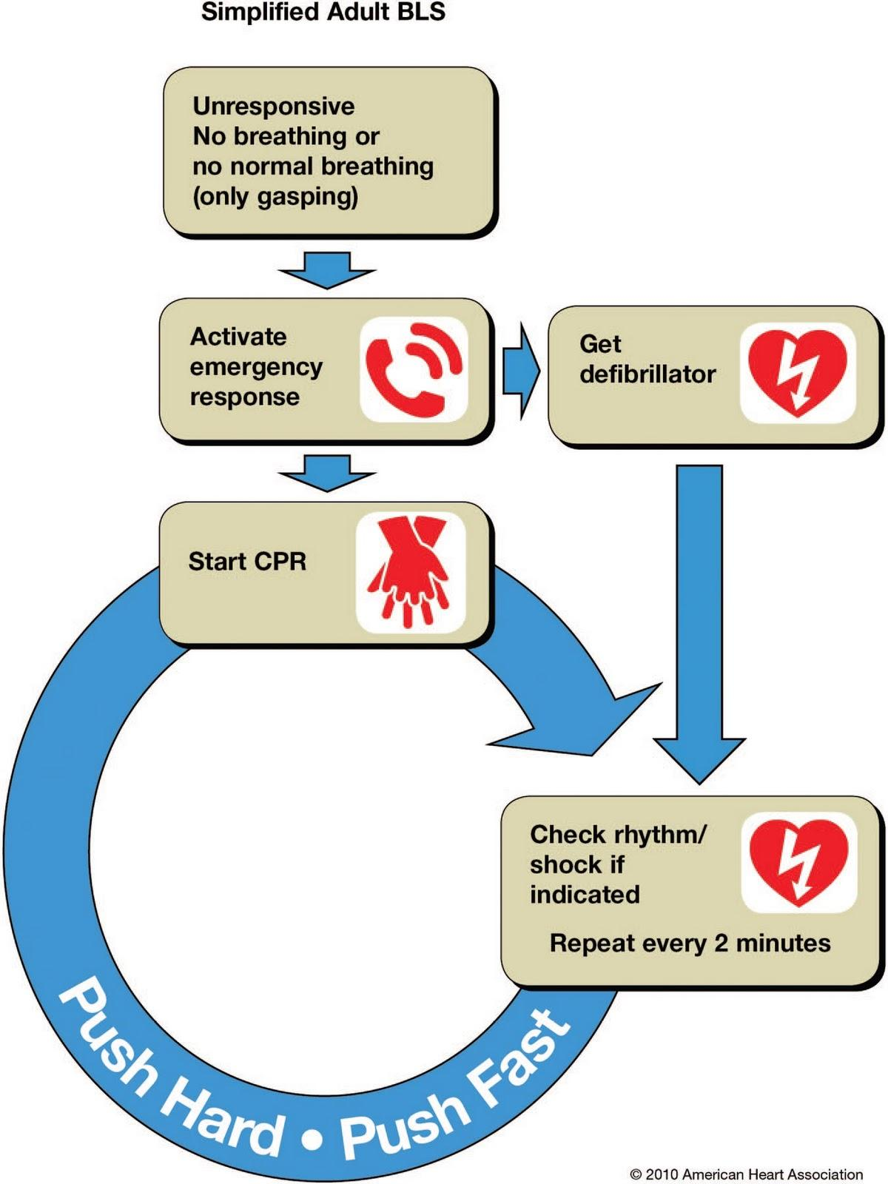

IMPORTANT: This is a draft document intended for use in formulating a plan for adoption by a school/school district. Medical and legal counsel for the school/school district should review this Plan before implementation. It is the responsibility of the school/school district to ensure that the Cardiac Emergency Response Plan as adopted is consistent with local, state and federal law.

