World Record Challenge

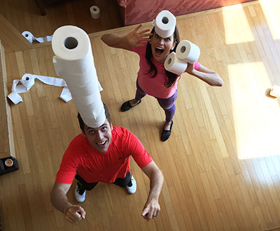

-Stack as many toilet paper rolls on top of a person’s head, hands, stomach or back

-If stack falls over, you must start over.

World Record Challenge

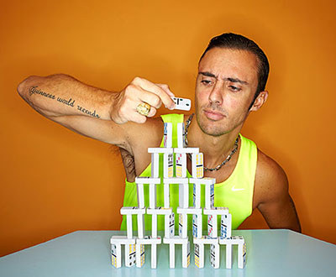

-Stack as many dominos as possible in the time given.

-If the stack falls over, you must start over.

World Record Challenge

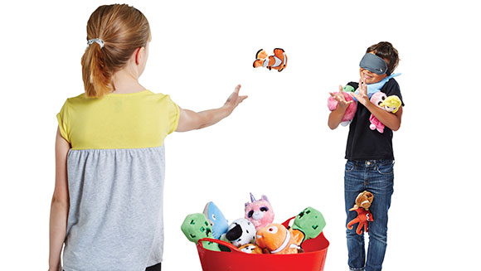

-Catch as many items (beanbags) as possible while being blindfolded.

-Partners can ONLY underhand toss the beanbags SOFTLY!

-Keep hands up in front of body so partner can toss towards your hands.

World Records Challenge

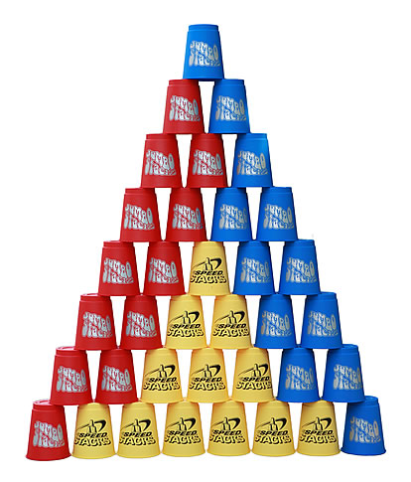

-Make a 36 stack of cups and take down as quickly as possible.

-Try with buckets, jumbo cups, regular cups, and tiny cups.

World Records Challenge

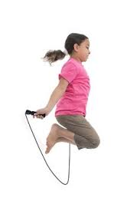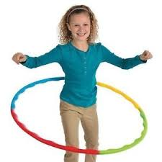

-See how long you can Jump Rope without stopping

-See how long you can hula hoop without stopping

World Records Challenge

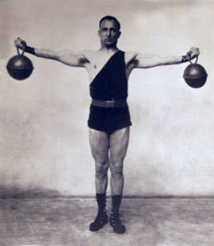

-Herculean weight challenge is completed by holding weights (objects) straight out to side for as long as possible.

-Time starts over when one or both arms come down.

Worlds Record Challenge

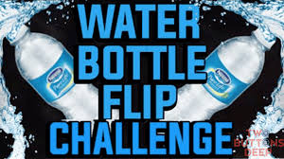

-Land as many flipped water bottles as possible in the time given.

-Bottles can ONLY be flipped. Not thrown or slide across the ground.