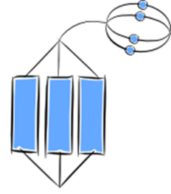  Extended Abstract  I have several ideas about …  I can link them to the big picture  I can look at these ideas in a new and different way | … and determine, based on my log, what actions I should take to keep improving when weight training
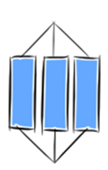  Relational  I have several ideas about …  I can link them to the big picture | I know FITT & I can apply all parts of FITT to making improvements when weight training.
Multistructural  I have several ideas about … | I know all parts of the FITT principle and I can apply at least 1 to making improvements when weight training.
Unistructural  I have one idea about … | I know one thing about FITT Principle and how to apply it to weight training.
Prestructural  I am not sure about … | I know nothing about the FITT Principle or how to apply it to weight training.

