THROWING & CATCHING
ASESSMENT

Directions: Write down the number of times you caught a ball using each of the following.

- How many times did you catch the sponge ball? _____________________________

- How many times did you catch the tennis ball? ______________________________

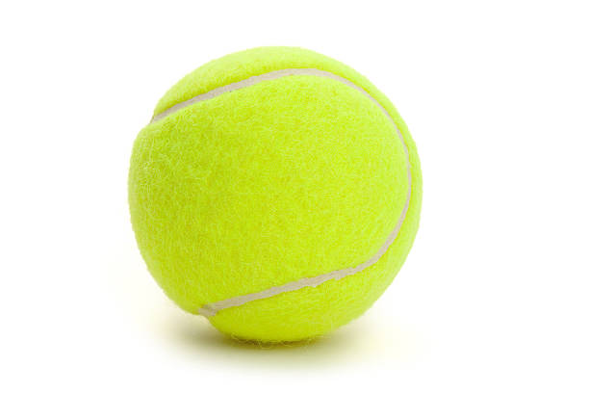

- How many times did you catch the football? ________________________________-

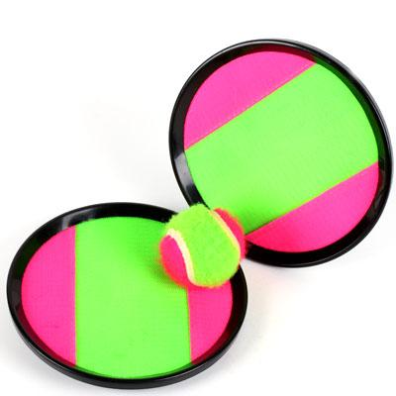
- How many times did you catch the ball with the Velcro pad? ______________________

- How many times did you catch the baseball with the glove? ______________________
