Aim – Personality in Sport Quiz
Answer every question correctly and create the Chicago Bulls 1995-1998 team; winning maximum points.
Instructions
Each player has a question and points attached to them
Answer the question – you must write your answer on the Microsoft Forms Sheet and submit:
The Last Dance Answers Form
NB: I have given specific examples for answers; but please read between the lines of what you have put and award yourself the point if it is similar/demonstrates the correct points but worded differently.
If you answer the question correctly you keep the player and their points
If you do not answer the question correctly, then you do not add the player to your team or the points.
Where do I find the correct answer?
Submit your answers on the Forms Sheet and receive the correct answers immediately
Once you have completed the quiz, add up your points and click on the link that relates to your score.

Q1. Ron Harper – 2 points
Personality was defined by Diane Gill as what?
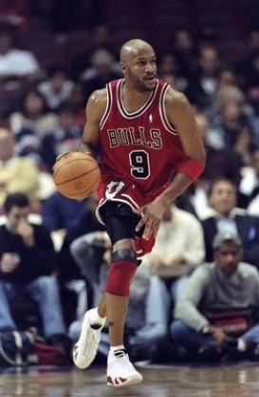

Q2. Randy Brown – 1 point
The link between personality and behaviour being accepted is known as which approach?
Sceptical OR
Credulous?

Q3. Michael Jordan – 3 points
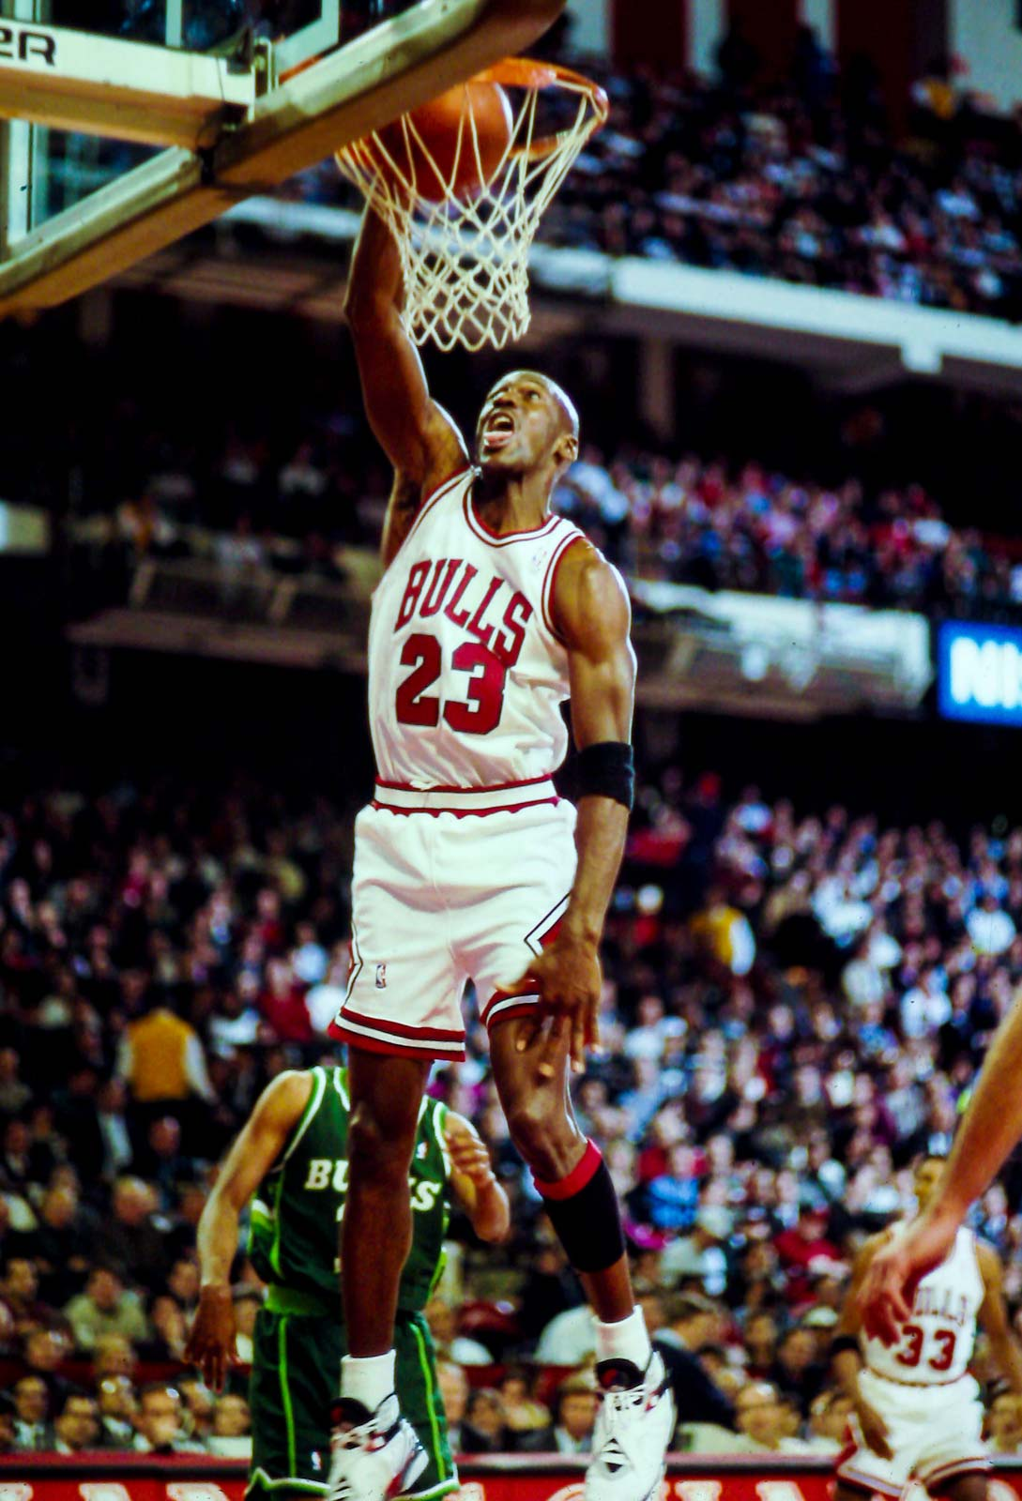
Why do some psychologists think that it is difficult to predict behaviour in sport?

Q4. Dennis Rodman – 2 points
Name 3 things you should consider when using persuasion to change an attitude
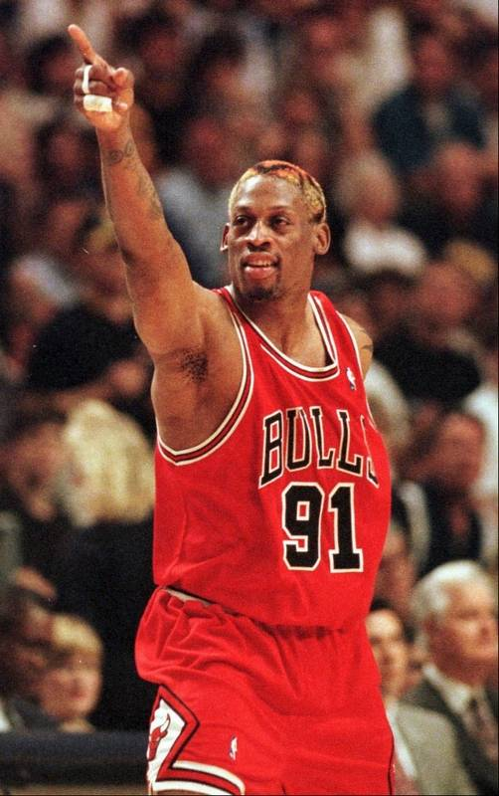

Q5. Jud Buechler – 1 point
Select the option that shows three features of the peak flow experience
(see multiple choice answers on the forms)

Q6. Bill Wennington – 1 point
Name the two features of somatic anxiety
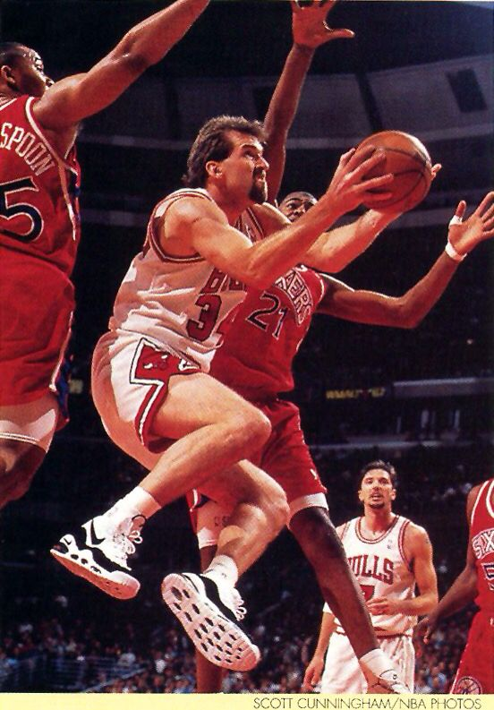

Q7. Luc Longley – 2 points
What aspects of play can cause frustration in sport?

Q8. Scottie Pippin – 3 points
Explain which type of motivation is more permanent and why
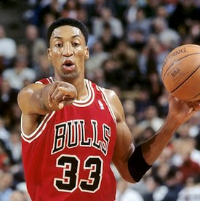

Q9. Toni Kukoc – 1 point
Name the 4 types of other who could be present at a sporting event, according to Zajonc
Q10. Steve Kerr – 2 points
Why could goals just set on winning have a negative impact on performance?
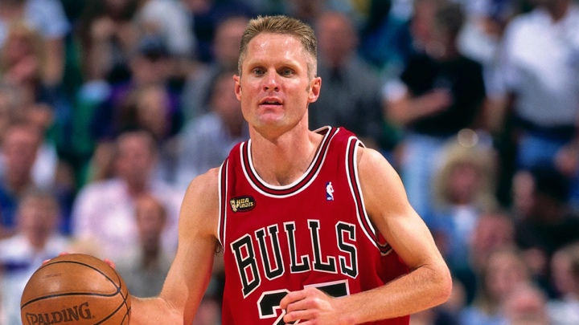

Score links – Final task
Watch the short clip and link what you have seen in the video clip to any topic in the psychology unit. Write a short paragraph explaining your thoughts.
0 – 2 points: https://www.youtube.com/watch?v=_akGhaZ7ZGI
3 – 6 points: https://www.youtube.com/watch?v=vDk2y2NwFXY
7 – 10 points: https://www.youtube.com/watch?v=wrFQ4F1M3Bg
11 – 14 points: https://www.youtube.com/watch?v=bn3a2gs3E0I
15 – 18 points: https://www.youtube.com/watch?v=dHshXWUoBH8

