Team Cardio
In a drinking fountain line, and on my signal, the first person will complete the cardiorespiratory activity and then high five the next person on the team, so they can go. Keep tally marks for laps and take the highest and lowest pedometer steps and add them up.
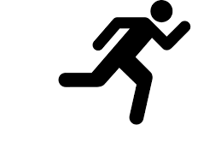 2 minutes of running = _____ laps ____ steps
2 minutes of carioca = _____ laps ____ steps 2 minutes of skipping = _____ laps ____ steps
2 minutes of power walking = _____ laps ____ steps
2 minutes of shuffle = _____ laps ____ steps
2 minutes of running = _____ laps ____ steps
TOTAL _____ laps ____ steps

