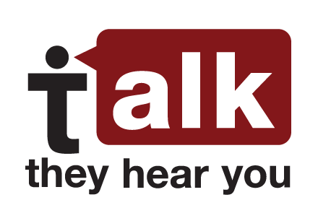
Talking to Kids About Alcohol – 5 conversation goals
Underage Drinking Prevention National Media Campaign
Research shows that parents are the #1 reason young people decide not to drink. So, start talking to your children about alcohol before they start drinking—as early as 9 years old. Even if it doesn’t seem like it, they really do hear you.
- Show you disapprove of underage drinking.
Over 80% of young people ages 10-18 say their parents are the leading influence on their decision to drink or not drink. So they really are listening, and it’s important that you send a clear and strong message.

- Show you care about your child’s happiness and well-being.
Young people are more likely to listen when they know you’re on their side. Try to reinforce why you don’t want your child to drink—not just because you say so, but because you want your child to be happy and safe. The conversation will go a lot better if you’re working with, and not against, your child.

- Show you’re a good source of information about alcohol.
You want your child to be making informed decisions about drinking, with reliable information about its dangers. You don’t want your child to be learning about alcohol from friends, the internet, or the media—you want to establish yourself as a trustworthy source of information.

- Show you’re paying attention and you’ll notice if your child drinks.
You want to show you’re keeping an eye on your child, because young people are more likely to drink if they think no one will notice. There are many subtle ways to do this without prying.

- Build your child’s skills and strategies for avoiding underage drinking.
Even if your child doesn’t want to drink, peer pressure is a powerful thing. It could be tempting to drink just to avoid looking uncool. To prepare your child to resist peer pressure, you’ll need to build skills and practice them.

Tip: Remember to keep it low-key. Don’t worry about getting everything across in one talk. Many small talks are better.

