Swimming Unit Rubric - SOLO Taxonomy

Concept/ Standard | Prestructural | Unistructural | Multistructural | Relational  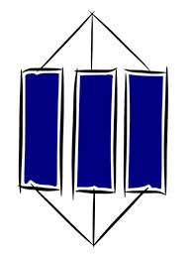 | Extended Abstract  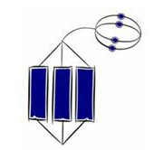
Corresponding grade | NE | I | C/BC | B/AB | AB/A
Health and Challenge  S5.H1.L1  S5.H2.L2 | I know nothing about swimming | I can tell you one benefit of swimming | I can describe several health benefits of swimming | ...and explain how swimming leads to these benefits | ...and evaluate which benefits are most applicable to me
Movement Concepts  S2.H1.L1  S2.H3.L1 | I know nothing about the health related components of fitness or the FITT principle | I can tell you one thing about the health related components of fitness/ FITT principle in relation to swimming | I can describe several health related components of fitness/ aspect of the FITT principle in relation to swimming | ...and explain how I can apply these to myself when swimming | ...and create a swimming plan that addresses specific health related components of fitness and the FITT principle
Assessment and Program Planning  S3.H11.L2 | I have no idea how to monitor my progress when swimming | I can monitor my progress by applying 1-2 elements of the BLABT acronym when swimming | I can monitor my progress by applying all of the BLABT acronym when swimming | ...and analyse both mine and my peer’s performance to see where improvements can be made | ...and make appropriate changes to my swimming strokes based on my analysis
Respect, Etiquette & Safety  S4.H2.L1  S4.H3.L2  S4.H5.L1 | I have no idea what respect and etiquette look like in a swimming pool/ aquatic setting | I have one idea of what respect and etiquette looks like in a swimming pool/ aquatic setting | I can describe multiple examples of respect and etiquette in a swimming pool/ aquatic setting | ...and I apply these examples when in a swimming pool/ aquatic setting independently | ...and help be a role model by modelling and showing my peers how/why they should be respectful

