Sudden Cardiac Arrest Training

Step 1. Go to (https://nfhslearn.com/)

Step 2. Select Sign-in at top of page
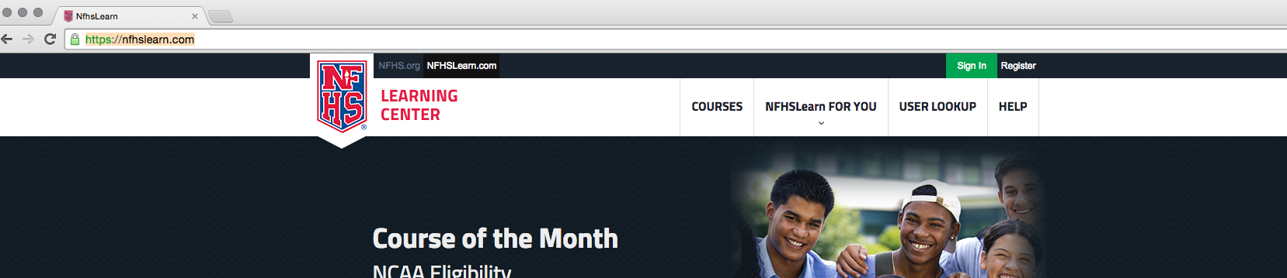

Step 3. Login or select Register Here to a create username and password
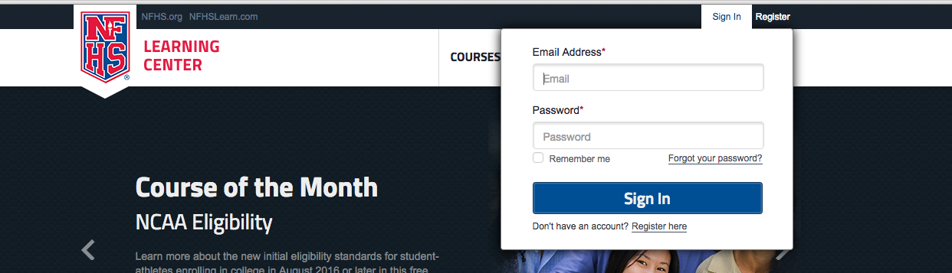

Step 4. Select “Courses” at top of the page after logging in
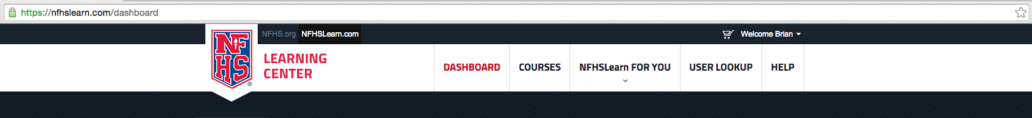

Step 5. “Type Sudden Cardiac Arrest” into search bar
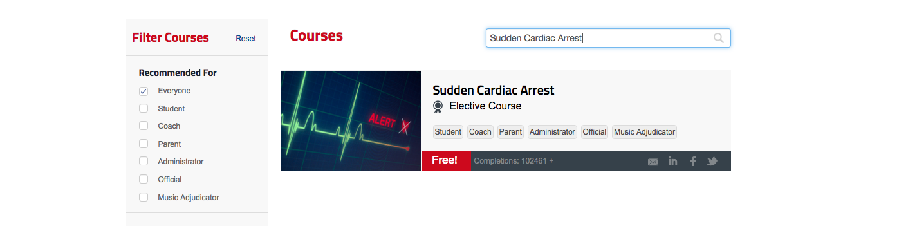

Step 6. Click on the SCA course, and then order the course (the course is FREE)

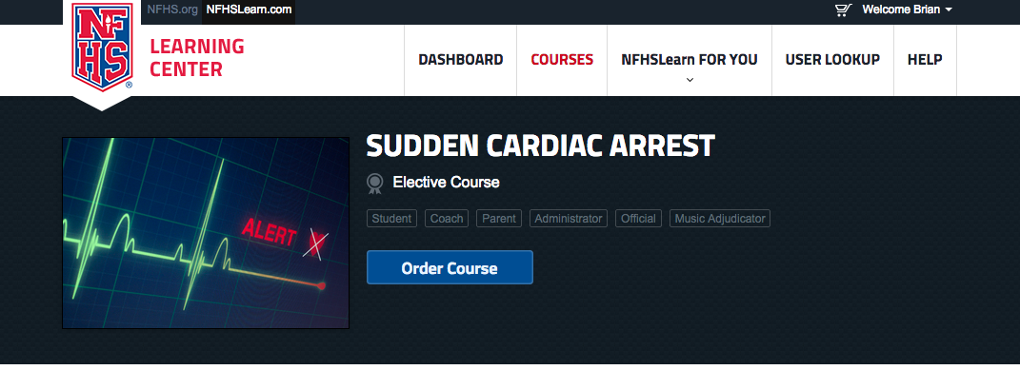

Step 7. The course will be completed by “Myself”, Click continue

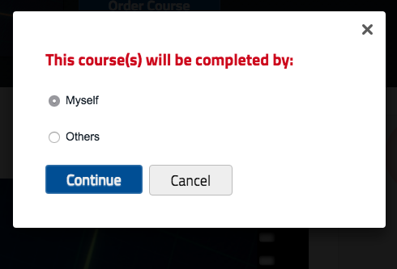

Step 8. Select state “we live in Tennessee”. Click checkout

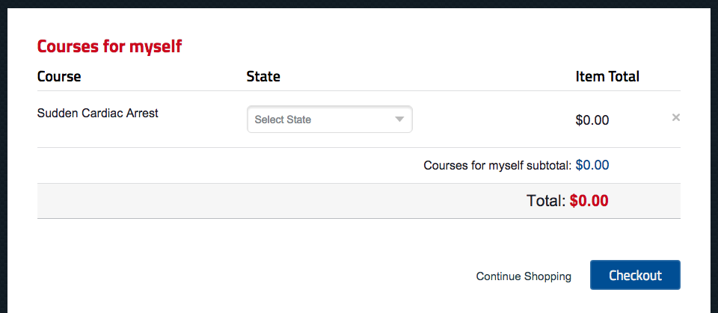

Step 9. Agree to site terms by “marking box” and then click “Continue”

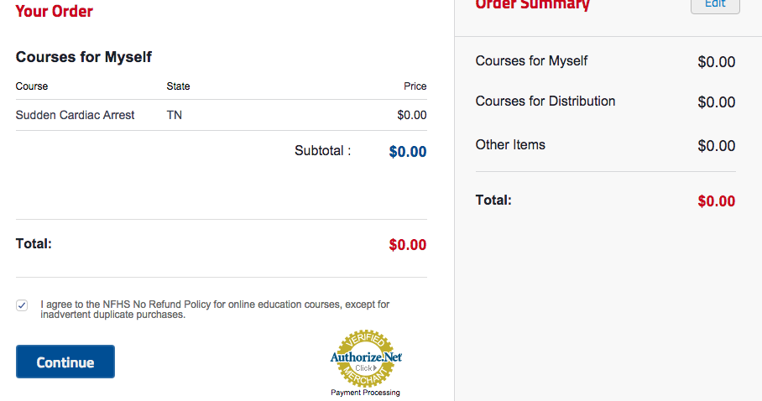

Step 10. After completing step 9, a registration email will be sent to you. You may start the course by clicking “ Click here”
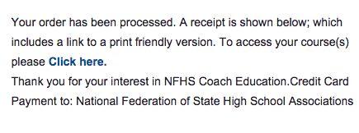
Step 11. Go to “My Courses” and begin your course.
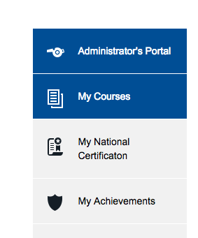
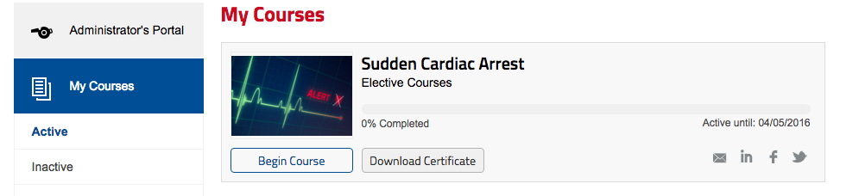

Once you have completed your course requirements, please print thecourse completion certificate and turn it into your Athletic Director or School Administration. If you have any questions, please feel free to reach out Chauncey Bland or Brian Fisher.

