Health and Wellness
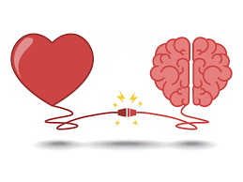

All about muscles

Bicep Draw it
Region
Push/Pull
Key Exercise
Stretch
Interesting Fact

Deltoid (anterior)
Region
Push/Pull
Key Exercise
Stretch
Interesting Fact

Pectorals
Region
Push/Pull
Key Exercise
Stretch
Interesting Fact

Obliques
Region
Push/Pull
Key Exercise
Stretch
Interesting Fact

Forearm
Region
Push/Pull
Key Exercise
Stretch
Interesting Fact

Abdominals
Region
Push/Pull
Key Exercise
Stretch
Interesting Fact

Trapezius
Region
Push/Pull
Key Exercise
Stretch
Interesting Fact

Latissimus Dorsi
Region
Push/Pull
Key Exercise
Stretch
Interesting Fact

Lower Back
Region
Push/Pull
Key Exercise
Stretch
Interesting Fact

Deltoid (Posterior)
Region
Push/Pull
Key Exercise
Stretch
Interesting Fact

Gluteus
Region
Push/Pull
Key Exercise
Stretch
Interesting Fact

Hamstring
Region
Push/Pull
Key Exercise
Stretch
Interesting Fact

Gastrocnemius
Region
Push/Pull
Key Exercise
Stretch
Interesting Fact
Soleus
Region
Push/Pull
Key Exercise
Stretch
Interesting Fact
