(Enter school name or logo)

GET YOUR FITNESS ON!

Dear Parents and Students

The HPE Team want your child and our students to keep active. To help, we have created an activity schedule during this time they are away from school.
It’s important to ensure we have a warm up before we start, and of course make sure you have a towel and drink bottle. Make sure you are keeping your social/physical distance from others, and that your room or backyard is safe from any hazards.
Remember, it is important that all children get a MINIMUM of 60-minutes of moderate to vigorous activity a day. You’re welcome to add any exercises or modify activities as needed.
Low Intensity | Moderate Intensity | High Intensity
Mindfulness | Walking the dog | Running
Meditation | Yoga | Skipping
 | Weights | Boxing
 | Stretching | Cycling
 | Basketball (shooting around)
The table below are some example activities which give you an understanding on what activities are at different intensities.

If you have any questions, please email your teacher

Monday  March 30th | Tuesday  March 31st | Wednesday  April 1st | Thursday  April 2nd | Friday  April 3rd
Challenge Day | PE with Joe | Dancing Fitness | Spell your Name | Circuit Day
WARM UP
DYNAMIC WARM UP EXERCISES ENABLE THE BODY TO BE BETTER PREPARED FOR DYNAMIC MOVEMENTS. DYNAMIC MOVEMENT IS ANY MOVEMENT THAT IS MOVING.
Start:
Star Jumps – 30sec
Walking knee hugs – With each step, raise one up to your hip or higher and hug it with both arms, pulling your knee towards your belly or chest
Arm Circles – Make big circles with your arms
Side Shuffles – 7 steps each side
Lunges – 7 lunges each leg
Leg swings – 20sec each leg.
CHALLENGE DAY!

Set a timer/stopwatch on your phones for 1 minute.
See how many of each exercise you can complete in 1min!
Take a 2 minute rest between each exercise.
Write down the number you complete to compare with next week!

• Burpees
• Push-Ups
• High-Knees on the spot
• Sit Ups • Plank
• Mountain Climbers

Visit
https://www.youtube.com/channel/UCAxW1XT0iEJo0TYlRfn6rYQ
Then click on Monday’s PE with Joe link

WHY JUST DO NORMAL FITNESS, WHY NOT DANCE IT!

VISIT THIS LINK
https://sites.google.com/view/dance-move-challenge/home?authuser=1
FOLLOW THE INSTRUCTIONS AND OFF YOU GO.
IF THAT ISN’T YOUR THING (RECOMMEND YOU TRY IT FIRST), THEN PLAY THIS PLAYLIST AND DO YOUR OWN DANCING
https://www.youtube.com/watch?v=3AyMjyHu1bA&list=PLcirGkCPmbmFeQ1sm4wFciF03D_EroIfr

CAN YOU SPELL YOUR OWN NAME?

LETS FIND OUT!

VISIT
https://docs.google.com/presentation/d/1erzRuuBFLah6IoayHTvSS8C4FmCy6gU7q6cYGw7jlaw/edit#slide=id.p1

THE CARD IS BELOW
SPELL YOUR ENTIRE NAME (FIRST AND LAST NAME, AND IF YOU HAVE A MIDDLE NAME, THAT TOO!)
15 SEC EACH EXERCISE/LETTER.

GOOD LUCK
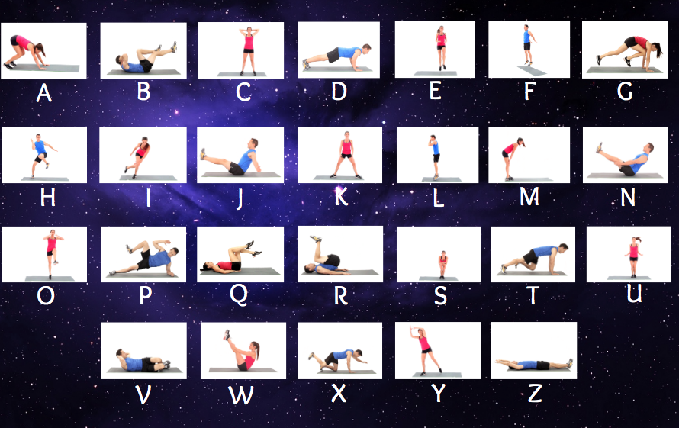

CIRCUIT DAY

10 Push -Ups
30 Star jumps
10 Squats
40 Mountain Climbers – 20 each leg
20 Sit ups
REST for 1 minute

REPEAT 3 TIMES

