**MONTGOMERY BELL TUNNEL**

**EXERCISE: KETTLE BELL**

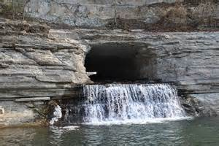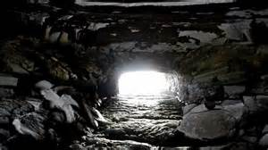

**FACTS:**

* **The Montgomery Bell Tunnel is also known as the 'Patterson Forge Tunnel.**
* **It is located in** [**Cheatham County, Tennessee**](http://en.wikipedia.org/wiki/Cheatham_County,_Tennessee)**.**
* **It is a 290-foot (88 m) long tunnel through** [**limestone**](http://en.wikipedia.org/wiki/Limestone) **rock which was the first "full-scale" water diversion** [**tunnel**](http://en.wikipedia.org/wiki/Tunnel) **built in the** [**United States**](http://en.wikipedia.org/wiki/United_States)**.**
* **It is also apparently the first "full-scale" tunnel of any type in the United States, according to histories of tunneling.**
* **It was built in 1819 by** [**Montgomery Bell**](http://en.wikipedia.org/wiki/Montgomery_Bell) **using the labor of** [**slaves**](http://en.wikipedia.org/wiki/Slave)**.**

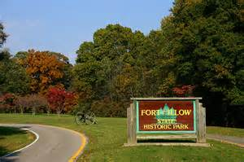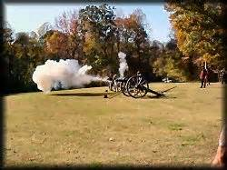

**FORT PILLOW**

**EXERCISE: HEAVY ROPE**

**FACTS:**

* **Fort Pillow State Park is a** [**state park**](http://en.wikipedia.org/wiki/State_park) **in western** [**Tennessee**](http://en.wikipedia.org/wiki/Tennessee)**.**
* **It preserves the** [**American Civil War**](http://en.wikipedia.org/wiki/American_Civil_War) **site of the** [**Battle of Fort Pillow**](http://en.wikipedia.org/wiki/Battle_of_Fort_Pillow)**.**
* **Fort Pillow is located in** [**Lauderdale County**](http://en.wikipedia.org/wiki/Lauderdale_County,_Tennessee) **on the Chickasaw Bluffs overlooking the** [**Mississippi River**](http://en.wikipedia.org/wiki/Mississippi_River)**.**
* **It is rich in both historic and archaeological significance.**
* **In 1861, the** [**Confederate States Army**](http://en.wikipedia.org/wiki/Confederate_States_Army) **built extensive fortifications here and named the site for General** [**Gideon Johnson Pillow**](http://en.wikipedia.org/wiki/Gideon_Johnson_Pillow) **of** [**Maury County**](http://en.wikipedia.org/wiki/Maury_County,_Tennessee)**.**

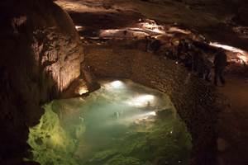

**CUMBERLAND CAVES**

**EXERCISE: FOAM ROLLER**

**FACTS:**

* **Cumberland Caverns is located in** [**McMinnville**](http://en.wikipedia.org/wiki/McMinnville,_Tennessee) **and is the second longest** [**cave**](http://en.wikipedia.org/wiki/Cave) **in** [**Tennessee**](http://en.wikipedia.org/wiki/Tennessee)**.**
* **It has a surveyed length of 27.6 miles (44.4 kilometers), which makes it the 19th longest cave in the United States and the 72nd longest cave in the world.**
* **The main entrance was discovered by Aaron Higgenbotham in 1810.**

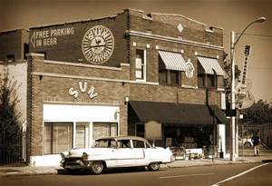

**SUN RECORDS**

**EXERCISE: FREE WEIGHTS**

**FACTS:**

* **Sun Studio is a recording studio opened by rock pioneer** [**Sam Phillips**](http://en.wikipedia.org/wiki/Sam_Phillips) **at 706 Union Avenue in** [**Memphis, Tennessee**](http://en.wikipedia.org/wiki/Memphis,_Tennessee)**, on January 3, 1950.**
* **It was originally called Memphis Recording Service, sharing the same building with the** [**Sun Records**](http://en.wikipedia.org/wiki/Sun_Records) **label business.**
* **Reputedly the first** [**rock-and-roll**](http://en.wikipedia.org/wiki/Rock_and_roll) **single, Jackie Brenston and his Delta Cats' "**[**Rocket 88**](http://en.wikipedia.org/wiki/Rocket_88)**" was recorded there in 1951**

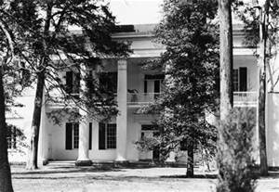

**THE HERMITAGE**

**EXERCISE: JUMPING JACKS**

**FACTS:**

* **The Hermitage is a historical** [**plantation**](http://en.wikipedia.org/wiki/Plantation) **and** [**museum**](http://en.wikipedia.org/wiki/Museum) **located in** [**Davidson County**](http://en.wikipedia.org/wiki/Davidson_County,_Tennessee)**,** [**Tennessee**](http://en.wikipedia.org/wiki/Tennessee)**,** [**USA**](http://en.wikipedia.org/wiki/United_States)**, 10 miles east of downtown** [**Nashville**](http://en.wikipedia.org/wiki/Nashville,_Tennessee)**.**
* **The plantation was owned by** [**Andrew Jackson**](http://en.wikipedia.org/wiki/Andrew_Jackson)**, the seventh** [**President of the United States**](http://en.wikipedia.org/wiki/President_of_the_United_States)**, from 1804 until his death at the Hermitage in 1845.**
* **Jackson only lived at the property occasionally until he retired from public life in 1837. It is a National Historic Landmark.**

**STONES RIVER NATIONAL BATTLEFIELD**

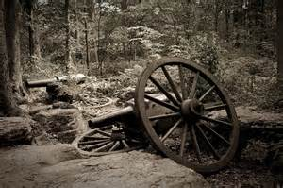

**FACTS:**

* **Stones River National Battlefield is a 570-acre park along the** [**Stones River**](http://en.wikipedia.org/wiki/Stones_River) **in** [**Rutherford County, Tennessee**](http://en.wikipedia.org/wiki/Rutherford_County,_Tennessee)**.**
* **It memorializes a key battle of the** [**American Civil War**](http://en.wikipedia.org/wiki/American_Civil_War) **that took place on December 31, 1862 and January 2, 1863, which resulted in a strategic** [**Union**](http://en.wikipedia.org/wiki/Union_(American_Civil_War)) **victory.**
* **The national battlefield was established through the efforts of the Stones River Battlefield and Park Association.**

**EXERCISE: CRABWALK**

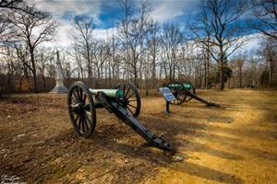

**FACTS:**

* **Shiloh National Military Park preserves the** [**American Civil War**](http://en.wikipedia.org/wiki/American_Civil_War) **Shiloh and Corinth battlefields.**
* **The main section of the park is in the town of Shiloh, with an additional area located in the city of** [**Corinth, Mississippi**](http://en.wikipedia.org/wiki/Corinth,_Mississippi)**.**
* **The** [**Battle of Shiloh**](http://en.wikipedia.org/wiki/Battle_of_Shiloh) **began a six-month struggle for the key railroad junction at Corinth**
* **The** [**Battle of Shiloh**](http://en.wikipedia.org/wiki/Battle_of_Shiloh) **was one of the first major battles in the** [**Western Theater of the American Civil War**](http://en.wikipedia.org/wiki/Western_Theater_of_the_American_Civil_War)**.**
* **The two-day battle, April 6 and April 7, 1862, involved about 65,000** [**Union**](http://en.wikipedia.org/wiki/Union_army) **troops under** [**Ulysses S. Grant**](http://en.wikipedia.org/wiki/Ulysses_S._Grant) **and** [**Don Carlos Buell**](http://en.wikipedia.org/wiki/Don_Carlos_Buell)**.**

**EXERCISE: WALL SITS**

**SHILOH NATIONAL MILITARY PARK**

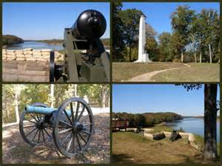

**FORT DONELSON**

**EXERCISE: STABILITY BALL**

**FACTS:**

* **Fort Donelson National Battlefield preserves** [**Fort Donelson**](http://en.wikipedia.org/wiki/Fort_Donelson) **and Fort Heiman, two sites of the** [**American Civil War**](http://en.wikipedia.org/wiki/American_Civil_War) **Forts.**
* **The capture of Fort Donelson and its garrison by the** [**Union**](http://en.wikipedia.org/wiki/Union_(American_Civil_War)) **led to the capture of Tennessee's capital and industrial center,** [**Nashville**](http://en.wikipedia.org/wiki/Nashville,_Tennessee)**, which remained in Union hands from February 25, 1862 until the end of the war.**
* **The park preserves much of the original battle site, including the river batteries and the eroded remains of the fort.**

**REELFOOT LAKE**

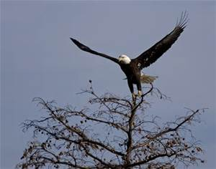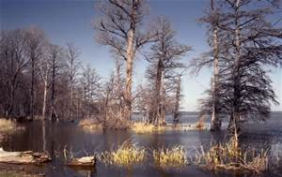

**FACTS:**

* **Reelfoot Lake is noted for its** [**bald cypress**](http://en.wikipedia.org/wiki/Taxodium) **trees and its nesting pairs of** [**bald eagles**](http://en.wikipedia.org/wiki/Bald_eagle)**.**
* **It is the site of** [**Reelfoot Lake State Park**](http://en.wikipedia.org/wiki/Reelfoot_Lake_State_Park)**.**
* **Reelfoot Lake was formed when the region subsided during the** [**New Madrid earthquakes**](http://en.wikipedia.org/wiki/New_Madrid_Earthquake) **of 1811–1812.**
* **Several eyewitnesses reported that the** [**Mississippi River**](http://en.wikipedia.org/wiki/Mississippi_River) **flowed backward for 10–24 hours to fill the lake.**
* **Reelfoot is the only large natural lake in Tennessee, and gives its name to** [**Lake County**](http://en.wikipedia.org/wiki/Lake_County,_Tennessee)**, Tennessee, in which it is located.**
* **Reelfoot Lake is said to be named for an** [**Indian**](http://en.wikipedia.org/wiki/Native_Americans_in_the_United_States) **chief who had a deformed foot and was nicknamed "Reelfoot" by settlers in the early 1800s.**

**EXERCISE: RESISTANCE BANDS**

**PINSON MOUNDS**

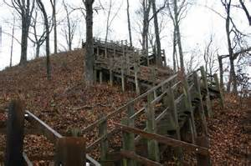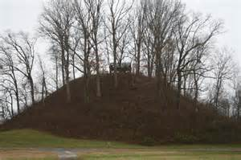

**FACTS:**

* **The Pinson Mounds comprise a prehistoric** [**Native American**](http://en.wikipedia.org/wiki/Native_Americans_in_the_United_States) **complex located in** [**Madison County, Tennessee**](http://en.wikipedia.org/wiki/Madison_County,_Tennessee)**.**
* **It is in the region that is known as the Eastern Woodlands.**
* **The complex includes 17** [**mounds**](http://en.wikipedia.org/wiki/Mound)**, an** [**earthen**](http://en.wikipedia.org/wiki/Earthen) **geometric** [**enclosure**](http://en.wikipedia.org/wiki/Enclosure)**, and numerous habitation areas.**
* **It was most likely built during the** [**Middle Woodland period**](http://en.wikipedia.org/wiki/Woodland_period) **(c. 1-500** [**A.D.**](http://en.wikipedia.org/wiki/A.D.)**).**
* **The complex is the largest group of Middle Woodland mounds in the United States.**
* **The Pinson Mounds are now part of Pinson Mounds State Archaeological Park, one of two** [**archaeological**](http://en.wikipedia.org/wiki/Archaeology) **parks in Tennessee**

**EXERCISE: MEDICINE BALL**

**GATLINBURG**

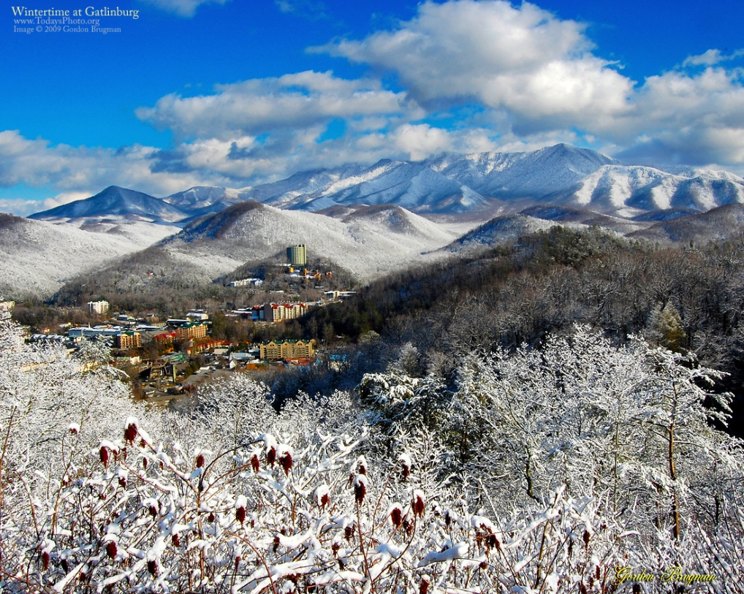

**FACTS:**

* **Gatlinburg is a mountain** [**resort city**](http://en.wikipedia.org/wiki/Resort_town) **in** [**Sevier County**](http://en.wikipedia.org/wiki/Sevier_County,_Tennessee)**,** [**Tennessee**](http://en.wikipedia.org/wiki/Tennessee)**.**
* **The population was 3,944 at the 2010 Census, and 4,047 according to the 2012 Census estimate.**
* **The city is a popular vacation resort, as it rests on the border of the** [**Great Smoky Mountains National Park**](http://en.wikipedia.org/wiki/Great_Smoky_Mountains_National_Park)**.**
* **A pivotal figure in Gatlinburg at this time was Andrew Jackson Huff (1878–1949), originally of** [**Greene County**](http://en.wikipedia.org/wiki/Greene_County,_Tennessee)**. Huff erected a sawmill in Gatlinburg in 1900.**

**EXERCISE: SIT-UPS**

**THE UNIVERSITY OF TENNESSEE**

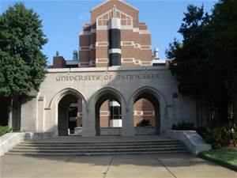

**FACTS:**

* **The University of Tennessee (also referred to as the University of Tennessee, Knoxville, UT Knoxville, UTK, or UT) is headquartered at** [**Knoxville**](http://en.wikipedia.org/wiki/Knoxville,_Tennessee)**,** [**Tennessee**](http://en.wikipedia.org/wiki/Tennessee)**.**
* **Founded in 1794, two years before Tennessee entered the Union as the 16th state.**
* **The University of Tennessee is the only university in the nation to have three presidential papers editing projects and holds collections of the papers of all three U.S. presidents from Tennessee—**[**Andrew Jackson**](http://en.wikipedia.org/wiki/Andrew_Jackson)**,** [**James K. Polk**](http://en.wikipedia.org/wiki/James_K._Polk)**, and** [**Andrew Johnson**](http://en.wikipedia.org/wiki/Andrew_Johnson)**.**
* **The mascot is a blue tick coonhound named Smokey.**
* **It has an estimated 28,000 students enrolled each year.**

**EXERCISE: SCOOTERS**

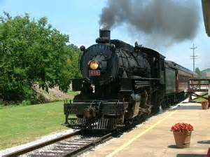

**CHATTANOOGA**

**EXERCISE: SCISSOR KICKS**

**FACTS:**

* **Chattanooga is the fourth-largest city in the**  [**state**](http://en.wikipedia.org/wiki/U.S._state) **of** [**Tennessee**](http://en.wikipedia.org/wiki/Tennessee)**.**
* **It has a population of 167,674 as of the 2010 census, and an estimated population of 171,279 in 2012.**
* **The first inhabitants of the Chattanooga area were** [**American Indians**](http://en.wikipedia.org/wiki/Native_Americans_in_the_United_States).
* **Chattanooga is the home of the** [**International Towing and Recovery Hall of Fame and Museum**](http://en.wikipedia.org/wiki/International_Towing_and_Recovery_Hall_of_Fame_and_Museum)**.**
* **Another transportation icon, the** [**passenger train**](http://en.wikipedia.org/wiki/Passenger_train)**, can be found at the** [**Tennessee Valley Railroad Museum**](http://en.wikipedia.org/wiki/Tennessee_Valley_Railroad_Museum)**.**
* **Chattanooga is home to the** [**Hunter Museum of American Art**](http://en.wikipedia.org/wiki/Hunter_Museum_of_American_Art)**.**

**SMOKY MOUNTAINS**

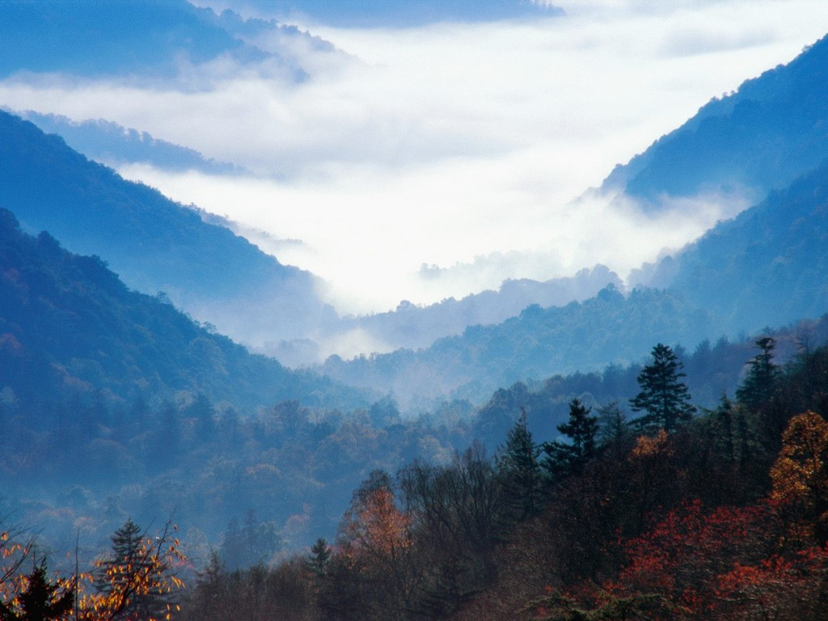

**FACTS:**

* **The Great Smoky Mountains are a** [**mountain range**](http://en.wikipedia.org/wiki/Mountain_range) **rising along the** [**Tennessee**](http://en.wikipedia.org/wiki/Tennessee)**–**[**North Carolina**](http://en.wikipedia.org/wiki/North_Carolina) **border.**
* **The range is sometimes called the Smoky Mountains and the name is commonly shortened to the Smokies.**
* **The Great Smokies are best known as the home of the** [**Great Smoky Mountains National Park**](http://en.wikipedia.org/wiki/Great_Smoky_Mountains_National_Park)**, which protects most of the range.**
* [**Native Americans**](http://en.wikipedia.org/wiki/Native_Americans_in_the_United_States) **have likely been hunting in the Great Smoky Mountains for 14,000 years.**
* **The name "Smoky" comes from the natural fog that often hangs over the range and presents as large smoke plumes from a distance.**

**EXERCISE: MOUNTAIN CLIMBERS**

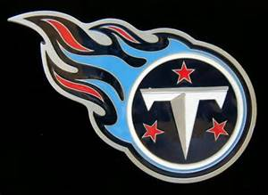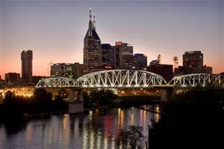

**NASHVILLE**

**EXERCISE: PUSH-UPS**

**FACTS:**

* **Nashville is the capital of the** [**U.S. state**](http://en.wikipedia.org/wiki/U.S._state) **of** [**Tennessee**](http://en.wikipedia.org/wiki/Tennessee)**.**
* **It is known as a center of the** [**music industry**](http://en.wikipedia.org/wiki/Music_industry)**, earning it the nickname "Music City".**
* **Nashville is the second largest city in Tennessee.**
* **The town of Nashville was founded by** [**James Robertson**](http://en.wikipedia.org/wiki/James_Robertson_(explorer))**,** [**John Donelson**](http://en.wikipedia.org/wiki/John_Donelson)**, and a party of** [**Overmountain Men**](http://en.wikipedia.org/wiki/Overmountain_Men) **in 1779, near the original Cumberland settlement of** [**Fort Nashborough**](http://en.wikipedia.org/wiki/Fort_Nashborough)**.**
* **Many visitors to Nashville attend live performances of the** [**Grand Ole Opry**](http://en.wikipedia.org/wiki/Grand_Ole_Opry)**, the world's longest running live radio show.**
* **The** [**Country Music Hall of Fame and Museum**](http://en.wikipedia.org/wiki/Country_Music_Hall_of_Fame_and_Museum) **is another major attraction relating to the popularity of country music.**
* **Nashville has several professional sports teams, the** [**Nashville Predators**](http://en.wikipedia.org/wiki/Nashville_Predators) **of the** [**NHL**](http://en.wikipedia.org/wiki/National_Hockey_League) **and the** [**Tennessee Titans**](http://en.wikipedia.org/wiki/Tennessee_Titans) **of the** [**NFL**](http://en.wikipedia.org/wiki/National_Football_League)**.**

**MEMPHIS**

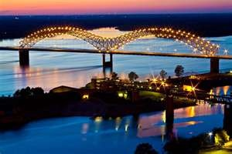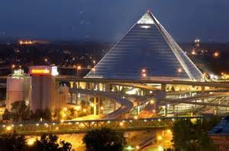

**FACTS:**

* **John Overton, James Winchester, and Andrew Jackson found the city of Memphis on May 22, 1819.**
* **Memphis had a population of 655,155 in 2012, making it the largest city in the state of** [**Tennessee**](http://en.wikipedia.org/wiki/Tennessee)**.**
* **The area was first settled by the** [**Mississippian Culture**](http://en.wikipedia.org/wiki/Mississippian_Culture)**, thence by the** [**Chickasaw**](http://en.wikipedia.org/wiki/Chickasaw)[**Indian tribe**](http://en.wikipedia.org/wiki/Native_Americans_in_the_United_States)**.**
* **This was followed by European exploration, beginning in the 16th century with Spanish explorer** [**Hernando de Soto**](http://en.wikipedia.org/wiki/Hernando_de_Soto)**.**
* **Rev.** [**Martin Luther King, Jr.**](http://en.wikipedia.org/wiki/Martin_Luther_King,_Jr.) **came to lend his support to the workers' cause during the 1960s.**
* **He stayed at the** [**Lorraine Motel**](http://en.wikipedia.org/wiki/Lorraine_Motel) **in the city, where he was** [**assassinated**](http://en.wikipedia.org/wiki/Assassination_of_Martin_Luther_King,_Jr.) **by a sniper on April 4, 1968, the day after giving his prophetic** [***I've Been to the Mountaintop***](http://en.wikipedia.org/wiki/I%27ve_Been_to_the_Mountaintop) **speech at the** [**Mason Temple**](http://en.wikipedia.org/wiki/Mason_Temple)**.**

**EXERCISE: STEP-UPS**

**GRACELAND**

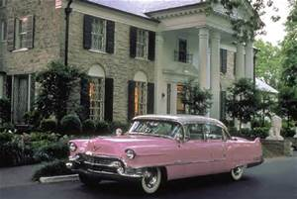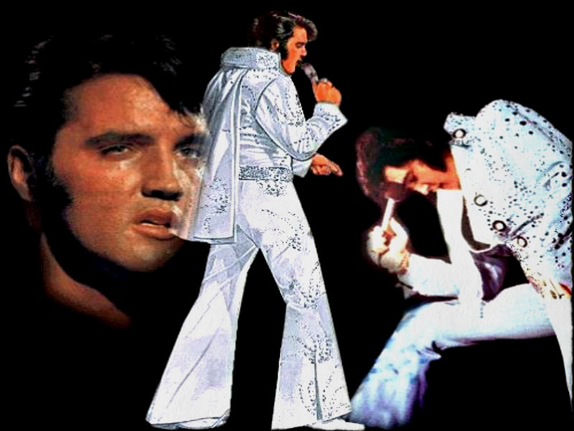

**FACTS:**

* **Graceland is a large white-columned mansion in** [**Memphis**](http://en.wikipedia.org/wiki/Memphis,_Tennessee)**,** [**Tennessee**](http://en.wikipedia.org/wiki/Tennessee) **that was home to** [**Elvis Presley**](http://en.wikipedia.org/wiki/Elvis_Presley)**.**
* **It currently serves as a museum. It was opened to the public on June 7, 1982.**
* **Graceland has become one of the most-visited private homes in America with over 600,000 visitors a year, behind the** [**White House**](http://en.wikipedia.org/wiki/White_House) **and** [**Biltmore Estate**](http://en.wikipedia.org/wiki/Biltmore_Estate) **(900,000 visitors per year).**
* **Elvis Presley died at the estate on August 16, 1977. Presley, his parents Gladys and Vernon Presley, and his grandmother, is buried there in what is called the Meditation Garden.**

**EXERCISE: HOULA HOOPS**

**THE MISSISSIPPI RIVER**

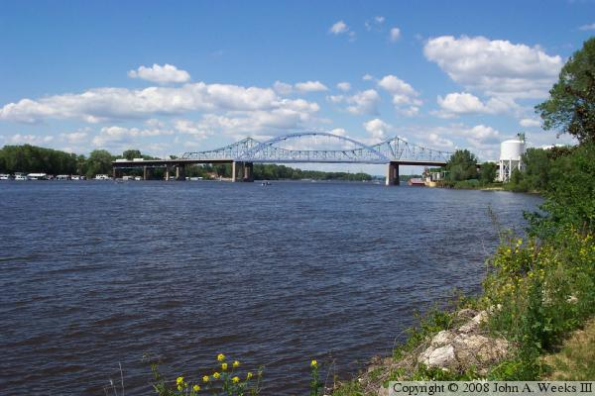

**FACTS:**

* **The Mississippi River is the third longest river system in the world.**
* **The Mississippi itself stretches approximately 2,350 miles from Lake Itasca to the Gulf of Mexico.**
* **With its many** [**tributaries**](http://en.wikipedia.org/wiki/Tributary)**, the Mississippi's** [**watershed**](http://en.wikipedia.org/wiki/Drainage_basin) **drains all or parts of 31 US states and 2 Canadian provinces between the** [**Rocky**](http://en.wikipedia.org/wiki/Rocky_Mountains) **and** [**Appalachian Mountains**](http://en.wikipedia.org/wiki/Appalachian_Mountains)**.**
* **The river either borders or passes through the states of** [**Minnesota**](http://en.wikipedia.org/wiki/Minnesota)**,** [**Wisconsin**](http://en.wikipedia.org/wiki/Wisconsin)**,** [**Iowa**](http://en.wikipedia.org/wiki/Iowa)**,** [**Illinois**](http://en.wikipedia.org/wiki/Illinois)**,** [**Missouri**](http://en.wikipedia.org/wiki/Missouri)**,** [**Kentucky**](http://en.wikipedia.org/wiki/Kentucky)**,** [**Tennessee**](http://en.wikipedia.org/wiki/Tennessee)**,** [**Arkansas**](http://en.wikipedia.org/wiki/Arkansas)**,** [**Mississippi**](http://en.wikipedia.org/wiki/Mississippi)**, and** [**Louisiana**](http://en.wikipedia.org/wiki/Louisiana)**.**
* [**Native Americans**](http://en.wikipedia.org/wiki/Indigenous_peoples_of_the_Americas) **long lived along the Mississippi and its tributaries. Most were** [**hunter-gatherers**](http://en.wikipedia.org/wiki/Hunter-gatherer) **or herders.**

**EXERCISE: JUMP ROPE**

**BEALE STREET**

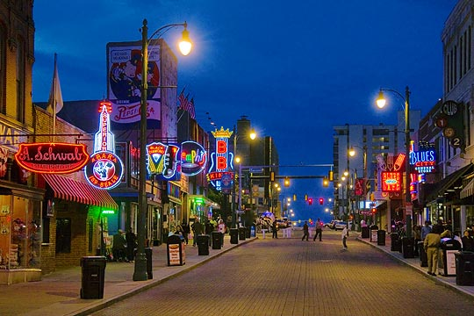

**FACTS:**

* **Beale Street was created in 1841 by entrepreneur and developer Robertson Topp (1807–1876), who named it for a forgotten military hero.**
* **Its western end primarily housed shops of trade merchants, who traded goods with ships along the** [**Mississippi River**](http://en.wikipedia.org/wiki/Mississippi_River)**, while the eastern part developed as an affluent suburb.**
* **It is a significant location in the city's history, as well as in the history of the** [**blues**](http://en.wikipedia.org/wiki/Blues)**. Today, the blues clubs and restaurants that line Beale Street are major** [**tourist**](http://en.wikipedia.org/wiki/Tourism) **attractions in Memphis.**

**EXERCISE: HURDLES**

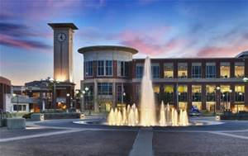

**FACTS:**

* **The University of Memphis was founded under the General Education Bill, enacted by the Tennessee Legislature in 1909.**
* **Known originally as West Tennessee State Normal School.**
* **It opened its doors Sept. 10, 1912, with Dr. Seymour A. Mynders as president.**
* **The University of Memphis is situated in a beautiful park-like setting in the state's largest city.**
* **It awards more than 3,000 degrees annually.**
* **The school’s mascot is Tom the Tiger.**
* **The University of Memphis has an enrollment of 21,000 students a year.**

**EXERCISE: BODY SQUATS**

**THE UNIVERSITY OF MEMPHIS**