PE with a Purpose & On the Move

- ILHS State Champ PE Program - Brochure
- 26 Years teaching & coaching
- 2016 SC State Middle School Teacher of the Year
- 2012 SC State High School Teacher of the Year
- 2002 & 2004 SC 4A State Championship Football Coach
- 2000 SC 4A State Championship Wrestling Coach
- Session Handouts
- ILHS PE Website
- ILHS PE State Champ Video
- PE Rules/Sports Slideshow
- Health Rules/Topics Slideshow
- State Champ PE Slideshow
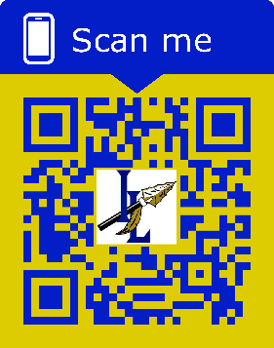

Brochure, Handouts, Slideshows, Videos
Contact Form
Evaluation

For a complete list of 35 conference presentations including Keynote, Lecture, and Activity Sessions – Click here

