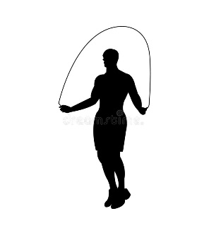
Skipping

Which level can you skip at?

Level 4 | Level 5 | Level 6 | Level 7
Basic skip  Bum kicks  Hopping  Double jumps  Side steps | Silors  Can can  Knee raises  Side lifts  Slalom  Jumping jacks  Jumping forward and backwards | Mmoving around the area  Crossover  Turn around  Backwards  Heel taps  Crossover legs  Criss cross | Run into and out of moving rope  Pretzel  Half twist with cross  Double douch
On the spot | Link together  Rope keeps moving | Moving with rope  Doing different things with rope  Working with partner at same time | Combining skipping techniques  Different pace

