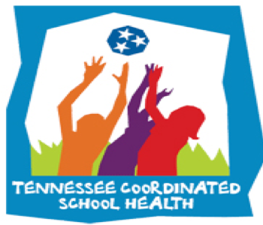

Coordinated School Health is based on the Centers for Disease Control 8 component approach to healthier schools:

1. Nutrition Services
2. Physical Ed/Physical Activity
3. Healthy School Environment
4. Counseling and Psychological Services
5. Health Promotion for Staff
6. Parent/Community Involvement
7. Health Services
8. Health Education

The purpose of a healthy school team is to utilize faculty and staff in each school building who are considered experts in each component so that we are able to capture a more comprehensive look at the school. After assessing the needs of your school, as a team, the school will develop a plan to not only address the weaknesses, but also highlight its strengths. We want to promote healthy schools and encourage healthy behaviors, for students, faculty and families.

**Important Links & Resources:**

HST Page on my Site: [Click Here](https://coachmartinpe.weebly.com/healthy-school-teams.html)

AFHK SHI Page on my Site: [Click Here](https://coachmartinpe.weebly.com/afhk-school-health-index.html)

**September Health Observances**

**8 Components of Coordinated School Health**

**Health Referrals**

We are taking Health Referrals for any student that might be hearing or vision impaired! These two areas can severely impact learning if left untreated! Contact school nurse for any referral needs.

**GMSD Updates:**

-[Go Noodle](https://app.gonoodle.com/) has been purchased for this year!

-700 FREE accounts from [Sworkit](https://coachmartinpe.weebly.com/sworkit.html). Get yours today!

-[Breakfast](https://coachmartinpe.weebly.com/school-breakfast-program.html) is important and there’s ways to highlight it!

**HST Important Dates:**

* Sept. 18th= HST List Due
* Sept. 18th= CPR List Due
* Oct. 9th= AFHK School Health Index Due
* Oct. 9th= Meeting 1 Notes Due

Suicidal thoughts can affect anyone regardless of age, gender, or background. Suicide is the third leading cause of death among young people and is often the result of mental health conditions that affect people when they are most vulnerable. We can all work together to combat this issue and provide the necessary care and support to our students. [Click here](https://www.tspn.org/suicide-and-population-groups/suicide-and-youth/) to learn more facts about youth suicide in Tennessee.

September is a busy month for health observances. This month we’ll focus on childhood obesity and suicide prevention.

[National Childhood Obesity](http://www.fitness.gov)