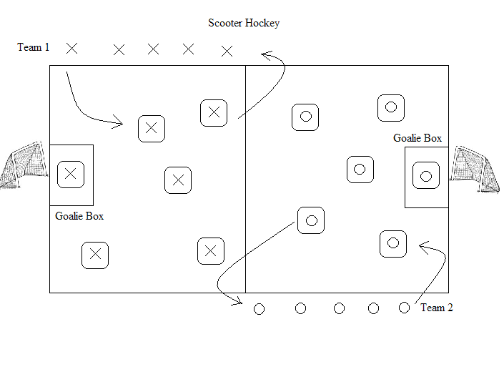
Grades: 1-5
Equipment: 1-3 small gator balls, 12 scooters, 12 scooter hockey paddles, 2 goals, score board floor tape for goalie box.
Object of the game: Score as many goals possible.
Rules: 2-3 minute rounds. First 6 in line for each team should walk to a scooter when called on. Only Goalies are allowed in the Goalie box. Goalie may pick up ball and roll or toss to a teammate. After scoring, scoring team must return to their side of the court to play half court defense until the ball crosses over the midline. At the end of the round, students should place paddles on top of scooters before returning to the end of the line.
Sideline should be sitting and may tap the ball back into play when it comes to them.
If more action is needed, you may toss out a few more extra balls to increase activity.
No stepping or standing on scooters. Remind students to not push the scooters across the floor.
If the ball gets stuck between the students, blow the whistle, pick up the ball and toss it away to resume play.

