SAFETY PROTOCOLS & INSTRUCTIONAL MODELS
One of the key recommendations of the Shelby County Health Department and Center for Disease Control (CDC) is to provide 3-6 feet of social distancing when possible.
Last year, school districts in TN received special permission from the Governor and the State Board of Education to operate virtually and with hybrid instruction. This year the Governor and State Board of Education have ruled that districts are not allowed to offer these forms of modified instruction. All GMSD schools will offer in-person, full-time instruction for the 2021-2022 school year.
The only exception to virtual learning allowed must be a state-approved stand-alone virtual school. GMSD received approval for a stand-alone virtual school for grades 6-12. The parent response for students in lower grades at the time of application did not support expansion to the lower grades.

Social Distancing & Masking

Classrooms will maintain at least 3-6 feet of physical distance between students within classrooms when possible. The wearing of masks will mirror Shelby County Health Department Directive No. 24.
Masks are mandated for all person(s) vaccinated and unvaccinated while indoors in a school building.

From the beginning of the pandemic, GMSD has followed the guidance of the Shelby County Health Department. We will continue to do so. *If your child has a valid CDC exemption and is unable to wear a mask, please reach out to your school administration (medical documentation will be required per the SCHD).

Contact Tracing
Vaccinated vs. Non-Vaccinated:
- Fully vaccinated individuals will not be required to quarantine if identified as a direct contact. (Unless experiencing symptoms).
- Non-vaccinated individuals will be required to quarantine if identified as a direct contact, regardless if currently experiencing symptoms or not.
A Student Tests Positive:
- Families will reach out to GMSD (building nurse, CSH Supervisor, or building admin to notify district of positive test results.
- Members of the district’s contact tracing team will reach out to gather additional information and provide a return to school/activity date.
- Positive cases will quarantine for 10 days based off the day they started symptoms (if known) or day they were tested.
- A school and district notification will be sent out informing of a positive COVID case. Names will not be shared in any district communications.
- Return to school date(s) will be communicated with building principals, attendance clericals, and the student’s teachers.

A Positive Case is Identified:
- Contact tracing takes place with CSH Supervisor and Lead nurse reaching out to start interviews.
- Close contacts will be identified based off case analysis and interviews.
- A return to school/activity date is generated based off last time contact was had with positive case and/or when symptoms started.
- Families can complete early return options (7 or 10 days) by meeting the criteria for early return.
Student Sent Home With Symptoms:
- A student sent home from school by the school nurse with Covid like symptoms must meet the following criteria for return:
  - Complete a 10-day isolation to monitor symptoms.
  - Receive a negative COVID test and remain fever free for 24-hours without the aid of fever reducing medications. (Can return the next day if this criterion is met).
- A COVID Parent Packet will be provided to the family once they pick their child up. The packet includes: Doctor's note that must be signed is seeking an alternative diagnosis, return to school options, and a COVID symptom monitoring log.
Return Options for Direct Contacts:
- 7 Day Quarantine = Must get a negative COVID test (no earlier than 5 days from last exposure) and remain without symptoms.
- 10 Day Quarantine = Must remain without symptoms for 10 days. No COVID test required.
- 14 Day Quarantine = If a direct contact cannot meet the criteria for early return, a 14-day quarantine is required.
- 24 Day Quarantine = If a direct contact is unable to isolate from positive cases in their household, then a 24-day quarantine is required.
- Positive Case: If a direct contact tests positive, they will complete a 10-day quarantine based either off the day symptoms started (if known) or date COVID test taken.
  - If fully vaccinated and identified as a direct contact, you are not required to quarantine unless you are experiencing symptoms.

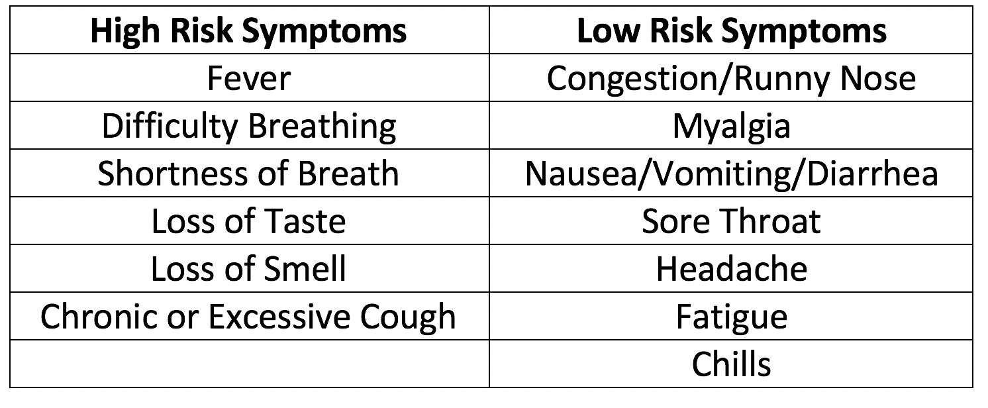
- Any student who presents to the clinic/nurse with any one of the high-risk symptoms or with any combination of 3 or more low-risk symptoms will be sent home.
- Further evaluation by a physician is recommended.
- Students with suspected Covid symptoms will be moved to the contamination/isolation area until picked up by parent/guardian/emergency contact.

- Student will not return to school until at least 10 days from the onset of symptoms and 24 hours without fever and without fever reducing medication.

- Or may return prior to 10 days with a negative Covid test and 24 hours after fever free without fever reducing medication (must return to normal at or below 98.6) and symptoms are improved if Physician approved.

- Examples of accepted diagnoses (From a Physician) would include fever due to urinary tract infection, strep throat confirmed by a positive strep test, rash from poison ivy, etc.

- Examples that DO NOT exclude the diagnosis of Covid-19 and DO NOT justify return to school would include diagnosis of respiratory and viral conditions such as allergic rhinitis, seasonal allergies, upper respiratory tract infection (URI), pneumonia, pharyngitis without positive strep test, viral illness.,

Close Contact:
A close contact is identified as the following:
- An individual within 3-6 feet of a confirmed positive case for a cumulative 15 minutes in a 24-hour span.
- Exception: In the K–12 indoor classroom setting, the close contact definition excludes students who were within 3 to 6 feet of an infected student (laboratory-confirmed or a clinically compatible illness) if both the infected student and the exposed student(s) correctly and consistently wore well-fitting masks the entire time.
Additional Health Considerations
Appearance/Behavior - Lethargy (unusually tired, pale, and difficult to wake), confused or irritable. These symptoms can be sufficient reason to stay at home, if severe or unusual.
Fever - Temperature of 100.4 F or higher, then child must go home and be fever free without medication for at least 24 hours (at or below 98.6) before returning to school. While at home, caregivers are encouraged to ensure that the child receives adequate fluids.
- It is recommended that all students who are sent home with a fever, are evaluated by a physician.
Diarrhea - Two (2) or more watery stools in a 24-hour period, unless accompanied by other symptoms, at which time the nurse will determine if there is a need to send home sooner.
Vomiting - Two (2) or more times within the past 24 hours, child should be kept home. If vomiting occurs at school, child must be sent home and free of vomiting episodes for at least 24 hours.
Rash - Children with a skin rash should see a doctor, as this could be one of several infectious diseases. Heat rash and allergic reactions are not contagious, and the student may come to school if symptoms are tolerable.
Sore Throat - A minor sore throat is usually not a problem, but a severe sore throat could be more serious, even if no fever exists. Special tests are needed to diagnosis strep throat. If other symptoms are part of the complaint, it is advised that the child’s parent be called to pick them up because they may be contagious.
Eyes - With pink eye (conjunctivitis), you may see a white/yellow discharge, matted eyelids after sleep, or eye pain and redness. Child should go home if suspected pink eye and treatment has not begun. The child may return to school after 24-hour treatment of an antibiotic eye medication.
Communicable Disease - Refer to Board Policy SP 6.403 and Shelby County Health Department guidance.
Ringworm - Ringworm is contagious, and to stop the spread of infection, timely treatment is extremely important. Avoiding skin contact with the infected person is the best way to stop it from spreading. Ringworm can be treated simply with some over-the-counter anti-fungal cream, though more severe cases may require the use of an oral anti-fungal medication. The area must be covered and treated for the student to remain in school.
Allowing your child to be in school with any of the above symptoms puts other children and staff at risk. The intent of these guidelines is in the best interest of all and can translate into fewer missed days due to illness. We will be proactive in maintaining a healthy environment in our schools for all our community.

Covid Questions and Notifications:
Forest-Hill Elementary: Alison Herrington, Mary.herrington@gmsdk12.org
Dogwood Elementary: Madhuri Srinivasan, Madhuri.srinivasan@gmsdk12.org
Farmington Elementary: Melissa Eskins, Melissa.eskins@gmsdk12.org
Riverdale Elementary (K-8): Julie Bebawy, Julie.bebawy@gmsdk12.org
Houston Middle School: Laura Smith, Laura.smith@gmsdk12.org
Houston High School: Celeste Waldrup, Celeste.waldrup@gmsdk12.org
GMSD Lead Nurse: Colleen Cheatham, Colleen.cheatham@gmsdk12.org
GMSD School Health Supervisor: Andrew Martin, Andrew.martin@gmsdk12.org

COVID Related Absences
When a student is identified as a direct contact to someone who has tested positive for COVID-19 or has tested positive and needs to quarantine according to the GMSD student COVID protocol, absences will be excused. Teachers will offer access to lessons and materials to keep students on track during their absence. This access can include Schoology assignments, printed assignments, and/or video-recorded lessons.
Students may participate in learning activities each day while quarantined to remain on track with lessons/curriculum; however, they may also wait to submit assignments upon returning according to the GMSD Grading Policy 4.600:
In the event of an excused absence, students are expected to make up missed work within a reasonable amount of time as determined by the school policy, with a minimum of one day allowed for each day absent.

TECHNOLOGY
For password resets, general troubleshooting, or technology questions:
Email helpdesk@gmsdk12.org or call (901)756-2323
If the device is stolen:
- Off campus – A police report must be filed by the student’s parent/guardian in the city where the device was stolen, and school administration must be notified immediately. In addition, the District may require restitution of property and damages, where appropriate.
- On campus – School administration should be notified immediately.
If the device is lost or misplaced:
- Please report lost or misplaced devices immediately to your school for assistance in recovering the device.
- Restitution will be required for the full replacement value of the device.

Health Checks
GMSD will not be continuing the daily student health checks in Skyward during the 2021-2022 school year. However, schools will continue working with families to provide excused absences if students have been exposed to COVID-19 or if they are showing any symptoms. GMSD wants families to practice the necessary precautions and are ready to work with parents to keep all of our students healthy.

Positive COVID-19 Cases in the Schools
Parents will continue to receive school wide COVID notifications.
Due to privacy issues governed by law, the identity of person(s) with either suspected or positive cases of COVID-19 cannot be publicly shared. It is, however, important that parents report confirmed COVID-19 cases to the school so that proper protocols can be enacted.
Standard health procedural letters will be sent via email or text message to notify parents if students or staff have come in direct contact with individuals who tested positive for COVID-19.

Building Sanitization and Cleaning Procedures
Increased cleaning efforts have been outlined with our custodial service provider, SKB, to include multiple daily cleanings of common areas and increased efforts in each classroom.
GMSD will continue the employment of day porters at each school building to both clean and monitor the increased cleaning effort protocols and ensure that their building is in alignment with district standards.
GMSD has purchased eight Clorox Total 360 Cleaning Systems. These systems are often used in hospitals to mitigate the spread of germs. High traffic areas will be disinfected on a regular basis, and classrooms on a case-by-case basis.
All school HVAC systems have been upgraded with High-MERV filters. The MERV-13 filters are the industry standard in reducing particles and bacteria in the air. Our HVAC systems also have the ability to circulate fresh air in programmed bursts through the building. GMSD has programmed fresh air in short, frequent bursts.
Schools will provide opportunities for all students to take regular breaks to wash their hands throughout the day. Restrooms will be regularly checked for necessary materials. Hand sanitizing stations have been placed throughout each building.

Limited Guest Access
The district will be limiting interactions between students and non-staff adults during school hours to minimize additional contact exposures to non-household members.
Our schools are excited to provide free, USDA subsidized, breakfast and lunch to students again this year. Food deliveries by parents will be strongly discouraged this year to minimize unnecessary exposures and disruptions to the school day.
In-person meetings such as IEPs and 504s will be offered to families. However, alternative options will still be provided for families.

After School Activities, Arts, & Athletics
After school activities, athletics, and fine arts are an important part of the social emotional well-being of students. GMSD has prioritized that these activities will continue with protocols and safety guidelines. Athletics will follow TSSAA & TMSAA guidelines.

R.E.A.C.H.
For many working parents, our partnership with the City of Germantown Parks and Rec Department R.E.A.C.H. Program is essential. R.E.A.C.H. will be permitted to provide this service on our campus and will follow all school procedures and safety measures. Questions about R.E.A.C.H. need to be directed to Germantown Parks and Recreation.

Transportation
Our transportation provider, Durham, will provide information about their safety procedures on buses. Social distancing may not be possible on buses and mask wearing will be recommended.

*Revised on 08/06/2021

