Running Strategies for Individuals with Visual Impairments

Guide Running
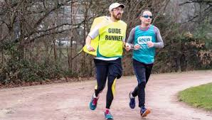
- Runner holds the elbow of the guide runner OR
runner runs with guide runner using a tether (runner’s preference)
- Guide runner should be faster than the runner who is Visually Impaired.
- It is helpful if both the runner and guide runner are similar in height.
- Communication is key, the guide must encourage the runner.

Tether Running
- The tether will have two knots, one on each end so that both runners put the rope in between their fingers to maintain contact.
- The length of the tether is approximately 1-2 feet, depending on individual preference and width of running space.
- The tether should have minimal elasticity. “Smiley Face” dip.

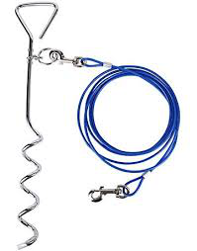
Circular Running
- Using a stake and a rope, this allows the runner to run in a small area.
- The runner pulls the rope tight and runs in a circle around the stake.
- The inner leg automatically supports more weight, so the runner should change direction mid-way through their run.
- The length of the rope simply depends on the size of the running space.

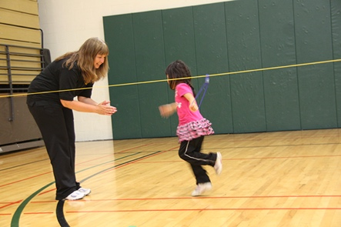
Guidewire Running
- Anything that would serve as an anchor point for the wire to be tied will work (hurdles, poles). The guide wire can be 30-100 feet long,
- The guidewire should be tight at all times and should be checked before each use.
- The guidewire should be at elbow height of the runner.
- Use a carabiner with looped rope clipped onto the wire, this allows the runner to move their arm back and forth using correct form (instead of holding the rope directly).
- A tactile indicator as well as an auditory sound source should signal the end of the wire for the runner to be aware of.

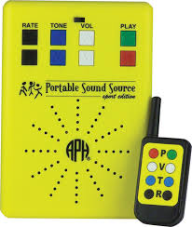
Running to a Sound Source
- Music connected to a speaker at the finish line.
- Someone clapping or have a sound source such as keys or a bell so the runner can follow the sound.
- The guide can be behind, beside or in front of the runner giving verbal instruction/cues.

Treadmill Running
- Allows for physical guidance from the coach.
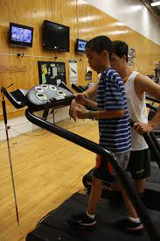
- Tactile modeling can be used to allow the runner to feel their coach going through the running technique and experience the rhythm.
- For safety, handrails are recommended to inform the athlete when they are drifting to the left or right.
- Runners can keep track of their distance/time.

Sources:
Delillo, J. (2017, February 13). Running without sight, for a cause. Retrieved from
https://www.perkins.org/stories/running-without-sight-for-a-cause
Guide running for beginners. (2016, May 18). Retrieved from
https://www.rnib.org.uk/rnibconnect/health-and-wellbeing/guide-running
Instructional Materials. (n.d.). Retrieved from https://www.campabilities.org/instructional-materials.html
Lieberman, L. J., & Haibach, P. S. (2016). Gross Motor Development Curriculum for Children for Visual Impairments. Louisville, KY: American Printing House for the Blind, Inc.
Lieberman, L. J., & Haley. Schedlin. (n.d.). WalkRun For Fitness. Retrieved from
https://www.aph.org/files/manuals/7-07520-00.pdf

