 | 1 | 2 | 3 | 4 | 5 | 6
1 | 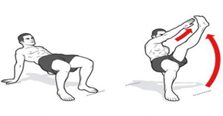  20 Crab Toe Touches | 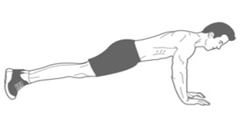  20 Second Plank | 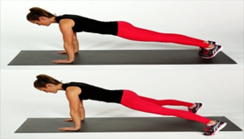  20 Plank Jacks | 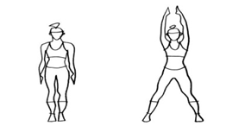  20 Jumping Jacks | 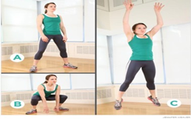  6 Frog Jumps | 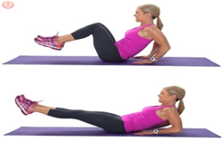  15 Knee Tucks
2 | 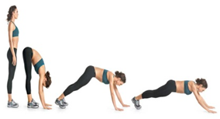  10 Walk Outs | 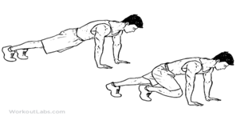  20 Mountain Climbers | 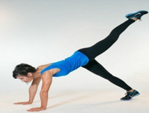  10 Plank Kicks | 20 Second Plank | 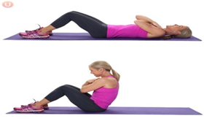  10 Full Sit Ups | 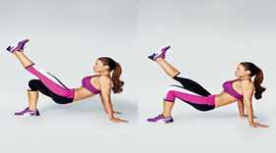  20 Crab Kicks
3 | 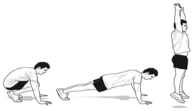  8 Burpees | 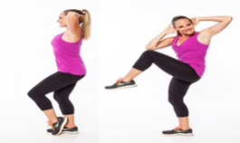  20 Elbow to Knees | 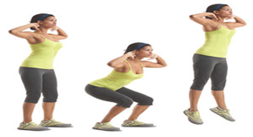  10 Squat Jumps | 1 lap Heel Kickers  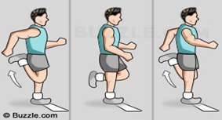 | 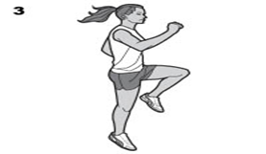  Skip 1 Lap | 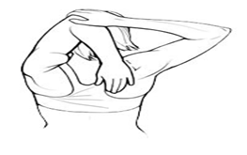  15 seconds each arm
4 | 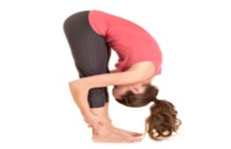  15 seconds | 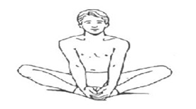  15 Seconds | 20 Ab Twists  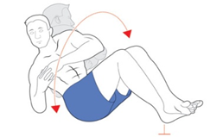 | 15 Seconds Each Arm  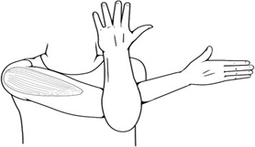 | 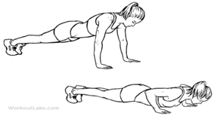  10 Push Ups | 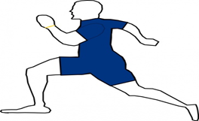  Jog 2 laps
5 | 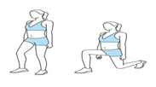  10 lunges each leg | 15 Seconds each side  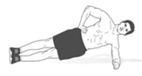 | 20 Arm Circles  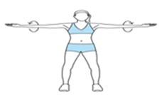 | 10 Wacky Jacks  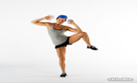 | 20 High Knees  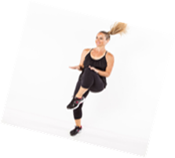 | 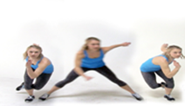  20 Skater Jumps
6 | 15 seconds | 15 Seconds Bridge | 15 seconds each leg  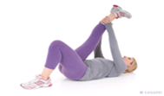 | 15 Seconds each leg  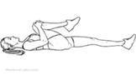 | 15 seconds  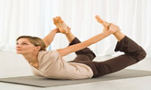 | 15 Seconds each arm  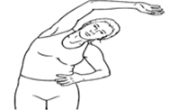
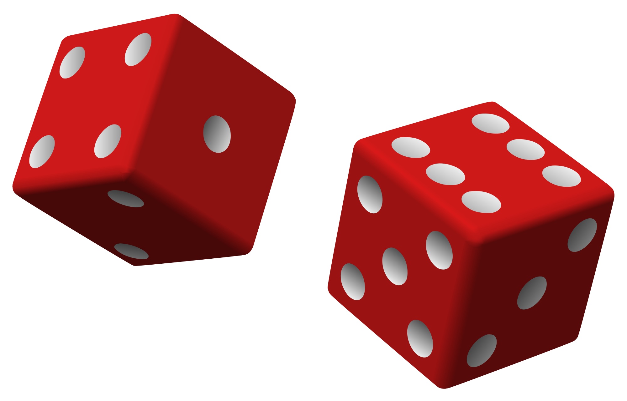
Roll
the Dice
Fitness
Warm-Up

**Print and laminate as many warm up sheets needed in your class to have 2-4 students in a group**
Instructions:
- Each group receives a warm up sheet and TWO dice.

- The first roll will be for the COLUMN (Left to Right), the second roll will be for the ROW (up and down). For example. If I roll a 4 then a 2, our group would perform a 20 second fore arm plank. (I typically give each group two different colored dice)

- Each student should take turns rolling the dice.

- Warm up activity lasts 5-8 minutes (totally up to you!)

