Recess Tips

- Survey your landscape to see how many classes you can safely social distance on the playground and/or open areas. (I would hold off on using any playground structures at this point)

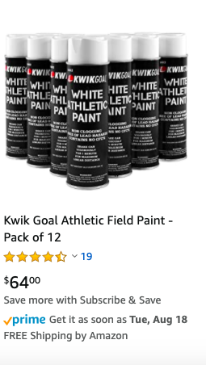
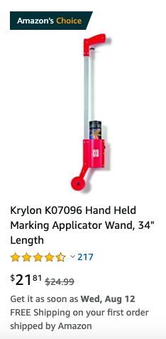
- Use cones and/or field paint to mark the areas that will be assigned for each class (their quadrants)

- Classes can use the list of socially distanced/No equipment games I’m sending you in their quadrants. This area could be their spot each time they go to recess.

- Consider scheduling recess to where classes won’t get stuck in clusters entering and exiting the building. (Give 5-10 minute gaps in between recess start/end times)

- Quadrants could and will have to be used for more than one section (Ex: Ms. Smith’s 1st grade class uses the “A Quadrant” from 9:00-9:30 and Mr. Johnson’s 4th grade class uses the “A Quadrant from 9:40-10:10).

- Monitor the weather and avoid being outside in excessive heat (it’s very hot and humid in August and September)

- Above all else, err on the side of caution and use your expertise to make sound and safe decisions when it comes to students on recess.

