Reading Nutrition Labels
Reading nutrition labels can help us find out what is in our food and how healthy our food is.

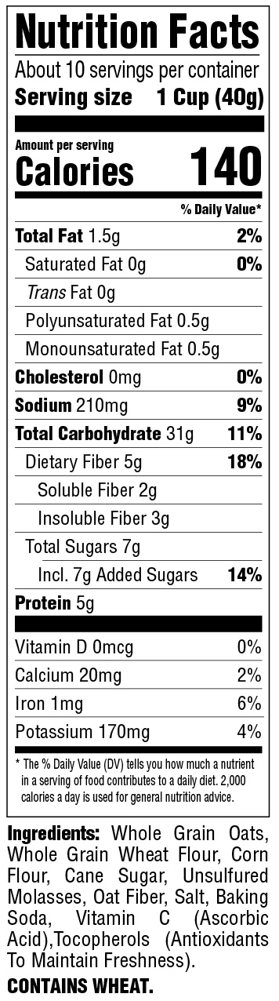
Your body needs calories for energy. But eating too many calories and not burning enough of them off through activity can lead to weight gain.

Sugar

Ingredients

Directions: Circle ‘Total Sugars’ on each food label. In the blank below, write which food item contains the most total sugar.
Pop Tart
Honey Bun
Wheat Thins
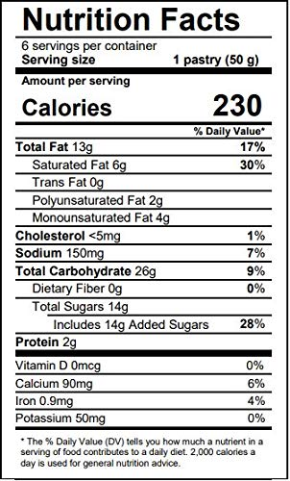
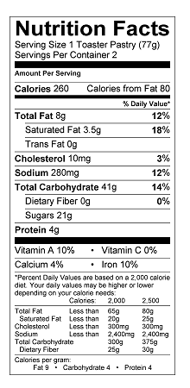
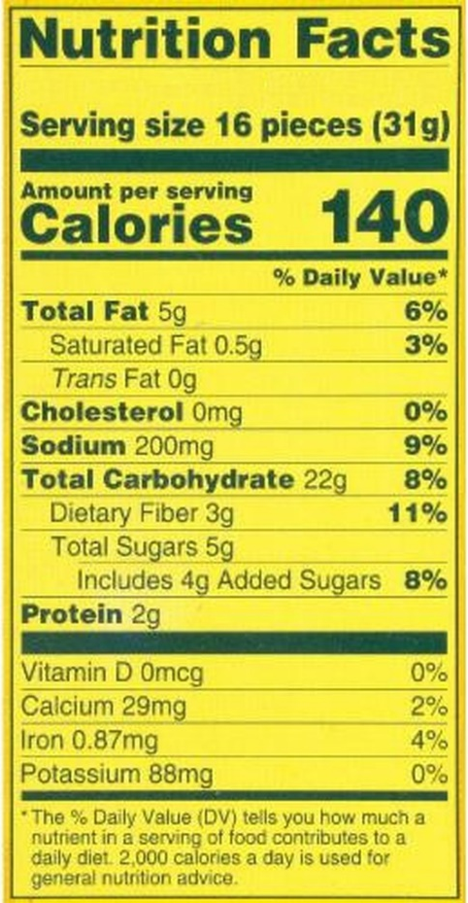

The ___________________ has the most Total Sugars.

Directions: Circle ‘Calories’ on the nutrition label. Then fill in the blanks.
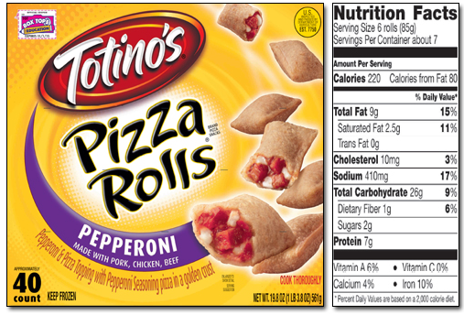

Your body needs calories for_________. But eating too

many __________ and not burning enough of them off

through ___________can lead to weight gain.

Directions: Circle the Ingredients on the Nutrition Labels. Find the food item that contains wheat.
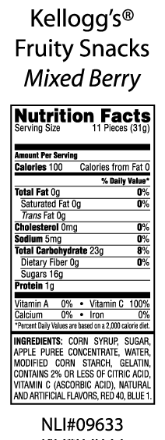
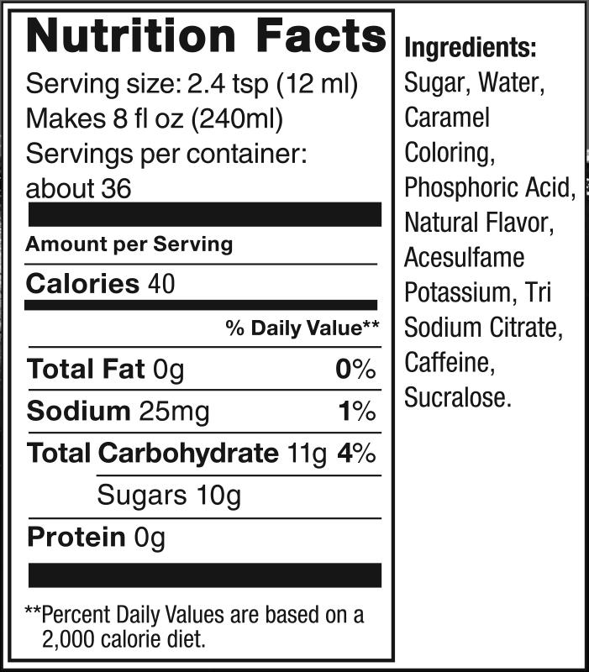
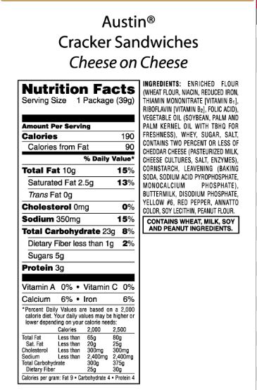
Ritz Crackers
Coca Cola
Pop Tarts

