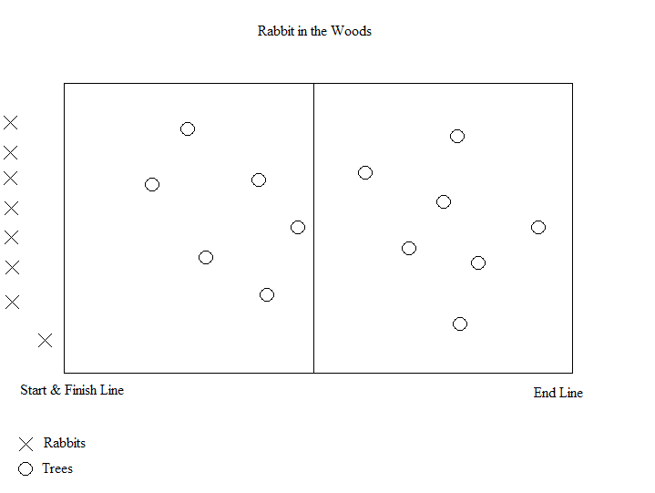
Grades: 1-5
Equipment: 2-3 yarn balls, score board.
Object of the game: Sending one at a time, Rabbits score a point by running through the woods to the end line and back without getting hit by the yarn ball.
Rules: Trees must toss the yarn ball while sitting. The ball is a hot potato, trees must pass or toss the ball within 3 seconds for the hit to count once the ball lands next to them. (They will try to hold onto the ball and wait longer than 3 seconds for the rabbit to get near them for an easy out, this will not count) Nearest person only should retrieve the ball if it is safe and must sit before tossing it.
Students should aim for the legs, but shoulders and below count (no head shots). If they (Rabbit) get hit they should put their hands up to signal they are out and return to the end of the line. When safe send the next student to go.
Remind Running team to keep back from the finish line.

Remind Trees to keep hands and feet in while Rabbits are passing by.

