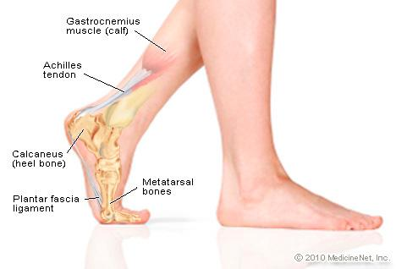
Put your best foot forward . . .
FITNESS
Name __________________________________ Period __________

ACTIVITY | ESTIMATED STEPS | ACTUAL STEPS | DIFFERENCE
Run around basketball court

Walk around the center circle

Sprint a set of lines

Skip to touch N, S, E, W walls

Walk from endline to endline

Carioca around the volleyball court 2 times

Do 50 jumping jacks

25 Steam Engines

10 Squat jumps

1 minute of the Fastest tag in Colorado
(5 pushups to get back in after being tagged)

