|  |  |  |  |
| --- | --- | --- | --- |
| **KABUTO** | **KABUTO** | **KABUTO** | **KABUTO** |
| **KABUTO** | **KABUTO** | **KABUTO** | **KABUTO** |
| **KABUTO** | **KABUTO** | **KABUTO** | **KABUTO** |
| **KABUTO** | **KABUTO** | **KABUTO** | **KABUTO** |
| **KABUTO** | **KABUTO** | **KABUTO** | **KABUTO** |
| **KABUTOPS** | **KABUTOPS** | **KABUTOPS** | **KABUTOPS** |
| **KABUTOPS** | **KABUTOPS** | **KABUTOPS** | **KABUTOPS** |
| **KABUTOPS** | **KABUTOPS** | **KABUTOPS** | **KABUTOPS** |
| **KABUTOPS** | **KABUTOPS** | **KABUTOPS** | **KABUTOPS** |
| **KABUTOPS** | **KABUTOPS** | **KABUTOPS** | **KABUTOPS** |
| **OMANYTE** | **OMANYTE** | **OMANYTE** | **OMANYTE** |
| **OMANYTE** | **OMANYTE** | **OMANYTE** | **OMANYTE** |
| **OMANYTE** | **OMANYTE** | **OMANYTE** | **OMANYTE** |
| **OMANYTE** | **OMANYTE** | **OMANYTE** | **OMANYTE** |
| **OMANYTE** | **OMANYTE** | **OMANYTE** | **OMANYTE** |
| **OMASTAR** | **OMASTAR** | **OMASTAR** | **OMASTAR** |
| **OMASTAR** | **OMASTAR** | **OMASTAR** | **OMASTAR** |
| **OMASTAR** | **OMASTAR** | **OMASTAR** | **OMASTAR** |
| **OMASTAR** | **OMASTAR** | **OMASTAR** | **OMASTAR** |
| **OMASTAR** | **OMASTAR** | **OMASTAR** | **OMASTAR** |
| **TANGELA** | **TANGELA** | **TANGELA** | **TANGELA** |
| **TANGELA** | **TANGELA** | **TANGELA** | **TANGELA** |
| **TANGELA** | **TANGELA** | **TANGELA** | **TANGELA** |
| **TANGELA** | **TANGELA** | **TANGELA** | **TANGELA** |
| **TANGELA** | **TANGELA** | **TANGELA** | **TANGELA** |
| **MAGMAR** | **MAGMAR**  **MAGMAR** |  | **MAGMAR** |
| **MAGMAR** | **MAGMAR**  **MAGMAR** |  | **MAGMAR** |
| **MAGMAR** | **MAGMAR**  **MAGMAR** |  | **MAGMAR** |
| **MAGMAR** | **MAGMAR**  **MAGMAR** |  | **MAGMAR** |
| **MAGMAR** | **MAGMAR**  **MAGMAR** |  | **MAGMAR** |
| **LICKITUNG** | **LICKITUNG** | **LICKITUNG** | **LICKITUNG** |
| **LICKITUNG** | **LICKITUNG** | **LICKITUNG** | **LICKITUNG** |
| **LICKITUNG** | **LICKITUNG** | **LICKITUNG** | **LICKITUNG** |
| **LICKITUNG** | **LICKITUNG** | **LICKITUNG** | **LICKITUNG** |
| **LICKITUNG** | **LICKITUNG** | **LICKITUNG** | **LICKITUNG** |
| **DITTO** | **DITTO** | **DITTO** | **DITTO** |
| **DITTO** | **DITTO** | **DITTO** | **DITTO** |
| **DITTO** | **DITTO** | **DITTO** | **DITTO** |
| **DITTO** | **DITTO** | **DITTO** | **DITTO** |
| **DITTO** | **DITTO** | **DITTO** | **DITTO** |
| **MEOWTH** | **MEOWTH** | **MEOWTH** | **MEOWTH** |
| **MEOWTH** | **MEOWTH** | **MEOWTH** | **MEOWTH** |
| **MEOWTH** | **MEOWTH** | **MEOWTH** | **MEOWTH** |
| **MEOWTH** | **MEOWTH** | **MEOWTH** | **MEOWTH** |
| **MEOWTH** | **MEOWTH** | **MEOWTH** | **MEOWTH** |
| **PERSIAN** | **PERSIAN** | **PERSIAN** | **PERSIAN** |
| **PERSIAN** | **PERSIAN** | **PERSIAN** | **PERSIAN** |
| **PERSIAN** | **PERSIAN** | **PERSIAN** | **PERSIAN** |
| **PERSIAN** | **PERSIAN** | **PERSIAN** | **PERSIAN** |
| **PERSIAN** | **PERSIAN** | **PERSIAN** | **PERSIAN** |
| **AERODACTYL**  **AERODACTYL** | **AERODACTYL** | **AERODACTYL** |  |
| **AERODACTYL**  **AERODACTYL** | **AERODACTYL** | **AERODACTYL** |  |
| **AERODACTYL**  **AERODACTYL** | **AERODACTYL** | **AERODACTYL** |  |
| **AERODACTYL**  **AERODACTYL** | **AERODACTYL** | **AERODACTYL** |  |
| **AERODACTYL**  **AERODACTYL** | **AERODACTYL** | **AERODACTYL** |  |
| **JYNX** | **JYNX** | **JYNX** | **JYNX** |
| **JYNX** | **JYNX** | **JYNX** | **JYNX** |
| **JYNX** | **JYNX** | **JYNX** | **JYNX** |
| **JYNX** | **JYNX** | **JYNX** | **JYNX** |
| **JYNX** | **JYNX** | **JYNX** | **JYNX** |

|  |  |  |  |
| --- | --- | --- | --- |
| **TO EVOLVE INTO KABUTOPS, YOU MUST DO:**   * **20 ALT. LUNGES** * **30 JUMPING JACKS** | **TO EVOLVE INTO KABUTOPS, YOU MUST DO:**   * **20 ALT. LUNGES** * **30 JUMPING JACKS** | **TO EVOLVE INTO KABUTOPS, YOU MUST DO:**   * **20 ALT. LUNGES** * **30 JUMPING JACKS** | **TO EVOLVE INTO KABUTOPS, YOU MUST DO:**   * **20 ALT. LUNGES** * **30 JUMPING JACKS** |
| **TO EVOLVE INTO KABUTOPS, YOU MUST DO:**   * **20 ALT. LUNGES** * **30 JUMPING JACKS** | **TO EVOLVE INTO KABUTOPS, YOU MUST DO:**   * **20 ALT. LUNGES** * **30 JUMPING JACKS** | **TO EVOLVE INTO KABUTOPS, YOU MUST DO:**   * **20 ALT. LUNGES** * **30 JUMPING JACKS** | **TO EVOLVE INTO KABUTOPS, YOU MUST DO:**   * **20 ALT. LUNGES** * **30 JUMPING JACKS** |
| **TO EVOLVE INTO KABUTOPS, YOU MUST DO:**   * **20 ALT. LUNGES** * **30 JUMPING JACKS** | **TO EVOLVE INTO KABUTOPS, YOU MUST DO:**   * **20 ALT. LUNGES** * **30 JUMPING JACKS** | **TO EVOLVE INTO KABUTOPS, YOU MUST DO:**   * **20 ALT. LUNGES** * **30 JUMPING JACKS** | **TO EVOLVE INTO KABUTOPS, YOU MUST DO:**   * **20 ALT. LUNGES** * **30 JUMPING JACKS** |
| **TO EVOLVE INTO KABUTOPS, YOU MUST DO:**   * **20 ALT. LUNGES** * **30 JUMPING JACKS** | **TO EVOLVE INTO KABUTOPS, YOU MUST DO:**   * **20 ALT. LUNGES** * **30 JUMPING JACKS** | **TO EVOLVE INTO KABUTOPS, YOU MUST DO:**   * **20 ALT. LUNGES** * **30 JUMPING JACKS** | **TO EVOLVE INTO KABUTOPS, YOU MUST DO:**   * **20 ALT. LUNGES** * **30 JUMPING JACKS** |
| **TO EVOLVE INTO KABUTOPS, YOU MUST DO:**   * **20 ALT. LUNGES** * **30 JUMPING JACKS** | **TO EVOLVE INTO KABUTOPS, YOU MUST DO:**   * **20 ALT. LUNGES** * **30 JUMPING JACKS** | **TO EVOLVE INTO KABUTOPS, YOU MUST DO:**   * **20 ALT. LUNGES** * **30 JUMPING JACKS** | **TO EVOLVE INTO KABUTOPS, YOU MUST DO:**   * **20 ALT. LUNGES** * **30 JUMPING JACKS** |
| **TO EVOLVE INTO OMASTAR, YOU MUST DO:**   * **SKIP 1 LAP** * **30 SECOND V-SIT**   **TO EVOLVE INTO OMASTAR, YOU MUST DO:**   * **SKIP 1 LAP** * **30 SECOND V-SIT** | **TO EVOLVE INTO OMASTAR, YOU MUST DO:**   * **SKIP 1 LAP** * **30 SECOND V-SIT** |  | **TO EVOLVE INTO OMASTAR, YOU MUST DO:**   * **SKIP 1 LAP** * **30 SECOND V-SIT** |
| **TO EVOLVE INTO OMASTAR, YOU MUST DO:**   * **SKIP 1 LAP** * **30 SECOND V-SIT**   **TO EVOLVE INTO OMASTAR, YOU MUST DO:**   * **SKIP 1 LAP** * **30 SECOND V-SIT** | **VTO EVOLVE INTO OMASTAR, YOU MUST DO:**   * **SKIP 1 LAP** * **30 SECOND V-SIT** |  | **TO EVOLVE INTO OMASTAR, YOU MUST DO:**   * **SKIP 1 LAP** * **30 SECOND V-SIT** |
| **TO EVOLVE INTO OMASTAR, YOU MUST DO:**   * **SKIP 1 LAP** * **30 SECOND V-SIT**   **TO EVOLVE INTO OMASTAR, YOU MUST DO:**   * **SKIP 1 LAP** * **30 SECOND V-SIT** | **VTO EVOLVE INTO OMASTAR, YOU MUST DO:**   * **SKIP 1 LAP** * **30 SECOND V-SIT** |  | **TO EVOLVE INTO OMASTAR, YOU MUST DO:**   * **SKIP 1 LAP** * **30 SECOND V-SIT** |
| **TO EVOLVE INTO OMASTAR, YOU MUST DO:**   * **SKIP 1 LAP** * **30 SECOND V-SIT**   **TO EVOLVE INTO OMASTAR, YOU MUST DO:**   * **SKIP 1 LAP** * **30 SECOND V-SIT** | **VTO EVOLVE INTO OMASTAR, YOU MUST DO:**   * **SKIP 1 LAP** * **30 SECOND V-SIT** |  | **TO EVOLVE INTO OMASTAR, YOU MUST DO:**   * **SKIP 1 LAP** * **30 SECOND V-SIT** |
| **TO EVOLVE INTO OMASTAR, YOU MUST DO:**   * **SKIP 1 LAP** * **30 SECOND V-SIT**   **TO EVOLVE INTO OMASTAR, YOU MUST DO:**   * **SKIP 1 LAP** * **30 SECOND V-SIT** | **VTO EVOLVE INTO OMASTAR, YOU MUST DO:**   * **SKIP 1 LAP** * **30 SECOND V-SIT** |  | **TO EVOLVE INTO OMASTAR, YOU MUST DO:**   * **SKIP 1 LAP** * **30 SECOND V-SIT** |
| **TO EVOLVE INTO PERSIAN, YOU MUST DO:**   * **30 SECOND PLANK** * **5 BURPEES** | **TO EVOLVE INTO PERSIAN, YOU MUST DO:**   * **30 SECOND PLANK** * **5 BURPEES** | **TO EVOLVE INTO PERSIAN, YOU MUST DO:**   * **30 SECOND PLANK** * **5 BURPEES** | **TO EVOLVE INTO PERSIAN, YOU MUST DO:**   * **30 SECOND PLANK** * **5 BURPEES** |
| **TO EVOLVE INTO PERSIAN, YOU MUST DO:**   * **30 SECOND PLANK** * **5 BURPEES** | **TO EVOLVE INTO PERSIAN, YOU MUST DO:**   * **30 SECOND PLANK** * **5 BURPEES** | **TO EVOLVE INTO PERSIAN, YOU MUST DO:**   * **30 SECOND PLANK** * **5 BURPEES** | **TO EVOLVE INTO PERSIAN, YOU MUST DO:**   * **30 SECOND PLANK** * **5 BURPEES** |
| **TO EVOLVE INTO PERSIAN, YOU MUST DO:**   * **30 SECOND PLANK** * **5 BURPEES** | **TO EVOLVE INTO PERSIAN, YOU MUST DO:**   * **30 SECOND PLANK** * **5 BURPEES** | **TO EVOLVE INTO PERSIAN, YOU MUST DO:**   * **30 SECOND PLANK** * **5 BURPEES** | **TO EVOLVE INTO PERSIAN, YOU MUST DO:**   * **30 SECOND PLANK** * **5 BURPEES** |
| **TO EVOLVE INTO PERSIAN, YOU MUST DO:**   * **30 SECOND PLANK** * **5 BURPEES** | **TO EVOLVE INTO PERSIAN, YOU MUST DO:**   * **30 SECOND PLANK** * **5 BURPEES** | **TO EVOLVE INTO PERSIAN, YOU MUST DO:**   * **30 SECOND PLANK** * **5 BURPEES** | **TO EVOLVE INTO PERSIAN, YOU MUST DO:**   * **30 SECOND PLANK** * **5 BURPEES** |
| **TO EVOLVE INTO PERSIAN, YOU MUST DO:**   * **30 SECOND PLANK** * **5 BURPEES** | **TO EVOLVE INTO PERSIAN, YOU MUST DO:**   * **30 SECOND PLANK** * **5 BURPEES** | **TO EVOLVE INTO PERSIAN, YOU MUST DO:**   * **30 SECOND PLANK** * **5 BURPEES** | **TO EVOLVE INTO PERSIAN, YOU MUST DO:**   * **30 SECOND PLANK** * **5 BURPEES** |

**KABUTO**

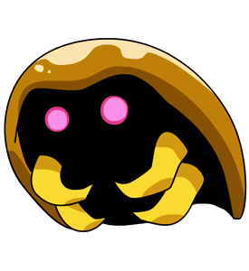

* **20 SECOND V-SIT**
* **3 PUSH UPS**

**KABUTOPS**

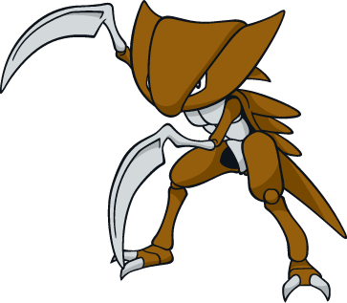

**\*\*To get KABUTOPS, you must evolve KABUTO\*\***

**OMANYTE**

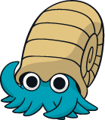

* **30 JUMPING JACKS**
* **20 SECOND STRADDLE STRETCH**

**OMASTAR**

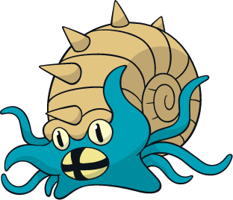

**\*\*To get OMASTAR, you must evolve OMANYTE\*\***

**TANGELA**

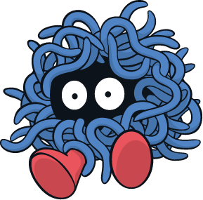

* **20 SECOND KNEE HUG STRETCH**
* **40 BOTTOM KICKERS**

**MAGMAR**

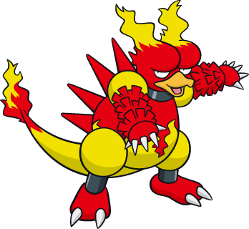

* **20 SECOND V-SIT**
* **10 PUSH UPS**

**LICKITUNG**

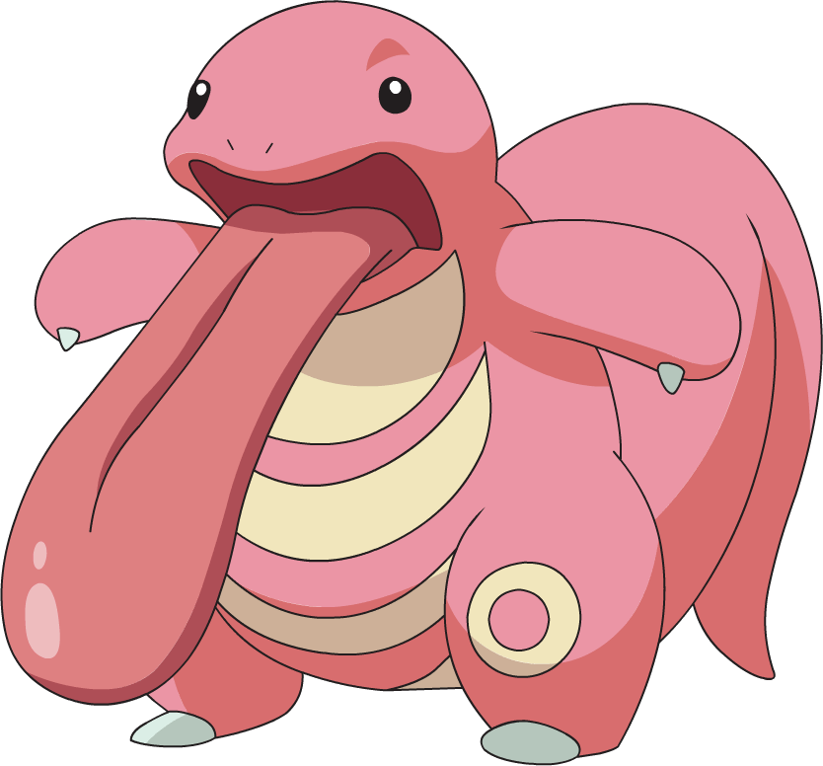

* **15 SQUATS**
* **25 HEEL LIFTS**

**DITTO**

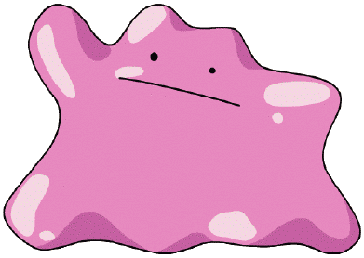

* **12 SQUAT JUMPS**
* **24 MOUNTAIN CLIMBERS**

**MEOWTH**

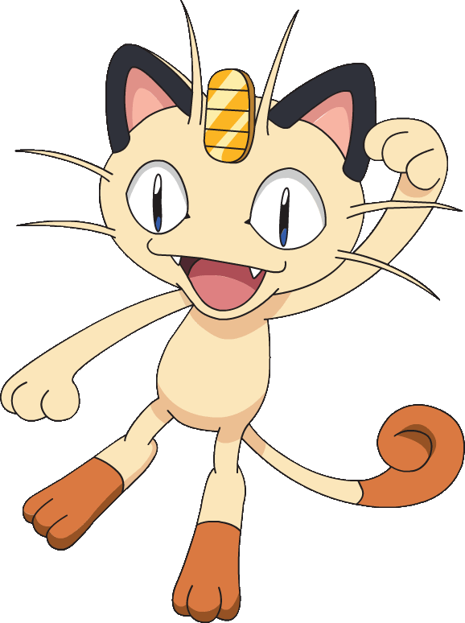

* **4 BURPEES**
* **20 SECOND TOE TOUCH STRETCH**

**PERSIAN**

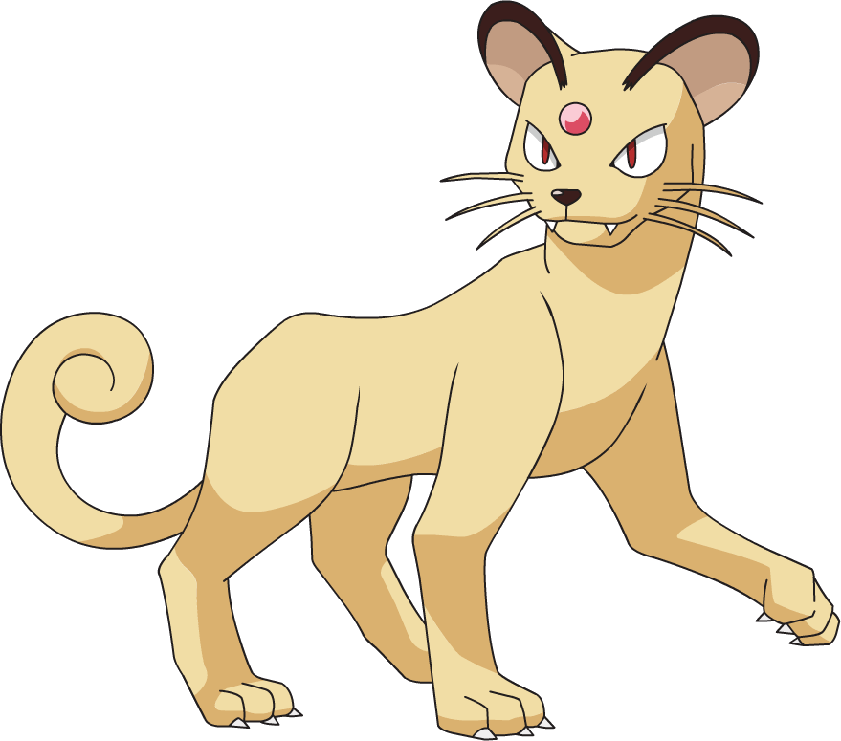

**\*\*To get PERSIAN, you must evolve MEOWTH\*\***

**AERODACTYL**

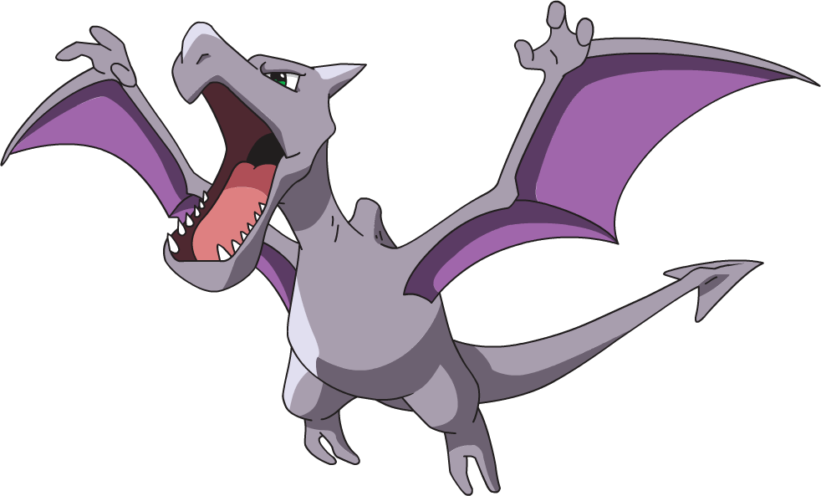

* **30 SECOND BUTTERFLY STRETCH**
* **26 PLANK SIDE TAPS**

**JYNX**

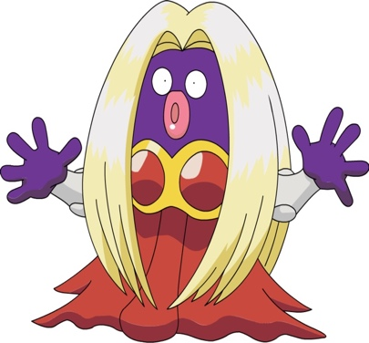

* **SLIDE 1 LAP**
* **10 SQUAT JUMPS**