**CHARMANDER**

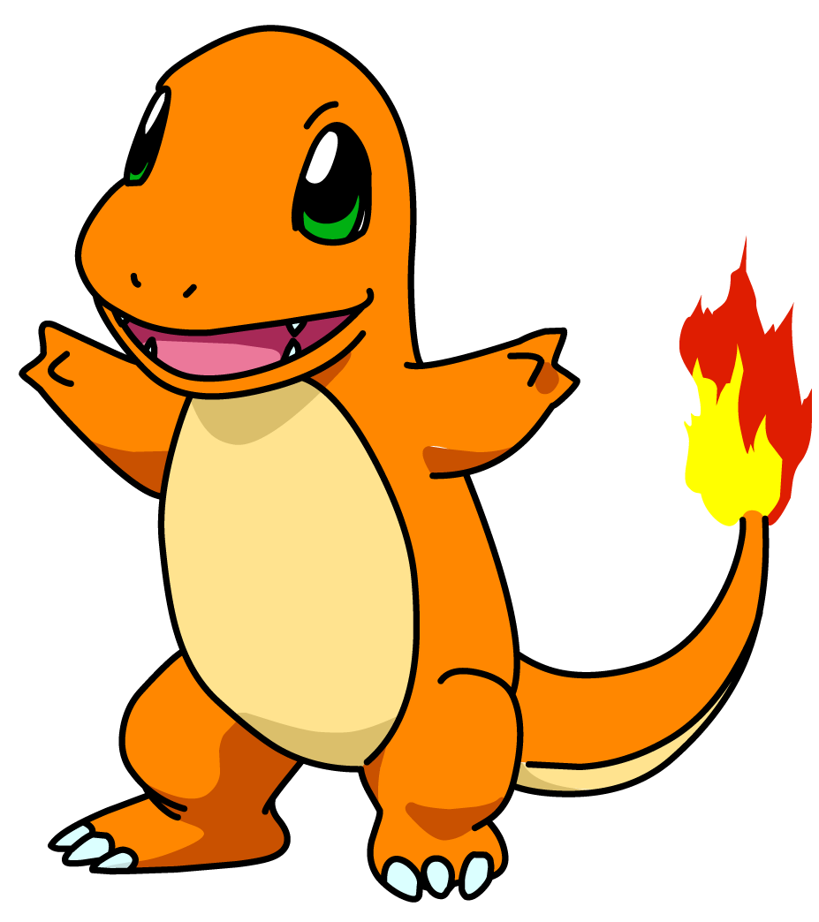

* **30 SECOND V-SIT**
* **5 PUSH UPS**

**SQUIRTLE**

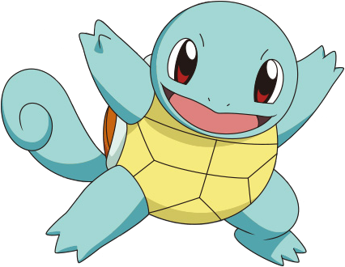

* **10 BURPEES**
* **20 SECOND TOE  
   TOUCH STRETCH**

**BULBASAUR**

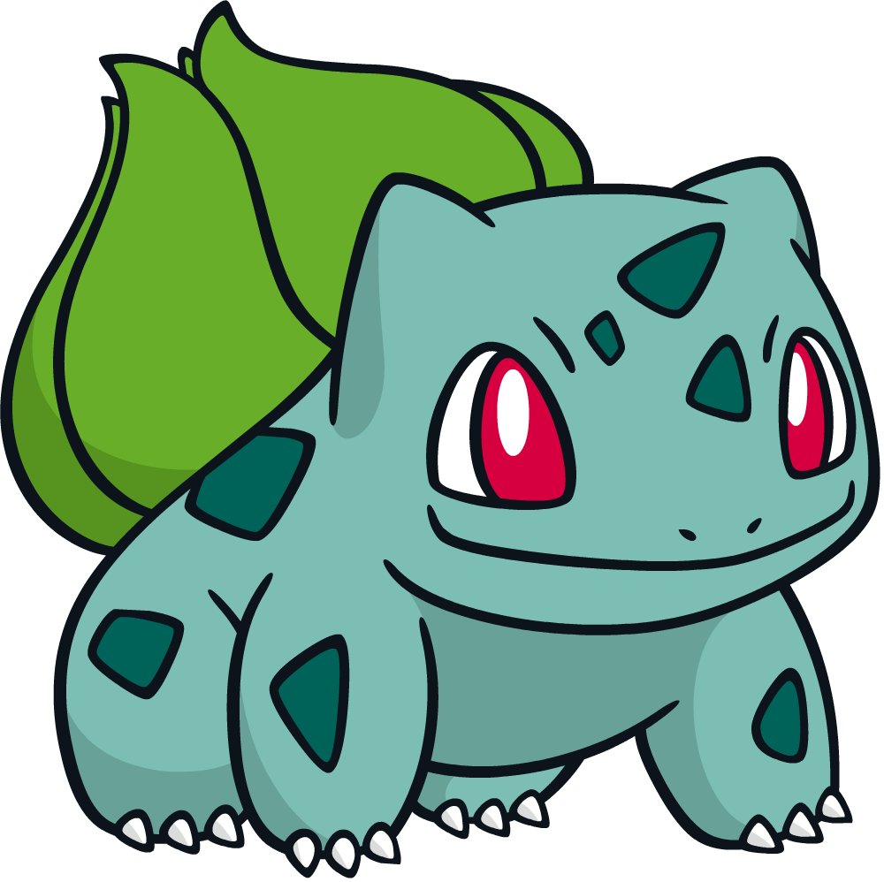

* **30 SKIER JUMPS**
* **JOG 1 LAP**

**PIKACHU**

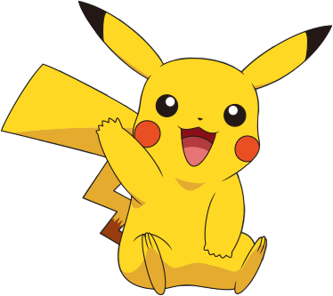

* **30 JUMPING JACKS**
* **10 SECOND PLANK**

**JIGGLYPUFF**

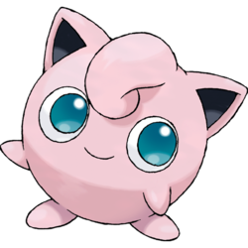

* **10 SQUATS**
* **30 BOTTOM KICKERS**

**GROWLITHE**

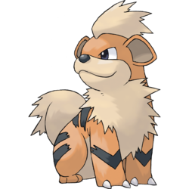

* **SKIP 1 LAP**
* **10 MAT DIPS**

**PONYTA**

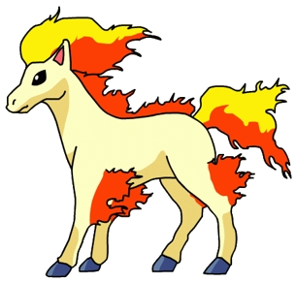

* **10 MOUNTAIN  
   CLIMBERS**
* **3 PUSH UPS**

**VOLTORB**

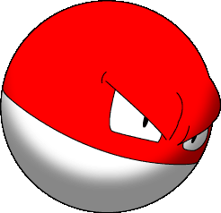

* **5 CURL UPS**
* **5 BURPEES**

**MAGIKARP**

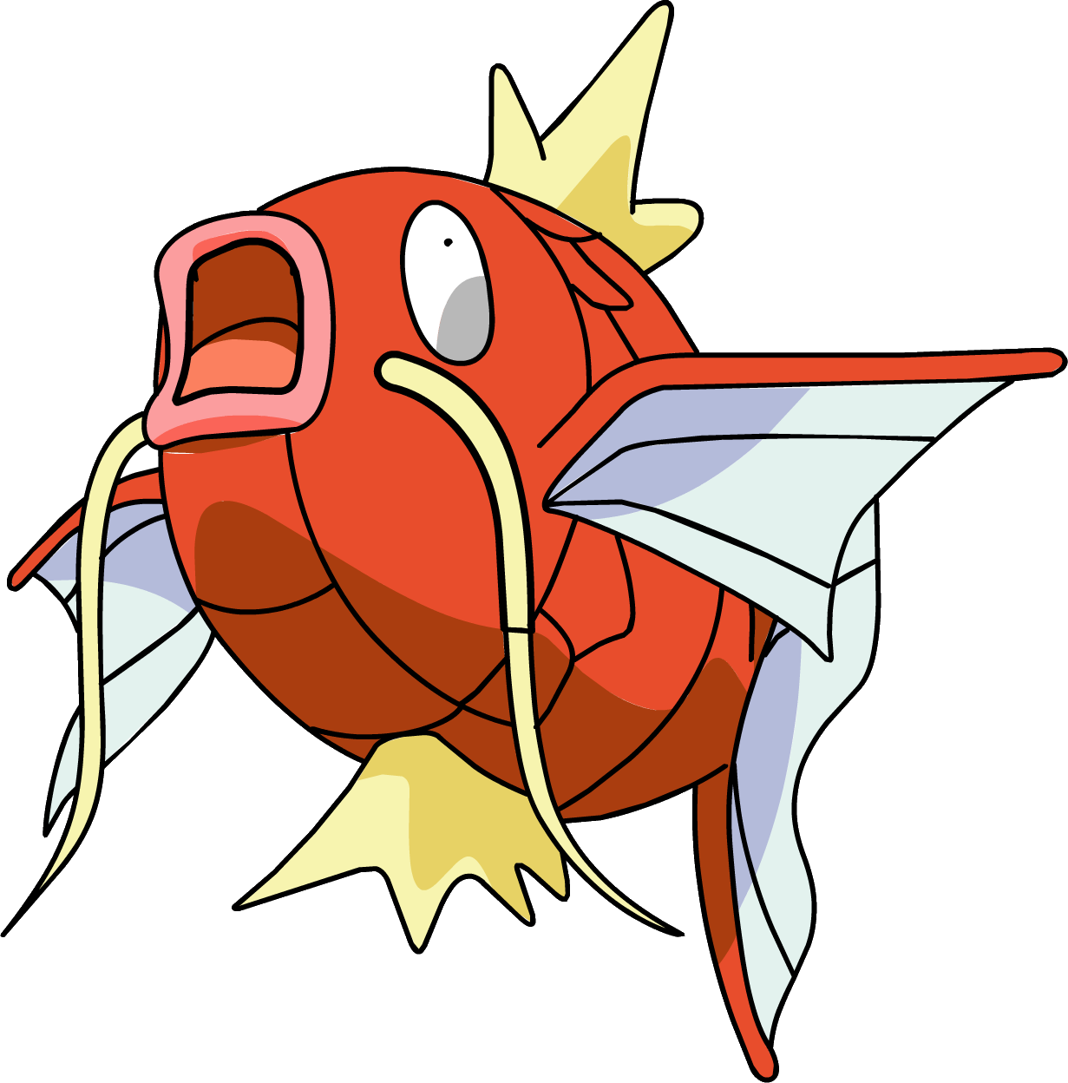

* **20 SECOND  
   BUTTERFLY STRETCH**
* **10 ARM CIRCLES**

**EXEGGCUTE**

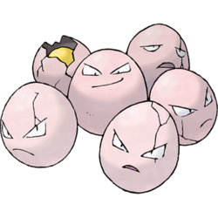

* **20 ALT. LUNGES**
* **10 SECOND V-SIT**

**EKANS**

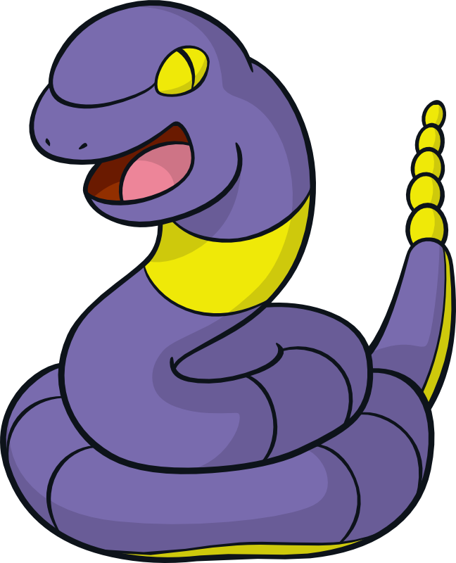

* **10 SQUATS**
* **20 SECOND CRAB  
   POSITION**

**DIGLETT**

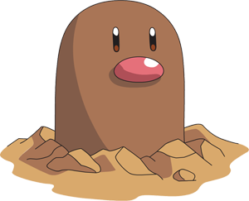

* **20 MOUNTAIN  
   CLIMBERS**
* **5 CURL UPS**

**DROWZEE**

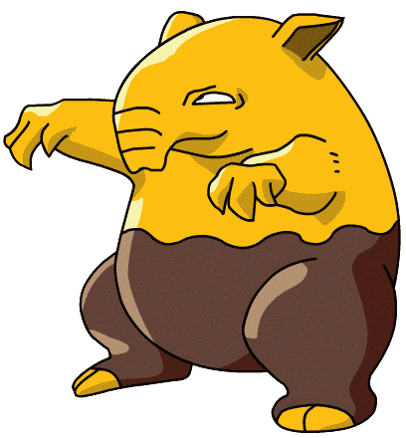

* **10 JUMPING JACKS**
* **10 HEEL LIFTS**

**TENTACOOL**

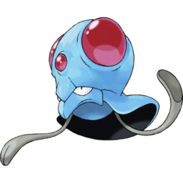

* **30 ARM CIRCLES**
* **GALLOP 1 LAP**

**CHARMELEON**

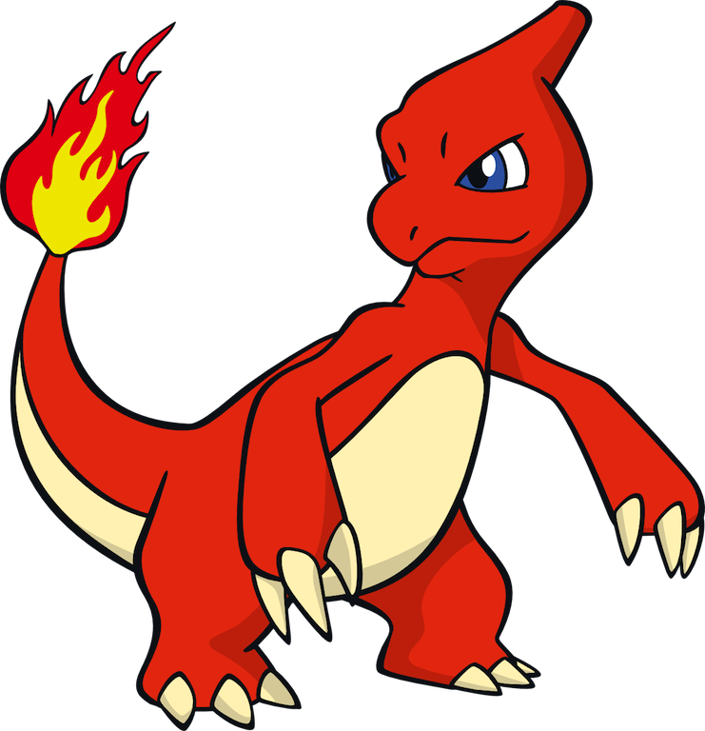

**\*\*To get CHARMELEON, you must evolve CHARMANDER\*\***

**CHARIZARD**

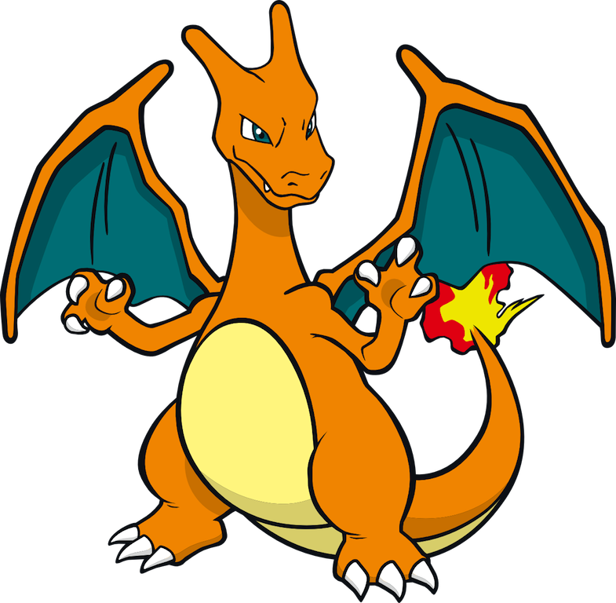

**\*\*To get CHARIZARD, you must evolve CHARMELEON\*\***

**WARTORTLE**

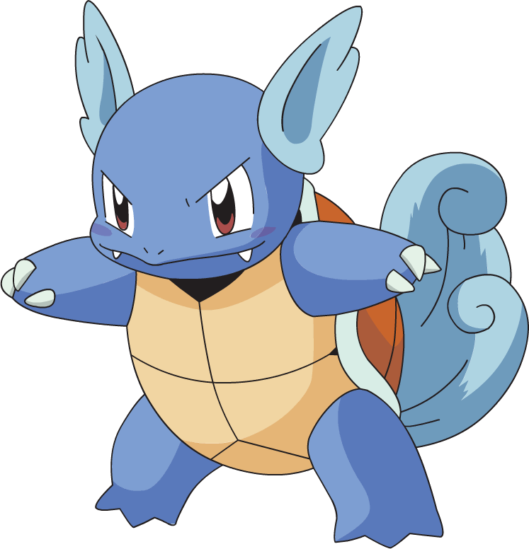

**\*\*To get WARTORTLE, you must evolve SQUIRTLE\*\***

**BLASTOISE**

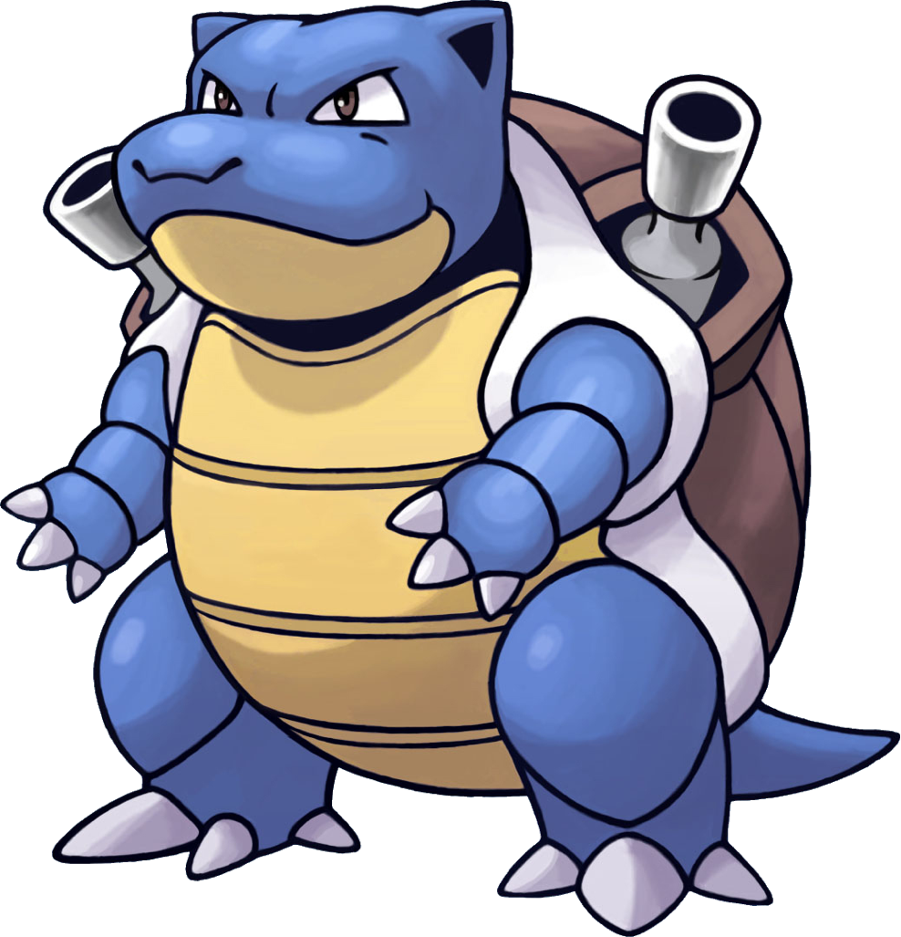

**\*\*To get BLASTOISE, you must evolve WARTORTLE\*\***

**IVYSAUR**

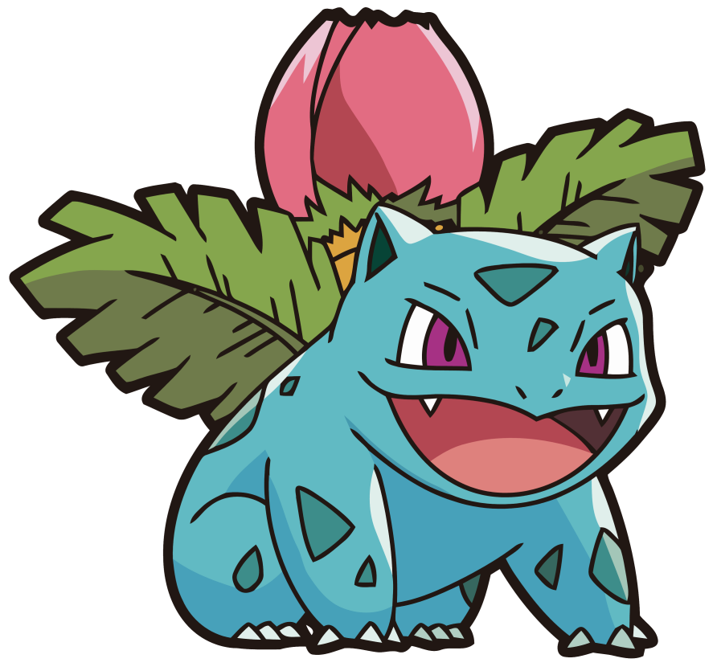

**\*\*To get IVYSAUR, you must evolve BULBASAUR\*\***

**VENUSAUR**

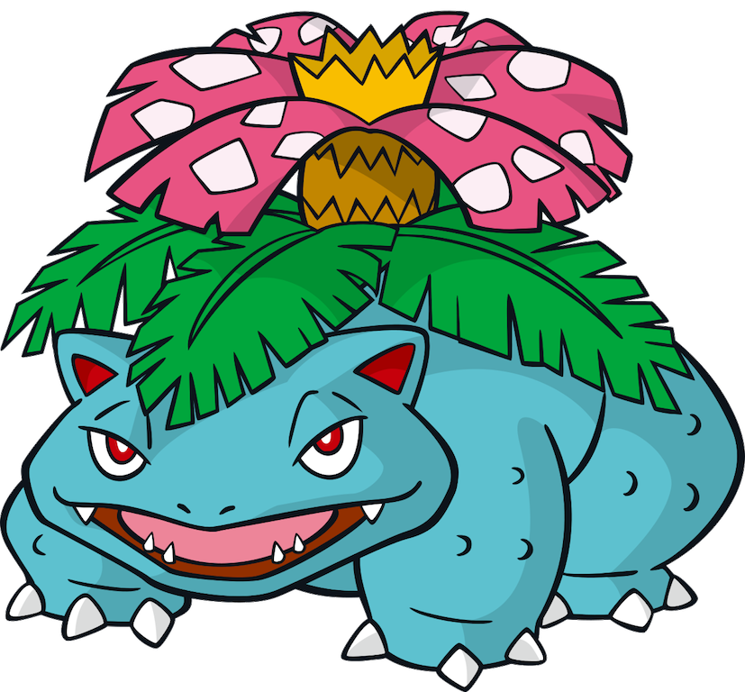

**\*\*To get VENUSAUR, you must evolve IVYSAUR\*\***

**RAICHU**

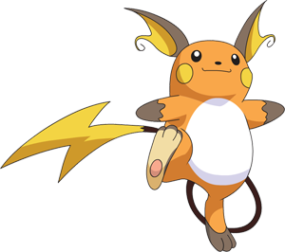

**\*\*To get RAICHU, you must evolve PIKACHU\*\***

**WIGGLYTUFF**

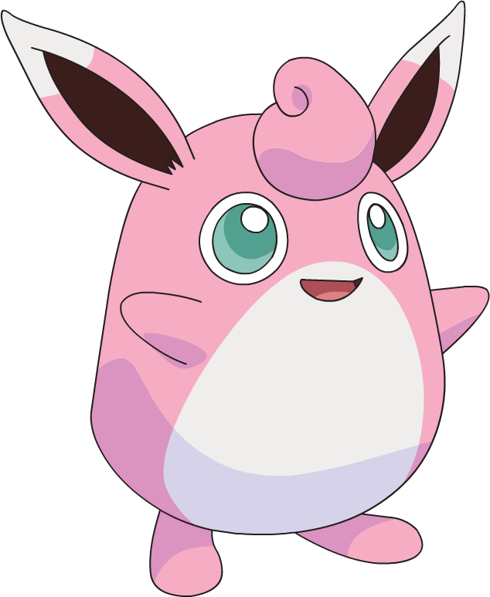

**\*\*To get WIGGLYTUFF, you must evolve JIGGLYPUFF\*\***

**ARCANINE**

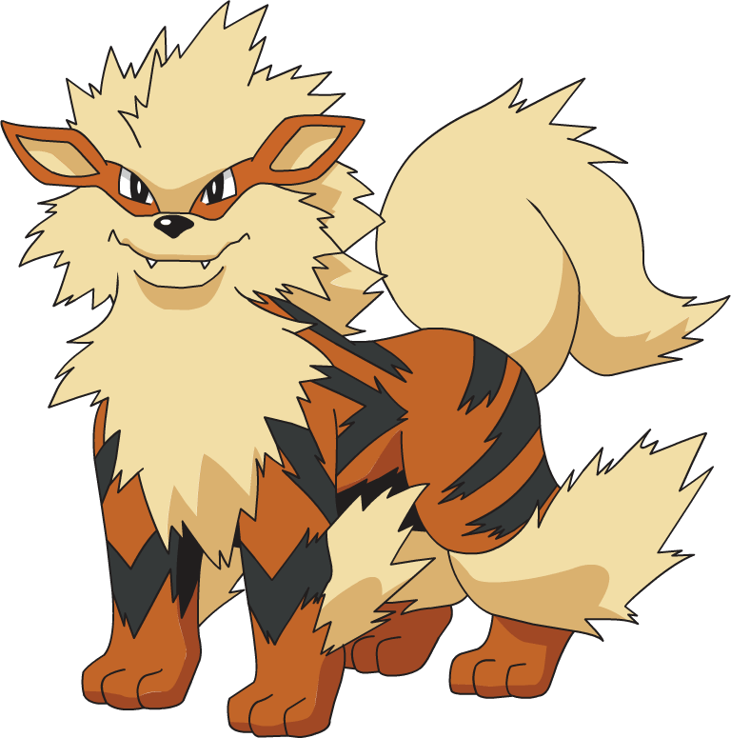

**\*\*To get ARCANINE, you must evolve GROWLITHE\*\***

**RAPIDASH**

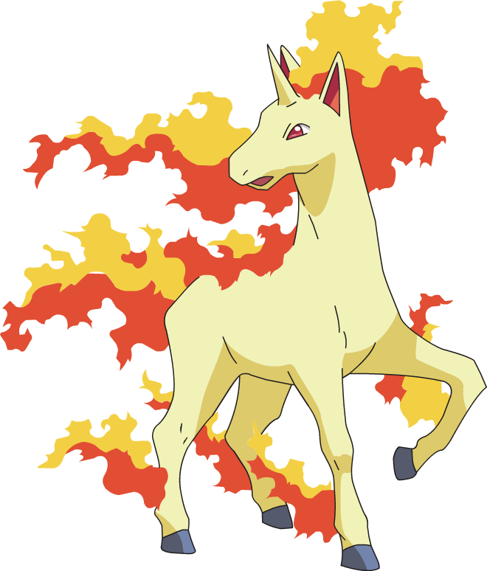

**\*\*To get RAPIDASH, you must evolve PONYTA\*\***

**ELECTRODE**

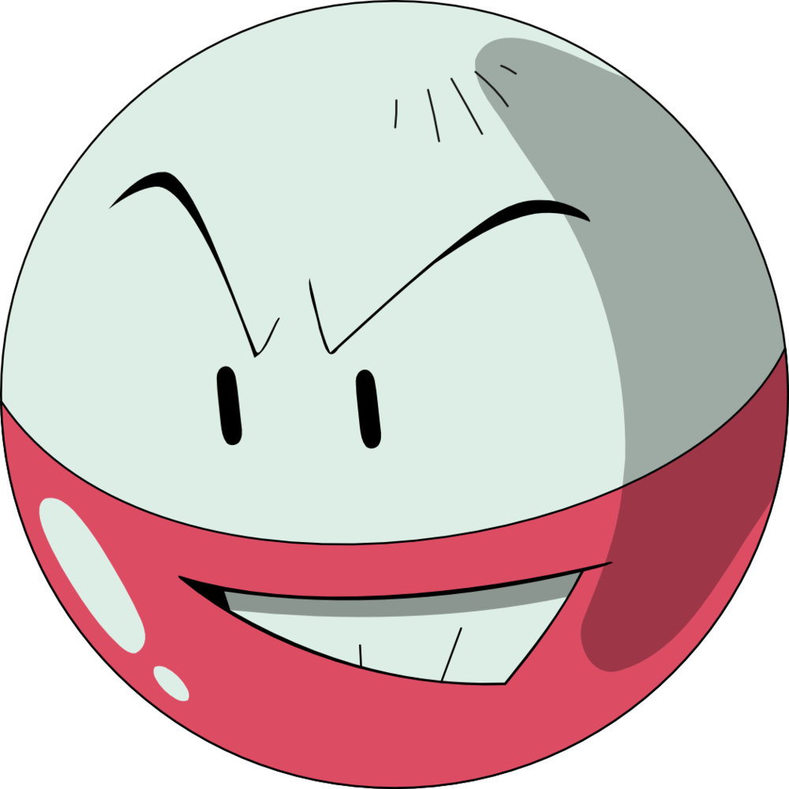

**\*\*To get ELECTRODE, you must evolve VOLTORB\*\***

**GYRADOS**

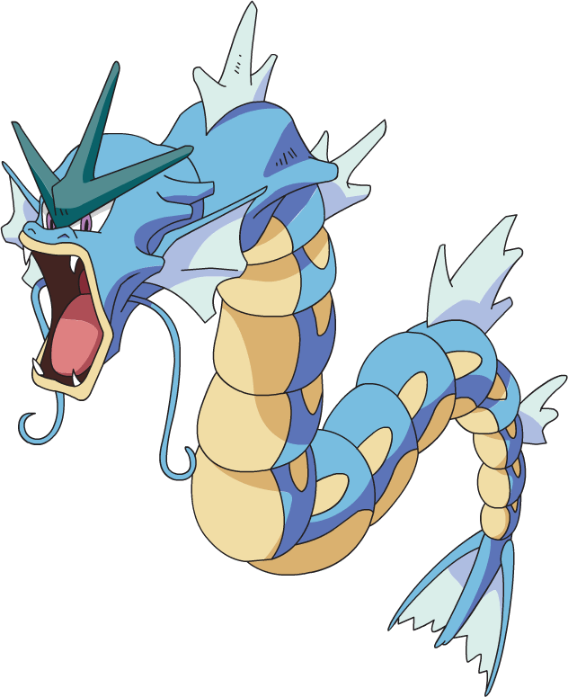

**\*\*To get GYRADOS, you must evolve MAGIKARP\*\***

**EXEGGUTOR**

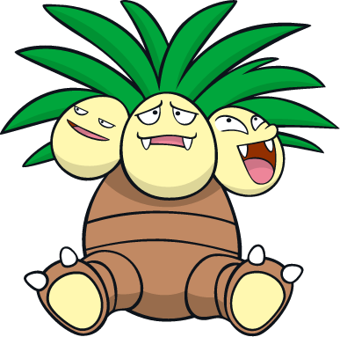

**\*\*To get EXEGGUTOR, you must evolve EXEGGCUTE\*\***

**ARBOK**

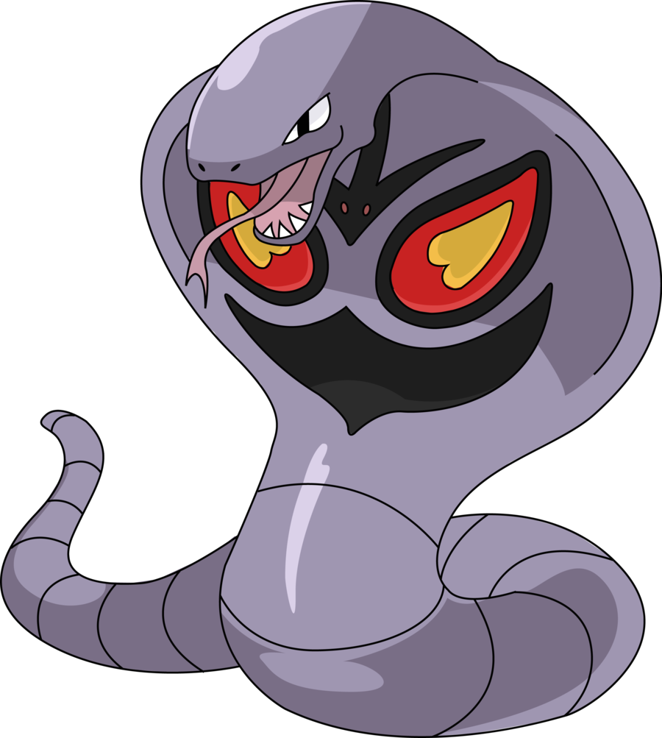

**\*\*To get ARBOK, you must evolve EKANS\*\***

**DUGTRIO**

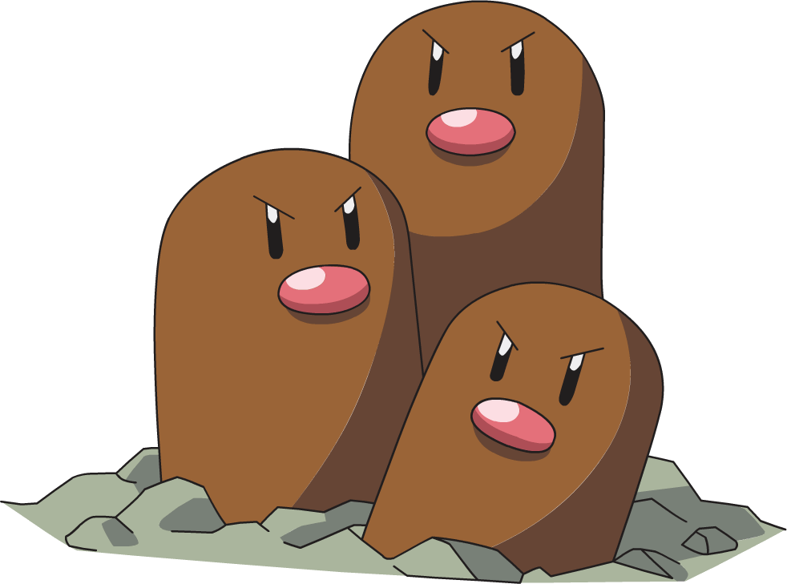

**\*\*To get DUGTRIO, you must evolve DIGLETT\*\***

**HYPNO**

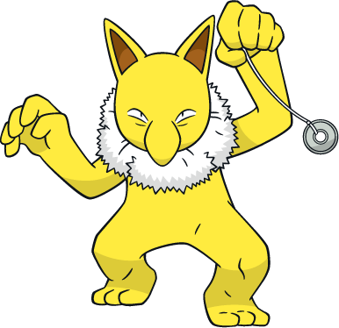

**\*\*To get HYPNO, you must evolve DROWZEE\*\***

**TENTACRUEL**

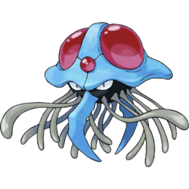

**\*\*To get TENTACRUEL, you must evolve TENTACOOL\*\***

**MEWTWO**

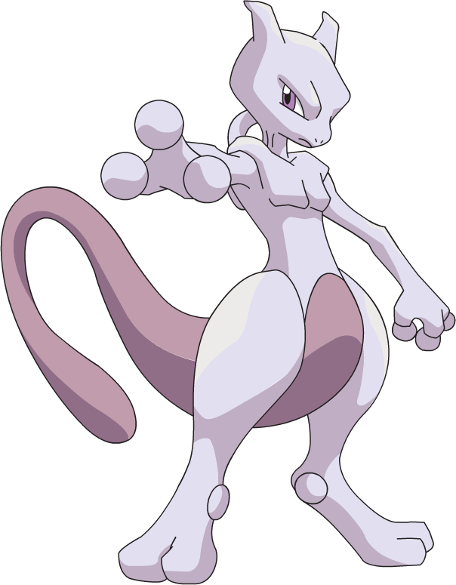

**ZAPDOS**

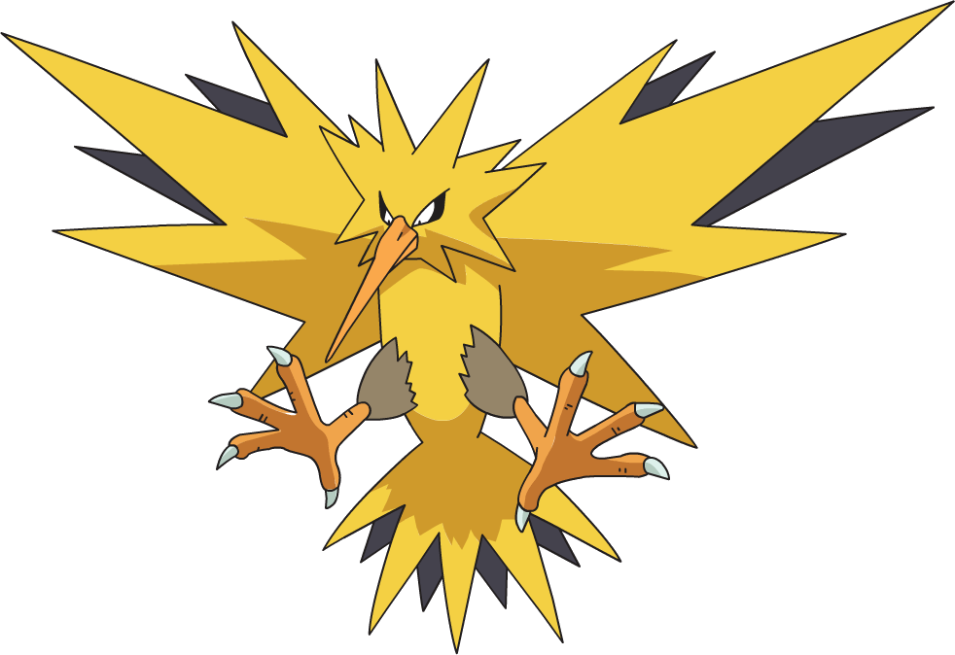

**MOLTRES**

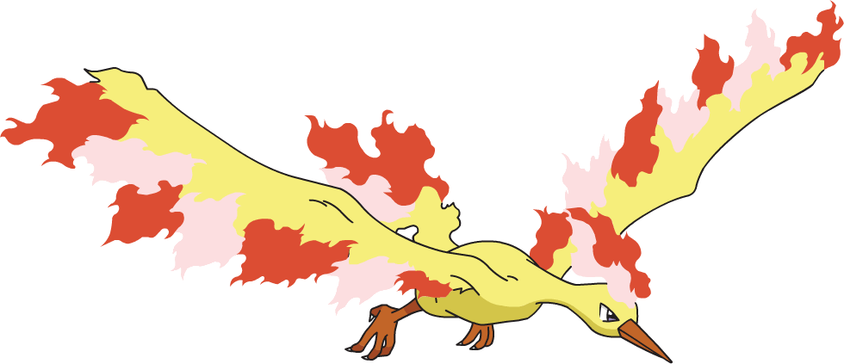

**ARTICUNO**

