Preparation:
- Set up Pickleball courts (3-Use Floor Tape/Cones)
- Get out Paddles (18)/Balls (ALL)
- Clipboards/Stat Sheets
- Scarves (18)

2:15 | Team Stations  -Use Scarves to indicate the different teams (3 Teams of 6)  -Each court is a team base.  -Equipment: Paddles and balls for each team, Scarves for each team. | -Managers: Please get paddles and balls for your team.  -Practice hitting with your team.
2:25 | Explain Competition Procedures  -Pair up on each team. This is your playing partner.  -Teams will play for a certain amount of time.  -Home team serves first.  -Follow Pickleball rules throughout.  -The duty team will both stand at net and keep stats for one team.  *Play a few points to help with understanding.  -Equipment: 6 Clipboards w/ stat sheet. | -Captains: I will bring them together to explain schedule and reminders about the day (i.e. practice skills, tactics).  -Explain stat sheet and how to determine accuracy.
2:35 | Competition Format  1. Team 1 vs. Team 2 (Team 3) 2:35  2. Team 2 vs. Team 3 (Team 1) 2:45  3. Team 3 vs. Team 1 (Team 2) 2:55  *After each game, officials will determine fair play points. Write down final score and calculate stats.  -Players will meet at the net and shake hands.  -Rotate: Team 2 goes to other side, Team 3 becomes players, Team 1 is now Officials/Statisticians. Give Team 3 a few minutes to warm up. | -Coaches: Decide who will go to each court. Now, this can be random draw or you can say to rank your three teams.
3:10 | Closure  -All my students have loved the Sport Education format. Yes, it will take a little work in the beginning, but it is worth it when you see student enjoyment and learning.  *Share Keith’s story. | -Have participants help with breaking down nets and putting away equipment.

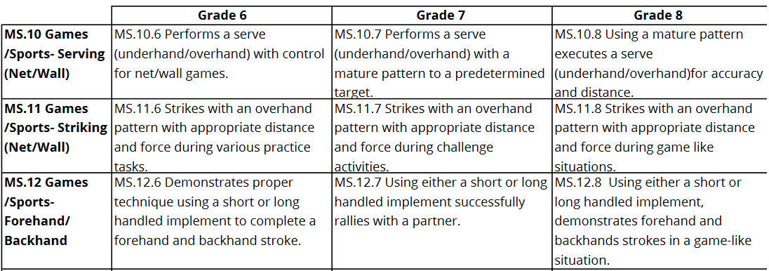

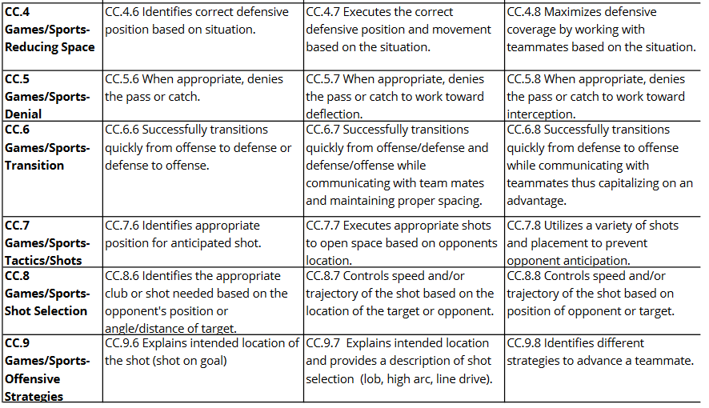

Court 1 How Point was Won
Team Name | Player Name | Drive | Serve | Drop Shot | Smash | Opp. Error | Pts Won | Final Score | Fair Play

Court 2 How Point was Won
Team Name | Player Name | Drive | Serve | Drop Shot | Smash | Opp. Error | Pts Won | Final Score | Fair Play

Court 3 How Point was Won
Team Name | Player Name | Drive | Serve | Drop Shot | Smash | Opp. Error | Pts Won | Final Score | Fair Play

