Preparation:
- Set up Pickleball courts (3-Use Floor Tape/Cones)
- Get out Paddles (18)/Balls (ALL)
- Team information chart, warm up sheet, clipboards, scoresheets, quizzes, sign-up sheet, QR Code

8:00 | Team Stations:  -Use Posterboards to indicate the different teams (3 Teams of 6)  -Two people will choose each Team Role: Captain, Manager, Coach.  -Create a team chant for your team’s name.  -Equipment: Provide Team Information Chart | -Managers: Please get paddles and balls for your team.  -Each team will showcase their chant.
8:10 | Warm Up:  - Flip it. Maintain control of the ball while hitting it on each side of paddle.  - Spin it. Try to spin the ball while hitting it down, then up. Try 10 times both ways.  - Dribble it. Try to dribble the ball 10 times with the paddle. Try it with both hands. Now see if you can walk and dribble at the same time. Finally, try to run and dribble. (General space). Part B-Now get with a partner. One will have both paddles. See if you can dribble with both hands while stationary. Now try to do it while walking.  -Equipment: 18 Paddles, balls, warm up sheet. | -Coach: Please lead your team through the 3 activities (Provide each team with warm up sheet)
8:20 | -Introduce Skill Practice-Everyone needs paddle/ball  -Serve to partner. Use the lines of the court to measure distance of hit. Partner A will hit 3 serves in a row (Goal: Hit it near the back baseline for a deep serve). Switch after 3. First one to 20.  *Mark scoring zones for all groups (1-3 pts)  -Competition. Each team will divide into two groups of 3. *Captain will decide on groups. Each group will go to one of the three courts.  Court 1: Yellow Bears-1 vs. Red Dragons-1  Court 2: Blue Princesses-1 vs. Yellow Bears-2  Court 3: Red Dragons-2 vs. Blue Princesses-2  -Now, each group member will be A, B, or C. A will be the server, B will be the scorer, and C will be the retriever. Then rotate A to C, B to A, and C to B. Each person gets 2 warm up shots and then 5 that count.  -Each group needs to write their names on the scoresheet and give it to the other team.  -Equipment: 18 paddles/cones, 27 balls, 6 Clipboards, 6 Scoresheets | -Use 3 different colored cones to indicate scoring zone on each court  -Get 3 balls and line up across from your partner.  -B is keeping score for the other team, add up how many points they earned.
8:40 | Keep it going! Use the Kitchen lines to create a court. In groups of four, your goal is to use forehand/backhands to keep the ball going. One person will start it by hitting it ‘up’ and using a continuous volley. See how many times you can hit it before it goes past a team, hits the net, or out of bounds.  -Rotate after each volley.  -Equipment: 18 paddles, 9 balls | -Stay at same court as previous exercise.  -Make sure the Kitchen line is visible.
8:50 | Closure  -Explain to each group how Quizzes can be taken in a SE unit. Provide each team with a Pickle Ball Quiz. They can work together to answer questions.  -Update standings. Announce leaders.  -Remind participants that all documents will be sent via email.  Purpose of activities: Based on what students usually struggle with the most; hitting it deep, reacting to the ball, working together as a team.  -Equipment: 3 Quizzes, Pass around sign-up sheet, QR code for Pickleball Videos | -Team points are earned based on results.  -Discuss the benefits of activities.

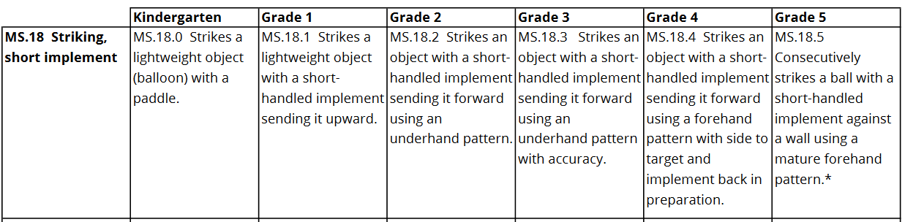

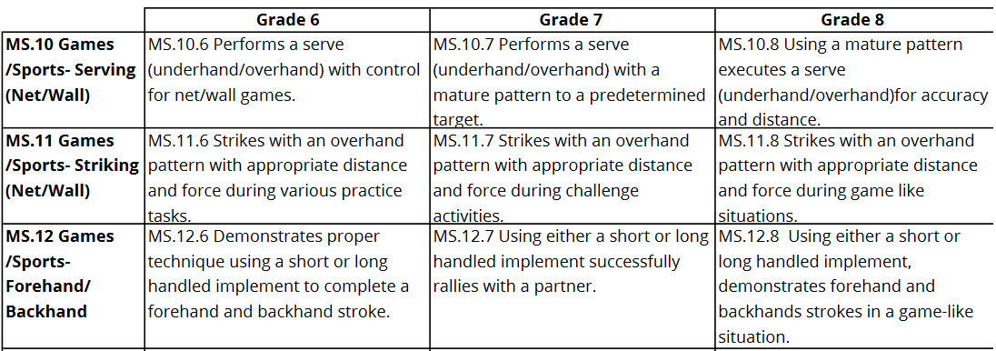
TEAM INFORMATION CHART-PICKLEBALL

Team:

Team Name

 | Adjective | Noun
Team Color

 | 1.
Mascot

- Captain_________________________________________________________________
- Provide general team leadership in a positive, encouraging manner.
- Meet with Dr. Layne to discuss issues related to class.
- Distribute and put away equipment.

- Coach__________________________________________________________________
- Lead team warm-up each class.
- Work on skills/strategies that are beneficial to the team.
- Give willing assistance to all team members in terms of improving their skills.

- Manager________________________________________________________________
- Design team logo.
- Decide and create appropriate awards for team members.
- Plan duty roles on days of competition.

Coach-Warm Up
- Flip it. Maintain control of the ball while hitting it on each side of paddle. Hit the ball up, flip the paddle and hit it again. Continue this for 20 hits.
- Spin it. Try to create spin on the ball while hitting it down, then up. Try 10 times both ways.
- Dribble it. Try to dribble the ball 10 times with the paddle. Try it with right and left hand. Now see if you can walk and dribble at the same time. Finally, try to run and dribble. (General space). Part B-Now get with a partner. One will have both paddles. See if you can dribble with both hands while stationary. Now try to do it while walking.

Team Name: Shots
Player Name | P1 | P2 | 1 | 2 | 3 | 4 | 5 | Total

*Please record a score for all shots (1-3). Calculate total when completed.

Team Name: Shots
Player Name | P1 | P2 | 1 | 2 | 3 | 4 | 5 | Total

*Please record a score for all shots (1-3). Calculate total when completed.

TAHPERD Team_______________________________

True or False
1.___The game of Pickleball is named after a dog.
2.___Singles play is the most appropriate format for Physical Education classes.
3.___The net is hung 34” on ends and should be 36” at the middle.
4.___A player must keep one foot behind the line when serving.
5.___A serve must be made underhand and after one bounce.
6.___A serve hitting the non-volley line is considered out.
7.___A point is won at the end of each service.
8.___On a volley, it is a fault if the player steps over the line on the follow through.
9.___The receiving team must let the serve bounce twice before returning to serving team.
10.___After the first service, both members of each team will serve and fault before the ball is turned over to the opposing team (in doubles).

