PE Warm-Up
To Do Finished

1.

2.

3.

4.

5.

6.

7.

8.

9.
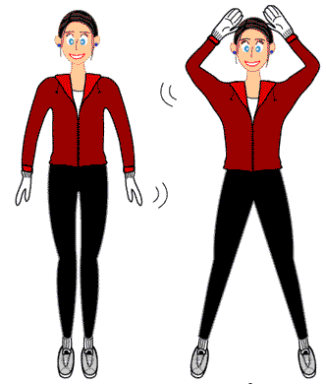
10 Jumping Jacks

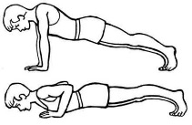
10 Push-Ups

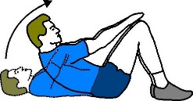
10 Curl-Ups

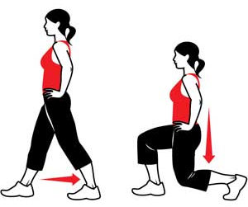
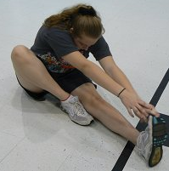
Leg Lunges
Sit and Reach
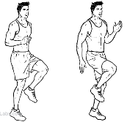
High Knees

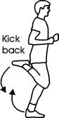
Bottom Kicks

Shoulder Stretch

Trunk Lift

