Sub Plan
3rd/4th/5th - Gaga Ball +

Students have a choice of several activities with the following rules:

- Gaga Ball:
Try to hit the ball at others below the belt. The goal is to get many out while staying in. It’s played in a “pit.” Players who are out must exit the pit. If they’re out, they should be all the way out of the pit (can sit on mat but not have legs in the pit)

Getting out:
Double tap/hold
Hit in Target Zone
Out of Bounds
Saying “you’re out”

Use the ELIMINATION TIMER. Turn on the projector (either hit the button on the projector or use the blue button on the white remote) and get the Apple TV remote (black and stuck to white board). Open YouTube app. On the left bar, go to the Folder icon. Then scroll down to playlists and select the GAGA BALL ELIMINATION TIMER playlist. Then play the first video. It should loop for Gaga Ball.

Game starts with the ball in the middle of the pit and all players are touching the wall. If they aren’t touching the wall when the starting ding sounds, they are out.

- Spooners (all grades) & Balance Boards (Only 3rd-5th). Place near the balls on the wall (so they can hold them while balancing). See setup image.

- Shooting Baskets in the corner:
      - Only shoot foam balls
      - Shoot from outside the orange lines (where the ceiling is taller)
      - All balls go toward the goal not toward others. Anybody throwing at somebody else is done for the day. Make sure they know this up front.
      - No more than a ball in each hand
      - No hanging on the goal
      - Blocking and defense is only allowed if the person shooting gives them permission and doesn’t take the ball from their hands

- Floor Square:
Try to hit it out of other’s square
No 2xTaps/Holds
If it bounces off a bucket, you can hit again
Can only hit ball if in YOUR square
Must hit players square to get them out
2-Hand serve with ball in your corner
Open/under hands only

- Air Pong:
SCORE: balloon lands in opponent’s square OR Opponent lands balloon out of bounds
  - 3 hits per side
  - Serve behind square
  - Spikes allowed inside square

- Dribbling a basketball or volleyball: anywhere nobody is working, as long as it isn’t disruptive. Keep the ball below shoulders.

BEHAVIOR
If a student can’t handle a choice, they can lose that choice for the day.

If a student gets 3 complaints in a game, they clearly can’t handle that choice. I let them know after two and tell them if I hear another complaint, they need to choose something else.

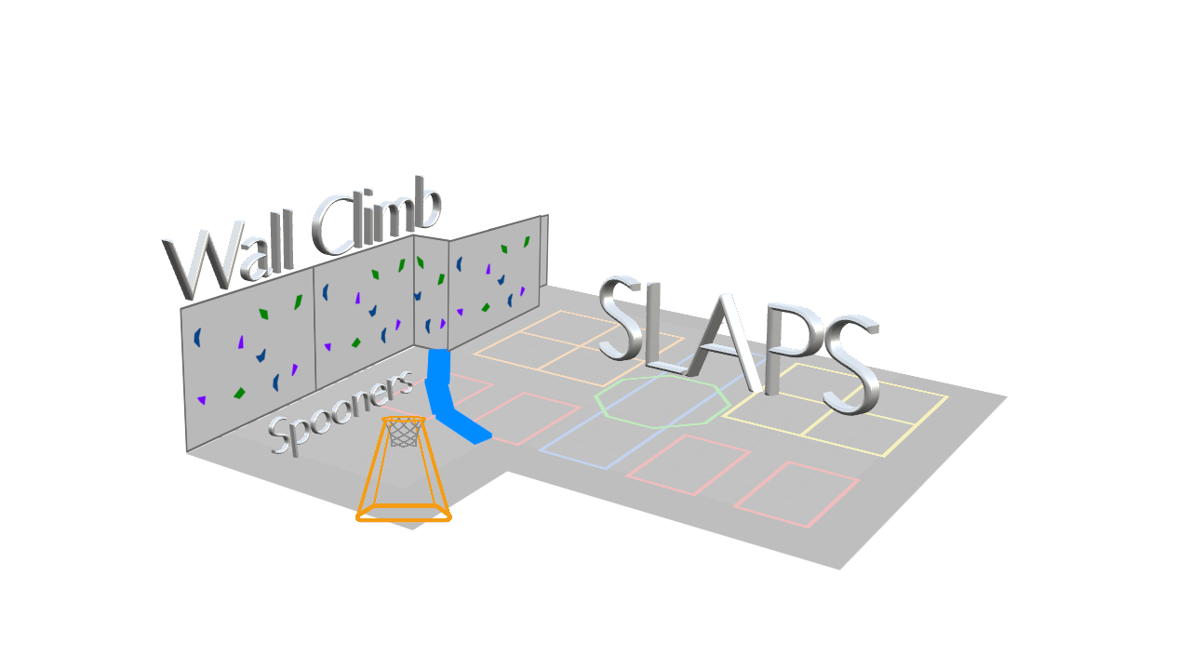
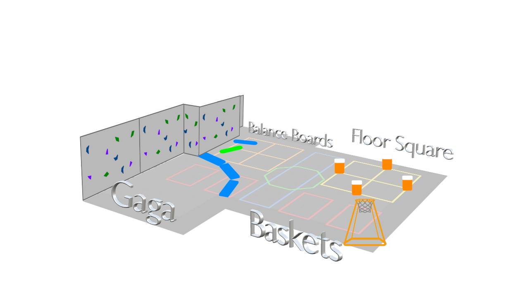
Setup 3rd-5th

Setup K-2nd

Sub Plan
PACE/K/1st/2nd - SLAPS +

Students have a choice of several activities with the following rules:

- SLAPS:
The goal is similar to Gaga Ball. You want to slap the ball in the direction of other players’ legs/feet. Instead of saying they’re out, they are “toast” and need to go to the toaster (just run and jump over the mats, then come right back into the game).

RULES:
You’re TOAST if you pick up a ball*
You’re TOAST if the ball touches your feet*
When you’re TOAST go to the toaster then join the game.

*If students are throwing or kicking balls at others, give them a warning or two, then just have them sit out.

- Spooners not Balance Boards (the ones with the board/roller). If they’re waiting on a board, they can stall count to 10. [NAME] 1, [NAME] 2, etc.

- Wall Climb. Only touch the rocks (the red balls are the rocks). Never the metal or ropes.
  - K/PACE - feet below red line
  - 1st/2nd - feet below screws

If you feel like it, you can open up a mat for kids to do tricks on. Back in the area behind the other mats. If nobody really wants to play SLAPS, you can open up the mats (one at a time, one direction, land safely, 5 second time limit per person) and put a basketball goal in the corner where they can shoot from (following the same rules as 3rd-5th, except they can’t block each others shots).

BEHAVIOR
If a student can’t handle a choice, they can lose that choice for the day.

If a student gets 3 complaints in a game, they clearly can’t handle that choice. I let them know after two and tell them if I hear another complaint, they need to choose something else.

AWESOME ACTIVITY IDEAS:
Scan the QR code on your device to see a brief video of how to play the game
Air Pong
Fire in the Hole
Volcano Ball
Pin Blaster
6 Ball Power Soccer

