Performing Arts of Germantown Joins Healthy & Active Germantown
GMSD
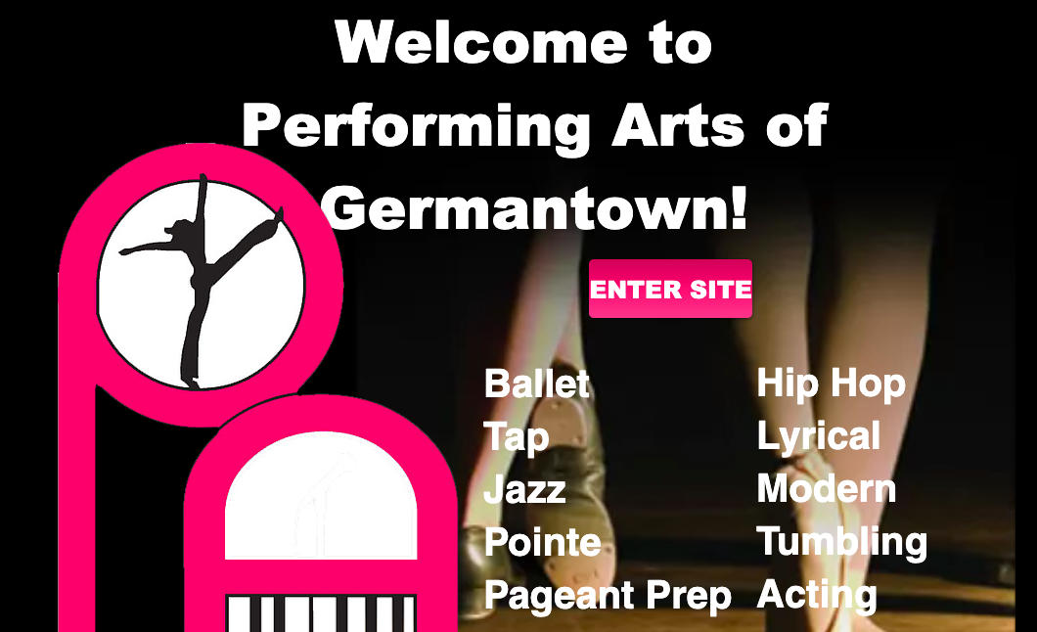

- Elizabeth Anne Brown's Performing Arts of Germantown Dance Studio , is now in its 61st year in business

- All forms of Dance, including, tap, ballet, pointe, lyrical. contemporary, tumbling, jazz, and hip hop are offered for boys and girls ages 3 and up.

- New classes are now being formed. We are offering blended classes at this time. ( in studio- and on Zoom)

- For any new customers, who are Germantown employees , we would love to waive our $35.00 new student registration fee ,and offer a 10% discount for the first month of Dance.

- For beginner dancers, this offer is good thru October 2020. For dancers with experience, this offer is good thru September 2021. . Please call 901-754-0024 for more information.

- Our website is paalltheway.org, our email is paalltheway@gmail.com

