Teaching Points- High serve | Teaching Points- Backhand/Flick Serve | Have they completed it?
Non-dominant foot forward | Dominant foot forward
Side on | Racket resting at the hip
Racket by the side | Holding shuttle by the ‘feathers’
Racket meets shuttle and lands mid to back court | Push through, shuttle landing behind the service line
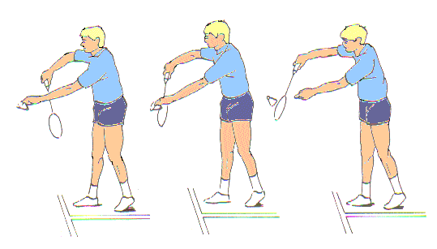
High Serve and Backhand/flick serve- is the racket below the waist?

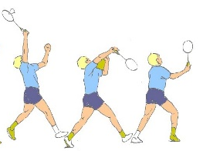
Overhead Clear
Teaching Points | Have they completed it?
Non-dominant foot forward
Side on
Contact high above their head
‘Whip’ action and follow through

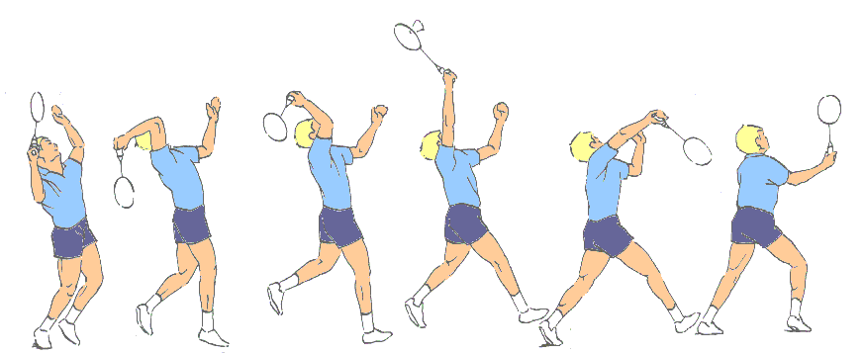

Teaching Points | Have they completed it?
Non-dominant foot forward
Side on
Contact high above their head
‘Tap’ action, shuttle lands just over the net
Drop Shot
Net Shot
Teaching Points | Have they completed it?
Dominant foot forward
Racket in front
Lunge at the net
‘Tap’ action, shuttle lands just over the net
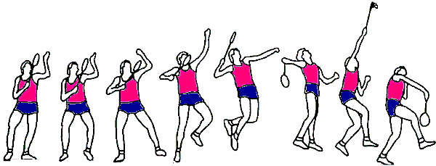
Smash Shot
Teaching Points | Have they completed it?
Side on
Non- dominant foot forward
Contact high
Angle racket down

Tick if they have completed any of these additional shots
Backhand Drop Shot Backhand Clear Backhand Smash
Areas for improvement

