Warm-up 1  Spell your Name  https://www.730sagestreet.com/name-workout/ | Warm-up 2  Playing Card Fitness  https://www.pinterest.ca/pin/606086062321881197/ | Warm-up 3  Circuit  https://www.pinterest.ca/pin/132856257734527698/ | Warm-up 4  Super Hero Training  https://www.pinterest.ca/pin/570268371559619810/ | Warm-up 5  Dice Warm-up  https://www.pinterest.ca/pin/570268371558059212/
Share Question 1  What are you grateful for today? | School Name  Phys Ed  Choice Board  Directions:  - Pick one warm-up each day from across the top to complete.  - Choose one work-out/activity each day from across the bottom to complete.  - Choose one Share Question each day from down the left side and share with your family.  - Choose one Chore each day from down the right hand side to help out your family.  - Choose different combinations for Week 2.  - Feel free to take pictures/videos and send to me at email address  - Descriptions of Activities on following pages.  Always ask your parents before doing any of the activities and clean up whatever you use for the activities  Teacher Message to Students |  |  | Chore 1  Make  Your  Bed
Share Question 2  Who can you check up on today? |  |  |  | Chore 2  Vacuum  Your  Home
Share Question 3  How do you feel about not being at school? |  |  |  | Chore 3  Do  The  Dishes
Share Question 4  How do you act when you’re worried? |  |  |  | Chore 4  Clean  Out the  Car
Share Question 5  What made me happy today? |  |  |  | Chore 5  Wash  The  Windows
Work-out 1  Make an Obstacle Course  https://www.youtube.com/watch?v=5fz9u0-ZFkE&feature=youtu.be | Work-out 2  Living Room Volleyball  https://www.youtube.com/watch?v=OIf-kuqqe1Q&disable_polymer=true | Work-out 3  Yoga  https://www.youtube.com/results?search_query=cosmic+kids | Work-out 4  Teach yourself a Tik Tok dance  https://www.youtube.com/watch?v=vCdV77eeRGk  (or find your own to learn) | Work-out 5  Basketball Challenges  Download the app Homecourt and try some different basketball challenges

Warm-up 1
- Spell your name.
- Do the activity associated with each letter.

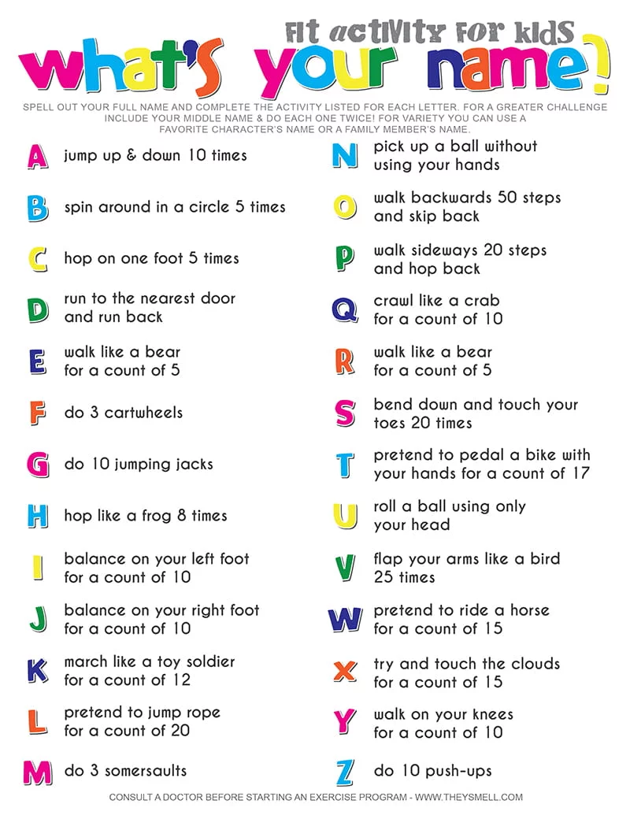

Warm-up 2
- Get a deck of cards.
- Draw 1 card
- Do the exercise associated with that card
- Repeat for a total of 5 cards.
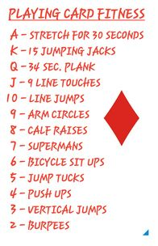
Warm-up 3
- Complete each activity in order.
- If you don’t have a hula hoop, just do hip circles
- Pretend you are on the monkey bars!
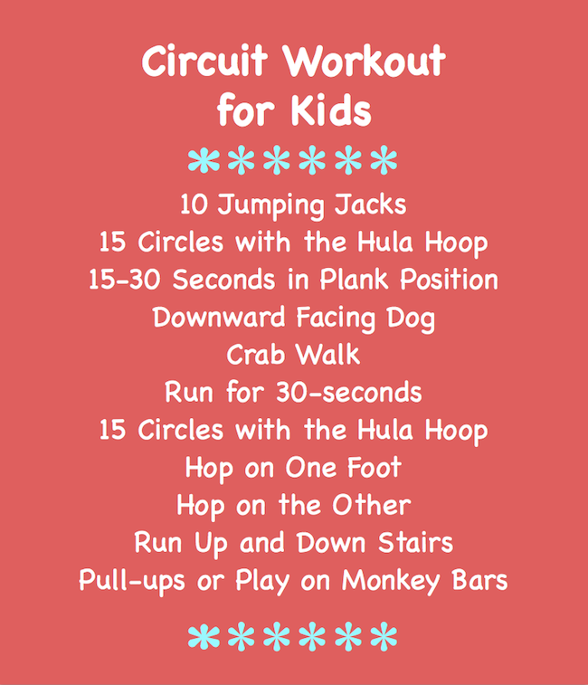

Warm-up 4
- Do each activity once.
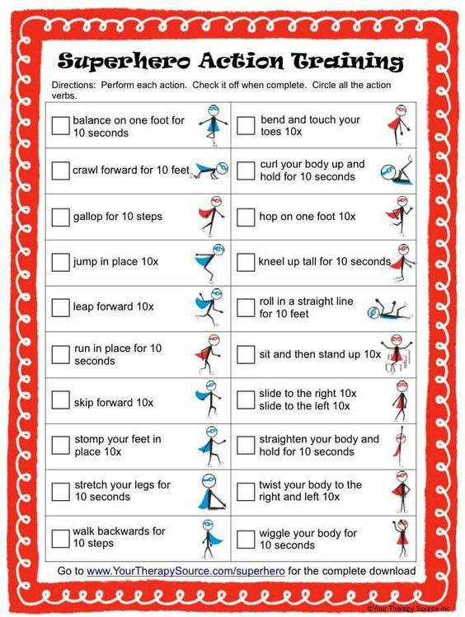

Warm-up 5
- Roll 2 Die.
- Add them together.
- See what activity you need to do.
- Roll the die again to see how many reps of that activity to do.
- Don’t have dice? Write the numbers 1-6 on paper and draw them from a hat instead.

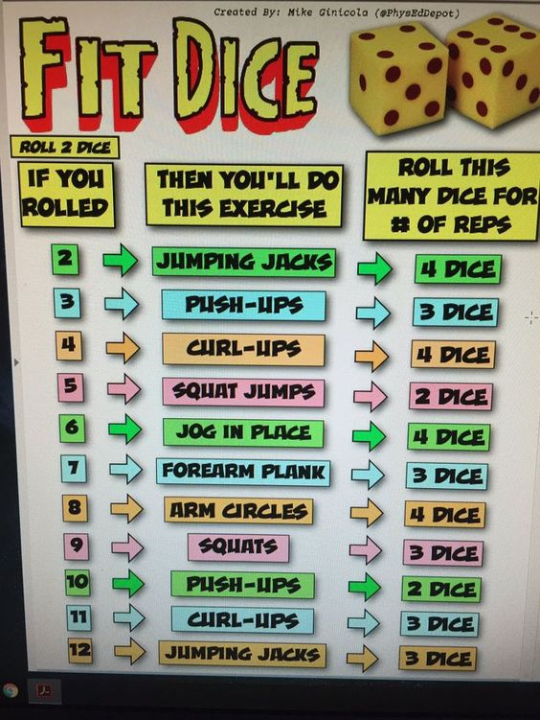
Activity 1
- Watch the video in the link for an example.
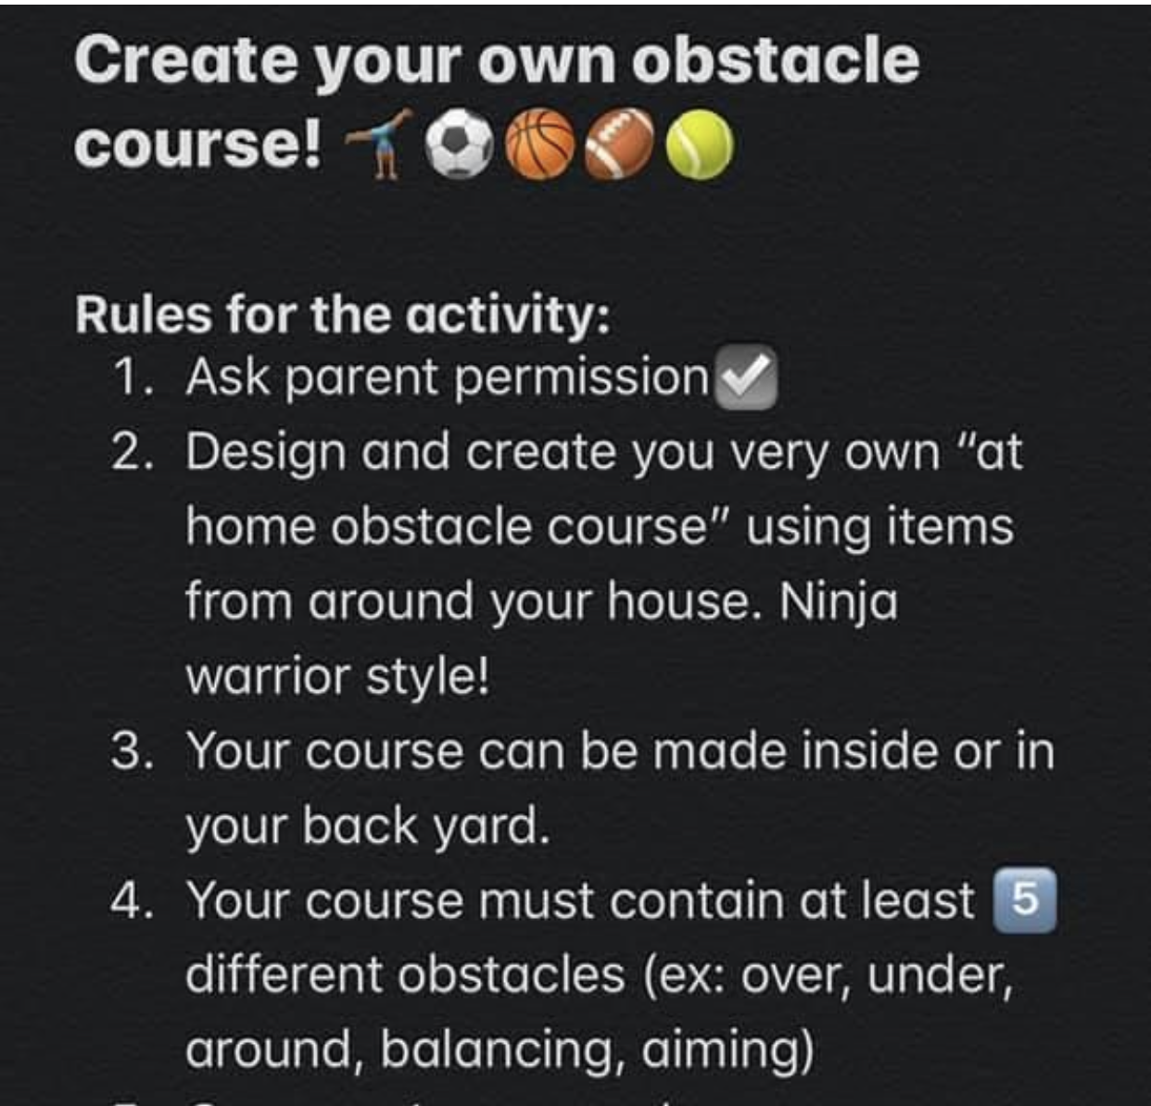
Activity 2
- Watch the video in the link to see how to play.
- Find a space to play
- Use a balloon or another light ball
- Make a net (we used a couch)
- See how many hits you can get without the balloon touching the floor.
- Play a game to 15 points.

Activity 3
- Follow the link to a list of yoga videos.
- Choose one of interest and follow along.

Activity 4
- Follow the link for an example of a clean, child-friendly Tik Tok Video.
- Teach yourself the dance.
- Find your own Tik Tok dance to learn.

Activity 5
- Download the App “Homecourt” (it’s free at the app store
- Try some different challenges
- We like the target practice one in ball handling!

