Pacer/Fitness Gram Reporting

- From your gradebook, click the student icon next to the student’s name
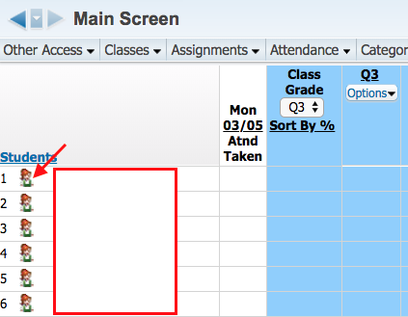

- Click Custom Forms
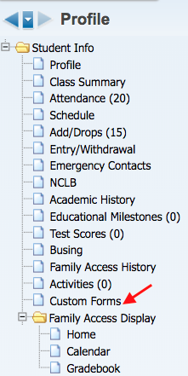

- Click the triangle by the student’s name to expand> Click the triangle by Pacer/Fitness Gram Reporting> Click Edit to enter the information

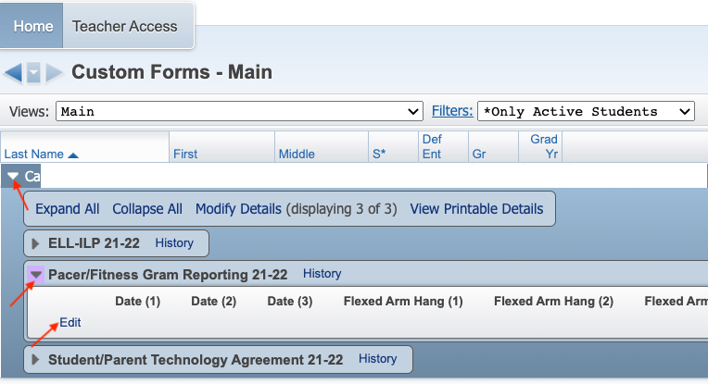
- Enter the test information> Click Save

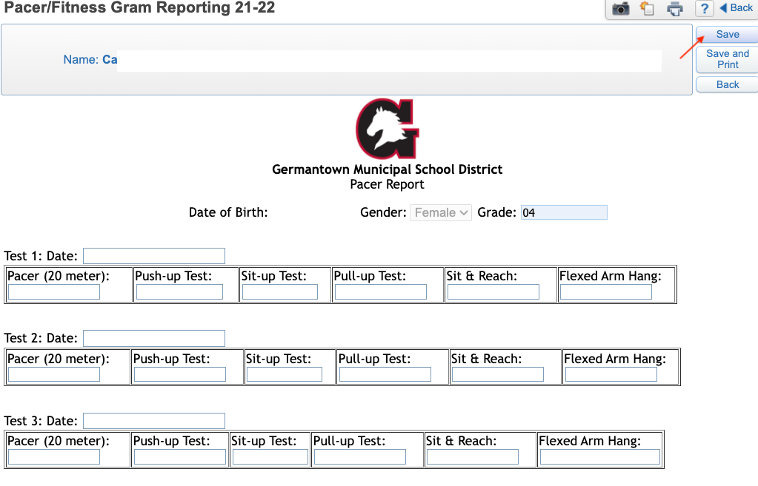

- Click Back to go to the list of students to continue entering information

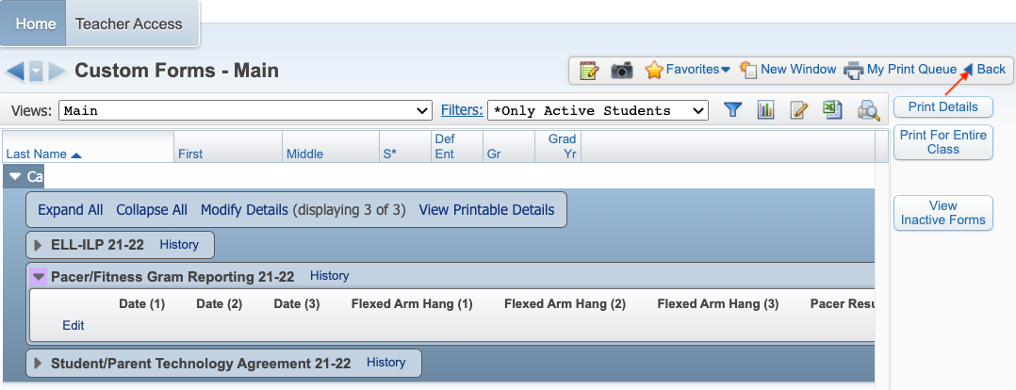

- Click the arrow next to the student’s name> Click the next student’s name to continue entering information>
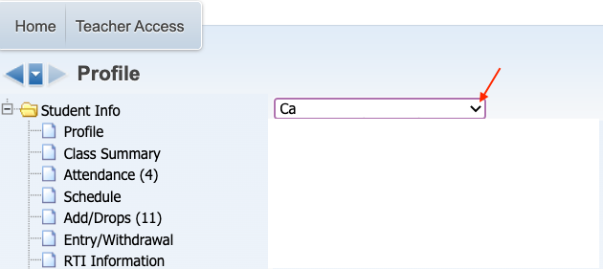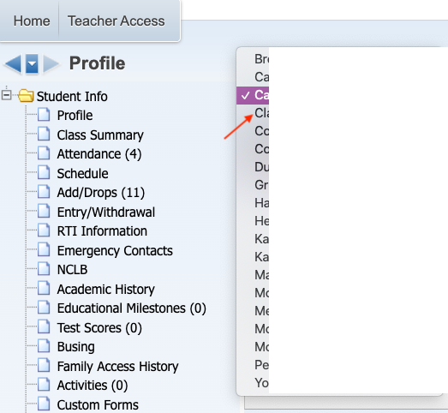

- Continue this process until all information has been entered

