One of the Alliance for a Healthier Generation’s schools, Grahamwood Elementary in Tennessee’s Shelby County Schools, benefits from a strong commitment to keeping kids active and eating healthy before, during and after school. Alliance for a Healthier Generation asked Andrew Martin, Grahamwood’s former physical education teacher, to reflect on the practices that helped the school create a healthier environment for students.
How do you think physical education and social-emotional learning (SEL) connect?
Physical education and SEL connect more than most people realize. SEL is considered “the hidden curriculum” of physical education. In the realm of physical education, high-quality instructors are using SEL even when they don’t realize it. The reason this is possible is that physical education allows us to educate the whole child in a single setting. We can hit every domain of learning (social, cognitive, affective and psychomotor) in our classes.
We know it’s important for students to have a healthy mind and body. How has the COVID-19 pandemic changed your approach to keeping students active?
COVID-19 has changed every aspect of our lives, including in the education setting. Physical education was bound to be hit hard by the drastic changes that occurred from this pandemic and having to social distance and/or teach virtually. Physical educators did what they do best, which is adapt! We adapted to the changes, revised our instruction and curriculum, and sharpened our technology skills.
As a Physical Education Supervisor, I’m always looking for activities and platforms that can easily connect to students and get them engaged and active. The key is engaged! Our students that are stuck doing virtual learning are in front of a screen for over six hours a day! We’ve got to find ways to engage our students and spark their interest in this virtual world of instruction. If you can engage them, then you’ve captivated them and the buy-in is present. The possibilities are limitless with buy-in!
Tell us about the virtual running club you started following the COVID-19-induced school closures. How did it help students feel connected while physically distant?
When COVID-19 hit in the spring, it created a hectic situation that nobody was prepared for. We had to find ideas to engage and reach our students. At this point, there was no district-wide plan through platforms that would roll-out a virtual instruction plan.
Educators had to think outside the box and we were told to do our best and find any way possible to get our students engaged and active. After spending a few weeks doing exercise videos and YouTube videos, I decided to implement something more authentic and creative for my students. They deserved that from me and I was able and willing to make something special happen.
I created the Virtual Running Club based on the idea of getting a community active in a virtual world, but also tying other areas of study into this challenge. I had my students use math to convert their steps to miles and wove in the history of Tennessee and the United States as we earned enough miles to expand our journey. Other areas of study I incorporated were science and writing to expand on other core subjects. The students and their families bought in and the virtual running club stuck because I created something that had meaning and value to my students. They were so excited to see how many miles we earned each day and the virtual shout-outs we received from celebrities, athletes, television personalities and educators across from the country!
Looking back, I’ll always cherish that special moment in time we had as a community and reflecting back on the impact it had on my students and their families during a difficult time.
How has Healthier Generation supported you and/or your schools in promoting health and wellness?
Healthier Generation has always been an advocate for health and physical activity in the school setting. Having an organization like Healthier Generation makes a world of difference in the life of an educator. The resources, information and programs provide next-level support that helps to create healthy and active schools and communities.
The comprehensive toolkits and School Health Index guides that are in place aid to ensure adequate compliance of standards that we aligned ourselves with to ensure the absolute best learning experience possible for our students!
What advice do you have for other teachers and parents looking to improve the physical and social-emotional well-being of children during these incredibly stressful times?
For educators, be creative and use the overwhelming amount of free resources you can find from physical education groups on Facebook and Twitter. The questions you have and/or will have are the same concerns others have already inquired about and have received excellent responses.
Also, show grace and understand that these are difficult times. Grace can and should be shown to yourself as well! Understand that it’s OK to not have all the answers or to get frustrated with how things are going. Reach out to your colleagues and talk things through. You would be amazed at how talking with your peers can aid in reducing stress and anxiety.
For parents, look for ways your family can be engaged and active together! There are programs out there that will allow students to be active from home and can aid in keeping their physical, social and emotional well-being in check.
Also, just as I told the educators, show grace! Understand that as a parent, you won’t have the answers for all the challenges we’re going through in this crazy school year. Try to set aside time each day for brain breaks for your family. Every family can benefit from a walk, run, bike ride, playing outside together or anything else that provides physical activity and that social component that we all need! Together, we’ll get through these times and come out of it stronger than before!
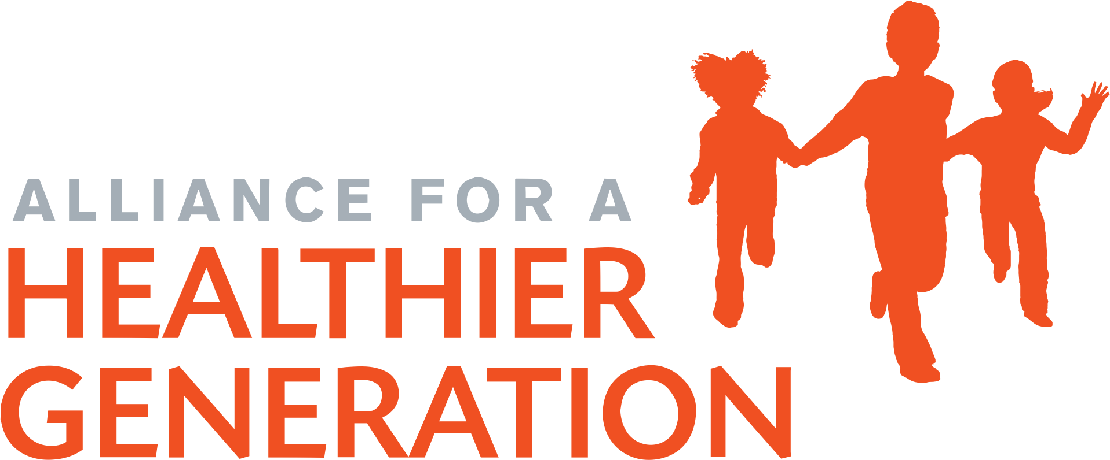
Ready to start your school or district on the path to becoming a healthy school? Learn more and get started on your journey with the Alliance for a Healthier Generation today!

Andrew Martin, School Health Supervisor and Physical Education Supervisor, Germantown Municipal School District (TN) formerly the physical education teacher at Grahamwood Elementary School in Shelby County Schools (TN)

