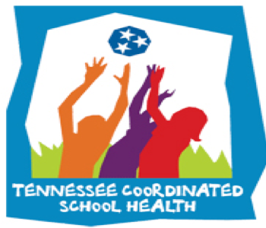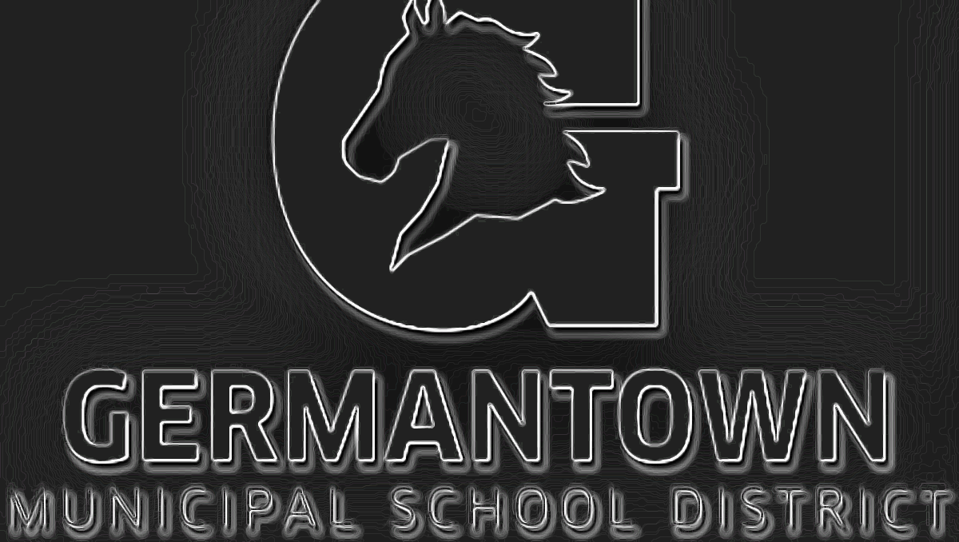

**GMSD Updates:**

-[Healthy & Active Germantown](https://coachmartinpe.weebly.com/staff-wellness.html) discounts available. Download E-Book

-[Go Noodle](https://app.gonoodle.com/) has been purchased for this year!

-700 FREE accounts from [Sworkit](https://coachmartinpe.weebly.com/sworkit.html).

**Important Links & Resources:**

HST Page on my Site: [Click Here](https://coachmartinpe.weebly.com/healthy-school-teams.html)

AFHK SHI Page on my Site: [Click Here](https://coachmartinpe.weebly.com/afhk-school-health-index.html)

**HST Important Dates:**

* Oct. 9th= SHI Due
* Oct. 9th= Meeting 1 Notes
* Email me names of clubs and/or programs your school has.
* Flu shots this month.
* CPR classes coming soon

Breast Cancer Awareness Month is every October! Join the movement and help to put an end to breast cancer! Together, we can make a difference by bringing awareness throughout our community and showcasing our support, whether it be through vocal support and/or monetary donation. You can make a donation below:

[American Cancer Society](https://secure.acsevents.org/site/SPageServer?pagename=strides_donate_now)

**Health Referrals**

We are taking Health Referrals for any student that might be hearing or vision impaired! These two areas can severely impact learning if left untreated! Contact school nurse for any referral needs.

Coordinated School Health is based on the Centers for Disease Control 8 component approach to healthier schools:

1. Nutrition Services
2. Physical Ed/Physical Activity
3. Healthy School Environment
4. Counseling and Psychological Services
5. Health Promotion for Staff
6. Parent/Community Involvement
7. Health Services
8. Health Education

The purpose of a healthy school team is to utilize faculty and staff in each school building who are considered experts in each component so that we are able to capture a more comprehensive look at the school. After assessing the needs of your school, as a team, the school will develop a plan to not only address the weaknesses, but also highlight its strengths. We want to promote healthy schools and encourage healthy behaviors, for students, faculty and families.

**October Health Observances**

**8 Components of Coordinated School Health**

October is Breast Cancer Awareness Month. Participate in our Virtual Run Challenge to bring awareness and earn prizes!

[Enter Your Miles](https://docs.google.com/forms/d/1Y6NXUjVzwYpLCV5UnQ7OKnogTiqulTzI2dLw5tA4Kzw/edit)