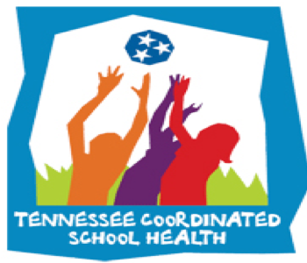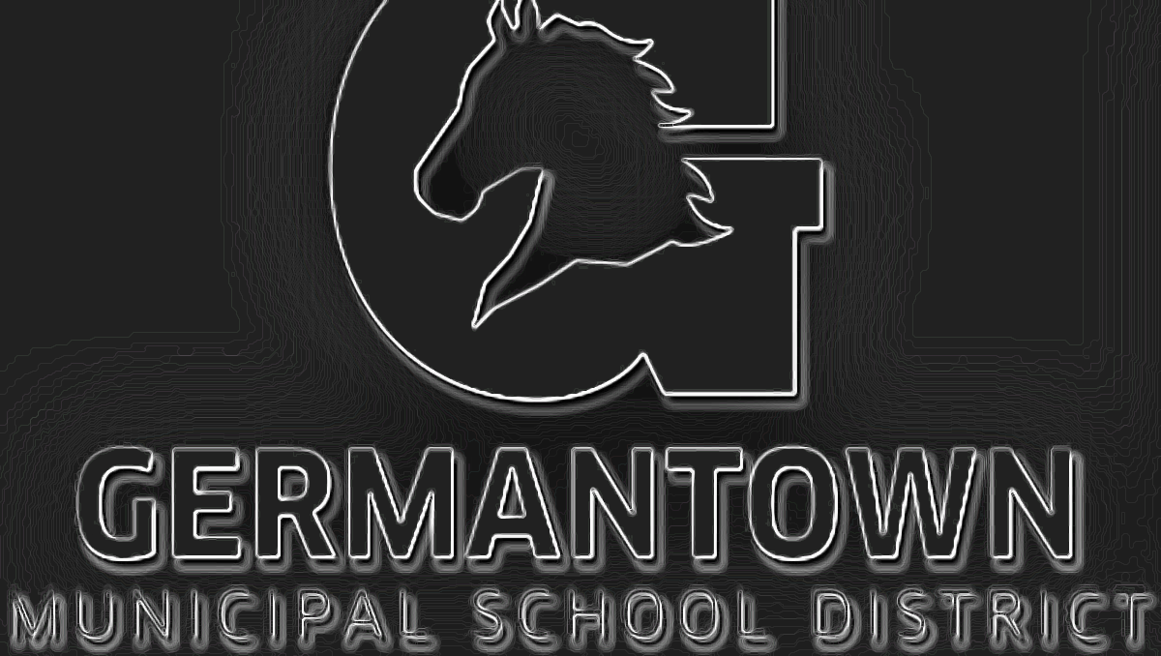

**Anti-Tobacco Initiative**

1. HS Wellness classes will participate in a contest to create Anti-Tobacco Magazine covers (Top 3 selections receive Amazon Gift Cards)
2. GMSD Art teachers will have the choice to participate in district wide Anti-Tobacco poster contest (Top 3 receive prizes).

**Staff Wellness**

**-**[Self-Care resources](https://coachmartinpe.weebly.com/self-care-resources.html) are available for all staff.

-[Staff Exercise](https://coachmartinpe.weebly.com/adult-exercises.html) resources.

-[Staff Wellness](https://coachmartinpe.weebly.com/staff-wellness.html) resources.

**Health Referrals**

We will continue to take health referrals for any student that might need it.

**GMSD Updates:**

-[Healthy & Active Germantown](https://coachmartinpe.weebly.com/staff-wellness.html) discounts available. Download E-Book

-[Anti-Tobacco Town Hall](https://coachmartinpe.weebly.com/tobacco--vaping-education.html) is a virtual page that can be shared with families & staff!

-[Red Ribbon Week](https://coachmartinpe.weebly.com/red-ribbon-week.html) is last week of October!

**Important Links & Resources:**

HST Page on my Site: [Click Here](https://coachmartinpe.weebly.com/healthy-school-teams.html)

AFHK SHI Page on my Site: [Click Here](https://coachmartinpe.weebly.com/afhk-school-health-index.html)

**HST Important Dates:**

* Activity Tracker Due January 5th
* Team Eval Semester 1 Due January 5th
* CPR certifications for staff starting week of November 2nd

Coordinated School Health is based on the Centers for Disease Control 8 component approach to healthier schools:

1. Nutrition Services
2. Physical Ed/Physical Activity
3. Healthy School Environment
4. Counseling and Psychological Services
5. Health Promotion for Staff
6. Parent/Community Involvement
7. Health Services
8. Health Education

The purpose of a healthy school team is to utilize faculty and staff in each school building who are considered experts in each component so that we are able to capture a more comprehensive look at the school. After assessing the needs of your school, as a team, the school will develop a plan to not only address the weaknesses, but also highlight its strengths. We want to promote healthy schools and encourage healthy behaviors, for students, faculty and families.

**November Health Observances**

**8 Components of Coordinated School Health**

November will have us focusing on Anti-[Tobacco & Anti-Vaping](https://coachmartinpe.weebly.com/tobacco--vaping-education.html)!

We will promote making healthy choices and promoting anti-tobacco! If you have ideas, let me know!