Germantown Municipal School District
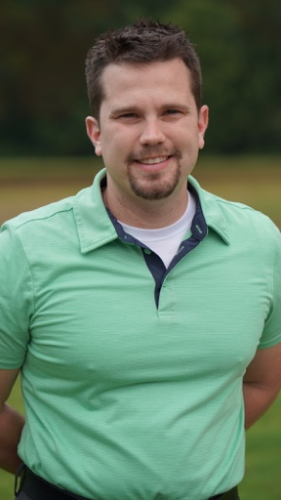
The Department of Coordinated School Health

A Note from Andrew Martin
Coordinated School Health Supervisor
My name is Andrew Martin I was named GMSD’s new Coordinated School Health Supervisor in July 2020. I’m a former Health & Physical Ed. instructor with Shelby County Schools. I have my B.S. In Health and Human Sciences from The University of Memphis and my M.S. in Educational Leadership from Arkansas State University. I’ve been married to my wife Lauren for 8 years and we have two beautiful boys together! Our family is honored to be a part of the GMSD community and I promise to work hard to provide this district with the absolute best when it comes to health, fitness, wellness, and community initiatives! Together, we’ll take GMSD to new heights and I’ so excited for what the future holds for us all!

Parent Guide, Updated COVID Guidelines
The COVID pandemic has not been easy on anyone and the GMSD takes great pride in providing updated and transparent information for our community. We have some great resources that can be useful in helping communications with our schools and families.
- COVID Guidelines & Resources from Department of CSH.
- The Shelby County Health Dept. has great information to reference

Please remember to social distance when at all possible (6 feet), wash hands frequently throughout each day, wear masks at schools, and follow the directives we provide to ensure the safety & well-being of all GMSD.

Healthy Tips & Resources
I take great pride in providing resources, activities, initiatives, and programs to the communities I have the privilege of serving. I have the following noteworthy mentions to share:
- GMSD is currently participating in a Virtual Run Challenge to bring awareness to Breast Cancer!
- We are starting Virtual Yoga this month and we’d love to have as many students, teachers, and parents register as possible! Kid’s Yoga Registration & Adults Yoga Registration.
- We will start the popular “Walk Across TN” program on October 19th! Get your classes registered and/or register for a teacher team!
- We will start a new initiative called “No Smoke November” to bring awareness to our Anti-Tobacco & Anti-Vaping programs we have in place. The initiative will see an art contest done in grade 5th-12th to determine the top 3 posters/ad created!
- Red Ribbon Week will start the last week of October and we’d love to see all our schools participate!
- Check out my website to see all the great information and resources that are available!

