Netball Shooting Technique
Taken from http://www.teachpe.com/netball/shooting/stationary.php
Coaching Points
Ready Position
- Feet in a comfortable forward facing position, not too far apart
- Balanced position, with equal weight on both feet and hips facing the front
- Ball held by dominant hand and high above the head. Fingers point back and are slightly open, ball sits in your hand.
- Second hand is placed at the side of the ball to steady its position
- Elbows slightly flexed, lined in the direction of the post.
Execution
- Focus on a point above the ring to give height to your shot
- Power through the ankles by pushing up through slightly flexed knees
- Maintain balanced position
- Flex elbows not allowing the ball to drop behind your head
- Wrist flicks as the ball is released off the fingers in order to create a backwards spin
- Fingers follow the ball on a high trajectory towards the post, dropping in to the ring
- Aim to drop the ball through the net without it touching the ring
Progressions:
- Increase the distance of your shots
- Set targets and/or forfeits for missing shots
- Stepping forward
- Stepping back
- Stepping to the Side
- Add a defender (2nd stage)

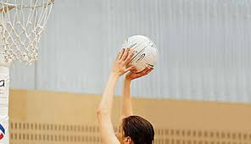
Taken from www.healthyactivekids.com.au

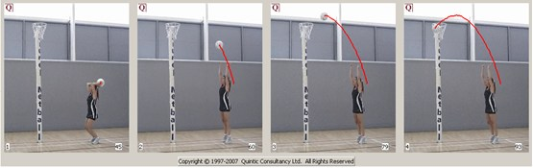

http://netballdrills.co.uk/netball-passing-drill-3-point-passing-with-core-stability/

