Muscles Worksheet

Use the image below and word bank to fill out numbered list below.

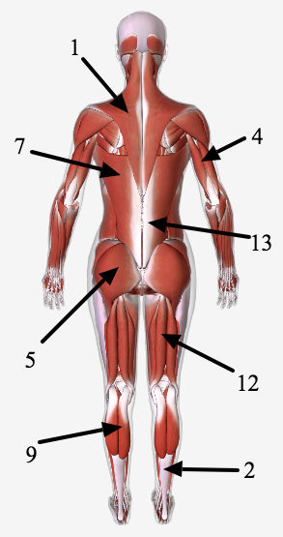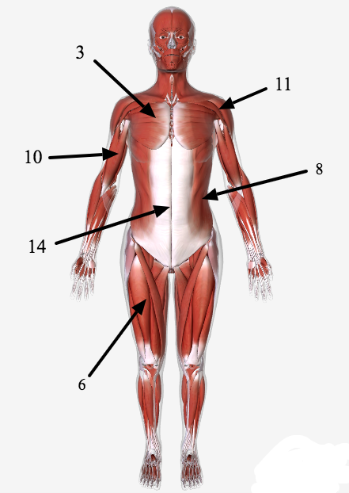

Hamstrings | Pectoralis Major | Latissimus Dorsi | Rectus Abdominus
Gastrocnemius | Triceps | Obliques | Deltoid
Biceps | Quadriceps | Gluteus Maximus | Trapezius
 | Erector Spinae | Soleus

1. | 8.
2. | 9.
3. | 10.
4. | 11.
5. | 12.
6. | 13.
7. | 14.

Name:_______________________________________ Class: _________________________

