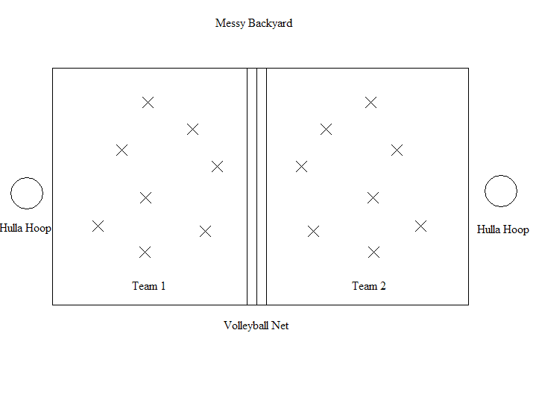
Grades: 1-2
Equipment: 20 or so Yarn Balls, Volleyball Net, 2 hula hoops.
Object of game: Have the least amount of yarn balls left on your side.
Rules: Divide students into 2 teams. Students must stay on their side of the court and throw the yarn balls over the net onto the other team’s court. After a minute or two, count down 3-2-1, then blow the whistle to end the round. All students should stop throwing once the whistle has sounded to keep the game fair.
Have students collect the yarn balls on their side and place into the hula hoop to be counted. Team with the least amount has the cleaner yard and wins a point.
You can change things up by having students use opposite hand, throwing backwards over their head, etc.
Remind students to watch where they are going. No Sliding or Diving for a ball.

