**TEAM BRADY**

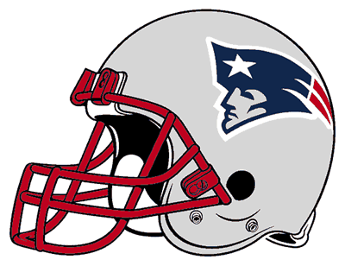

**QB LINE**



**WR LINE**

**TEAM BRADY**

**TEAM MANNING**

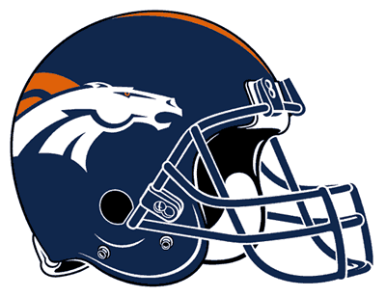

**WR LINE**



**QB LINE**

**TEAM MANNING**

**TEAM MANNING**