**JUMP**

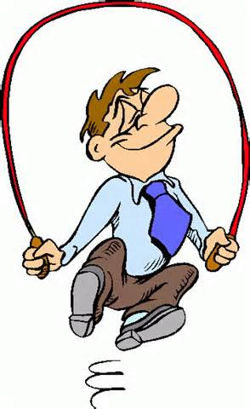

**CUES:**

* **Stand with feet shoulder width apart**
* **Keep hands on sides**
* **Bend knees slightly**
* **Explode up with legs**
* **Bend knees when landing**

**GALLOP**

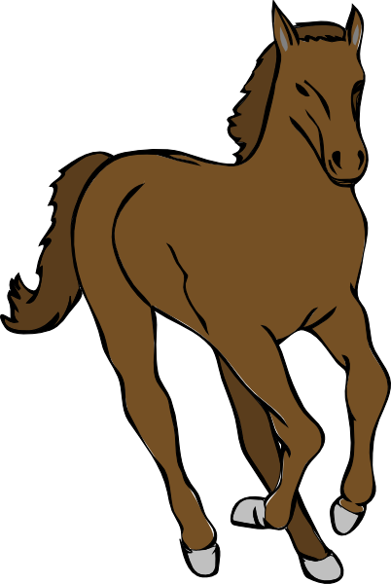

**CUES:**

* **Stand with feet shoulder width apart**
* **Step forward with lead foot**
* **Take long slide forward**
* **Back foot chase to catch lead foot**
* **Close feet fast together**

**WALK**

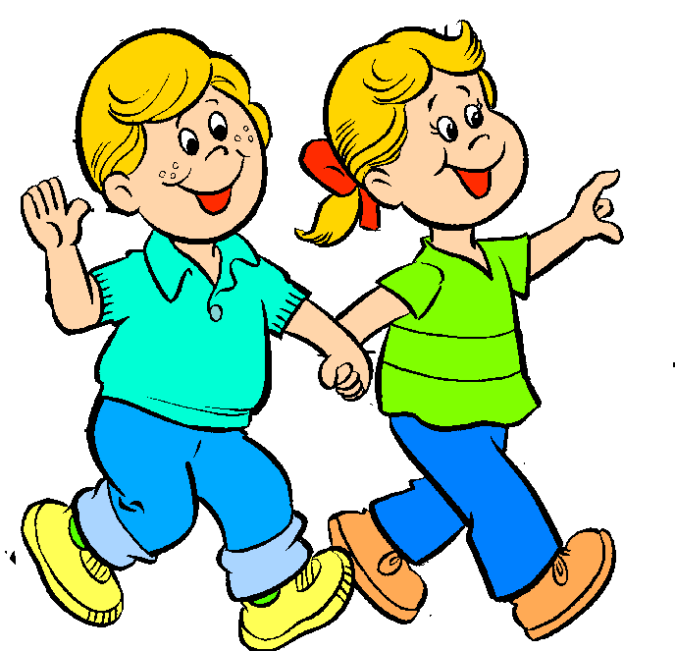

**CUES:**

* **Stand with feet shoulder width apart**
* **Step forward with lead foot**
* **Keep feet apart and don’t cross them**
* **Keep eyes up and forward**

**RUN**

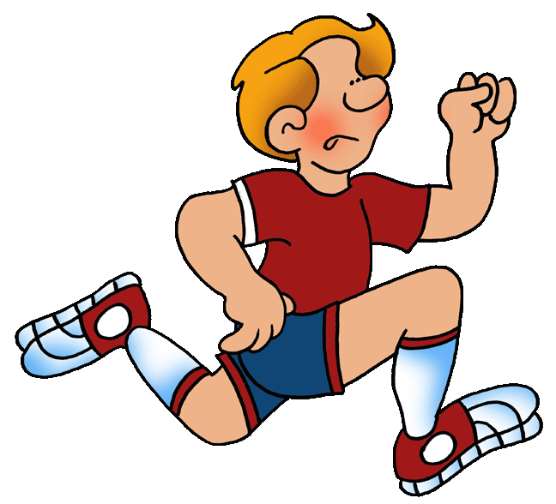

**CUES:**

* **March high, lift knees to waist**
* **Push your toes off the ground**
* **Swing hands from low to high fast (hips to ears)**
* **Keep head and chin straight ahead**

**LEAP**

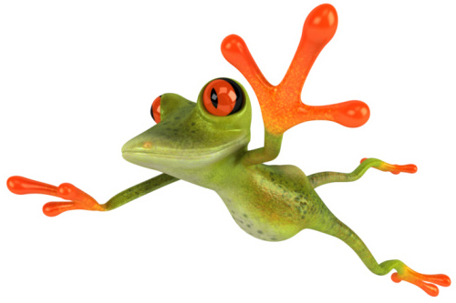

**CUES:**

* **Stand with feet shoulder width apart**
* **Bend knees slightly**
* **Do a long jump off one foot and land on the opposite foot**
* **Keep eyes up and forward**

**SLIDE**

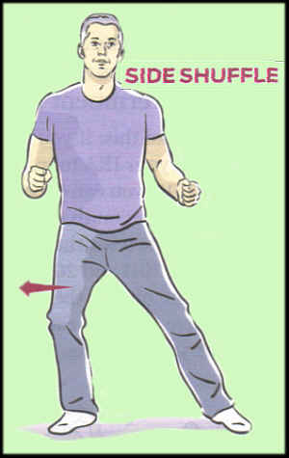

**CUES:**

* **Stand with feet shoulder width apart**
* **Bend knees slightly**
* **Step to the side with lead foot**
* **Back foot chase to catch lead foot**

**HOP**

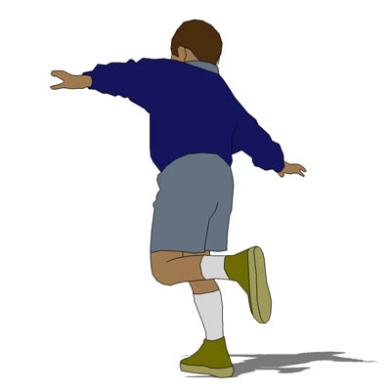

**CUES:**

* **Balance on one foot**
* **Keep other foot off the ground**
* **Have arms to sides to help balance**
* **Bend knees when hopping off ground and when landing**
* **Keep eyes up and forward**

**SKIP**

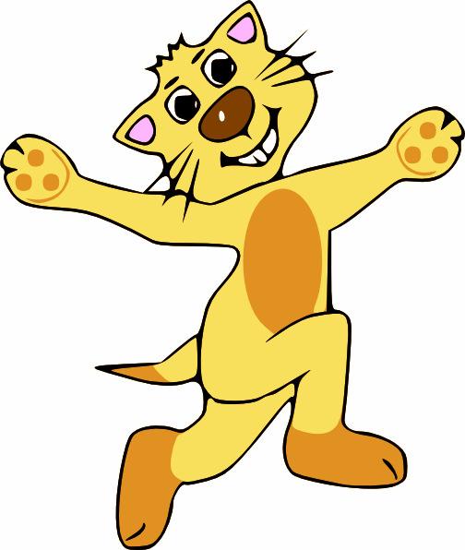**CUES:**

* **Stand with feet shoulder width apart**
* **Step forward with your lead foot and hop**
* **Repeat pattern on opposite foot**
* **Keep eyes up and forward**