TO TRY AND CAPTURE MEWTWO, USE ONLY THE PURPLE POKEBALLS. REMEMBER, YOU EACH ONLY GET 1 THROW PER VISIT!

TO TRY AND CAPTURE ARTICUNO, USE ONLY THE BLUE POKEBALLS. REMEMBER, YOU EACH ONLY GET 1 THROW PER VISIT!

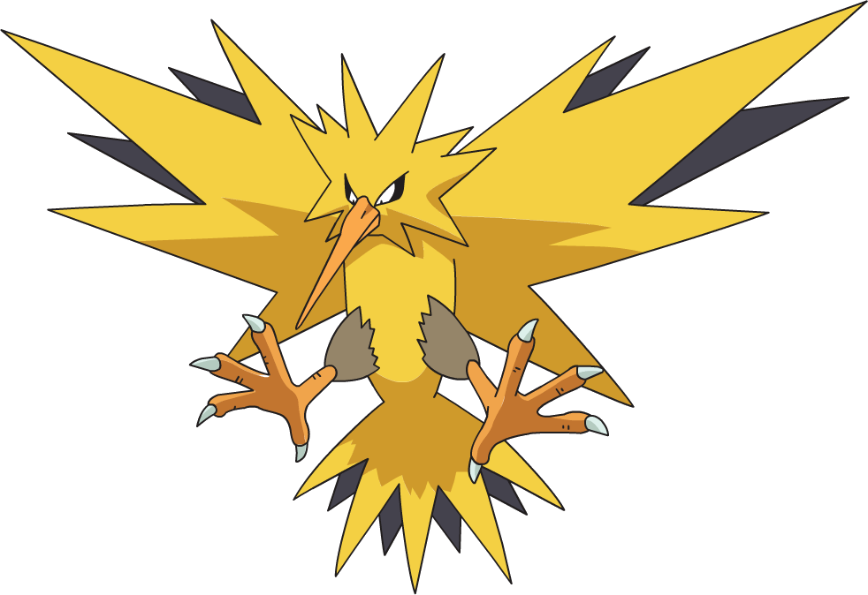
TO TRY AND CAPTURE ZAPDOS, USE ONLY THE YELLOW POKEBALLS. REMEMBER, YOU EACH ONLY GET 1 THROW PER VISIT!

TO TRY AND CAPTURE MOLTRES, USE ONLY THE ORANGE POKEBALLS. REMEMBER, YOU EACH ONLY GET 1 THROW PER VISIT!

