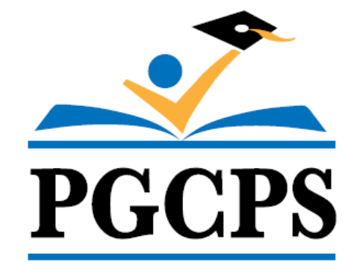 | Kindergarten Physical Education  Course Syllabus
Physical Education | Prince George’s County Public Schools

Prerequisites: None

Course Description:
The physical education program is based on the Society of Health and Physical Education (SHAPE America) Standards and Grade Level Outcomes. SHAPE America’s five standards focus on developing physically literate individuals that have the knowledge, skills, and confidence to enjoy a lifetime of healthful physical activity. At the elementary level, the focus is on the foundational skills, knowledge and personal/social responsibility in a physical activity setting.

By the end of Kindergarten, students will have learned fundamental skills including, but not limited to:
- Locomotor Skills
  - Performs hopping, skipping, jumping, sliding, galloping, running while maintaining balance
- Non-locomotor Skills
  - Curling, stretching and balancing
- Manipulative Skills
  - Including underhand throwing, catching and kicking.

Additionally, students participate in a wide variety of activities that involve fitness concepts and development exercises that lead to experiences of personal feelings of success.

Note: Lesson activities depend on a number of factors that include but are not limited to time, space, and equipment.

GRADING:

Elementary School Physical Education
Overview: The goal of grading and reporting is to provide the students with feedback that reflects their progress towards the mastery of the indicators and objectives align to the Society of Health and Physical Educators (SHAPE) America Standards.

Factors | Brief Description | Grade Percentage  Per Quarter
Classwork | This includes all work completed in the classroom setting. This may include but is not limited to:  - Warm ups  - Worksheets  - Notebooks  - Whole/Small group work or discussions  - Vocabulary  - Skill Assessments/Performance Based Assessments  - Personal/Social/Emotional Development | 70%
Homework | This includes all work begun or completed outside the classroom/gymnasium. This may include, but is not limited to:  - Journals  - Written reports  - Projects  - Fitness Logs | 10%
Assessment | This category entails both traditional and alternative methods of assessing student learning. This may include:  - Skill Assessments  - Written Assessments  - Rubrics  - Task Cards  - Pre/Post Fitness Assessment  - Pair/Self Evaluation  An instructional rubric should be created to outline the criteria for success and scoring for each alternative assessment. | 20%

