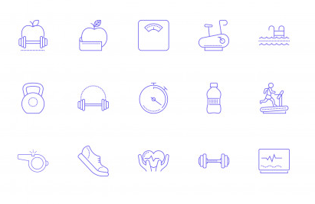
Name:
PE Group:
Teacher Name:
Room
Year 7
Physical Education Theory

Assessment | WWW | EBI
1
2
3

Task Work Space e.g. table to complete, diagram, notes
Label the skeleton:
Interesting fact:
Adults will end up with only 206 bones, but babies are born with almost 100 more. It’s not that bones disappear as we grow older. Instead, these tiny bones fuse together to form the larger bones of the skeletal system.

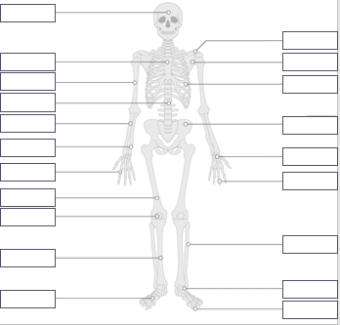
Helpful hints to remember those tricky bones:
A way to remember carpals and ……………… are in the wrist and …………. is that you use them to drive a '………..' ('…………-' is the start of the word 'carpals'). The 't' of ……….. and toes helps you remember tarsals and ……………………. are in the feet.

Questions (AoL)/ Plenary (Bronze = Answer 2 questions Silver answer 3 questions Gold = Push yourself and think of more answers you could use to answer the question ask your teacher for an example)

Where in the body are the metacarpals found?

……………………………………………………………………………………………………………………….

What are the three bones found in the arm?
………………………………………………………………………………………………………………………..

Label the bones in highlighted in the picture bellow:
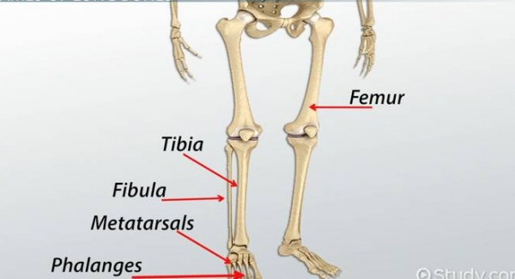

Task Work Space e.g. table to complete, diagram, notes

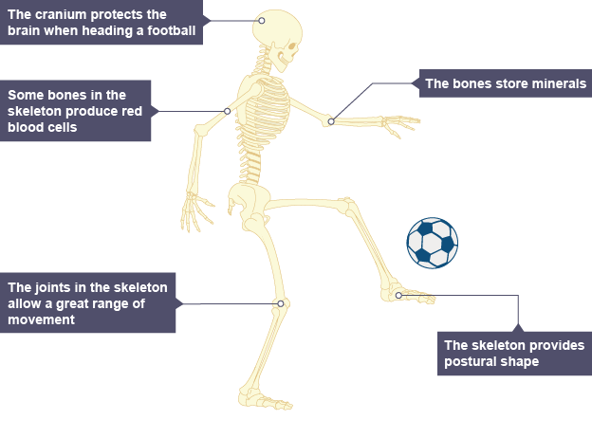
Function | Description

Function | Description

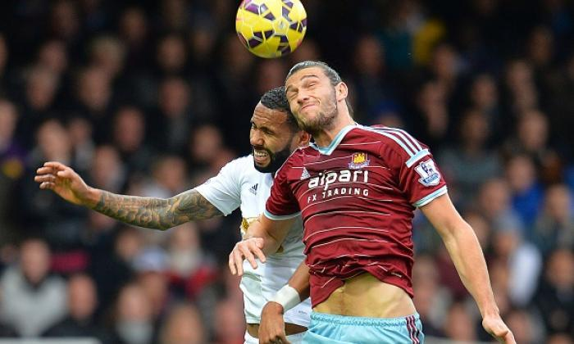
.
Questions (AoL)/ Plenary (Bronze = Answer 2 questions Silver answer 3 questions Gold = Push yourself and think of more answers you could use to answer the question ask your teacher for an example)

What are 3 functions of the skeleton?

……………………………………………………………………………………………………………………….

Describe two of the functions you used in your previous answer?
………………………………………………………………………………………………………………………..
………………………………………………………………………………………………………………………..
………………………………………………………………………………………………………………………..
………………………………………………………………………………………………………………………..
………………………………………………………………………………………………………………………..

What type of function is the body using in the picture bellow?

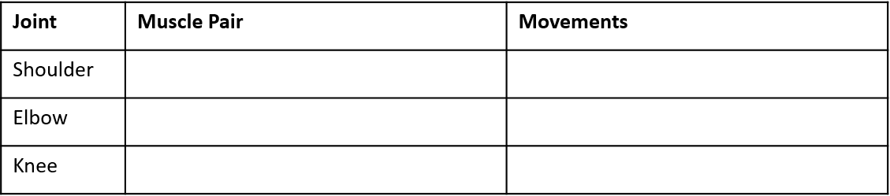
Task Work Space e.g. table to complete, diagram, notes

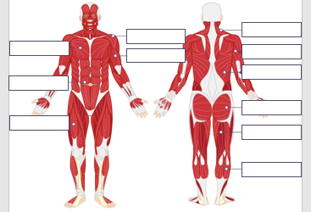

Function | Description

Questions (AoL)/ Plenary (Bronze = Answer 2 questions Silver answer 3 questions Gold = Push yourself and think of more answers you could use to answer the question ask your teacher for an example)

What two types of movement can occur and the elbow and knee?

……………………………………………………………………………………………………………………….

What is the difference between an agonist and antagonist?
………………………………………………………………………………………………………………………..

Label the three muscles in highlighted red box in the picture bellow:
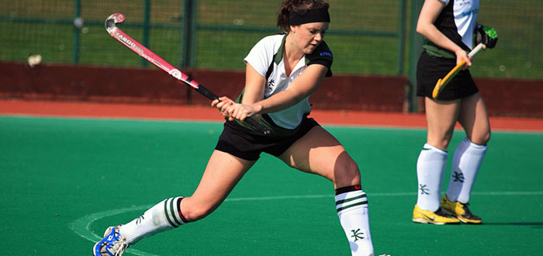

r
A synovial joint is…

Task Work Space e.g. table to complete, diagram, notes

Synovial joints (freely movable joints) allow us the free movement to perform skills and techniques during physical activity.
Synovial joints have synovial fluid in the joint cavity that lubricates or 'oils' the joint so it moves smoothly. The synovial membrane makes synovial fluid.

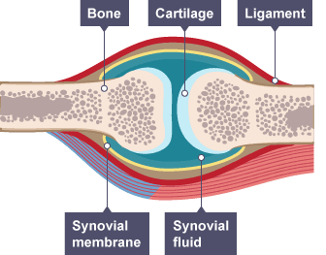
Questions (AoL)/ Plenary (Bronze = Answer 2 questions Silver answer 3 questions Gold = Push yourself and think of more answers you could use to answer the question ask your teacher for an example)

What is the main purpose of a synovial joint?

……………………………………………………………………………………………………………………….

What is the function of a ligament?
………………………………………………………………………………………………………………………..
Label the synovial joint bellow:

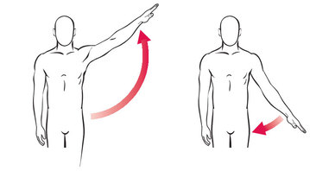
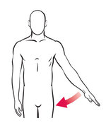
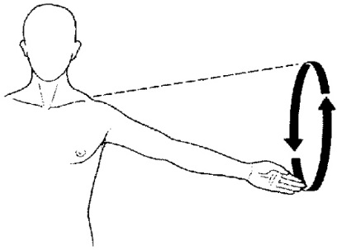
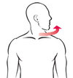
………………………..
………………………..
………………………..
………………………..
………………………..
………………………..
Task Work Space e.g. table to complete, diagram, notes

Joint | Type | Articulating Bones | Movements
Knee
Hip
Elbow
Shoulder

Questions (AoL)/ Plenary (Bronze = Answer 2 questions Silver answer 3 questions Gold = Push yourself and think of more answers you could use to answer the question ask your teacher for an example)

Name 3 types of Movement?

……………………………………………………………………………………………………………………….

What are the articulating bones found at the Knee?
………………………………………………………………………………………………………………………..

What are the three articulating bones found at the elbow?
………………………………………………………………………………………………………………………..

What type of movement is happening in the photo bellow? 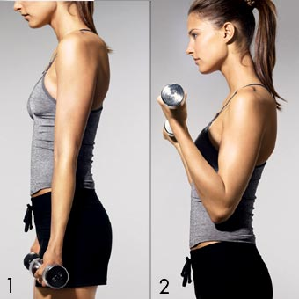
………………………………………………………………………………………………………………………..

Test:

Label the four muscles bellow (4 Marks)

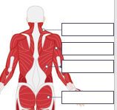

Total 20 marks: __/20
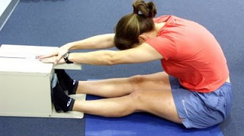
Sit and reach test
What does the sit and reach test measure?

 | Male | Female
Super | +27 | +30
Excellent | 17 - 27 | 21 - 30
Good | 6 - 16 | 11 - 20
Average | 0 - 5 | 1 - 10
Fair | -8 to -1 | -7 to 0
Poor | -20 to -9 | -15 to -8
What is the definition of this?

How to complete the test:

1st Attempt | 2nd Attempt | 3rd Attempt

Your results:
Highlight your best result.

Questions (AoL)/ Plenary (Bronze = Answer 2 questions Silver answer 3 questions Gold = Push yourself and think of more answers you could use to answer the question ask your teacher for an example)
Name three sports where flexibility is an important component of fitness.

Name the muscle that’s flexibility is being measured in the sit and reach test?

“A gymnast requires a good level of flexibility” Explain why?

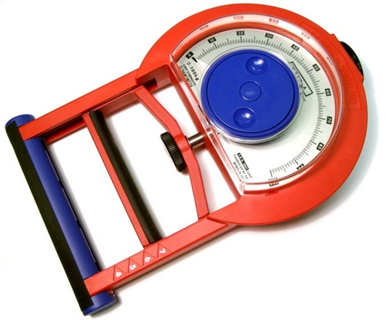
Testing Strength
What are the two ways we can test strength?

What is the definition of strength?

How to complete each test:
Test 1 Test 2

 | Male | Female
Excellent | 52 + | 32 +
Good | 47-51 | 28-31
Average | 44-46 | 25-27
Below Average | 39-43 | 20-24
Poor | <39 | <20

1st Attempt | 2nd Attempt | 3rd Attempt

Your results: Highlight your best result.
Questions (AoL)/ Plenary (Bronze = Answer 2 questions Silver answer 3 questions Gold = Push yourself and think of more answers you could use to answer the question ask your teacher for an example)
Name three sports where Strength is an important component of fitness.

Name the muscle that’s strength is being measured in a one rep max bench press?

“A Rugby player requires a good level of Strength” Explain why?

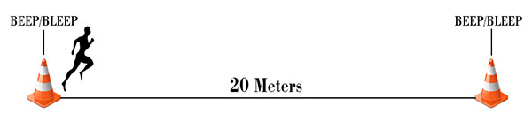
Multi-stage fitness test
The Multi-stage fitness test measures your?

What is the definition of this?

How to complete the test:

 | Male | Female
Excellent | > 13 | > 12
Very Good | 11-3 | 10-12
Good | 9-11 | 8-10
Average | 7-9 | 6-8
Poor | 5-7 | 4-6
Very poor | < 5 | < 4

Attempt

Q) Questions (AoL)/ Plenary (Bronze = Answer 2 questions Silver answer 3 questions Gold = Push yourself and think of more answers you could use to answer the question ask your teacher for an example)
Name three sports where Cardiovascular Endurance is an important component of fitness.

Is Cardiovascular Endurance an important component of fitness for a Darts player? Explain your answer.
What two body systems are used in Cardiovascular endurance?

Alternative to the Multi stage fitness test is the 12 minute Cooper Run
My Heart Rate:
Before (Resting) __________ BPM After (Working) ________ BPM

I completed ________________ laps.

Calculate the total distance covered? ___________________ metres

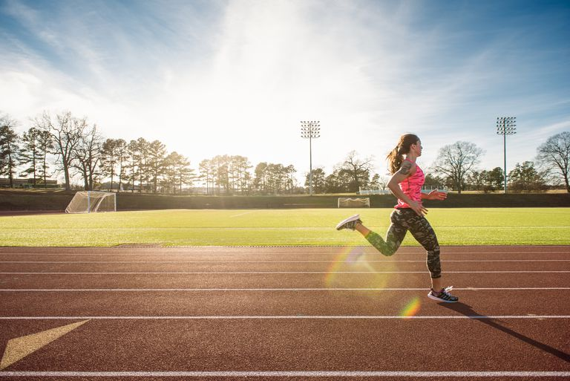

In the box bellow draw and explain how the 12 minute cooper run test is carried out….

___________________
___________________
___________________
___________________
___________________
___________________
___________________
___________________
 | Male | Female
Excellent | <15.2 | <17
Good | 15.2 - 16.1 | 17.0 - 17.9
Average | 16.2 - 18.1 | 18.0 - 21.7
Fair | 18.2 - 18.3 | 21.8 - 23.0
Poor | > 18.3 | > 23
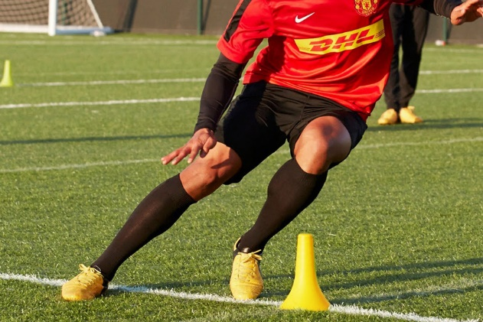
The Illinois agility test
The Illinois agility test measures your?

What is the definition of this?

How is this test carried out?

Attempt

Q) Questions (AoL)/ Plenary (Bronze = Answer 2 questions Silver answer 3 questions Gold = Push yourself and think of more answers you could use to answer the question ask your teacher for an example)
Draw out the test in the box bellow showing the direction of travel….

What athletes would require agility?

Why would these athletes require this type of component?

30m sprint test
The 30M Sprint test measures your?

What is the definition of this?

How to complete the test:

 | Male | Female
Excellent | < 4 | < 4.5
Above Average | 4.2 - 4 | 4.6 - 4.5
Average | 4.4 - 4.3 | 4.8 - 4.7
Below Average | 4.6 - 4.5 | 5 - 4.9
Poor | > 4.6 | > 5

1st Attempt | 2nd Attempt | 3rd Attempt

Q) Questions (AoL)/ Plenary (Bronze = Answer 2 questions Silver answer 3 questions Gold = Push yourself and think of more answers you could use to answer the question ask your teacher for an example)
Give an example of three sports where this component of fitness may be used?

Explain one of your answer above in more detail; think about why they would need that component of fitness and when they would likely use it in a sporting situation?

Mr Binfield is a Goalkeeper, is Speed an essential component of fitness for him? Explain your answer.

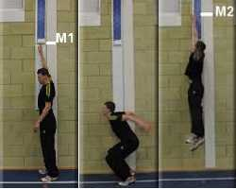
Vertical jump test
The vertical jump test measures your?

What is the definition of this?

How to complete the test:

 | Male | Female
Excellent | > 70 | > 60
Very Good | 61 - 70 | 51 - 60
Above Average | 51 - 60 | 41 - 50
Average | 41 -50 | 31 - 40
Below Average | 31 - 40 | 21 - 30
Poor | 21 - 30 | 11 - 20
Very poor | < 21 | < 11

Attempt

Q) Questions (AoL)/ Plenary (Bronze = Answer 2 questions Silver answer 3 questions Gold = Push yourself and think of more answers you could use to answer the question ask your teacher for an example)
What is a good practical example of where this component is particularly important in sport?

Can you think of three other sports where Power is used?

Does a Swimmer player require Power in their event? Explain your answer

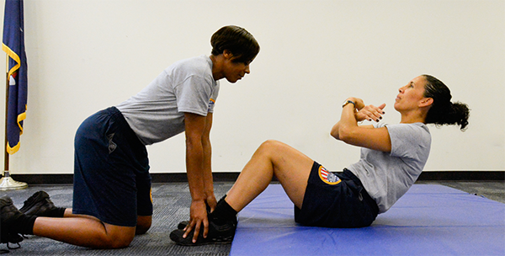
Press up/Sit up test
The Press up/Sit up test measures your?

What is the definition of this?

How to complete the tests:

 | Male | Female
Excellent | 60 | 50
Good | 45 | 40
Fair | 30 | 25
Poor | 15 | 10

Attempt

Q) Questions (AoL)/ Plenary (Bronze = Answer 2 questions Silver answer 3 questions Gold = Push yourself and think of more answers you could use to answer the question ask your teacher for an example)
What is a good practical example of where this component is particularly important in sport?

If a rower had poor muscular endurance, how could this affect their sport performance?

How would you make sure the results in the test are accurate and valid?

 | Seconds
Excellent | > 50
Good | 40-50
Average | 25-39
Poor | 10-24
Very poor | > 10
Attempt
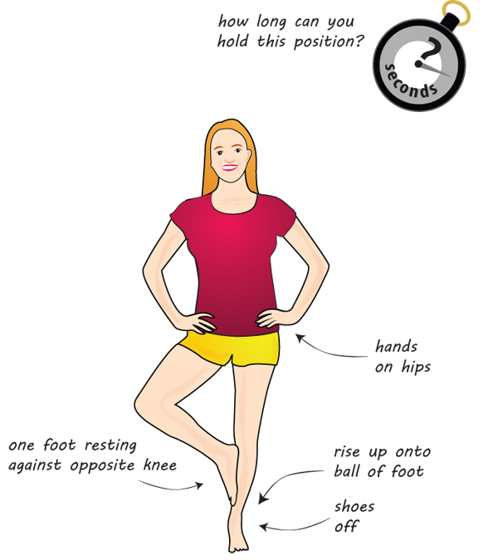
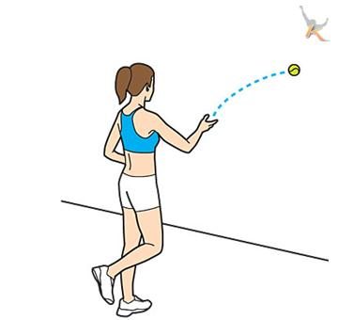
Standing Stork Test
Wall throw test
The Standing stork test measures your?

What is the definition of this?

How to complete the test:

Questions (AoL)/ Plenary (Bronze = Answer 2 questions Silver answer 3 questions Gold = Push yourself and think of more answers you could use to answer the question ask your teacher for an example)
What is a good practical example of where this component is particularly important in sport?

A gymnast would need a high level of balance in their sport, explain this statement?

How would you make sure the results in the test are accurate and valid?

The Wall throw test measures your?

What is the definition of this?

How to complete the test:

 | Score (No of Catches)
Excellent | > 35
Good | 30 - 35
Average | 20 - 29
Poor | 15 - 19
Very poor | < 15

Attempt

Questions (AoL)/ Plenary (Bronze = Answer 2 questions Silver answer 3 questions Gold = Push yourself and think of more answers you could use to answer the question ask your teacher for an example)
What is a good practical example of where this component is particularly important in sport?

Between a Tennis player and a Marathon Runner, which athlete would require this component of fitness more? Explain your answer.

How would you make sure the results in the test are accurate and valid?

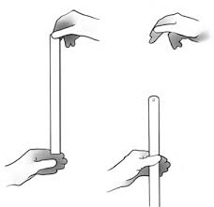
The ruler drop test
The Ruler drop test test measures your?

What is the definition of this?

How to complete the test:

Excellent | Above Average | Average | Below Average | Poor
< 7.5cm | 7.5 - 15.9cm | 15.9 - 20.4cm | 20.4cm - 28cm | > 28cm

1st Attempt | 2nd Attempt | 3rd Attempt

Questions (AoL)/ Plenary (Bronze = Answer 2 questions Silver answer 3 questions Gold = Push yourself and think of more answers you could use to answer the question ask your teacher for an example)
What is a good practical example of where this component is particularly important in sport?

Why might a 100m sprinter require this component of fitness? Explain your answer.

How would you make sure the results in the test are accurate and valid?

Extension/Independent area:
Measuring the components of fitness

Q) Can you think of 5 reasons for carrying out fitness tests?

Q) What are the limitations of fitness testing?

The components of fitness
Q) Complete the table identifying the component of fitness, then give a definition of the component of fitness followed by a sporting example and finally link to the correct fitness test :)

Component | Definition | Sporting Examples | Fitness Test
Muscular  Endurance |  | Rapidly contracting the muscles in your legs to pedal when cycling.
 | The maximum rate at which an individual is able to perform a movement or cover a distance in a period of time. |  | 30m sprint test.
Muscular
Strength
Flexibility |  | Performing the splits in gymnastics.
Agility
 | The ability of the heart and lungs to supply oxygen to the working muscles.
Coordination |  | Using your eyes and feet to dribble in football.
 | Being able to maintain your centre of mass over the base of support.
Power

 | The time taken to initiate a response to a stimulus.

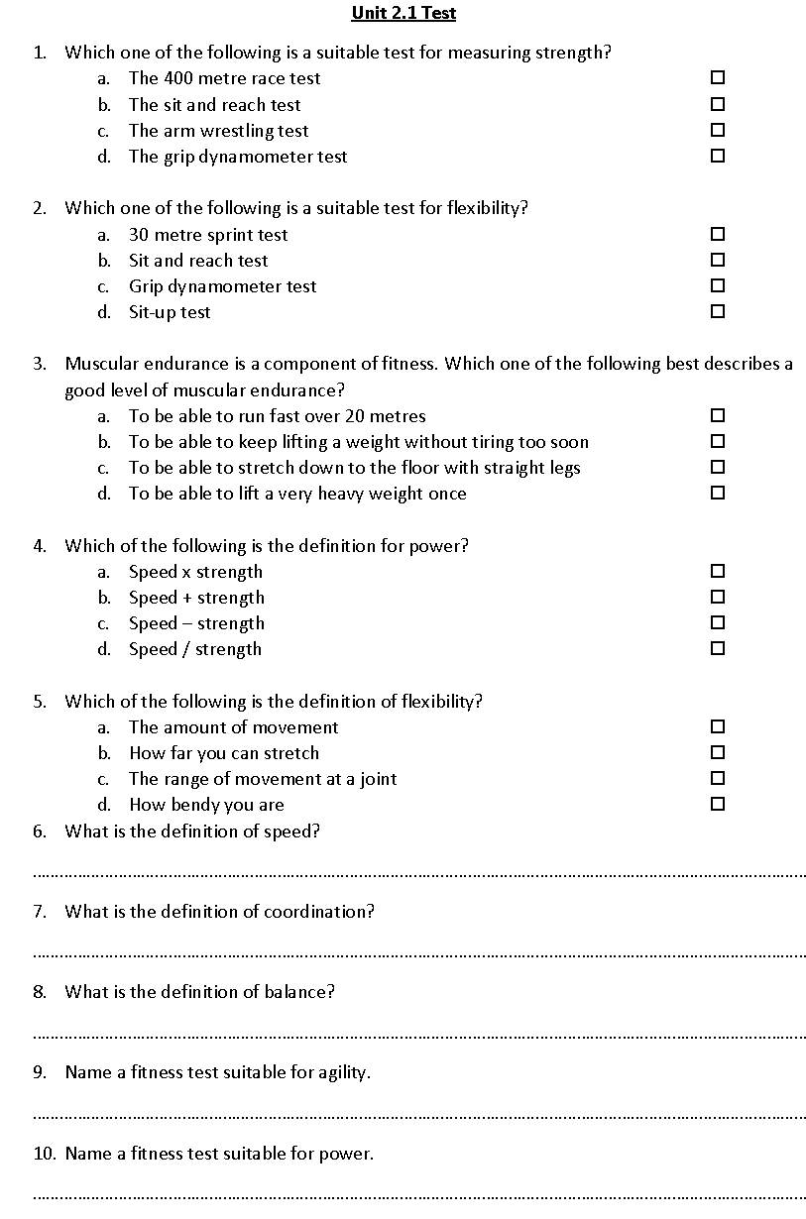
Test:

Which component of fitness is the most important for a Marathon Runner?
…………………………………………………………………………………………………………………………………………….. (1 Mark)

Explain your answer
………………………………………………………………………………………………………………………………………………………………………………………………………………………………………………………………………………………………………………………………………………………………………………………………………………………………………………………………………(2 Marks)
To be able to dodge players quickly in a game of netball, which component of skill related fitness do you need?
................................................................................................................................................... (1 Mark)
Name 3 other sports where this component of fitness would be useful:
………………………………………+…………………………………………………………+………………………………………(2 Marks)

In the box bellow draw out the test for the above component of fitness. Use lines to help show the direction of travel: (3 Marks)

Training Method | Definition | Example
Circuit Training
Fartlek Training
Continuous Training
Weight Training
Plyometric Training
Interval Training

Continuous Training
Name a sporting example of an athlete who would use this type of training method?

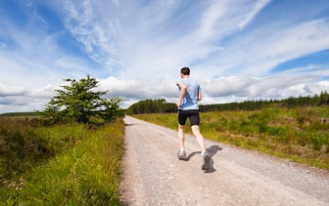

Advantages:

Disadvantages:

Questions (AoL)/ Plenary (Bronze = Answer 2 questions Silver answer 3 questions Gold = Push yourself and think of more answers you could use to answer the question ask your teacher for an example)

Names 2 sports where this would be a useful training method for an athlete:

Where could you train for this method of training? Is that an advantage of this method?

Give a sporting example of an athlete who would use this type of training?

Fartlek Training
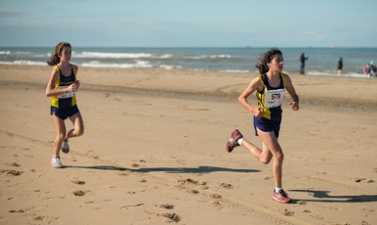
Name a sporting example of an athlete who would use this type of training method?

Advantages:

Disadvantages:

Questions (AoL)/ Plenary (Bronze = Answer 2 questions Silver answer 3 questions Gold = Push yourself and think of more answers you could use to answer the question ask your teacher for an example)

Names 2 sports where this would be a useful training method for an athlete:

Where could you train for this method of training? Is that an advantage of this method?

Give a sporting example of an athlete who would use this type of training?

Interval Training
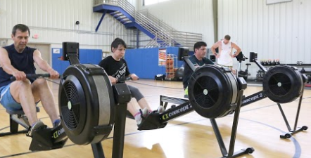
Name a sporting example of an athlete who would use this type of training method?

Advantages:

Disadvantages:

Questions (AoL)/ Plenary (Bronze = Answer 2 questions Silver answer 3 questions Gold = Push yourself and think of more answers you could use to answer the question ask your teacher for an example)

Names 2 sports where this would be a useful training method for an athlete:

Where could you train for this method of training? Is that an advantage of this method?

Give a sporting example of an athlete who would use this type of training?

Weight Training
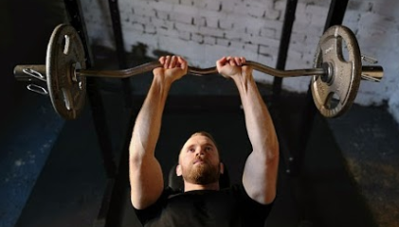
Name a sporting example of an athlete who would use this type of training method?

Advantages:

Disadvantages:

Questions (AoL)/ Plenary (Bronze = Answer 2 questions Silver answer 3 questions Gold = Push yourself and think of more answers you could use to answer the question ask your teacher for an example)

Names 2 sports where this would be a useful training method for an athlete:

Where could you train for this method of training? Is that an advantage of this method?

Give a sporting example of an athlete who would use this type of training?

Circuit Training
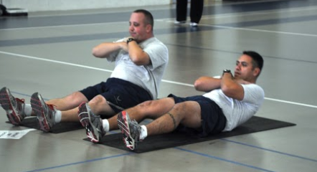
Name a sporting example of an athlete who would use this type of training method?

Advantages:

Disadvantages:

Questions (AoL)/ Plenary (Bronze = Answer 2 questions Silver answer 3 questions Gold = Push yourself and think of more answers you could use to answer the question ask your teacher for an example)

Names 2 sports where this would be a useful training method for an athlete:

Where could you train for this method of training? Is that an advantage of this method?

Give a sporting example of an athlete who would use this type of training?

Plyometric Training
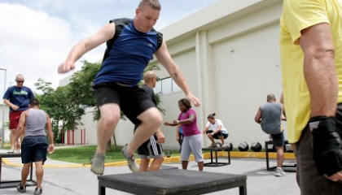
Name a sporting example of an athlete who would use this type of training method?

Advantages:

Disadvantages:

Questions (AoL)/ Plenary (Bronze = Answer 2 questions Silver answer 3 questions Gold = Push yourself and think of more answers you could use to answer the question ask your teacher for an example)

Names 2 sports where this would be a useful training method for an athlete:

Where could you train for this method of training? Is that an advantage of this method?

Give a sporting example of an athlete who would use this type of training?

High Intensity Interval Training(HIIT)
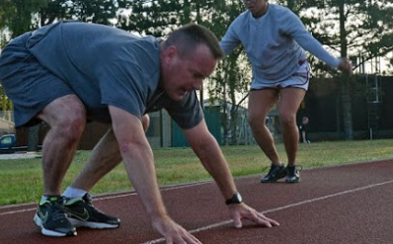
Name a sporting example of an athlete who would use this type of training method?

Advantages:

Disadvantages:

Questions (AoL)/ Plenary (Bronze = Answer 2 questions Silver answer 3 questions Gold = Push yourself and think of more answers you could use to answer the question ask your teacher for an example)

Names 2 sports where this would be a useful training method for an athlete:

Where could you train for this method of training? Is that an advantage of this method?

Give a sporting example of an athlete who would use this type of training?

Principle | Definition | Example
Specificity
Progression
Overload
Reversibility
Frequency
Intensity
Time
Type

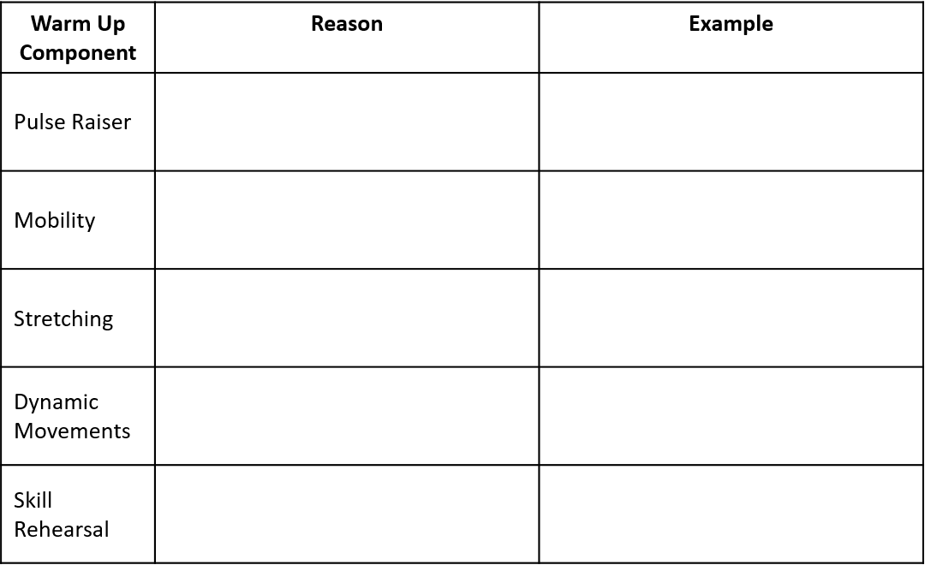

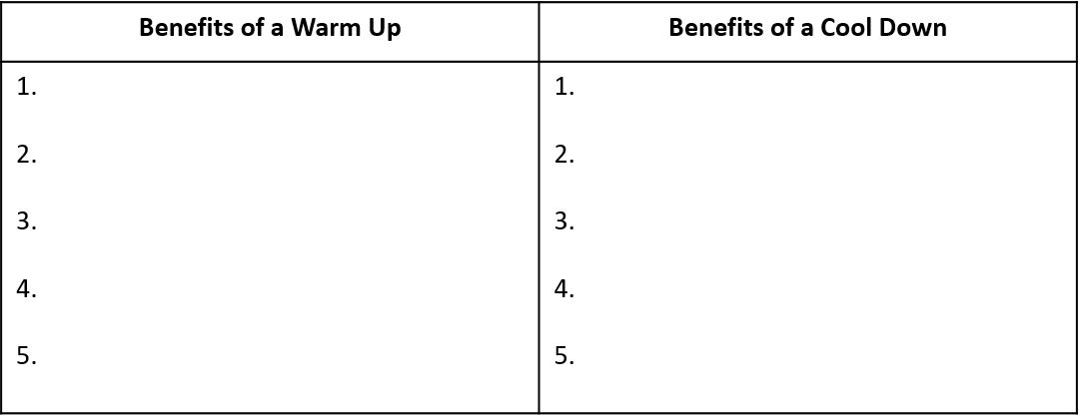
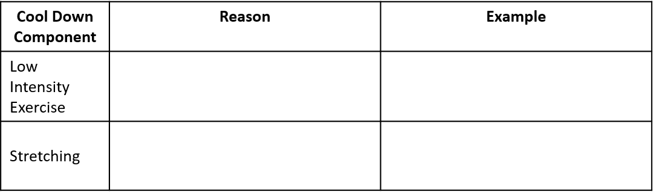
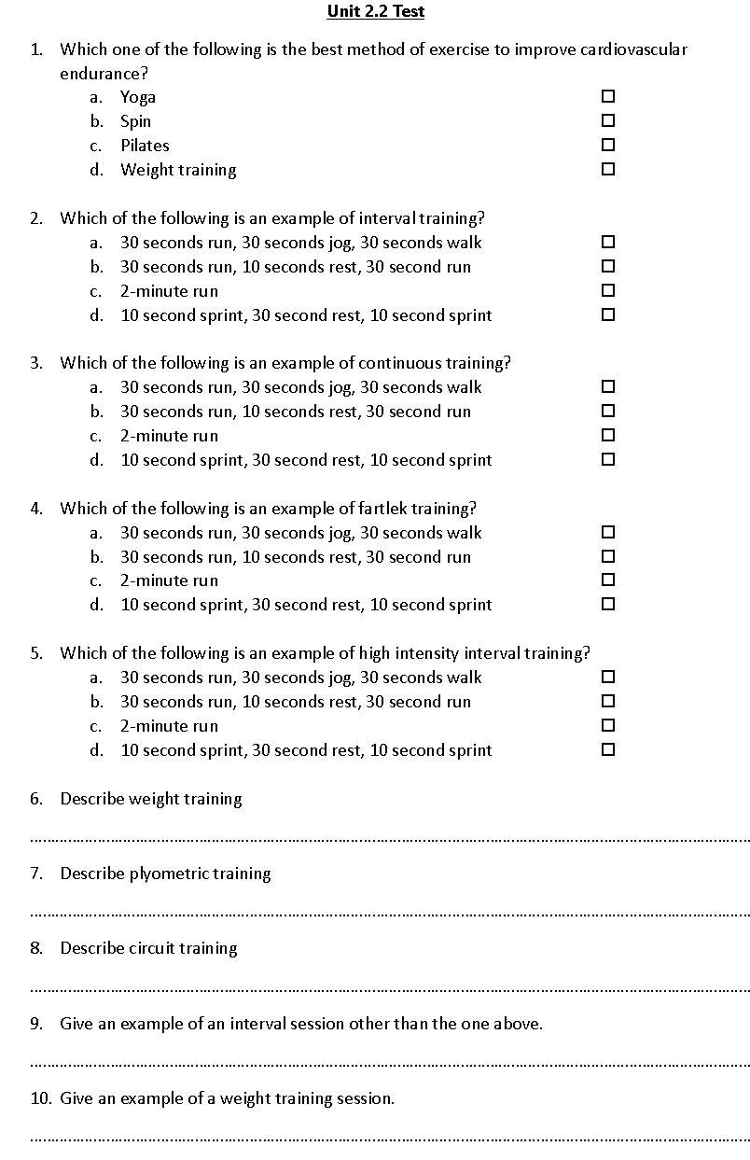

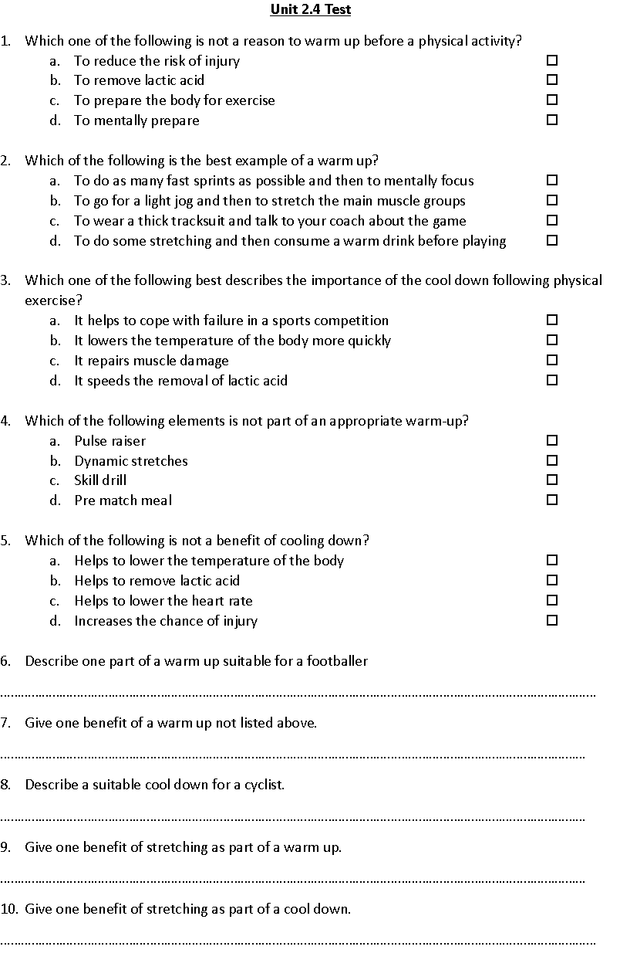

Independent area and extra task/questions:
