Germantown municipal school’s
Healthy January initiatives
Healthy at home
a gmsd health challenge
the fitness warehouse:
a gmsd fitness challenge

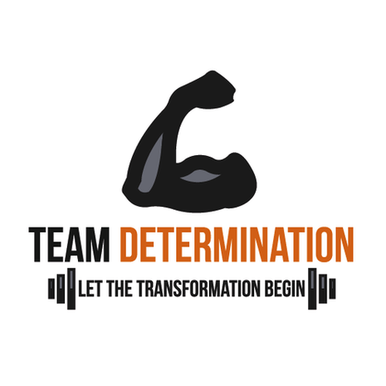

Staff yoga
Register for a chance to get free yoga
The biggest loser
a gmsd weight loss challenge

Additional Resources

Virtual calming room Staff self-care resources

Healthy & Active Germantown Staff Exercise Resources

