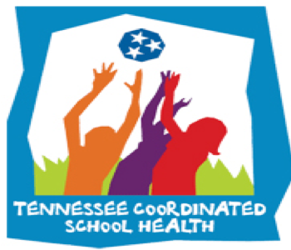

**January Health Observances: Fitness**

**GERMANTOWN MUNICIPAL SCHOOLS**

**CSH NEWSLETTER**

**Initiatives & Offerings:**

-[The Fitness Warehouse](https://www.thephysedexpress.com/the-fitness-warehouse.html) (students & staff)

[-The Biggest Loser Challenge](https://www.thephysedexpress.com/the-biggest-loser.html)

(staff only)

[-The Healthy At-Home Challenge](https://www.thephysedexpress.com/healthy-at-home-program.html)

(students & staff)

[-Learning Labels Nutrition](https://www.thephysedexpress.com/learning-labels.html)

(students)

-[Healthy & Active Germantown](https://www.thephysedexpress.com/staff-wellness.html) Resources for staff

**Important Links & Resources:**

HST Page on my Site: [Click Here](https://coachmartinpe.weebly.com/healthy-school-teams.html)

AFHK SHI Page on my Site: [Click Here](https://coachmartinpe.weebly.com/afhk-school-health-index.html)

-Email me if you have anything health & fitness related taking place that we can highlight!

**HST Important Dates:**

* Activity Tracker Due January 5th
* Team Eval Semester 1 Due January 5th

**Staff Wellness**

**-**[Self-Care resources](https://coachmartinpe.weebly.com/self-care-resources.html) are available for all staff.

-[Staff Exercise](https://coachmartinpe.weebly.com/adult-exercises.html) resources.

-[Staff Wellness](https://coachmartinpe.weebly.com/staff-wellness.html) resources.

-[Virtual Calming Room](https://www.thephysedexpress.com/virtual-calming-room.html) available.

-[15 Second Exercises](https://www.thephysedexpress.com/15-second-workouts.html) available.

**Health Referrals**

Email us with anyone that needs a health referral for vision or hearing.

**COVID-19 INFO:**

-COVID-19 Vaccinations should be available for staff by end of January!

-We’ll work with SCHD to provide info once it becomes available!

January will have us focusing in on fitness & health improvements for students & staff!

-Several initiatives for GMSD will be available. Please share with your students & staff!

Coordinated School Health is based on the Centers for Disease Control 8 component approach to healthier schools:

1. Nutrition Services
2. Physical Ed/Physical Activity
3. Healthy School Environment
4. Counseling and Psychological Services
5. Health Promotion for Staff
6. Parent/Community Involvement
7. Health Services
8. Health Education

**We Want to Hear From YOU!!!**

The Department of Coordinated School Health & GMSD take staff and student well-being very seriously. If you have an idea for an initiative, challenge, or contest that we could implement, then please email me to share your great idea.

-Any idea selected will receive a gift from CSH!!

-Andrew.martin@gmsdk12.org

**8 Components of Coordinated School Health**