Indoor Brain Breaks/Recess – Go Noodle

Go to Website: GoNoodle.com

Sign-up for FREE - Create User Name and Password:

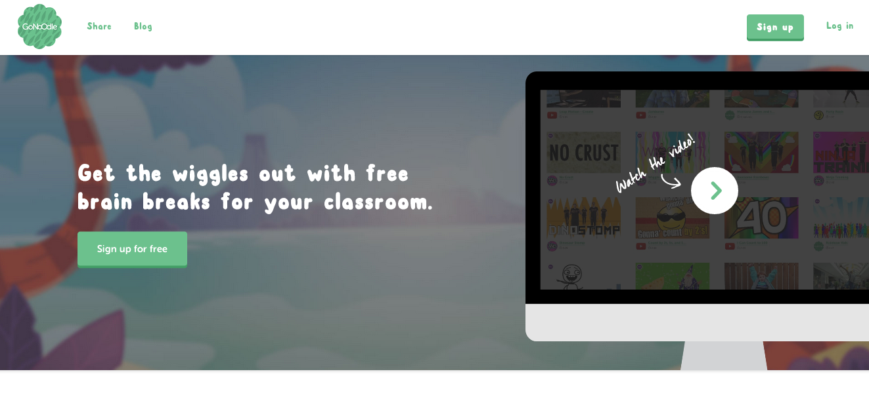
Pick your position:

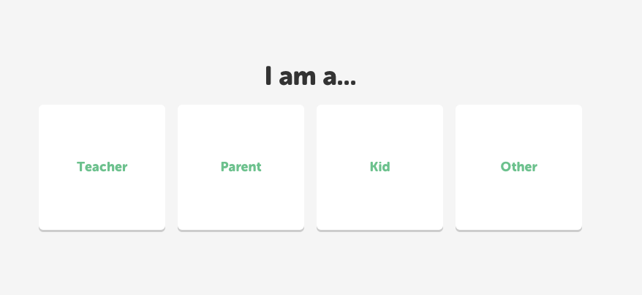

Enter your information:

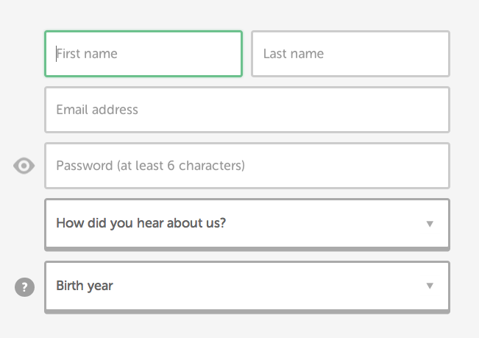

Type the name of your school:

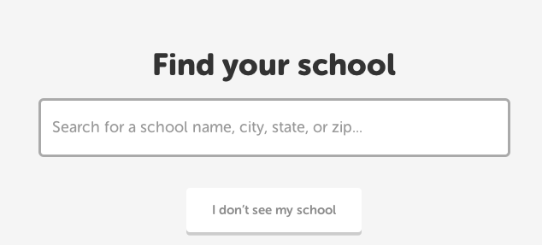

HAVE FUN!

