**ASSASSINATION OF**

**ABRAHAM LINCOLN**

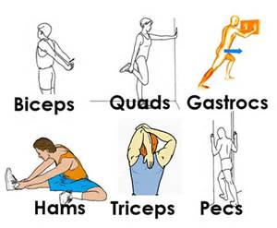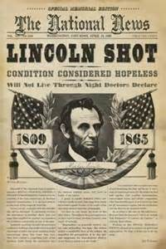

**FLEXIBILITY EXERCISES:**

* **Refer to chart for different exercise to perform**
* **Breathe!**

**FACTS:**

* **Abraham Lincoln was voted into office as our 16th president in March of 1861.**
* **John Wilkes Booth assassinated Lincoln on April 14, 1865, while attending a play called Our American Cousin.**
* **Lincoln died after being shot on April 15, 1865.**

**THE INDUSTRIAL REVOLUTION**

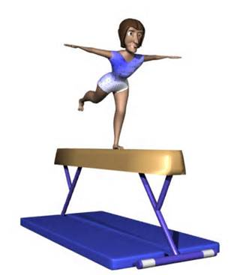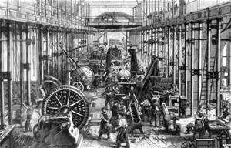

**FACTS:**

* **The Industrial Revolution was the transition to new manufacturing processes in the period from about 1760 to sometime between 1820 and 1840.**
* **This transition included going from hand production methods to machines, new chemical manufacturing and iron production processes, improved efficiency of** [**water power**](http://en.wikipedia.org/wiki/Water_wheel)**, the increasing use of steam power, and the development of** [**machine tools**](http://en.wikipedia.org/wiki/Machine_tool)**.**

**BALANCE BEAM:**

* **Walk on the beam using both feet**
* **Use arms to help you balance**

**SINKING OF TITANIC**

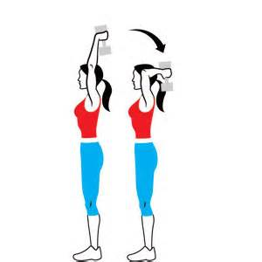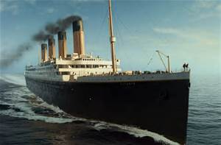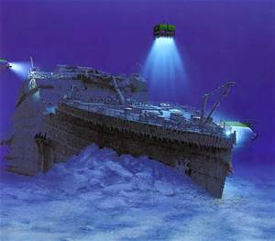

**TRICEPS EXTENSION:**

* **Refer to chart for different exercise to perform**
* **Don’t drop the weights**

**FACTS:**

* ***Titanic*** was a British [passenger liner](http://en.wikipedia.org/wiki/Superliner_%28passenger_ship%29) that [sank](http://en.wikipedia.org/wiki/Sinking_of_the_RMS_Titanic) in the North Atlantic Ocean in the early morning of 15 April 1912 after colliding with an [iceberg](http://en.wikipedia.org/wiki/Iceberg) .
* The sinking of *Titanic* caused the deaths of more than 1,500 people

**THE GREAT DEPRESSION**

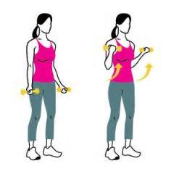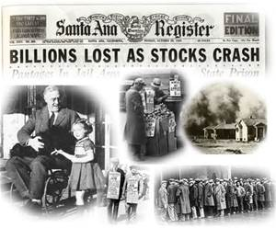

**BICEP CURLS:**

* **Refer to chart for different exercise to perform**
* **Don’t drop the weights**

**FACTS:**

* The **Great Depression** was a severe worldwide [economic depression](http://en.wikipedia.org/wiki/Depression_%28economics%29) in the decade preceding [World War II](http://en.wikipedia.org/wiki/World_War_II).
* The depression originated in the U.S., after the fall in stock prices that began around September 4, 1929, and became worldwide news with the [stock market crash](http://en.wikipedia.org/wiki/Wall_Street_Crash_of_1929) of October 29, 1929 (known as [Black Tuesday](http://en.wikipedia.org/wiki/Black_Tuesday)).

**BARACK OBAMA ELECTED**

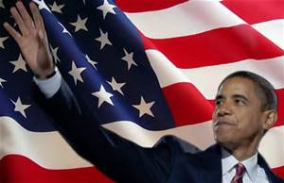

**FACTS:**

* Barack Obama is the [44th](http://en.wikipedia.org/wiki/List_of_Presidents_of_the_United_States) and [current](http://en.wikipedia.org/wiki/Presidency_of_Barack_Obama) [President of the United States](http://en.wikipedia.org/wiki/President_of_the_United_States), and the [first](http://en.wikipedia.org/wiki/List_of_African-American_firsts) [African American](http://en.wikipedia.org/wiki/African_American) to hold the office.
* Obama was [re-elected president](http://en.wikipedia.org/wiki/United_States_presidential_election,_2012) in November 2012, defeating Republican nominee [Mitt Romney](http://en.wikipedia.org/wiki/Mitt_Romney), and was [sworn in for a second term](http://en.wikipedia.org/wiki/Second_inauguration_of_Barack_Obama) on January 20, 2013.

**HEAVY ROPE EXERCISE:**

* **Hold the rope with both hands**
* **Swing the rope going from a low to high position**
* **Alternate hands**

**WORLD WAR I**

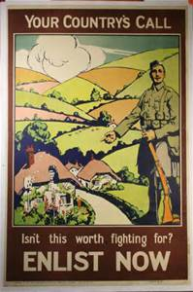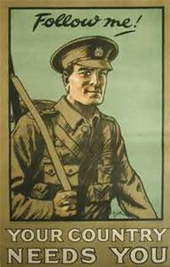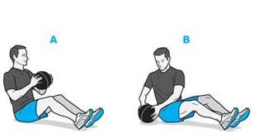

**MEDICINE BALL EXERCISE:**

* **Refer to chart for different exercise to perform**
* **Do not throw the ball**

**FACTS:**

* **The world’s first global conflict, the “Great War” pitted the Central Powers of Germany, Austria-Hungary and the Ottoman Empire against the Allied forces of Great Britain, the United States, France, Russia, Italy and Japan.**
* **The immediate origins of the war, however, lay in the decisions taken by statesmen and generals during the** [**July Crisis of 1914**](http://en.wikipedia.org/wiki/July_Crisis) **caused by the** [**assassination of Archduke Franz Ferdinand**](http://en.wikipedia.org/wiki/Assassination_of_Archduke_Franz_Ferdinand_of_Austria)**.**

**SEPTEMBER 11, 2001**

**NYC**

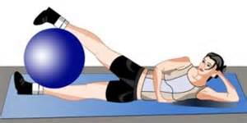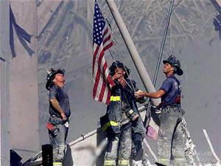

**STABILITY BALL EXERCISES:**

* **Refer to chart for different exercise to perform**
* **Do not bounce the ball**

**FACTS:**

* **9/11 was a series of four coordinated** [**terrorist attacks**](http://en.wikipedia.org/wiki/Terrorist_attack) **launched by the** [**Islamic terrorist**](http://en.wikipedia.org/wiki/Islamic_terrorism) **group** [**al-Qaeda**](http://en.wikipedia.org/wiki/Al-Qaeda) **upon the** [**United States**](http://en.wikipedia.org/wiki/United_States) **in** [**New York City**](http://en.wikipedia.org/wiki/New_York_City) **and the** [**Washington, D.C. metropolitan area**](http://en.wikipedia.org/wiki/Washington_metropolitan_area) **on Tuesday, September 11, 2001. The attacks killed almost 3,000 people.**

**MARTIN LUTHER KING JR.**

**“I HAVE A DREAM” SPEECH**

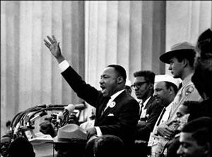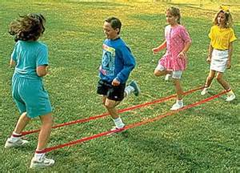

**JUMP BANDS**

* **Attach bands to your legs as well as your partners.**
* **Jump together while staying on your feet**

**FACTS:**

* "**I Have a Dream" is a public speech delivered by American civil rights activist** [**Martin Luther King, Jr.**](http://en.wikipedia.org/wiki/Martin_Luther_King,_Jr.) **on August 28, 1963, in which he calls for an end to** [**racism in the United States**](http://en.wikipedia.org/wiki/Racism_in_the_United_States)**.**
* **Delivered to over 250,000 civil rights supporters from the steps of the** [**Lincoln Memorial**](http://en.wikipedia.org/wiki/Lincoln_Memorial) **during the** [**March on Washington**](http://en.wikipedia.org/wiki/March_on_Washington_for_Jobs_and_Freedom)**, the speech was a defining moment of the** [**American Civil Rights Movement**](http://en.wikipedia.org/wiki/African-American_Civil_Rights_Movement_%281955%E2%80%931968%29)**.**

**JOHN F. KENNEDY**

**ASSASSINATION**

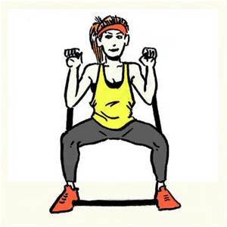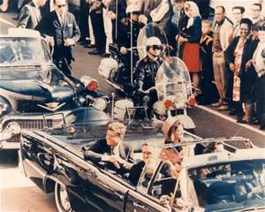

**RESISTANCE BANDS:**

* **Hand bands with both hands**
* **Refer to chart for different exercise to perform**
* **Don’t swing the rope**

**FACTS:**

* [**John Fitzgerald Kennedy**](http://en.wikipedia.org/wiki/John_F._Kennedy)**, the** [**35th**](http://en.wikipedia.org/wiki/List_of_Presidents_of_the_United_States)[**President of the United States**](http://en.wikipedia.org/wiki/President_of_the_United_States)**, was** [**assassinated**](http://en.wikipedia.org/wiki/Assassination) **at 12:30 p.m. on Friday, November 22, 1963, in** [**Dealey Plaza**](http://en.wikipedia.org/wiki/Dealey_Plaza)**,** [**Dallas**](http://en.wikipedia.org/wiki/Dallas)**,** [**Texas**](http://en.wikipedia.org/wiki/Texas)**.**
* **Kennedy was assassinated by** [**Lee Harvey Oswald**](http://en.wikipedia.org/wiki/Lee_Harvey_Oswald)**, acting alone.**

**PEARL HARBOR**

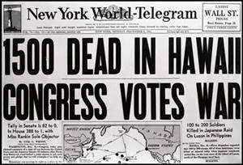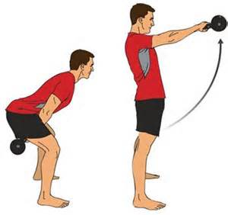

**KETTLE BELL**

* **Hold with both hands**
* **Never drop kettle bell**
* **Move it slowly, don’t swing it**
* **Refer to chart for different exercise to perform**

**FACTS:**

* **The** [**attack on Pearl Harbor**](http://en.wikipedia.org/wiki/Attack_on_Pearl_Harbor) **by the** [**Empire of Japan**](http://en.wikipedia.org/wiki/Empire_of_Japan) **on Sunday, December 7, 1941 brought the** [**United States**](http://en.wikipedia.org/wiki/United_States) **into** [**World War II**](http://en.wikipedia.org/wiki/World_War_II)**.**
* **2,403 Americans were killed as a result of the attacks on Pearl Harbor.**

**THE WRIGHT BROTHERS**

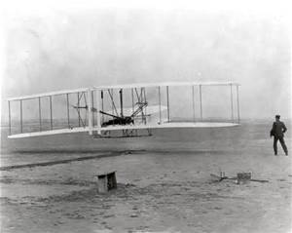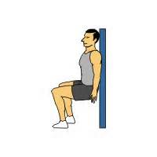

**WALL SITS:**

* **Stand feet should width apart**
* **Bend knees at angle**
* **Keep back flat against wall**
* **Breathe!**

**FACTS:**

* **Orville and Wilbur were two American brothers, inventors, and aviation pioneers who were creditedwith inventing and building the world's first successful** [**airplane**](http://en.wikipedia.org/wiki/Airplane) **and making the first controlled, powered and sustained heavier-than-air** [**human flight**](http://en.wikipedia.org/wiki/Flight#Mechanical)**, on December 17, 1903.**
* **From 1905 to 1907, the brothers developed their** [**flying machine**](http://en.wikipedia.org/wiki/Aircraft) **into the** [**first practical fixed-wing aircraft**](http://en.wikipedia.org/wiki/Wright_Flyer_III)**.**

**THE LOUISIANA PURCHASE**

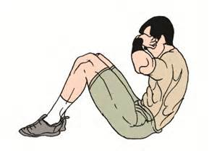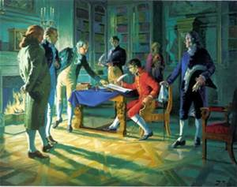

**SIT-UPS:**

* **Start by laying flat on back**
* **Keep feet flat on ground**
* **Curl body up so shoulders are off ground**
* **Return to ground so shoulders touch**

**FACTS:**

* **The Louisiana Purchase was the acquisition by the** [**United States of America**](http://en.wikipedia.org/wiki/United_States_of_America) **in 1803 of 828,000 square miles (2,140,000 km2) of** [**France**](http://en.wikipedia.org/wiki/French_First_Republic)**'s claim to the territory of** [**Louisiana**](http://en.wikipedia.org/wiki/Louisiana_%28New_France%29)**.**
* **The purchase of the territory of Louisiana took place during the presidency of** [**Thomas Jefferson**](http://en.wikipedia.org/wiki/Thomas_Jefferson)**.**
* **The Louisiana territory encompassed all or part of 15 present** [**U.S. states**](http://en.wikipedia.org/wiki/U.S._state)**.**

**CIVIL WAR**

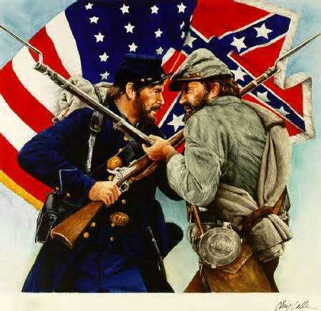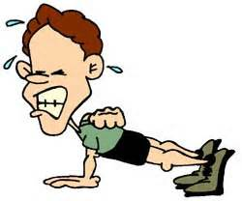

**FACTS:**

* **The American Civil War, also known as the War Between the States, or simply the Civil War in the** [**United States**](http://en.wikipedia.org/wiki/United_States) **(see** [**naming**](http://en.wikipedia.org/wiki/Naming_the_American_Civil_War)**), was a** [**civil war**](http://en.wikipedia.org/wiki/Civil_war) **fought from 1861 to 1865, after seven Southern** [**slave states**](http://en.wikipedia.org/wiki/Slave_states) **declared their** [**secession**](http://en.wikipedia.org/wiki/Secession) **and formed the** [**Confederate States of America**](http://en.wikipedia.org/wiki/Confederate_States_of_America)**.**
* **Abraham Lincoln was president during the Civil War.**

**PUSH-UPS:**

* **Place hands shoulder width apart on ground**
* **Keep back straight and flat**
* **Bend elbows when going down**
* **Straighten out elbows when coming up**

**AMERICAN REVOLUTION**

**FACTS:**

* **The American Revolution was a political upheaval that took place between 1765 and 1783 during which the** [**Thirteen American Colonies**](http://en.wikipedia.org/wiki/Thirteen_Colonies) **broke from the** [**British Empire**](http://en.wikipedia.org/wiki/British_Empire) **and formed an independent nation, the** [**United States of America**](http://en.wikipedia.org/wiki/United_States)**.**
* **The American Revolution was the result of a series of social, political, and intellectual transformations in American society.**

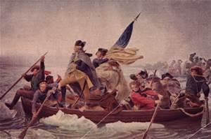

**JUMP ROPE:**

* **Hold one handle in each hand.**
* **Start Rope behind body**
* **Swing rope over head**
* **Jump when rope is at eye level**

