HEALTH-RELATED PHYSICAL ACTIVITIES

20-Second Interval Training
- Objective: Aerobic endurance; muscular strength & endurance; cooperation.
- Equipment: Jump ropes
- The students form groups of three. Each group has a jump rope.
- On the signal to begin, student 1 jumps rope, student 2 does push-ups, and student 3 rests.
- After 20 seconds the students rotate (1 does push-ups, 2 rests, and 3 jumps rope).
- They continue through this circuit for the allotted time.
- You can change the 3 activities every 2 or three times through. Try crunches, squats, jumping jacks, etc.

Aces Wild
- Equipment: Small deck of cards (only include 1 or 2 of each suit), 1 Aces Wild task card for each group, Frisbee to keep cards organized
- 3-5 students per group
- Groups find self safe space
- Students take turns choosing one card from deck
- When a card is chosen students match it with Task Card and perform associated activity
- Card # = reps of activity
- Aces are “Wild”
- Variation; Include sport and dance skill

Add a Fitness Trick (Chip Candy)
- The first person in the group does a fitness activity…one push-up.
- The second person does one push-up and adds a new activity…one jumping jack. The next person does a push-up, a jumping jack and adds their own.
- This continues until the group forgets the order, or can’t remember all of the activities, at which time they give up and start over.

Aerobics
Teach the students the following basic steps. After the students are familiar with the steps, the aerobic program can be set up either by the teacher leading the class with repetitions of the steps performing 8-16 reps of each step for 8-10 min. Or have three to four students at each station. OR the teacher sets up stations throughout the area with each station representing a different aerobic step. Three or four students are at each station, the teacher plays music and the students perform the step until the music stops, then the students move to the next station (every 30-45 seconds)
Basic aerobic steps:
- Stride Jump- stand with one foot in front of the other; jump up and switch feet; land with the other foot in front; repeat
- Elbow to Knee- lift the R knee and touch it with the L elbow; then lift the L knee and touch it with R elbow; repeat
- Bounce and Twist- bounce up and down with feet together, twisting each time you land; repeat
- Downhill Skier- with feet together, jump side to side, repeat
- Superball-with feet together, bounce straight up and down, repeat
- Knee Slap- lift R knee, touching it with both hands; lift L knee touching it with both hands, repeat
- Pendulum Swing- swing your legs from side to side, landing on one foot at a time, repeat
- Lunge- start with both feet together; jump to the R, landing with the R foot forward and the L foot extended back; jump to the L, landing with the L foot forward and the R foot extended back, repeat
- Leg Kicks- bounce up and down; alternate kicking your R leg out in front of you, then your L leg
- Jumping Jacks
- Run in Place
Combination steps are made up by combining two or more basic steps together for 4, 8, 26, or 32 two counts
For example:
4 jumping jacks and 8 knee slaps; repeat
8 pendulum swings and 8 downhill skiers, repeat
4 elbow to knee and 4 lunge steps
32 running it place steps and 16 bounce and twist, repeat
8 superballs and 16 stride jumps, repeat

Aerobic Bowling
- You need a pin and ball for each group of 3-4 students
- Set the pin 15’ to 30’ from the bowlers depending on the age group
- One member will stand 2’ behind the pin
- On the teacher’s signal, all students begin
- The first bowler rolls the ball at the pin
- If the pin is knocked over or off the line it is the bowlers responsibility to set the pin back up properly, and then replaces the person behind the pin
- Person behind the pin retrieves the ball and runs it back to give to the next person in line
- Continue this rotation for a set period of time and see how many times each group can hit the pin

Aerobic Circle
- Equipment, music with a strong 4/4 beat
- Students form 2 circles facing in arms length apart, one with PE teacher, one with PE assistant
- Tell students that if they want to they can take a turn being the leader for 16 beats
- After 16 they get out of the middle and someone else can lead
- Examples of aerobic activities:
  - Jog, clapping hands overhead, behind, in front, under right leg, under left leg
  - Sailor jumps; jump with one leg forward and the other back while swinging arms in time to music
  - Jumping jacks
  - Combo Jacks; alternating jumping jacks and sailor jumps
  - Side kicks; kick legs from side to side and wave hands
  - Seat kicks, jump up and kick your buttocks with your heels
  - Mule kicks, place hands on floor, kick legs straight behind
  - Front kicks, kick legs out front
  - Skier kick; jump from side to side
  - Bell jumps; jump forward and back
  - X-jumps- jump to cross and uncross legs
  - Pantomime jumping rope
  - Cool dancing

Aerobic Conga Line
- Students stand in groups of six.
- When the music starts, the person in front of the line moves in a “wild and crazy” aerobic kind of way.
- The others will follow the moving pattern of the leader.
- On teacher signal (Switch/change leader) the leader goes to the back of the line and a new leader takes over.
- Continue until all students have a chance to be the leader.

AEROBIC NUMBERS
- Make a set of cards approximately four inches square with numbers on them.
- Have four cards for each number such as four number ones.
- Divide the group into small groups of 3 or 4 and assign them a number that matches the cards you are using for the game.
- Place the number cards face down about 60 to 80 feet away from the small groups.
- On the signal one person from the group may come to the numbers, turn ONE up and look at it. If it matches the number of his/her group they take it back to their line. If it does not match they turn it face down and return to their line, and the next person takes a turn. This continues until the groups find all four of the number cards that match their number.
- Having a point where the returning player crosses that allows the next person to start helps to speed up the activity and cuts down on just sitting and waiting. Keep the groups to 3 or 4.
- Be creative and come up with some excellent math relays with these same cards. Make flash cards with problems on them and lines keep looking for the right digits to for the answers. Go for it!

AEROBIC SCRABBLE
- Look on the front of a SCRABBLE board and it will list how many of each letter is used in the game. Make a set of letter cards just like the number cards described in AEROBIC NUMBERS.
- The group sizes should be about the same and the movement to get the letters will be as it is in AEROBIC NUMBERS. Place a mark under M, W, N, and Z so the players can tell them apart.
- Use flash cards with words to spell or tell the group they are to spell a word with a certain number of letters. When spelling words allow the group to have no more than 2 letters more than what you are looking for.
- Players may take one letter back at a time to change it for a new letter. Players must bring back the first letter they pick up.
- Traded and all other letters in the holding area should be face down.

Agility Ladder Challenge
Suggested Grade Level: K-2
- Materials Needed: Using floor tape, create six agility ladders around the outside of the basketball courts. Each ladder is about 12 feet long with 10 rungs. Two ladders are taped to the floor on each sideline and one ladder is taped on each end line. Note: these ladders are made with strips of tape attached to the floor. Create station cards to attach to a cone at each ladder. These cards should include a picture of the activity and a fun name of the
- Divide the class equally depending upon the number of stations you have (keep numbers to 2 or 3) and assign them a starting station.
- Moving in a clockwise rotation around the room, have students read the card and perform that skill through the agility ladder.
- When they have finished have the group move to the next ladder, read the card and do the next skill through that particular ladder.
- Continue around the room until they have finished all stations.
- Rules: Wait until the player in front of you is halfway through the ladder before you "GO." Do not pass!
- Station Cards:
  - Kangaroo Jump - jump with both feet in each ladder space.
  - Flamingo Hop - hop on the same foot through the ladder.
  - Hip Hop - hop on one foot into the first ladder space, hop on the other into the next space - alternate feet.
  - Slide - facing sideways move leading foot into a space, the second foot follows into the same space then move leading foot into the next space.
  - Hopscotch - hop on one foot into the first ladder space, in next ladder space land on two feet spread apart (straddle), hop on one foot in the next space. Repeat this hop/jump pattern until you complete the ladder.
  - Horse - use a gallop - place leading foot in first space, follow with the other foot into the same space.
- This idea brings agility ladders to the lowest level by using pictures instead of words. Even non-readers can follow along!
Variations:
- This can also be done like circuit training. A squad starts at a ladder and taking turns goes through the ladder using the station card as a guide. When the music stops, the whole group jogs clockwise to the next ladder, reads the card, and begins performing the skill through the ladder. Continue until all groups have performed all skills.
- Once they have learned the different ways to move through the agility ladder, it can be an easy warm up. They can choose how they would like to move through the ladder as they jog clockwise around the gym.
- This activity can also be done outside using chalk to make the agility ladders.
Assessment Ideas:
- A great way to assess jumping and hopping skills. Have one station designated whatever skill you wish to assess and check students off as they come through.
- Have students put together repeatable patterns using different movement concepts and locomotor skills or jump patterns.

Alien Tag
- Play on basketball court or designated area
- You start this tag game with two people as the Alien. They have to lock their arms together and cannot come apart.
- Once the Alien tags someone, they become part of the Alien and add to the end. The Alien becomes bigger and bigger.
- Only the ends of the alien can tag someone, so players can run through the alien, if possible without getting tagged
- Once the alien group has 12 students, the alien can sub-divide into two alien groups

Alligator Alley
Suggested Grade Level: 1-2
- 30-40 (or more) hoops and/or polyspots; drum or other signal; cones to make end lines in a rectangular shape, if your playing area does not have lines on the floor to use; 4 medium sized foam balls.
- As a good "instant activity" as well as review of the types of jumps, have each student get one hoop, place it in a self-space on the floor, and stand in the middle of the hoop.
- At your (drum) signal, call out a type of jump (hop, for example); students must then hop out of the hoop and then hop back into the hoop.
- No matter what type of jump they perform, they should always end up back in the middle of the hoop.
- If need be, demonstrate each type of jump before calling it out; give students the chance to practice each of the jumps, such as two-feet out and two-feet back in; from one-foot to two-feet and back in the hoop using one-foot; and even leaping over their hoop (don't have to land in the hoop for this one).
- After practicing the jumps, call students over into a group. Explain they will now be getting to use these jumps in a "game" situation, and that you will need to first show them how to play (use students to demonstrate as needed).
- First scatter all of the hoops around the playing area so that each hoop is close enough to another so that for students to jump from one to the other. (You may need to use only half of your gym or playing area, for example, in order to do this.)
- Four students will be chosen to be the "alligators"; these students will use the foam balls in order to gently tag students.
- All other students will be spread out on different end lines, so they are not close to other students.
- On your start signal, students will jump from the end line to a hoop, then proceed to jump from one hoop to another.
- Their goal is to reach a different end line without getting tagged by the "alligators" (you can choose to also have alligators jump in order to move).
- Alligators may only tag someone that does not have both feet in a hoop. When both feet are in a hoop, a student is "safe"; only one person is allowed in a hoop at a time.
- Taggers may not "guard" a hoop, waiting for a student to jump out; conversely, a student may not stay in a hoop for more than a count of ten.
- When tagged by an alligator, the student must go back to their beginning line and start once again. They can earn a "point" if they make it safely to a different end line, if desired -- they can see how many points they can earn in each "round" (they just begin again from this new end line).
- Periodically stop the game; allow each tagger to give the ball to a new student, and everyone begins again at an end line.
- During the game, you can specify different types of jumps for the students to do, or allow them to choose their own jumps.
Variations:
- Students who do not jump as well have the choice to be given "swamp shoes" that allows them one step between the hoops before jumping to a new hoop.
- For an added challenge, give older students not only a jump to use in and out of their hoop, but also give them a direction to jump in (i.e. forward, backward, right, or left).

All on One Side
- Equipment; a balloon or beach ball for each team, nets or ropes as nets, or cones
- Students in groups of 5-6
- Whole team on one side of net keep the ball in air while passing overhead to net, under net, to other end line without dropping the ball or missing a person in the group
- One lap is from one end line to the other and back without dropping the ball or missing a person in the group without dropping the ball or missing a person in the group
- Variation; team only go half court and back; use different kind of passes, different parts of the body

Alphabet Hustle Erika Buscaglia
Grades K-2
- 4 buckets, 26 cones, 26 polyspots (A-Z) 52 letter cards (A-Z, 2 each)
- Scatter polyspots, letters up on the floor. Place a cone over the spot covering the letter
- Place buckets in four corners of the area and randomly place equal number of letter cards in each bucket.
- On the signal, students run and get 1 letter out of a bucket and then attempt to find the same letter by lifting up a cone. If no match, they continue moving from cone to cone until they find a match
- Clean Up: students go to one cone at a time, lay the cone on its side, pick up 2 letters and bring to teacher. Students must tell the letter and a word that begins with that letter

ALPHABET SOUP
- The entire alphabet is scattered around the playing area. The task is not very complex: Very simply - find the fastest way to touch the alphabet in order.
- Rules:
- Each player must touch at least one letter
- No one may touch 2 letters in a row.
- The alphabet must be touched in order (A-Z).
- Variations:
- How fast can the group touch all the letters from Z-A?
- The letters must be touched by 2 players at a time, in order, and no player may touch two letters in a row.
- Use the regular rules, but blindfold one or more players

Alphabet Spot Locomotor Fitness (Gregg Montgomery)
- Using the Alphabet Spot Markers scattered on the floor have the students perform each locomotor movement by moving in that manner from one Alphabet Spot to the next, spelling the locomotor movement word as they travel from letter to letter.
- Example:
  - #1 WALK Proceed behind a partner toward the letter “W” by Walking to the “W” then to the letter “A” then “L” then “K” then students say WALK and spell it W- A-L- K
  - #2 SKIP to the “S” then to the K” then to the “I’ Then to the “P” then spell SKIP. S-K-I- P
LOCOMOTOR MOVEMENTS
- Walk
- Skip
- Hop
- Gallop
- Jump
- Leap
- Jog
- Run
- Power-Walk
- Slide

Alphabet Tag Grades K-2
- Select 2-3 students to be taggers and wear pinnies
- When a student is tagged, he/she freezes in the shape of a letter. They must stay frozen until an unfrozen student comes by and correctly guesses the letter
- Frozen students may not form letters that require them to lay on the floor
- Taggers may not tag students who are trying to guess a letter
- After 2 minutes, switch taggers

ALPHABET WARM-UP
A Alternate stride jumps
B Balance in the airplane position on each foot 10 seconds
C Cardio exercise of your choice
D Dance
E Exercise your back. Do cat pose stretch 10 times.
F Fast feet knee slaps 20 times
G Strengthen Gluteal muscles with Donkey Kicks 10 times
H Hamstring stretch (+20 seconds each leg)
I Inchworm walk
J 20 Jumping Jacks
K Karaoke down and back length of gym
L 10 Leg Lifts in forward or slide direction
M 20 Mountain climbers
N High Knee lifts (+10 each leg)
O Ohmmmm…Your favorite yoga pose for 20 seconds
P At least 5 really good Push-ups
Q Quick skip across the room
R Run safely for a few moments
S 10 really good Sit-ups
T Touch your toes in the sitting position for at least 20 seconds
U Under the knee clap for 20 times
V Vertical jump (beat your personal record!)
W Wall sit for 20 seconds
X Sky write letter X by Crossing the midline or pretend to juggle
Y Your choice
Z Zoo animal walks of your choice in a zig-zag direction

ANIMAL WARM-UP: VEHICLE WARM-UP:
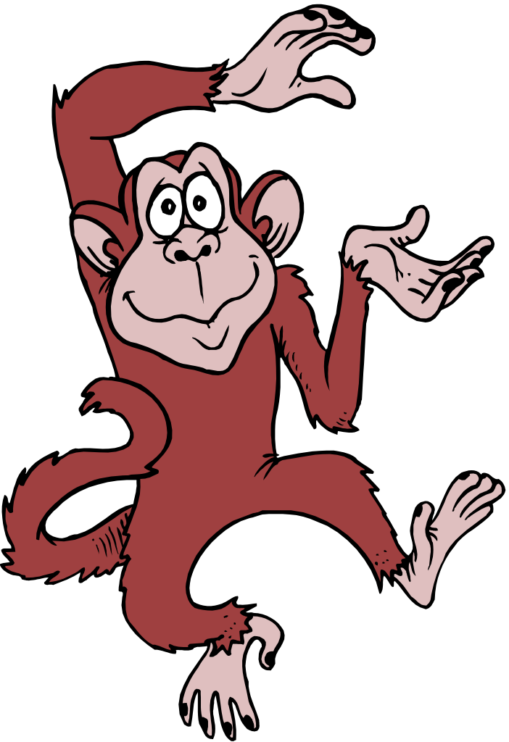MONKEY CLIMB 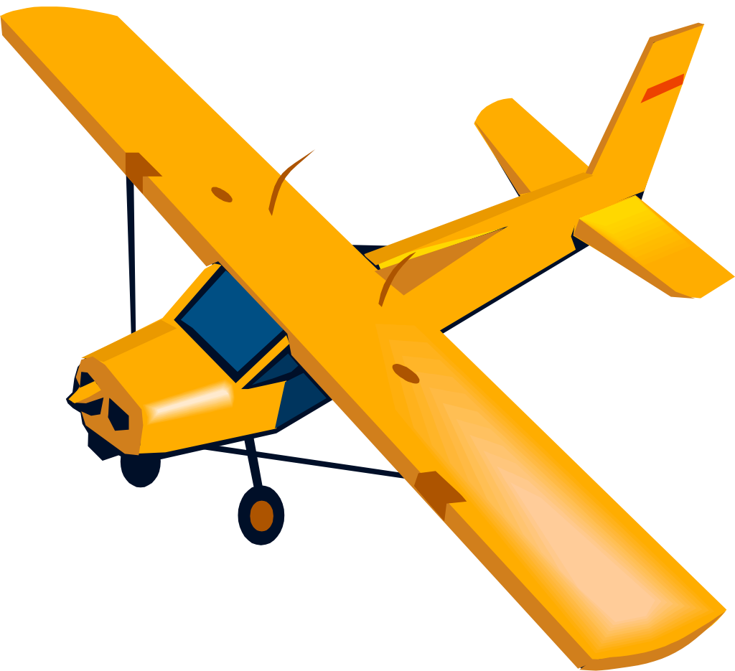 AIRPLANE
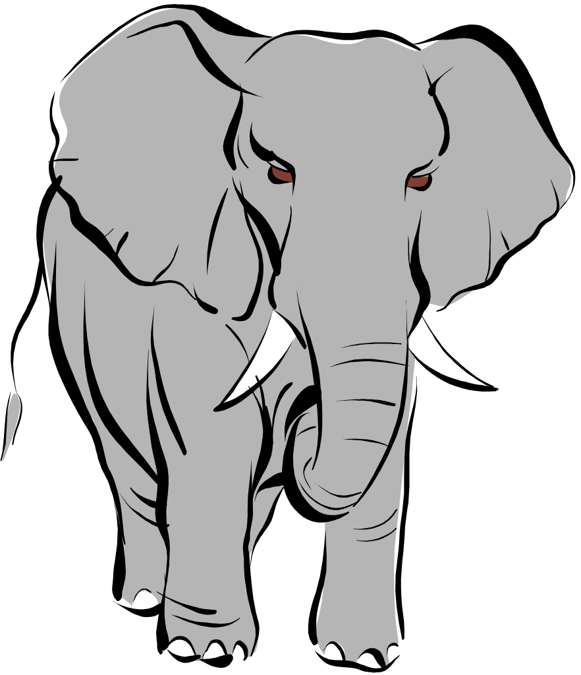ELEPHANT WALK 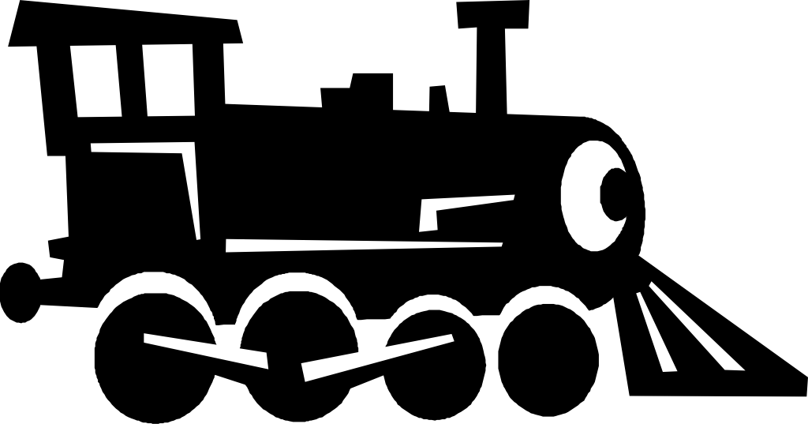 TRAIN
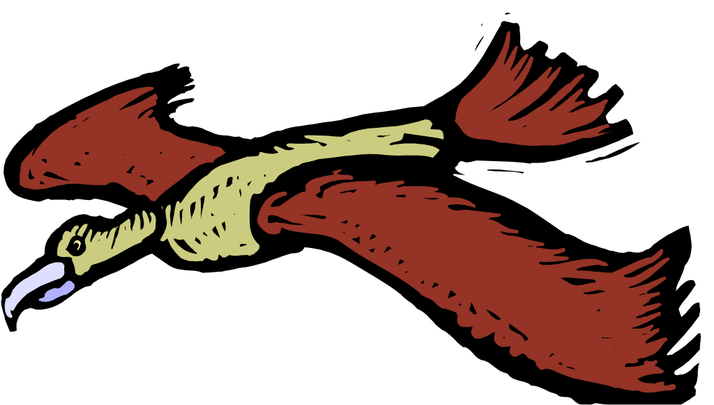EAGLE SOAR CAR
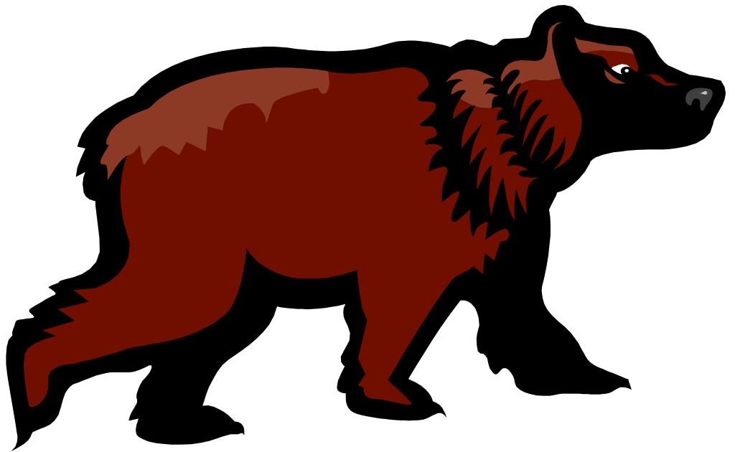BEAR WALK 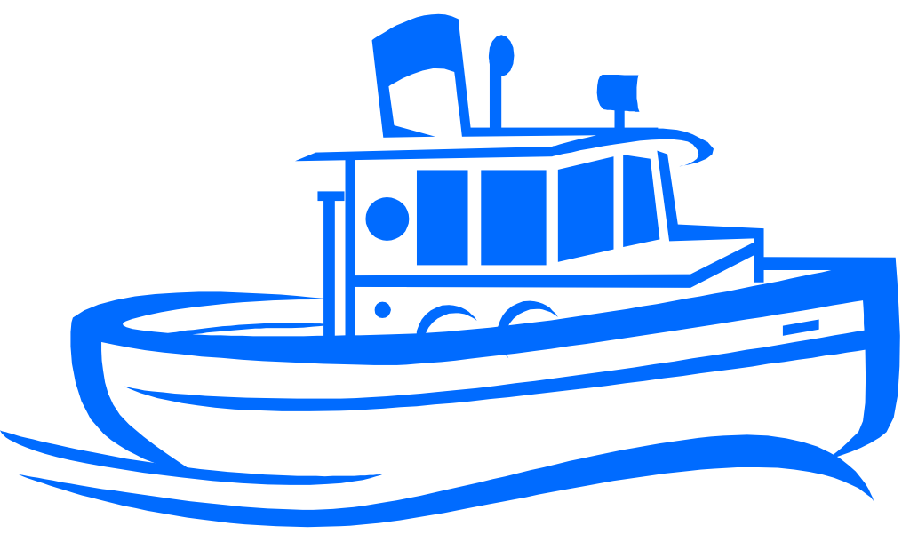 BOAT
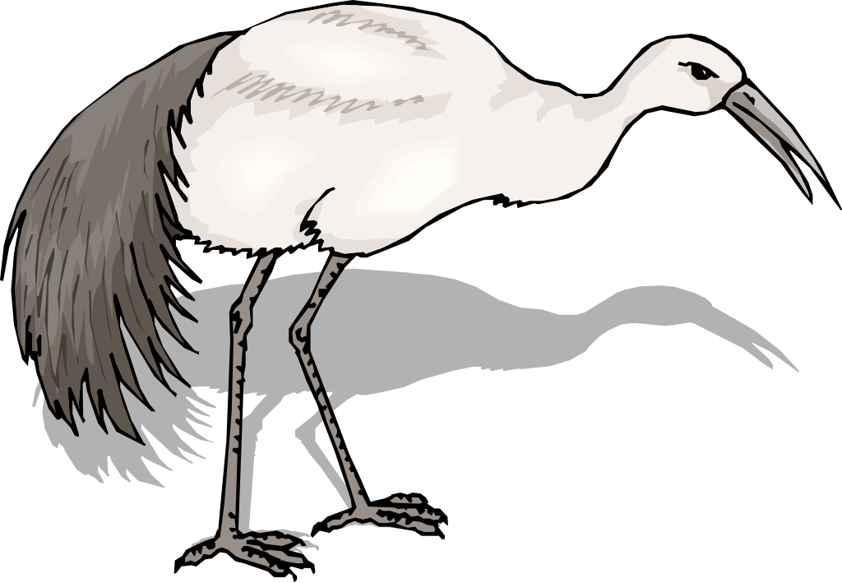CRANE SKIP ROCKET
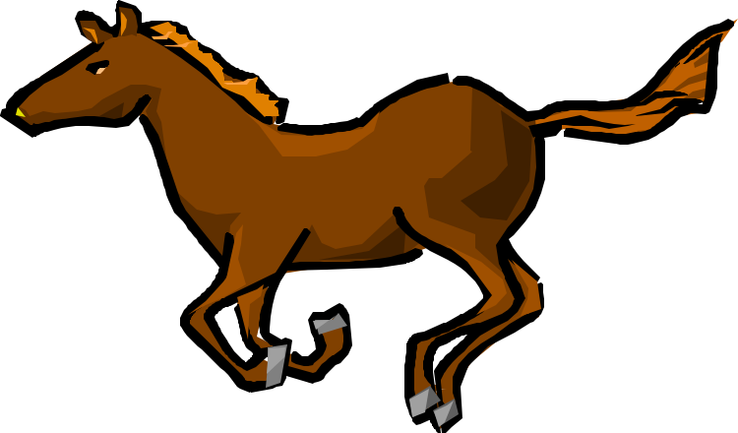HORSE GALLOP 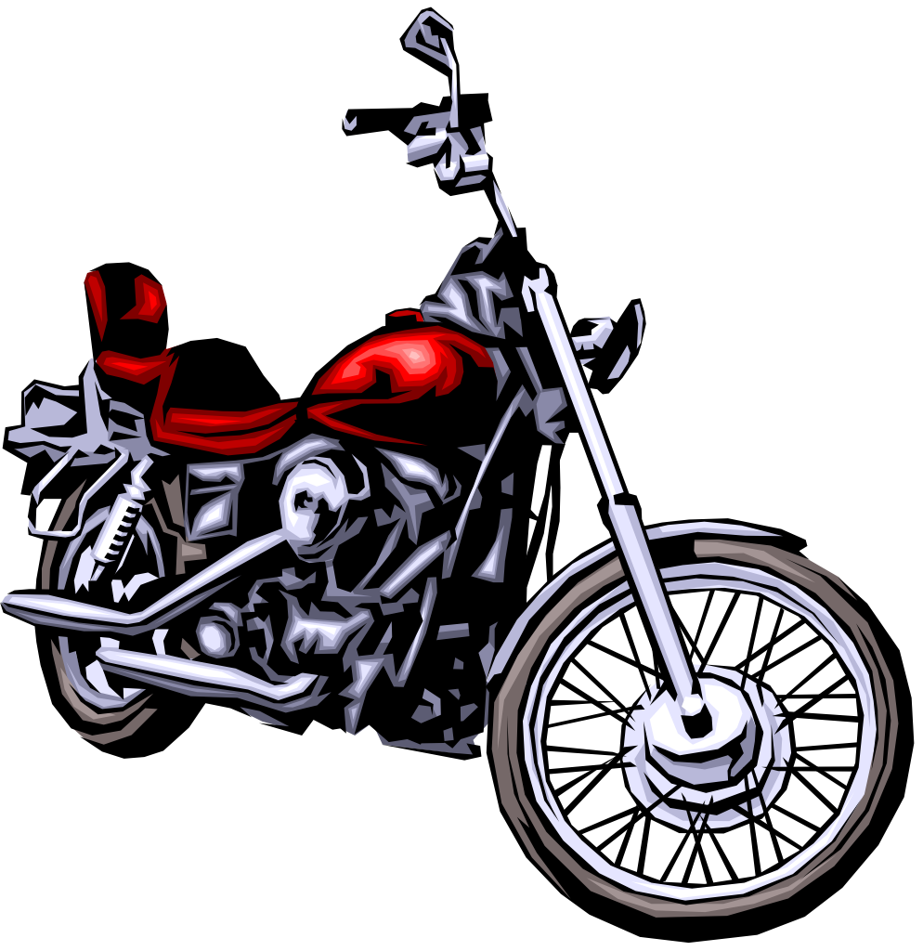 MOTORCYCLE

BODY WARM-UP:
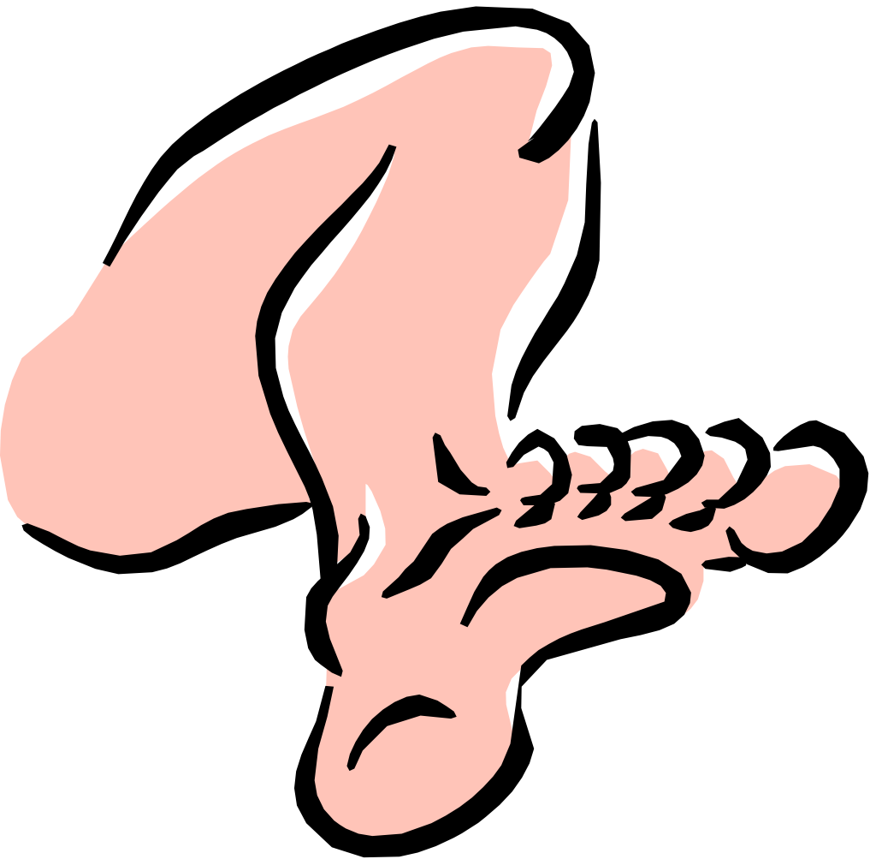LEGS
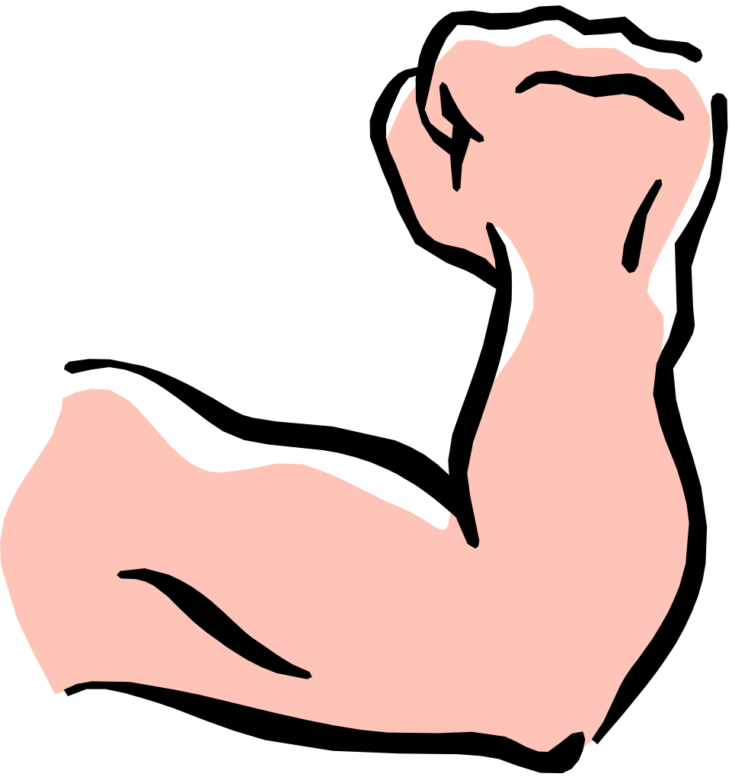ARMS
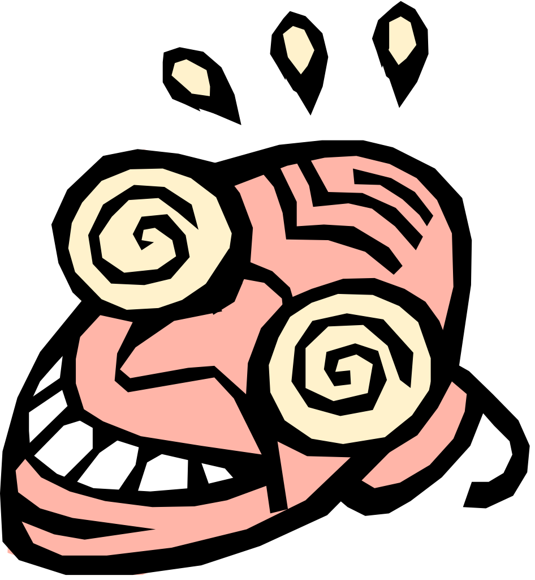HEAD
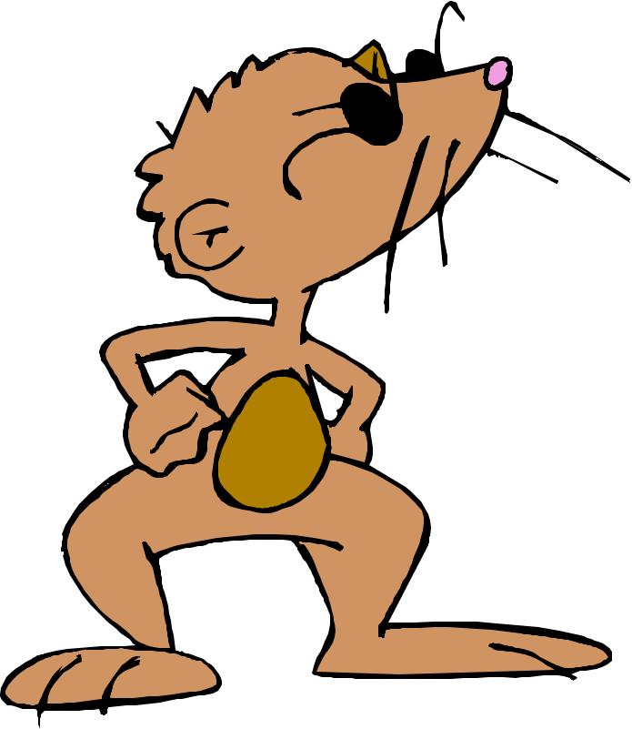HIPS
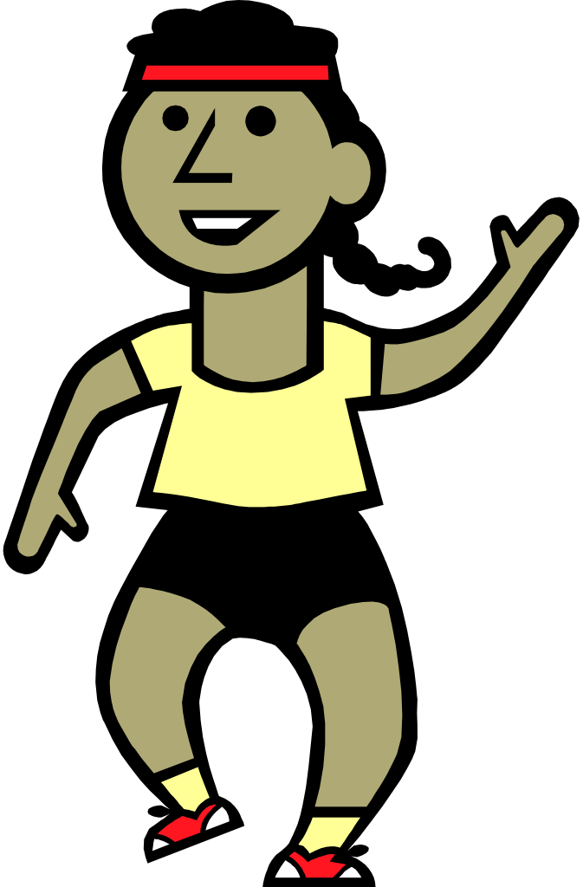BODY
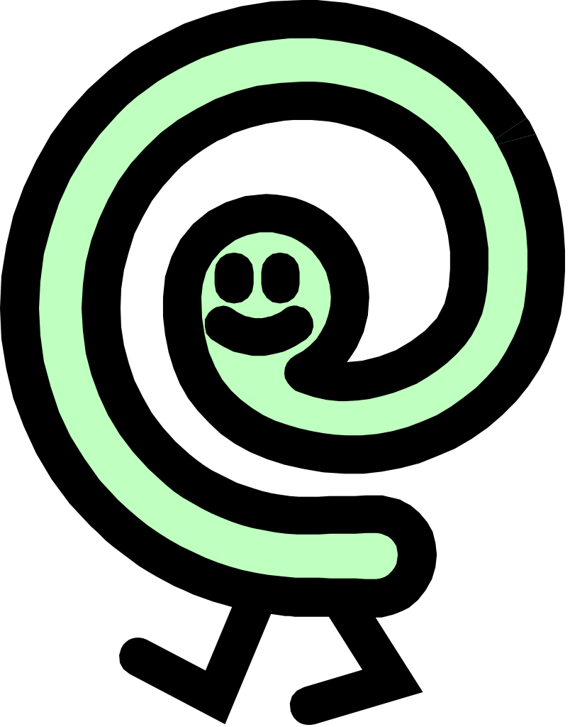FREE CHOICE

Arch & Roll Relay
- Several groups of 5-10 in single file with the student in the back holding a ball
- On signal, the back student rolls the ball forward between the legs of teammates
- Students help hit the ball forward to the front student
- When the front student receives the ball, the back student moves up to become the new front person while the ball is being passed overhead back to the new back student
- Continue until the original back student is back at the end of the line for the third time at which point the team sits down

Awesome Add-Ons
- Students walk, jog, gallop, skip, etc (teacher decides) around area (20 x 20)
- Students begin when teacher gives signal (music, whistle, GO, etc)
- When music stops (or teacher’s second signal) the students stop and perform a designated skill or exercise. For example, touch the ground, change directions, and turn around, or ten jumping jacks.
- Each time the teacher signals for students to stop a new skill will be added on
- Students must do all the other skills first before adding the new skill

Back to Back Tag
- Choose one student per ten to be it and give them on object to hold to designate them as taggers
- Play tag
- In order to be safe from taggers you must stand back to back with another student
- Can only stay back to back for 3 seconds
- When tagged switch places with the tagger or go to sideline to perform exercise/routine and rejoin game

Badminton Tag
- Boundary is a basketball court or approximate size
- All students have 1 racket and 1 shuttlecock
- Choose 2 taggers to start in the middle ( can use vest to identify )
- Game is played by all students balancing the shuttlecock on their rackets while staying away from taggers. If tagged or the shuttlecock falls off the racket, the student must stop and perform 10 jumping jacks before coming back into play
- Select new taggers

Balloon Blitz
    - Equipment- noodles (1/student), 2 sets of pinnies, 20-25 balloons, cones to separate the goalies from the play area, 2 containers to hold balloons that have scored
    - Object of the game is for each team to score the most point by hitting balloons with their noodles to their own goalies. Only the noodles can be used to hit the balloons
    - Divide the playing area in half and assign half the class to each end into a safe area-have each team select their two goalies (must be a male and female).Goalies must be behind their goal line
    - Place all the balloons in the center of the playing area
    - On signal the students begin hitting the balloons with their noodles to their goalies
    - Because goalies have to stay behind the goal line, the balloon must clearly cross over the goal line before the goalie can put it in their team’s bucket

Bandana Tag (from Jim Deline)
Equipment: One or two bandanas per student
Skills: Dodging, Fleeing, Locomotor Patterns
Organization: Random (everyone must remain inside the boundaries)
Activity:
Each student will get one bandana.
- The bandana will be tucked into the student’s pants like they were tucking in a shirt. Most of the bandana should be visible and it must be tucked in on the side of the body near the hip. If the student is wearing a long shirt, they should tuck the shirt in where the bandana is located for safety reasons.
- When the game begins, all students will try to pull off other player’s bandanas while avoiding having their bags taken. If a bandana is pulled out, it will be dropped on the floor and play will continue.
- The person who had the bandana pulled will pick it up and move to outland (somewhere outside the playing area). Once in outland, the student will perform a physical activity that has been designated by the teacher before they may rejoin the game.
- Adaptations/Tips:
  - Have each participant start with two bandanas, as long as one bandana is still tucked in, the player is in the game
  - Have the students travel using different locomotor patterns while playing a round
- Remind students that they may NOT hold their own bandana, they may NOT dive or slide on the floor, and they should avoid grabbing the opponent’s clothing

Bandana Team Tag
Equipment: At least two different colored bandanas, enough of the bandanas for all participants
Skills: Dodging, Fleeing, Locomotor Patterns
Organization: Random (everyone must remain inside the boundaries)
- Each student will be on one of two teams depending on the color bandana that he/she collects. The bandana will be tucked in on the side of the waist.
- The objective is to try and pull the bandanas of the opposing team. If a bandana is pulled, it should be dropped and play continues.
- The person who had the bandana pulled will pick it up and move to outland (somewhere outside the playing area). Once in outland, the student will perform a physical activity that has been designated by the teacher before they may rejoin the game.
- Adaptations/Tips:
- Have each participant start with two bandanas, if one bag is still tucked in, the player is in the game
- Have the students travel using different locomotor patterns while playing a round
- Introduce a third colored bandana to make the game more interesting/challenging
- Remind students that they may NOT hold their own bag, they may NOT dive or slide on the floor, and they should avoid grabbing the opponent’s clothing

Base Runner Erika Buscaglia
- Grades 3 & up
- Foam tennis balls (Or similar type balls) and one poly spots
- Place 2 poly spots about 10 feet apart on the floor.
- Students are in groups of 3. 2 students stand on the spots. These are the base players. Place 2 other spots parallel to the original spots. These spots are for the 3rd student who is the runner
- The base players toss the ball back and forth 10 times
- The base runner tries run between their bases as many times as possible before the throwers complete their 10 throws
- Switch runners after 10 throws

Basketball Square Dancing
- Each student has a basketball and will dribble the ball to various square dance calls.
- Students have partners and are in groups of 6-8. Examples of calls:
- Forward & back
- Circle right & left
- Do-si-do
- Swing- hook left elbows, dribble with right then reverse
- Promenade; standing side by side with a partner, dribble the ball around the square
- Add other calls, be creative!

Batman
- Obtain a pre recorded version of the 1960‟s Batman theme
- Designate one area as the bat cave where the children start the warm up from and they wait for the start cue.
- Teacher says, “To the bat mobile let’s go!” the students run out to the bat cave and onto a line getting into their “cars”.
- The teacher says “atomic batteries to power, turbines to speed. Roger ready to move out.” The students start their cars and do arms circles to rev up their engines.
- The tune of the music changes and they start driving their cars all over Gotham City (Pretend to drive a car around the gym staying on the lines). After this point of the music you change up the student’s way of moving around the gym by giving them different cues such as:
  - Mr. Freeze – the students stop in their tracks.
  - Joker – they go to the floor laughing.
  - Batman - they “fly” around Gotham City.
  - Dynamic Duo – they “fly” with a friend.
  - Poison Ivy - the students stop and scratch themselves.
  - Cat Woman – they stop and lick their “paws”. This warm up not only promotes fitness and is fun but also is excellent for listening skills.
- Repeat this warm up three times.
- Try and add new characters in as the batman movies do.

Beam Me Up
- 2-4 Demi-noodles, hoop for every student
- Select 2-4 students to be aliens and have them hold the Demi-noodles
- Choose one student to be the Captain, who can not be tagged by the aliens
- The game begins with everyone inside a hoop
- On the signal, everyone leaves their hoop and begins running around the area trying not to be tagged by the aliens
- If a student is tagged, they must step inside a hoop and assume a frozen position with the hand in the air
- The Captain’s job is to unfreeze the frozen students by performing 5 jumping jacks with them, which gets the student back in the game
- If a runner wants to be safe they must stop inside a hoop and jump up and down 3 times while saying, “Beam me up, beam me up, beam me up.”
- Play for 2-3 minutes and change the aliens and the Captain

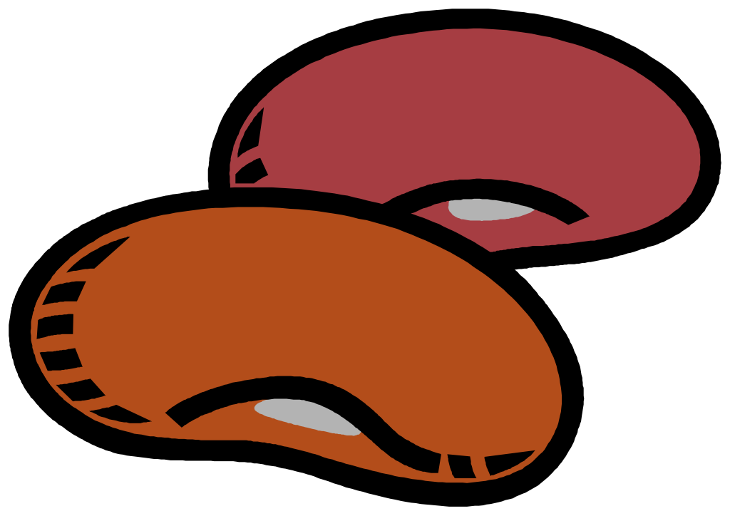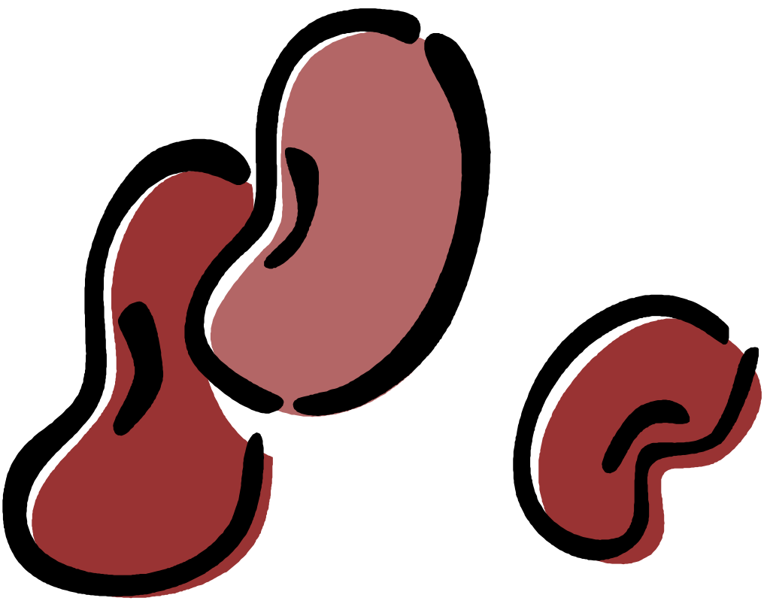

BEAN: ACTION:
JUMPING BEAN – Jump around the room
RUNNER BEAN – Run around the room or in place
JELLY BEAN – Move around the room doing wobbly movements
STAR BEAN – Move like a star (arms/legs straight and extended)
PONY BEAN – Gallop around the room like a pony
FROZEN BEAN – Stand very still as if frozen
TINY BEAN – Make yourself as small as possible and move around room
GIANT BEAN - Make yourself as large as possible and move around room
FRENCH BEAN – Make a shape and say Bonjour! to the teacher
SLOW BEAN – Move around the room in slow motion
SKIPPING BEAN – Skip around the room
BUTTER BEAN – Slide around the room (seated or standing)
SAD BEAN – Move around the room pretending to be sad
HAPPY BEAN – Move around the room pretending to be happy
TAKE – A – SEAT BEAN – Walk to the teacher and take a seat!!!

Bean Bag Shuffle Erika Buscaglia
Grades K – 2
- Bean bags – one for each student to hold
- Each student has a beanbag. Each color represents a locomotor skill blue- skip, red - gallop, green – hop, yellow – slide, purple – jump, etc.)
- On the signal, students move according to the color bean bag they are carrying
- When the music stops, students place beanbags on the floor, then get a new beanbag, but not the same color they just had.
- Repeat

Beanbag Switch Erika Buscaglia
Grades K-3
- Beanbags, task cards, music
- Make a colored task card for each colored beanbag you are using. Put exercises on the task cards
- Give each student a beanbag
- On the signal students locomotor around the area. When they come to another student they yell “Switch” and they trade beanbags.
- Continue until the music stops
- When the music stops, the students perform the exercise that matches their beanbag

Bean Bag Transfer Erika Buscaglia
- Grades 2 & up
- Bean bags (or noodlettes) & poly spots (or plates)
- Spread the spots throughout the area, placing a bean bag on top of all but 4 spots
- On the signal, students use a designated locomotor movement to move throughout the space and move a bean bag to an empty spot, counting the amount they transfer

Be Healthy
- Equipment; lively music, 8 cones to be set up around a basketball court sized area, (1 cone at each corner, 2 spread out on the sides)
- Divide students into 4 equal groups, each group starts at a different corner
- When the music starts, each group jogs forward around the course staying in the same order—do not pass each other. Maintain an easy pace for everyone in group
- Last jogger, sprint forward on the inside passing your teammates. When they get to the front of the group yell “Be Healthy!”
- As soon as “Be Healthy!” is yelled, the new last person runs to the front
- Continue this pattern until music stops
- Walk slowly around course, inhaling and exhaling deeply, groups can compare how many yells they completed
Variations; increase time music plays, increase the course

Biggie Dek Ring Fitness (Chip Candy)
- Sets of partners (or...it’s better with groups of 3) will begin the activity by practicing their Dek Ring throws (Frisbee style/flat is the best), and catches (one hand/arm through the hole, or two hands through the hole...dolphin/shark style).
- Next, add movement, with the receiving partner always running to a new open space.
- We want to teach this sports concept of always looking for open space.
- When the signal is given, the partners, or trio, come together with their ring and perform the designated exercise (ex. 6 squats, or 5 push- ups, or 3 burpees) ...while staying in contact with the ring throughout.
- Continue the pattern of throwing/moving and exercises until a good workout has been completed!

Board Game Erika Buscaglia
- Grades 3 & Up
- Cones, dice, exercise cards with equipment to match cards
- Students are in pairs
- Line the perimeter of the area with the cones, placing exercise cards beneath them
- The students are the game pieces; they roll the dice and move that number of spaces (cones)
- The students look under the cone, perform the task and roll again

Bokwele (from Africa)
- Divide the class into 4-6 teams; scattered in the play area
- 1 hoop and 3-5 small objects per team
- Each team starts behind their hoop in which 3-5 of the same objects are placed; each team should have a different set of objects (team A deck rings, team B bean bags, etc.)
- On teacher’s signal, students run from their hoop to other hoops taking ONE object at a time back to their hoop
- As the students take an object they must yell, “Bokwele, Bokwele!” (bok-WEH-le)
- The object of the game is to take as many objects from the other teams without getting tagged
- If tagged, the student must return the object back to the hoop he/she took it from
- Play continues until there are no items left in one team’s hoop or play to a predetermined amount of time with the team having the most objects winning
- Students may not guard their own hoop.

Bounce Tag
- Divide the basketball court (or other area) in two halves.
- Divide the students as evenly as possible into two groups (one group per area)
- Choose 2-4 students as “taggers”
- Students are equipped with pickleballs or other small balls.
- On your signal “taggers” and students will bounce the balls and walk or jog around the designated area.
- “Taggers” will tag with their free hand.
- Any student tagged must run a lap around the playing area before returning to the game.
- If a “tagger”/student mishandle their dribble they must also run around the playing area before returning to the game.
- On your signal change taggers

Boxer Training -Theme from Rocky:
- Jog, hop, skip, or whatever movement teacher says clockwise, counterclockwise or scrambled eggs (any direction student chooses).
- Teacher calls out commands-- champions hold hands high; training-pretend to jump rope, shadow box; dead bug lie on back screaming & quickly get up.
- Add any other commands you can think of, sit-ups, push-ups, etc.

Bucket Jumps (Chip Candy)
- Three people begin in a line with a stack of buckets (or cups, Frisbees, poly spots, small cones, etc.).
- The first person carries a bucket out to the designated distance, puts the bucket down, jumps over it, and returns to the start.
- As soon as the first person begins their jump, the second person grabs a bucket, runs out and puts it down next to the first bucket, and jumps back and forth over the buckets 2 times.
- The third person begins as the person in front starts jumping and must perform 3 jumps over the three buckets.
- As this continues, it is possible to have all three people jumping at the same time (when the number of jumps gets higher).

Buckets
- This is an easy way to set up a circuit when the buckets are filled ahead of time
- Students in groups of 4-6
- Put at least 6 of the one kind of equipment in each bucket, using 8 buckets (more students-add more equipment per bucket)
- Each group of students moves to a bucket to start
- When music begins, the students participate at that station
- When music stops, students return equipment to the bucket, move CW to the next bucket and wait for music to begin again

Buddy Hop
- Have the entire class get into partners.
- Have the partners facing each other but looking opposite directions.
- Begin playing the music and students will hop in opposite directions away from each other.
- When the music stops the partners must find each other and sit beside one another.
- The students that find one another last are eliminated and they can jump rope or run laps until one last pair is left!

BUMPER CARS
- Aim - To develop space awareness and Locomotion / Traveling skills
- Expectations: travel in a variety of ways (e.g. run, walk, leap) in different directions in response to signals (e.g. stop or go signals)
- Equipment needed: Hula-hoops and a gymnasium.
- Explain what personal space is and how you use it.
- Give each student a hula-hoop and have them hold it at waist level.
- Explain that this is there personal space car and they should not touch any other student’s car.
- Give them word directions e.g. stop & go, stand up & sit down.
- Have the students run from one end of the gym to the other.
- After, give them some directions while they are running, let them run freely around the gym.
- You can use different movements with the hula-hoop like skipping or jumping and spinning.

PFA Indoor Bunco (Gregg Montgomery)
- Get in groups of 4, each group gets 3 dice.
- Take turns rolling the dice.
- Roll the dice. If the dice are all the same, this is a BUNCO and everyone in the group runs a lap.
- If the dice are NOT all the same then total the dice and everyone in the group does the following:
  - 17 = 17 Jumping Jacks
  - 16 = 16 Sit-ups
  - 15 = Jump rope 15 times
  - 14 = 14 Wall Push-ups
  - 13 = 13 Step Ups
  - 12 = Use Hula Hoop for 12 seconds
  - 11 = 11 “X” Jumps
  - 10 = Skip 2 times around the Gym
  - 9 = Runners stretch, 9 seconds for each leg
  - 8 = 8 Basketball Dribbles
  - 7 = Jump over Hoop 7 times
  - 6 = 6 Mountain Climbers
  - 5 = Jump 180’ or 360’ 5 times
  - 4 = Crab Walk around Hoop 4 times

Buzzerk
- This activity requires 1 foam ball per every 10 students. For 30 students this means there will be 3 games going on simultaneously, so use different colored balls, if possible, in order for students to distinguish which ball is theirs.
- Use the entire gym/playing area
- Students form groups of 5.
- Two groups play each other with one team batting first.
- Each student has a number from 1 – 5.
- Batting team starts out in a line (#1-5), fielding team spreads out in the playing area
- Batter # 1 throws ball anywhere in the playing area, there are no foul balls. After completing the throw, the batter runs around his/her team until the fielding team completes the task below.
- Batting team must yell out the number of times the batter runs around their team.
- The fielding team retrieves the ball; everyone gets in a line and passes the ball down the entire line. The last person on the team that receives the ball throws the ball to the new “batter” on his/her team. When the batter receives the ball he or she yells stop and teams switch roles.
- Variations: The teams can keep score; after 1-2 minutes switch teams so they play other teams, score can be cumulative against all teams or just against individual teams.

Calculator Toss and Catch (Gregg Montgomery)
- Use the calculator to add up the scores for exercises, Tossing and catching or any activity that needs to record a number as a motivational tool.
- Equipment needed:“Catch Us If You Can” by the Dave Clark Five, Fleece Balls, Rubber Chickens, Bass, Animal Beanbags, Playground Balls, Dinoskin Balls
- Partners
- While most of us use partners at times to practice tossing and catching skills, there seems to be no "incentive" for the throwers to make an accurate throw and the catchers to make a valid attempt to catch the object.
- Partners face each other and try to make accurate throws to their partner so they might catch the thrown object.
- To encourage this type of behavior ask the students to count the number of correct attempts and report it to me at the end of one minute.
- One partner from each group would line up in front of me and tell me their score and I would place it on the calculator.
- After all of the students reported their scores I would press the calculator for the grand total and ask one of the students to read the score aloud.
- Suggest to the class that they could better that score and create a new "World Record” for their grade if they could add a few more to their total the second time around. It is amazing how their scores improved when they actually had a greater incentive to catch the object. The "Grand Total" plan works...Try it... You'll like it
- Variation(s): Use various size and shape objects. Underhand throws, Overhand throws, Bounce Passes, Chest Passes

Cannonball Run
- Place a cone at each corner and two along each sideline of a rectangular track that is about the size of a basketball court.
- Form 4-5 equal teams
- Have last person get a medicine ball.
- Each team stands in file formation at a different corner of the area facing in a CCW direction.
  - When the music starts, each team starts jogging around the track with the last runner carrying the medicine ball. Stay in this order and do not pass to each other.
  - On the teacher’s signal, the last runner sprints forward on the inside of the track, passing all teams runners. As the last runner reaches the front of the team, they yell “Cannonball!” This is the signal for the whole team to turn sideways and slide step along as the cannonball is passed from player to player down the line to the new last person. (the music can be used as signal-on/off)
  - The last runner, when receiving the ball runs to the front on the team and continues the cannonball pass.
  - Continue at a steady pace, taking turns until the music stops. No team is permitted to pass another during the run.
  - Each team should yell out the number “cannonball runs” made by the team.
  - To cool down, walk slowly around the track inhaling & exhaling deeply. Each team can report their score to the teacher.
  - Variations; each team could pass a basketball or large utility ball; increase the size of the track (where possible); increase the duration of the run as fitness improves; introduce a break signal in which the team stops in place, quickly forms a circle, and while jogging in place, passes the ball back and forth across the circle to a teammate who is not on either side of them.

Card Suit Aerobics
- Purpose of Activity: To enhance aerobic fitness and help students understand different movements that can be used to keep fit and active.
- Prerequisites: Students should be able to perform a variety of locomotor skills.
- Suggested Grade Level: 1 and up
- Materials Needed: Four cones or hula-hoops, three to four decks of playing cards, white board or chalkboard.
- First discuss with students activities they perform that are good -- and not good -- for their heart (for example, "riding their bike" is helpful to keep the heart strong, while "watching TV" is not). Relate how the movements they will be performing today and the activity in general will be helpful to make and keep their heart strong.
- Then, on the whiteboard/chalkboard, draw the four card suits and write the locomotor skill each suit represents next to it. Review this with the students. Example: Heart=Run, Spade=Skip, Diamond=Gallop, Club=Hop.
- Note to students: the cone or hoop at each corner of the gym and how different cards are scattered around the cone or in the hoop. Explain how they will be going to one station to begin, pick a card, and then move to the next station (show direction of movement) using the movement their card suit represents. (You may wish to have a child demonstrate how this is all done.) At the next station, they leave the first card (face down) and choose another one, then move on to the next station using that new movement.
- Once the activity is explained, divide students equally between corners in order to begin. Periodically, you may choose to have students come back in and change the movements that will be done for each suit (this will give them a needed rest!). It is also a good idea at this time to discuss how their heart (should be) beating faster...if they are getting hot...etc., to show that they are being active.
- Variations:
- You may do this activity for a set time limit, or have the students keep all the cards they pick up and continue until all cards are gone.
- You can remove the wild cards or leave them for students to perform the skill of their choice.

Card Suit Pick Up –
- Have a full deck of cards. Divide class into 4 equal groups. Assign each group a suit from the deck – spades, hearts, diamonds, and clubs.
- None of the students are to leave the START area until the person before them has returned (relay style).
- The instructor and the cards are at the far end of the gym.
- On “go”, the first student in their row runs to the far side of the gym. Each student is allowed to turn over ONE card only at each trip down the gym. If the card is their suit, they take it back with them and if it is not, they must turn the cad back over.
- The first row to bring all 13 cards of a particular suit back to their row and sits down, wins. (Make the other rows do 5 pushups or something to make that row think they really did something special!)

Carry & Fetch Relay
- Students in a closed squad formation with a large hoop or circle positioned up to 30’ in front of each team
- First student has a bean bag
- On the signal, the first student ruins down to the hoop and puts the beanbag inside the hoop, then returns and tags the next student in line
- The second runner got to the hoop and retrieves the beanbag and brings it back to the next student in the line
- Use different locomotor skills

Cartoon Tag;
- Choose 1 student/ten to be it and give them on object to hold to designate them as taggers
- On signal taggers chase students
- When tagged the students must kneel down
- To be freed the student must say the name of a cartoon show, a cartoon character or TV show/character to one person who approaches. If the show has not been repeated to that “freer” then the tagged person is free to rejoin the game
- If the name was already used, the freer runs away without freeing the tagged person
- Variations; have tagged students call out fruits or vegetables; call out sports or physical activities

CAT AND MOUSE
- Choose two of the class to be cats, everyone else is a mouse and wears a tail (bandana) in the back of their shorts.
- The mice run around and the cats try to catch them by pulling the tails out. Make sure tails are showing before starting and ask cats to collect tails that they pull out so that no one slips on them.
- Count the tails at the end and the cat with the most tails is the winner!

Catch the Dragons Tail
- Dragons (Lines) of 8-10 students
- Everyone places their hands on the shoulder of the person in front of them
- Last person in the line wear flag belt or a bandana tucked in
- At signal the head of the dragon (1st person) chases the tail, trying to get the flag from the last person
- 30 seconds for the head to try, then head becomes tail and everyone else moves up one place toward the head.
- Variation: have dragons try to catch tails of other dragons

Caught in the Middle Erika Buscaglia
Grades K-4
- Cones or spots, music
- Students in groups of 3
- For each group, place 2 students on one line and the 3rd on the opposite line
- When the music starts, student 1 runs across the area to student 2 and gives him/her a high five. Student 2 runs across to student 3 as the activity continues
- When the music stops, the student who is running the middle stops and performs a specified exercise
- Music starts again and the activity continues

Caught Up
- Boundary is a basketball court or general size. Exercise task cards are needed
- Choose 4 to 5 taggers each with a task card and noodle.
- Taggers run around specified area and try and tag students.
- When a student is tagged the tagger must hand the task card to the student and they must perform the activity stated on the card.
- When a student is tagged, the tagger must hand the task card to that student and they must perform the activity stated on the card
- Once the student performs the task, they become a tagger

Clam Be Free
- Demi-noodles
- Select 2-3 students to be taggers They are actually the bad old nuclear reactors who have just suffered a nervous breakdown (meltdown).
- Everyone else are happy go lucky clams
- ‘If tagged, by the nuclear reactors, the clam must close up (kneel down) and freeze
- To become unfrozen, two other clams must join hands around the frozen clam and yell three times “Clam be free!” whilst jumping up and down.
- If all the clams become frozen, they become extinct and got he way of the dinosaur. If they work together, the clams will always thrive and live relatively peaceful lives

Colored Cone Touch Erika Buscaglia
Grades K-3
- Cones, color cards, small baskets
- Spread the cone around the area. Place the cards in baskets at one end of the area
- On the signal, students select a card and use a designated locomotor movement to touch all the colors listed on the card
- After all the colors on the card have been touched, students return the card and get a new one

Continuous Everybody’s It
- Everyone in class is it
- If a student gets tagged they must sit down where they were tagged
- If two students tag each other at the same time, both sit. (if they can’t decide or argue, they must do a round of rock, paper, scissors, however if both put out the same sign they both sit)
- This game is usually over quick with most students sitting, however, add 1-2 students wearing pinnies to be “un-freezers”
- The “un-freezers” can do a special high-5 handshake, exercise, hug, etc. with frozen student to free them

Continuous Flag Tag
- All students have a flag tucked in their back pocket, or in the back of their pants. Take a flag check to make sure the flags are all hanging at about the same length.
- On signal, students run around the area pulling other student’s flags while attempting to keep their own flag intact.
- When a flag is pulled from a student’s pocket, it is dropped to the floor immediately and the student who owns the flag must pick the flag up run around the teacher, or give the teacher a high-five, the replace the flag back in their pocket and return to the game.
- Game Ender – the last minute can be changed to “Last Flag Pulled”. Students run around and pull other student’s flags and drop them on the spot. Students cannot pick the flags up, but they continue to run around pulling flags until the last student’s flag is pulled.

Copy Cat
- Need lively music
- Students get a partner
- Decide which partner will lead first
- When the music starts, leader will move around area performing a variety of movements, at different levels and moving to the music
  - Running, leaping, rolling, dodging
  - Hopping, jumping, slide-stepping
  - Twisting twirling, crawling
  - Jumping jacks, knee bends, sit-ups, push-ups
  - Finger snapping, hand clapping, arm circling
  - Dance steps
- Partners should stay close performing identical movements
- At the end of 1 minute, teacher signals switch so partners can change roles
- Teacher can then callout new partner and students have to find a different partner

Cookie Jar Activity Exchange
- Several “Cookie Jars” (e.g., shoe boxes, Frisbees, gallon ice cream containers)
- Activities on paper or index cards (if using paper, cut into index card size)
- Students get partners
- Use activities that match the components of Health-related Physical Fitness (i.e., Muscular strength and endurance, Flexibility, and Cardiovascular Endurance)
- Color code activity cards (e.g., red = C.V. Endurance)
- Each “Cookie Jar” should be color coded and represent one of the components from above
- “Cookie Jars” are set in the middle of the gym
- Students take turns going to the “Cookie Jar” and must choose a different color, or fitness component, each time
- Once completed, activity cards go back into “Cookie Jar”
- Students start over once each component has been chosen
- If students accidentally choose the same activity twice, just have them place it back in the “Cookie Jar” and choose a new activity
- Variations; Sport related skills can be integrated; programmed music could cue students to perform the activity (e.g., for 20 sec.) and change activities (e.g., 5 sec. pause); programmed music approach would allow students to perform activities based on time vs. repetitions!

Cooperative Hi-fives
- This is an add on activity.
- Have students face partner across the gym.
- On teachers signal partners run to the middle give each other a Hi-five and run back to their line.
- Add on activity-teacher only calls what to add on next, previous commands will not be repeated students must remember them.
- Suggested sequence:
- Hi-five rt;
- Hi –5 left,
- Hi 10,
- Low 5 right,
- Lo 5 left,
- Lo 10,
- Back to back over the head 10,
- Back to back between the legs 10,
- Sitting face to face-touch bottom right foot,
- Sitting touch bottom of left foot, Bottom of both feet,
- Finish with dead bug (lie on back screaming).
To make this a fitness activity, just add exercises to add on.

Cooperative Team Relay:
- Students in groups of four with three students forming a circle and the fourth student in the middle.
- On the signal, the groups maintain contact and run down and back.
- Once back a new student gets in the middle and the groups runs down and back again.
- Continue until all 4 students have been in the middle.

Cooperative Team, Stepping Stone Relay:
- Students in groups of four with three carpet square per group. Students number themselves from 1-4 Number 1 student will step from carpet square to carpet square.
- After stepping off of a square numbers 2-4 will move one carpet square each in front of number 1 until he/she gets to line on opposite side of area.
- Then Number two will step from carpet to carpet while #’s 1, 3, 4 move the squares until reaching the original line then #3 goes back across where #4 goes across on the carpets.

Cotton Eye Joe
- Intro – Stomp/clap
- CEJ – slide R, L, fwd, back (4 cts each movement), repeat
- Fiddle – jumps
- Girl – arm circles
- CEJ – slide R, L, fwd, back (4 cts each movement), repeat
- Banjo – claps crossing midline
- Girl – arm circles
- CEJ – slide R, L, fwd, back (4 cts each movement), repeat
- Fiddle – jumps
- CEJ – slide R, L, fwd, back (4 cts each movement), repeat
- Fiddle – claps crossing midline
- CEJ – slide R, L, fwd, back (4 cts each movement), one time

Couch Potato
- Purpose of Activity: For students to learn the concept of being healthy and active. Don't be a "couch potato!"
- Prerequisites: Basic knowledge of tag games (chasing, fleeing, dodging), locomotor skills, moving safely in general and safe space, and use of boundaries.
- Suggested Grade Level: K-2
- Materials Needed: plastic fruits and veggies, cones to create a "fridge," cones or mat to create an area for the couch, foam balls or other identifiers for taggers
- Anticipatory Set: Discuss with your students: “What is a couch potato?” “Do you think a couch potato is healthy?” Most likely you will receive answers like: “A couch potato is lazy, does not exercise and eats junk food like potato chips.” Introduce the concept of being healthy and how we don’t want to be a couch potato. “How can we keep from being a couch potato?” Answers: get exercise, keep moving, eat healthy stuff.
- Set-Up: Choose five or six people to be "it" (remote controls freezing others into couch potatoes). Identify them using a pretend remote or other identifying pieces of equipment (pinnie, beanbag, rubber critter). Number of "its" will vary depending upon your class size.
- Designate an area using cones or a mat as the couch where couch potatoes go, and another area where the refrigerator is, in which pretend fruits and vegetables have been placed. Fruits and vegetables can include laminated pictures of fruits and vegetables or plastic ones you can buy. Be creative!
- Designate playing boundaries: usually the black line around the gym and remind students to move safely in the open space, staying inside the boundaries and using soft tags.
- Play: Using various locomotor movements, students travel around the playing area. If a student is tagged by the “remote control,” (s)he moves to the couch where (s)he sits down, stretches out with legs crossed pretending to be lazy and watches TV.
- To re-enter the game another student retrieves a fruit or vegetable from the “fridge,” brings it to a couch potato and tells her/him to “get off the couch!” The couch potato needs to prove that (s)he is not a couch potato by performing a designated body reward while the helper counts (for example: five good push-ups or 10 crunches).
- The helper sees that (s)he deserves the fruit or vegetable and hands it to her/him. The couch potato pretends to eat the healthy snack, returns it to the refrigerator and then re-enters the game.
- Change taggers periodically.

Courtesy Tag:
- Equipment: flags for each student, 4 cones (20 x 20 yds.-depending on class size)
- Each student has flags and moves quickly inside the 4 cones
- Once you get your flags pulled (you can say one or both flags), you must sit or kneel down
- If you took someone’s flag(s) you must give them away, you can only have ONE set of flags
- To give the flags away, find a student who is kneeling and give the flags to them
- You are safe while you are giving flags to a student
- The person receiving the flags must say “thank you,” and you must reply, “you’re welcome.”
- Then you continue to keep your flags while removing someone else’s.
- If someone takes your flags while you are carrying another set of flags, you must kneel down and put the flags you were carrying on.

Crazy Colors
- Purpose of Activity: To help learn about and improve students cardiovascular fitness.
- Suggested Grade Level: K-2
- Materials Needed: 36 small (index-size) cards -- 6 each with the color "red", "green", "purple", "orange", "yellow", or "blue" written on them; 36 small color cones (6 each of red, green, purple, orange, yellow, and blue; up-beat music at least 4-5 minutes long.
- Place cones in a scattered formation around the activity area, as far apart as possible. Under each cone, place one small index card that has a color written on it. Be sure not to put a color card under a cone of the same color (i.e., a card with the word "red" written on it should not be placed under a "red" cone).
- Students begin in a scattered formation in the activity area.
- When the music begins, students jog (medium speed) to any cone and look under it, read the color which the card says, replace the card under the cone (demonstrate to students how to place the cone over the card so the next person does not see the color on the card), and then jog to a cone of that same color (e.g., if the color "green" is written on a card, the student would jog to a "green" cone).
- Students continue moving from cone to cone until the music stops.
- At the end of a minute or so, stop the music. Have students feel their heart and how fast it is beating. Remind them that their heart loves for them to be active like this!
- Call out a new locomotor movement for children to use, challenge students to move to as many cones as possible, and begin the music again.
- After repeating the activity a few times, have children sit in a group. Discuss why the heart was going fast (they were moving, etc.) and how being active like this is important to keep one's heart healthy. Ask students to name other activities which are good for their heart.
- Teaching Suggestions:
- Use music which of varying tempos so children speed up and slow down to the beat.
- Have students move in different directions (forward, backward,
sideways, etc.)
- Pair a child who does not know his/her color words with a child who does.
- You can also arrange the cones around the perimeter of the playing area.
- Children can be challenged to see how many cones they can go to in a specific time span, for added fun. Or, have them count how many total cones they go to throughout the whole activity.
- For some added fun "confusion", write the color words on the small cards in a magic marker color different than the word you are writing. For example, write the word "green" using a red marker. This really makes students read the words carefully!
- If you do not have different colored cones, you can use colored poly spots or even cones of all one color. Students have to move from cone to cone until they find a card with a different color than the one they just read. This is a little more difficult!

Crazy Foam Relay Erika Buscaglia
Grades K & up
- Noodlettes, baskets
- Divide students into groups of 3-4
- Scatter the noodlettes at the other end, away from the students. Place the baskets in a line or circle in the middle
- On the signal, the first student from each team runs up, takes TWO noodlettes, brings them to the baskets and sorts them by color, returns to their team to high five the next person
- Continue until all noodlettes are sorted

Criss Cross Tag
- Play on one half of basketball court or designated area
- Designate 5-6 “taggers”. Play takes place lengthwise on designated area. The “taggers” will position themselves lengthwise in the middle of the area. The remainder of the students will be positioned as evenly as possible on each side of the “taggers”.
- On your signal students will attempt to run across the “taggers” area and get to the other side of the playing area.
- The “taggers” will attempt to tag as many students as possible as they cross over.
- Tagged students must jog a lap around the play area before rejoining the game.
- On your signal new taggers may be rotated if you so choose

Detective
- The entire class forms a circle.
- One person is sent out of the room as the “detective “.
- You assign one of the members of the circle as a member of the “mafia”. The name is not announced and that member is now the leader and will begin performing a variety of exercises.
- The detective is asked to return and goes to the center of the circle. The detective tries to guess the leader or the “mafia “person.
- The leader needs to change exercises regularly to give the detective a chance to figure out who it is. (Hopefully the leader changes activities when the detective is not looking directly at them.)

Dice Corn Hole
- Equipment: Hula Hoops and large dice (2 different colors) & fitness grid
- Divide students into partners. Each group of partners will be given a die.
- Two hula hoops will be placed approximately 15 feet apart.
- Two groups of partners will play each other. Partners will then sit at opposite hula hoops of one another.
- To start the activity, the partner with the die will stand in the hoop they are stationed at and roll it attempting to get it to stop in the hoop opposite of the one they are standing.
- Then the opposing player will roll and attempt the same.
- The players use the dice to look on fitness grid to see what exercise task they will perform. White die across, color die down.
- The player whose die is closest to the hoop wins the amount of points rolled for their team.
- If a die stops in the hoop, the team will get the amount of points rolled plus what was rolled by the other team.
- Then the other teammates will roll from the other side of the playing area.
- Scores will be tallied from each round. This will be repeated.
- The group with the highest score after the allotted time wins!

Dice Fitness (John L. Smith)
- This activity combines math and fitness into one, fast, fun, furious fitness lesson.
- The set up is 2 lines approximately 15 feet apart. These lines can be any distance apart and the further the distance the greater the fitness component in the activity.
- The activity can be done individually, in pairs, partners or in teams of up to 6. The # of dice depends on the activity but the most you will need is 6 per team.
- Stand behind the first line and roll the die across the second line trying to roll the following challenges.
- After each roll either return to line 1 and roll again or stand behind line 2 and roll back past line 1. The locomotor skill can be changed on each activity using walking, running, sliding, galloping, skipping, crab walk etc.
- One Die Activities:
  - Roll all of the #s 1-6
  - Roll only the even #s 2, 4, 6
  - Roll only the odd #s 1, 3, 5
  - Roll the die to score a total of 30 points (addition) Roll #s 1-6 in order
- Two Dice Activities: Using 2 dice...
  - Roll all of the #s 1-6
  - Roll 3 sets of doubles
  - Roll both dice to score a total of 40
  - Roll both dice and roll all the possible #s added together 2-12
  - Roll the #s in order 1-6 (first roll must be 1-2, second roll 3-4 and third roll 5-6) roll until you achieve the sequence or roll again until you complete the next sequence.
- Three Dice Activities: Using 3 dice...
  - Roll all of the #s 1-6
  - Roll 3 sets of triples
  - Roll 3 dice to score a total of 50
  - Roll 3 dice and roll all the possible #s added together 3-18
  - Roll the #s in order 1-6 (first roll must be 1, 2, 3 second roll 4, 5, 6). Roll until you achieve the sequence or roll again until you complete the next sequence.
  - Roll 3 dice and get all even numbers on one roll and all odd numbers on next roll
- Six Dice Activities: Using 6 dice...
  - Roll all of the 6 numbers 1-6
  - Roll all 6 dice and roll all of the 6 numbers on one roll
  - Roll all 6 dice to get all even numbers
  - Roll all 6 dice to get all the odd numbers
  - Roll all of the 6 dice and score a total of 100 points
  - Roll all of the 6 dice and get the same number on all 6 die (if too difficult use the” leave a die” rule where you may leave a die or dice that you want to stay on the floor)
Dice Game
- Equipment: 1 exercise dice
- Divide students into two even groups (or more groups depending on the size of the class).
- A student from Team 1 rolls the dice that determines which exercise and how many reps the students in Team 2 will complete.
- If Team 2 completes the required amount of reps of the exercise, they will receive the same number of points as reps. For example: If a team completes 25 burpees, they will receive 25 points. 5 star jumps would receive 5 points.
- Team 2 rolls for Team 1 and so on.
- The team with the most points at the end of the activity is the winner.

Dizzy Dominoes Erika Buscaglia
Grades 3 & up
- Hoops & dominoes
- Students in groups of 2-3. Each group has a hoop with dominoes inside. Around the sides of the area place posters corresponding to the numbers on the dominoes
- On the signal, the group takes one domino out of the hoop and subtracts the smaller number from the larger number.
- The students then go to the poster that corresponds to the answer of their subtraction problem and complete the exercise
- When finished, they put that domino in to another teams hoop and repeat

DO AS I SAY, NOT AS I DO
- Students stand facing the leader.
- To warm up, the teachers give a command with the students performing the command and repeating the command out loud.
- The commands are: FORWARD (1 step forward), BACK (1 step back), RIGHT (1 step right), LEFT (1 step left), UP (rise up on tip toes or jump up once), DOWN (bend at the knees).
- After warming up, try some of the variations:
  - Students say opposite command and do opposite command
  - Students repeat command, but do opposite of the command
  - Students say opposite but do command

Double Die Fitness
- Post 6 exercises numbered 1 through 6 on a wipe-off board...then everyone rolls 2 dice, one white, and the second any other color.
- The white dice will tell you the exercise from the list, the colored one the number of repetitions.
- How many rolls in 3 minutes?
- Variation
  - On My Toes – Circles of students stand in a toe to toe to toe circle.
  - The teacher will yell out a category that one person in the circle fits (tallest student...longest hair...oldest, etc.).
  - That person runs to another part of the gym and yells; “on my toes”.
  - The group must reform their circle, and as above, roll the 2 dice and do the listed exercise and reps from the posted list as fast as possible (trying to beat the other teams).
Down the Room in Waves-
  - Line students up on line facing the width of the gym so that there is enough space for all the students. Give students a number from 1-4
  - Move the width in waves (students own quick pace) by calling their number. Practice locomotor skills, combinations and dance steps.
  - Don’t forget to combine sport skills (ex. Jump stops, jump shots, kicking motion, throwing on the run, etc.). Use running, leaping, galloping, schottische (walk, walk, walk, hop & can be done forward backward, sideways, & diagonally), skipping, sliding, two-step (step-close-step; left, right, left or right left, right; triple step or step-ball-change), and grapevine.
  - Also add twisting, bending, shaking, turning to the movements.

Doves and Hawks (from China)
- Students in groups of three, join wrists
- Student in the middle is known as the “Chinese Child.”
- The other two students are designated as hawk and dove
- The “Chinese Child” releases one student, who becomes the dove, who takes off running away from the threesome
- After 3 counts the “Chinese Child” releases the other student, the hawk
- The hawk tries to tag the dove before the dove is able to return to tag the “Chinese Child” (The “Chinese Child” chooses either to help the dove or the hawk by moving toward one or the other)
- Rotate spots after each round

Dragons Tail Tag
- Groups of 3 standing in lines away from other groups
- First student steps out and faces his/her line
- Last student in line places his/her hands on the shoulders of the student in front of them and places a flag/bandana in their back pocket. (the flag cannot be stuffed in the back pocket)
- The goal of the first student is to pull the last player’s flag
- The two in-line students move around and try to keep the second student in line from getting their flag pulled from their back pocket.
- If the flag is pulled, all students switch positions and continue the activity.
- If the two hooked up students come apart, it’s the same as the flag being pulled.
- Ask for a flag check every so often. Make sure most of the flag is showing.
Variation – allow one minute before stopping play and having students rotate, even if the flags have not been pulled

Dyna-Bands- Achy-Breaky Heart:
- Verse 1: 4 slow front pulls to 8 slow beats
- 4 slow right pulls to 8 slow beats
- 4 slow left pulls to 8 slow beats
- 4 slow front pulls to 8 slow beats
- Chorus: 8 right hand pulls from the heart (left hand holds band on heart)
- 8 left hand heart pulls
- 16 overhead pulls
- Verse 2: 8 front pulls, 8 right pulls, 8 left pulls, 8 front pulls
- Chorus: repeat
- Verse 3: 8 right hand pulls from the heart (left hand holds band on heart)
- 8 left hand heart pulls
- 8 right hearts
- 8 left hearts
- NON-INSTRUMENTAL PART: 16 front pulls and hold
- Chorus: 16 front pulls or 32 fast pulls
- Wild finish with 32 fast pulls to beat

Dyna-Band Routine (music-“Soul Man”)
- Expanding front pulls on beats.
- 8 front pulls
- 8/8 right/left diagonal pulls
- 4 big front pulls on “Soul Man” with quick pulls on beats
- 4/4/4/4 Right/left diagonal pulls
- 4 Big front pulls on “Soul Man” with quick pulls on beats
- 2/2/2/2/2/2/2/2 Right/left diagonal pulls
- 4 big front pulls on “Soul Man” with quick pulls on beats
- 16 Alternating Right/left diagonal pulls
- 2 Front expanding pulls on “YEAH!”
- 4 Soul Man over head pulls
- 8 above head pulls
- 24 front pulls
- 1 L o n g E n d i n g p u l l !

Exercise & Go Erika Buscaglia
Grades 1- 4
- Cones, plates, balls, jump ropes, scarves, etc.
- Students work in pairs
- Scatter plates around the area. Each plate has as activity on it
- Pairs move around the area performing the activities
- Example: run 2 laps, dribble one lap, 25 step-ups, jump rope math (do that # of jumps to solve the problem), lunges (forward and side), 20 shoulder touch push-ups, 5 push-ups, 10 mountain climbers, pass medicine ball with partner, dribble & juggle a scarf 10X,

Exercise Bowling
      - You need two pins and two balls for each group of 4 students.
      - Have the students form two teams of 2 students.
      - Place the pins 15’ to 30’ from the bowlers depending on age group.
      - Each team will stand 2’ behind the pins.
      - On the teacher’s signal, the assigned side of teams may begin to bowl.
      - The first bowler rolls the ball at the pin.
      - If the pin is knocked over, the team that knocked the pin over chooses an exercise.
  - (Sit-ups, push-ups, jumping jacks, etc.)
      - The opposing team must complete the exercise before they begin their turn.
      - If the bowling team does not knock the pin over, they must then complete the exercise picked by the opposing team.
        - A turn consists of 1 bowl from each team. Each team must switch bowlers every turn.
        - Continue this rotation for a set period of time.
        - Variation:
- For every pin knocked over the amount of the exercise will increase by 5. (Turn 1- 5 sit-ups, Turn 2- 10 push-ups, etc.)
- The same increment of 5 applies to missed pins.

EGGS-ERCISE! (plastic eggs)
  - Before the class enters, place numbers on pieces of paper and place the paper inside the eggs.
  - Students grab an egg out of the “basket” and go back to their own spaces. Students open the eggs and perform a predetermined task the number of times that is written on the paper inside the egg.
  - You might try writing the task on the paper along with the number of repetitions as something different.

Eggs for Fitness
Purpose of Activity: For students to actively participate in a fitness-enhancing activity.
Prerequisites: Prior knowledge of the movements/actions which students will be using would be helpful.
Suggested Grade Level: 1-2
Materials Needed: 5 hula hoops, 5 Frisbees, 24 colored plastic Easter eggs -- 4 each of 6 different colors, a large poster with color codes and explanations of exercises, strips of paper, CD/boom box with motivating music.
Prior to the lesson, decide on the six actions which students will be doing that day and which color each action will represented. For example, "yellow" equals ten jumping jacks; "purple" means jump over a line or rope on the floor ten times, etc.. Other examples of actions can include "doing the twist", a straddle stretch, mountain climbers, dancing, push-ups, etc. Then, make a poster showing what action should be done for each egg (e.g., yellow = jumping jacks). If possible, use pictures to help illustrate the given actions. Also, write each action on four different slips of paper; put each action into the corresponding colored egg.
Place one hula-hoop in the center of the playing area and four hula-hoops in one each of the four corners of the activity space. Place a Frisbee in the middle of each hoop. After reviewing the actions with students by showing the poster and/or demonstrating the actions, explain that they will be in a group of six. Each group will start out at their own hoop. When the music begins, one person from the group (they decide who will go first, second, etc.) moves to the middle hoop, retrieves an egg, and opens it to see what action to perform (they can look at the poster if need be to help with this). After putting the egg into the Frisbee in the middle of the hoop, this person leads the rest of the group in performing the action.
When done, the next person in the group follows in the same fashion until the entire group has had a chance to lead one exercise. If one group finishes before another group, the first person can pick an egg from their Frisbee and continue until all groups are done.
Variations:
This activity can be done as an "instant activity", where the time of each action is limited by the music, not by a certain number of repetitions. For example, when the music stops, the action stops and the next person gets a new egg. Keep each action time short enough so students don't get too tired (or bored!).
If one uses this as a longer class activity, use actions involving equipment such as "dribble the ball in your space"; "hula hoop"; etc. Place enough equipment in each corner of the gym for students to use.
Depending upon the number of students in your class, you can add additional colored eggs so group numbers stay small enough.

EXERCISE CARDS
  - Make several task cards and place them in the center of the activity area.
  - The players will be scattered in their personal space.
  - On a signal the players travel to the center, select a card, return to their personal space and complete the task.
  - When the task is completed they return the cards, get a new card and repeat the process. Play until everyone has done 8 or 10 tasks and move on to another activity.
  - You will need an area with jump ropes and balls if you make task cards involving skills with that equipment.
  - The task cards need only simple tasks such as "10 push-ups", "Jog 1 Lap", or "Jump Rope 25 Times Backwards".

Exercise Musical Islands
- Hula hoops, music
- Students scattered throughout area
- Students exercise while the music is playing – jumping jacks, sit-ups, crab-kicks, tummy touches, Trojan push-ups, jump twists, jogging around outside area, etc.
- When the music stops, everyone must step into a hoop. More than one student can be in a hoop
- Start with 15-20 hoops and eliminate hoops while music is playing

Farmer and the Crow
- Equipment; 4-6 bean bags per team of 5-6, 4-6 cones per team placed in a line
- Students in groups of 5-6 and numbered 1-5,6
- Odd number students are the farmers, evens are the crows
- On signal, 1st farmer takes seeds, (bean bags), and places them at cones, then runs back and tags 1st crow.
- Crows run out to get seeds, run back and hands seeds to 2nd farmer
- Continue until all students have gone at least once-tell students to keep running until you tell (or signal) them to stop, some students will go more than once
- Switch roles of farmer and crows and run again

Fence Bowling Erika Buscaglia
Grades K – 2
- Tennis balls, cones/pins
- Students working with a partner. Each pair gets 1 ball and 2 cones/pins
- Set up cones in middle of playing area about 6 inches apart
- Have pairs stand about 3 giant steps apart on either side of the cones
- On the signal, each tries to roll the ball between the cones. If successful=1 point
- Go 2-3 minutes and change partners
- Each time they get a new partner, they do an exercise together
- When a student is successful, have them take a step back

Figure Eight Balance
- Set up 5 rows of 8-10 cones
- Divide students into 5 groups lined up in front of each group of cones.
- Equip all students with a pickleball racquet and a pickleball or similar size ball.
- On your signal students will bounce the pickleball on the racquet while walking in a figure 8 method around the cones and back to the starting line.
- Students who drop the pickleball must perform 5 reps of a physical activity (your choice) before they can rejoin their group

Fire & Ice
- Purpose of Activity: To engage students in vigorous physical activity.
- Prerequisites: Students must have already learned the concept of moving to open space and "using good eyes".
- Suggested Grade Level: 2-3
- Materials Needed: 2 soft red balls and 3 soft blue balls (4- to 5-inch "Gator skin" type balls work great); upbeat music; a large open space with boundaries marked.
- Explain how the game works as follows:
- Three students have blue balls (which represent ice) and two students have red balls (which represent fire). Everyone else is "free" and can run wherever they want.
- The game begins when the music is turned on. The "ice people" try to freeze the "free people" by tagging them with their blue ball.
- When a student gets tagged by an ice person he/she becomes frozen (standing still with both hands on head).
- The fire people (who cannot be tagged by the ice people) try to then free all of their frozen teammates. They do this by handing the fireball to a frozen person. The person receiving the fireball must say “Thank you”. If he or she doesn’t, they stay frozen and the fire person then goes to free someone else. If the person does say “thank you” they then take the ball and become a new fire person; the person who unfroze him or her becomes a "free person".
- The fireballs keep getting passed on and on, but the ice people stay ice people until you stop the music, which means the game is over.

Fitness Cards Erika Buscaglia
Grades 3 & up
- Playing cards, 4 exercise posters, various equipment
- Scatter the playing cards face down on the floor
- Display the four posters in the corners of the area.
- Each student selects a card & travels to the poster that matches the suit on their card
- The students selects an activity listed on that poster and performs the number that is on their card

Fitness Chips
- 16- 32 colored poker chips (4-8 of each color, blue, yellow, red, white), 1-2 dice, 2 color coded wall charts
- Place a poker chip in each student’s left hand and have students spread out in open space
- Explain the chart
  - Blue – push-ups
  - Yellow – jumping jacks
  - Red – crunches
  - White – squat thrusts
  - Green – crunches
- Students begin to move (any locomotor movement) around the area as the music starts. When the music stops, student go to the nearest student, shake hands, and switch chips with that student
- Next the teacher rolls the dice to see the number of repetitions to be done, the student then perform the exercise that is indicated by the color chip they have.
- Students begin to move around the area again when the music starts

Fitness Deck
- Equipment: 60 x cones,1 x deck of cards, 4 x fitness deck sheets (attached), 4 x pencils
- Set up 6 rows of 10 cones and using a deck of cards, randomly place 1 card face down underneath each cone. Leave a few cones without a card.
- Divide students into 4 groups. Each group assigned hearts, diamonds, clubs or spades. One student at a time runs out and chooses a cone. The student checks the card underneath the cone, to see if it matches the suit of their team.
- If yes, the student takes the card back to their team and the next student has a turn. If it is not a card matching their suit, or there is no card underneath the cone, the student must return back to their team.
- Once a team has found all 13 cards of their suit, and they are placed in order, their team is the winner.
- It is recommended that the student use the attached sheet (see attached) to check off which cards they have found and under which cones they have looked.
- This game also works as a memory game where teams attempt to find as many pairs as possible.

Fitness Frenzy
- Work in pairs
- After listening to directions and modeling from the teacher, the students will move around five stations. They will complete the directions in each station before moving on to the next.
- Tell students what locomotor movement you want them to perform and what muscle needs to touch a Polyspot when then the music starts.
- When the music stops, then ANY student can find a Polyspot. Remember that students who don't find a Polyspot are not out of the activity; they must stand by a cone and check to make sure the other students are touching a Polyspot with the appropriate muscle or body part. Continue to play the activity for 2-3 minutes.
- Boundary is entire gym/area

Fitness Grid –
- Set up 36 Poly spots or cones in a large grid (6 spots per side then fill in the rest of the grid). Place an exercise under each spot (36 different ones, or the same 6 in each line...takes a little organizing).
- Students start anywhere around the outside of the grid and roll a double die (or two different colored dice).
- One die will tell you how many spots to move up in the grid (and what exercise to do at that labeled spot).
- The second die tells the number of repetitions.
- When finished the student runs to the opposite line.
- There can be as many as 24 or more students active at a ti

Fitness in Four
- Before beginning activity have students find their beginning heart rate
- On the signal, all students begin the first activity as directed
- After 20 seconds, they begin the second activity. This sequence continues for a total of 12 activities
- At the completion of 4 minutes, have the students take their pulse rate again and note the difference
- A cool down activity should follow lasting 1-2 minutes
- Sample Activities:
- Jumping jacks
- Curl-ups
- Crab kicks
- Hand walk over a line
- Can-can kicks
- Push-ups
- Rope jumping
- Jogging in place
- Skier jump over a line
- Crab walk
- Aerobic steps
- Keep the activities moving at a fast pace. Students should not be given a break between activities – keep it continuous for 4 minutes

Fitness Lines –
- Set up fitness activities in lines across the gym with groups of students starting at each line.
- Everyone begins at the same time and performs their exercise for 45 seconds; they then have 15 seconds to move up to the next line/exercise.
- When you get to the end line, you sprint back to the first line and continue. Lines might be...planks, seated oblique twists, crab kicks, mule kicks, ski jumps, jump rope, push-ups, sit-ups, split jumps, squats, Roman salute push-ups, crab position foot slaps, etc.

Fitness Poker
- One deck of playing cards for each group of 5; one set of Fitness Poker activity cards; jump ropes, hula hoops, exercise bands, cones, mats, aerobic steps
- Divide class into groups of 5-6 students and assign to an area with a deck of playing cards, a set of “Fitness Poker” activity cards along with appropriate equipment to accomplish the activities
- On the signal, one student deals the playing cards face down to each group member. After the cards are dealt, the dealer turns over an activity card and all the students turn over their cards. At that point, all the students begin performing the number of repetitions as shown on their cards; face cards are worth 12, an ace is worth 15
- After completing the activity, cards are placed in the discard pile and the procedure is repeated.
- Try going through the playing card deck twice in 5-7 minutes
- Place various skill activities in the “activity” deck along with several “pass” cards. If a “pass” card is drawn, the group gets a free turn and deals again

Fitness Puzzles (gr 3 & up) Thanks to Erika Buscaglia
- Students are in pairs. Each pair gets a puzzle envelope
- Students then take one piece of the puzzle, read the back of the piece for the exercise, perform the exercise, then put he puzzle piece down and take a second puzzle piece.
- When finished with each puzzle piece, use the pieces to put the puzzle together.

Fitness Sticks
- 18-30 colored popsicle sticks, 3-5 of each color: blue, yellow, red, green, orange, and purple
- Students randomly select a stick and spread out in the open area.
- Next explain the wall chart
  - Blue – Walk
  - Yellow – Jump
  - Red – Hop
  - Green – Skip
  - Orange – Gallop
  - Purple – Slide
- As the music starts, students begin movement pattern based on the color stick they have
- When the music stops, students go back to back with another student and exchange sticks with that student
- When the music begins again they perform the new movement

Fit Slips –
- Place slips of paper with fitness activities on them in buckets around the outside of the floor (a different colored set in each bucket). Students go to a bucket, pull a slip, and do the activity.
- When finished the slip of paper is placed in the bin (middle of the floor).
- If they do not know what the slip means, they ask the teacher, who will demonstrate it for them.
- That student then becomes the “expert” and will be the go to person the next time someone asks the teacher...”How do you do this”?

Fitness Tag
- Write different exercises on heart shaped cards
- Any player with a card (3-4 students) is a tagger
- When tagged the student is given the card and must perform the exercise then that student becomes the tagger

FIVE PASSES
- Scatter numerous balls around the playing area.
- As students move around the area they pick up a ball get a partner's attention and complete five passes. Lay the ball on the floor or ground, move to another ball and get a new partner's attention and complete the same task.
- The instructor can designate the type of pass to be made, the speed at which to travel, how to travel, and stop the activity for demonstration and remediation at any time.

Five Touches Erika Buscaglia
Grade K-5
- Beanbags
- Scatter the beanbags
- When the music starts, the students locomotor (teacher choice) without touching the beanbags
- When the music stops, the teacher calls out a body part (elbow, stomach, back, knee, etc.). Students touch that body part on 5 different beanbags
- On 5th beanbag, students freeze in a pose with the called body part touching the beanbag
- Change locomotor movement and repeat

Flag Thief
- Equipment: 60 flag football belts w/ flags & 5-6 cones
- Each student will begin by putting on a flag belt and attach two flags so that they are hanging from their hips.
- On the whistle students must move throughout the space (walking, hopping, skipping etc) trying to steal as many flags as possible from other students in the play area.
- When a student steals a flag they are to go to the stolen flag/safe area that is coned off in the middle of the gym and drop the flag. They can either go back and get more flags or they can replace the ones on their belt.
- No students are eliminated and games stops only on teachers command.

Follow the Leader
  - Students in groups of 5-6 in a single file behind the “leader”
  - Leader uses different movements to go down the line
    - Hopping
    - Long steps
    - Moving backwards
    - Crab walk
    - Sliding
    - Skipping
    - Other movements
      - On teacher’s signal, leader moves to back of line and new leader takes over
      - Variation: use equipment; each student has a basketball, soccer ball, jump rope, etc. and follows the leader

Foot Pass Relay
- Students in groups of 5-6 lie down shoulder to shoulder
- The end student picks up the object with his/her feet and passes it to the next student.
- Once the student passes the object, the student quickly stands and runs to the front of the line to lay down ready to continue passing the object down the area

Four Corners
- Set 4 cones 20 x 20 depending on class size, with task cards on each cone
- Cones should be placed far enough away from walls to allow for teacher/student movement around perimeter
- 3-5 students per group
- Students continually move around the rectangle:
- At each corner a different activity is performed to the next cone
- Activities for the long sides of the rectangle include jogging, power skipping, basketball shuffle, & carioca/grapevine
- Activities for the short sides include squat lunges, crab walk, broad jumps, & high knees
- Start students in several different areas of the rectangle so there is less of a chance of “bunching”
- Stop students once and awhile and do a strengthening activity for 10 sec. such as curl-ups or push-ups
- Variations; incorporate sport skills and equipment such as basketballs or team handballs (e.g., students can dribble when appropriate); incorporate tumbling skills (e.g., rolls) and pieces of equipment (e.g., low hurdles) to go over on the short sides of the rectangle

Frisbee Shuttle
- One Frisbee and on cone marker for each group of 4 students
- Assign each group of 4 to a position on a starting line acing a cone marker placed approximately 50 yards away
- On the signal, the first student in each group throws the Frisbee toward the opposite side; the entire group runs to the landing site of the Frisbee where the next student on the group throws the Frisbee toward the cone
- This rotation continues until one student hits the cone marker
- After the cone is hit, the group returns to the starting line, doing a designated activity followed by another throwing and running relay toward the target
- Sample “Start Line” activities:
- Can your team do 100 jumping jacks
- Can each member do 20 curl-ups
- Can each member do 30 jump rope turns
- Can your team do 40 push-ups
- Can your team do 200 jump rope turns

Gargoyles
- Purpose of Activity: To give students experiences using quick changes of directions and pathways when fleeing from a tagger.
- Prerequisites: Moving safely in general space; changing speeds and directions on signal.
- Suggested Grade Level: K-2
- Materials Needed: Self-space markers such as space stations, poly-spots, taped shapes on the floor, hoops, etc.
- Divide the class into two groups. One group is selected to be the "gargoyles".
- The gargoyles spread out within the playing area, find a marked spot to be in/on, and assume a stone (tucked) position.
- The other half the class is "movers", who also spread throughout the playing area.
- At the "go" signal, the movers move through the playing area (walking is best and safest to start off with) moving as close as they dare to the gargoyles.
- The gargoyles may jump straight up and roar whenever they like, but may only jump up once without "losing energy". After jumping straight up, the gargoyles must return to the stone position to replenish their energy supply before they can once again jump into the air. (Make sure students are not jumping out away from their spot as that is dangerous).
- The movers try to get away from the live gargoyles by changing directions and pathways quickly.
- After approximately 30 seconds, have the movers and gargoyles switch roles.
- Challenge the movers to move as close as possible to the gargoyles and move as quickly away as possible. When you notice students are able to do this with ease and control, add some variations as mentioned below.
- Variations:
- Add music (theme from the movie "Halloween" is great).
- Encourage the gargoyles to jump up once in a while rather than repeatedly. The kids find the suspense factor very amusing.
- Give the gargoyles tagging power - they may tag anyone while keeping their feet on a space station, mark, or in a hoop.
- Allow the gargoyles to jump up and run after students for 5 seconds. If someone is tagged s/he switches roles with the gargoyle. If no one is tagged, the gargoyle becomes a stone once again.

Giants, Wizards, Elves, and Dragons
- Equipment- 4 different colored sets of pinnies and 4 different colored hoops and one hoop for the jail
- Divide the class into 4 teams giving each team pinnies to wear and a designated hoop in the corner of the playing area
- Assign each team a name, Giants Wizards, Elves, or Dragons
- Giants can only tag Wizards, Wizards can only tag Elves, Elves can only tag Dragons, and Dragons can only tag Giants
- When tagged the students go to the center hoop
- Teammates must form a chain with their tagged teammates, starting from the center hoop and extending out to a student standing in their own team hoop (home base)
- Once they can touch someone in their home base, the entire team is set free
- Students in home base and forming the chain cannot be tagged

Go 10 Go
- Scatter polyspots around the area
- On the signal, student go to a spot, count to 10, then move to a new spot
- Emphasize moving safely, staying on feet, and one student at a time on a spot
- Variation:
  - Say alphabet instead of counting
  - Pick 2-3 student to be taggers who try to tag students as they are changing spots (when tagged do an exercise)

Grass Drill
- Lively music
- On signal “Jog!” jog in place with knees high and clap for 20 seconds; then on signal “Front!” lie face down
- “Rope jump!” pantomime jumping rope in place for 20 seconds then on signal, “Back!” lie on your back
- “Jumping Jacks; “Turtle!” lie on back with hands and legs in air
- Sprint in place; “Curl up!” hold modified v-sit position
- Straddle jumps; “seal!” in front support position,, raise body and drag feet
- Cross over steps; “crab” in back support position, bend knees and lift hips
- Twist jumps; “Bridge!” hold back support position
- Repeat until music ends

The Great Escape
- Divide the playing area in half and assign half the class to each end into a safe area.
- One player from each team is designated to stay on his/her teams half
- The object of the game is to free all your teammates before the other team does
- Players are freed from the safe zone if they catch a ball thrown (or kicked if you are working on punting skills) by a teammate
- Defense may also be played from outside the safe zone, but any dropped balls send the student back to his/her safe zone
- Any intercepted passes sends the passer back to his/her safe zone
- Variations;
  - After five students are freed, a ball thrown into a designated basketball hoop wins the game/round
  - Allow students to cross over to opposing team’s side to have a closer pass to teammates. However, if they are tagged, the student must go back to the safe zone
  - Add “safe hoops” for students to gain a closer pass to their teammates and be safe from being tagged (of course they have to get there and back without getting tagged)

The Great Race
- Students in partners with one hula hoop and one basketball
- Place the hoops on the floor in a large circular pattern with about 3’ between each hoop
- One student has the basketball and stands outside the hoop on the outer perimeter of the circle
- Student without the ball stands behind his/her partner
- When the music begins partner without the ball runs around the outside perimeter of then circle while their partner dribbles the ball so that the ball bounces inside the hoop
- When the runner makes one lap around the circle, he/she tags their partner and they change roles
- The object of the game is to be the dribbler when the music ends, which encourages the runner to sprint around the circle
- Faster runners can pass slower runners on the outside lane; however they are not permitted to cut through the circle
- Remind runners to watch out for and avoid loose balls and other runners as they enter and exit form the dribbling position
- Tips and Variations:
  - Have the students begin by running CCW first then switch to CW
  - Make the dribble specific-right hand only,, left hand only, switch hands
  - Have the student with the ball dribble around the outside of the circle while their partner does jumping jacks (or other exercise) in the hoop with the object being the one inside the hoop when the music stops is the winner

Grid Fitness
- Students in groups of 2-4. Each group has a grid and a pair of dice
- Students roll the dice, take the number from each and locate where they intersect on the grid
- Students then perform that activity
- Roll & repeat

Groups Of 2
- Students jog (or any locomotor skill) around the area
- The teacher calls out a number indicating how students per group
- Examples:
  - 2 students doing ankle hooked sit ups
  - 3 students doing stand ups
  - 4 students lying in a square
  - 5 students sitting with feet touching
  - 6 students in crab position with hands touching
  - 7 students in a straight line doing the Bunny Hop
  - 8 students hugging
  - 9 students high giving in the middle
  - 10 students spelling out whatever teacher chooses

HEALTHY 500
- Create an oval track about 50 meters in perimeter
- Need one cone and one piece of exercise equipment (jump rope, duck walker, Dyna-band, etc) for every 2 students. You can also make 2-3 posters to list exercises or activities for students to read
- Students need to work with a partner
- One partner begins by standing next to a cone on the oval to be the runner. The other partner performs the first exercise/activity staying on the inside of the cones
- On teachers signal the runner completes one lap while the partner performs the exercise. When the runner returns the partners switch jobs
- This continues until all the activities are completed by both students.
- Set a time limit instead of finishing all the exercises so that the students who finish early do not have to wait for the other students to finish. Challenge the students…how many exercises can you and your partner complete?
- Challenge the students to do as many exercises as they can while their partner runs the lap.

Heart Disease Tag
- Have a poster on the wall to show positive risk factors for Coronary Heart Disease.
      - Inactivity
      - Overweight
      - High cholesterol
      - High blood pressure
      - History of heart attacks in family
      - Current tobacco use
      - Excessive alcohol
      - Stress
      - Select 3-4 students to be taggers, each one wearing a pinnie
      - Emphasize that students will keep their own score.
      - When the music starts, taggers try to tag a many students as they can. Tagged students, run in place with arms overhead as a signal to another student to come free them by doing 5 jumping jacks together with you.
      - If tagged once, that student has one risk factor; tagged twice, two risk factors; tagged three times, three risk factors, etc.
      - When a student is tagged for the fifth time, that student has a “heart attack” and becomes a tagger by putting on a pinnie

Heart Power
- Purpose of Activity: This tag game is used to reinforce three important ways to keep your heart healthy.
- Prerequisites: Teach the American Heart Association's motto for having a healthy heart. “You can have a healthy heart, it’s as easy as 1, 2, 3!" "Eat healthy stuff" "Move around enough" "Live tobacco-free"
- Suggested Grade Level: K-4
- Materials Needed: wrist bands, scrimmage vests or other items to identify taggers
The American Heart Association has a motto for having a healthy heart. It is: “You can have a healthy heart, it’s as easy as 1, 2, 3! Eat healthy stuff, move around enough, live tobacco-free."
- This tag game reinforces the three important ways of keeping the heart healthy. The first discussion revolves around eating healthy stuff.
- The taggers are the unhealthy foods that one wants to stay away from.
- If tagged, the student jogs in place with his/her hand over the heart.
- Two persons running around join hands over the tagged person. (i.e. like playing "London Bridge") They say, “Eat healthy stuff.” and the tagged person is now free.
- The second round is played focusing on the theme of “move around enough.”
- Discussion takes place about how important exercise is for the heart.
- The taggers represent "Couch Potatoes." During this round the students unfreezing the child jogging in place, join hands and say, “Move around enough.”
- In the third round the class discusses living tobacco-free. The taggers represent cigarettes that one should stay away from. The children unfreezing the tagged students say, "Live tobacco free."

High Five Jive Tag
- Chose 2-4 students to be taggers (depending on the size of the class).
- The rest of the students scatter around the gym.
- When the teacher gives the signal to begin the taggers try to tag as many students as they can.
- When a student is tug, they freeze with both hands held up at shoulder height until someone comes up to them and does Hi-5 right hand, Hi-5 left hand, both hands Hi-10, 2 claps on thighs, and 2 hip bumps. Rescued person MUST SAY THANK YOU, while the rescuer responds, YOU’RE WELCOME.
- Variation; after students get used to playing you can add that the rescuers can be tug while doing the High Five Jive.

Hit & Run Warm-up
- Place numbers randomly (usually 1-40 will do) on walls (or on cones) around the room
- Students in groups of 2-4. First student begins at number at their cone/wall and runs to the next number in sequence hits it and runs back to tag next student
- Next student runs to the next highest number & returns to tag next student
- Variation:
  - Go in backward sequence
  - Count by twos or threes
  - Touch only odd/even numbers
  - Add ball handling skills to sequence

Hokey Pokey Aerobics
Recording of the Hokey Pokey, Small dumbells or dyna-bands
- Put your right foot in (lunge forward on the right leg)
Put your right foot out (return to standing position)
Put your right foot in and shake it all about (lunge forward on right leg and lightly bounce up in down in lunge position)
Do the Hokey Pokey and turn yourself about (do jumping jacks while turning in a circle)
Repeat above but do the opposite for the left leg
- Put your right arm in (extend arm at the elbow)
Put your right arm out (flex arm at the elbow)
Put your right arm in and shake it all about (do bicep curls)
Do the Hokey Pokey and turn yourself about (do vertical jumps while turning in a circle)
Do the opposite for the left arm
- Put your right elbow in (elbow flexed, forearm parallel to the ground, flex shoulder away from body)
Put your right elbow out (elbow flexed, forearm parallel to the ground, extend shoulder back towards body)
Put your right elbow in and shake it all about (arm in same position, flex and extend shoulder)
Do the Hokey Pokey and turn yourself around (hop on your right foot turning in a circle)
Do the opposite for the left elbow
- Put your head in (slowly touch chin to chest)
Put your head out (slowly move it back to starting position)
Put your head in and shake it all about (slowly move head side to side)
Do the Hokey Pokey and turn yourself around (jog in place while turning in a circle)
- Put your right hip in (side jump in)
Put your right hip out (side jump out)
Put your right hip in and shake it all about (jump side to side)
Do the Hokey Pokey and turn yourself around (march in place while turning in a circle)
Do the opposite for the left hip
- Put your whole self in (forward jump in)
Put your whole self out (backward jump out)
Put your whole self in and shake it all about (jump in and out)
Do the Hokey Pokey and turn yourself around (do leg squats)
- Put your backside in (backward jump in) backwards
Put your backside out (backward jump out)
Put your backside in and shake it all about (jump in and out)
Do the Hokey Pokey and turn yourself around (do pushups)
- Do the Hokey Pokey, do the Hokey Pokey, ending – can do regular ending or have students pick their favorite exercise. End with a partner high five!
Variations:
- Can add light hand weights or Dynabands for older children to expand or challenge.
Change activities or exercises.
Have students work with partners and make up their own Hokey Pokey Aerobics.

HOOP (K+)
- Spread 4 different color hoops around floor space.
- Students move around the space (run, skip, crawl etc.) until music stops.
- Students run to a hoop.
- The adult says the color of one hoop. Everyone in this hoop has to perform an exercise – 5 jumping jacks, 5 shoulder touch push-ups, crab kicks, etc..

Hoop Warm-up
- Objective: Aerobic endurance; flexibility; agility.
- Equipment: 20-30 hoops; music
- Spread the hoops out randomly around the area.
- The children are scattered around the area as well.
- When the music begins, the children move around the area and perform the following tasks:
  - Move around the area without touching any hoops.
  - Step inside as many hoops as possible with one foot; two feet at the same time; one foot than the other.
  - Touch inside as many hoops as possible with:
- one hand; two hands;
- one hand & one foot;
- two hands & two feet;
- one hand & two feet;
- one elbow;
- two elbows; one knee;
- two knees;
- one elbow & one knee;
- your buttocks; two elbows;
- two knees;
- two knees & two hands; etc.
- hands in a hoop/ 2 hands in a hoop
- 3 hands and 3 feet in a hoop
- 6 fingers and one foot in a hoop
- 8 feet in a hoop
- 5 feet, 2 elbows, and 3 hands in a hoop
- 2 feet in a hoop
- 10 hands in a hoop
- 6 feet in a hoop
- 2 feet and 6 hands in a hoop
- Jump inside a hoop, lift it up and over your head, and then place it back on the floor.
- Put your hand inside a hoop and run one time around the outside of the hoop.
- Jump in and out of each hoop two times then move on to another hoop. Do everything above with a partner.
- Do everything above while dribbling a ball.
- Make up your own movements as you move around the hoops.
Be creative...the list is endless!

Hoopers
- Divide the class into two teams
- Each team will have 4-6 hoops (depending on class size) and one student inside each of the hoops
- Each team will try to throw a ball to someone in their hoop for a point
- Students can run with the ball, if this gets too wild or students are advanced, then change the rule so that they cannot run with the ball
- If tagged by the other team the student must give up the ball and perform three jumping jacks
- Every minute change receivers in the hoops
- Have one more ball than hoops (5 hoops=6 balls)
- Variations:
  - Play game with no tagging
  - Play with no tagging and students can only use their feet; the person in the hoop must trap the ball for a point

Hoop Hoppers
Suggested Grade Level: 3-5
- Materials Needed: Half as many hula hoops as you have students. Not necessary, but you may want to make extra large task cards- half round and half rectangular. Tasks may include exercises (jumping jacks, speedy hopscotch, floor jacks, ABC push ups, Superman...) or challenges (push up beanbag toss, hula hoop around your waist, crab tag, leap over the hula hoop, jump your hula hoop as if it is a rope...).
- Students find partners by standing either toe-to-toe or back-to-back with a classmate. Hula-hoops are scattered throughout the area.
- The teacher holds task cards and says, "Hoop hopper!"
- Students must hop with their partners to a hula hoop. One partner stands inside and one partner stands outside the hoop.
- The teacher holds up a rounded task card and a rectangular task card.
- The student inside the hoop performs his task or challenge (circle task card) and the student outside performs his task (rectangular task card.)
- When the teacher says, "Hoop Hopper!" again, students hop to a new hoop and switch places with their partners from inside to outside.
- Repeat as time, energy, and interest dictate.
- Variations:
- Music may be played to indicate when to change hoops. Play music while students perform tasks, and stop it to indicate that they must change hoops.
- Students could also use different locomotor skills while changing to another hoop.

Hoop Jumper
Suggested Grade Level: K-2
- Lively music; 1 hula hoop for each student, 6 of which must be of three different colors; 6 vests and foam balls for taggers; cones (if necessary) to mark a large open area
- Have students take a hula-hoop to a self-space as they enter the playing area.
- Ask them to stand outside their hoop and to jump into and out of it using 2 foot-to-2 foot jumps when the music begins. (Begin music and give students ample opportunity to practice this jump.) If necessary, pinpoint a few students who are jumping using the correct 2 foot-to-2 foot pattern and any cues used as a focus for the activity*.
- Repeat this, having students also practice their 2 foot-to-1-foot jumps (start with 2 feet outside the hoop, jump into it on one foot, jump back out onto two feet). Again, pinpoint students who are doing this pattern correctly.
- Then, have students practice a 1 foot-to-the other foot jump (for example, start outside the hoop on left foot; jump into it on the right; jump out of the hoop on the left).
- Let students know they will be playing a tag game in which they will need to use these three types of jumps.
- There will be six "taggers" (who will wear vests) and 6 "un-freezers" (hoop jumpers). All other students will try not to get tagged.
- At the signal, students will travel inside the boundaries using the motor skill called out by the teacher (skip, gallop, jog, etc.).
- The freezers or taggers will circulate the area, trying to tag regular players by touching them with the foam ball (throwing it is not allowed).
- While the game is going on, the "un-freezers" or "hoop jumpers" will be speed walking around the perimeter of the boundaries while carrying a (red, yellow, or green) hoop.
- When a student is tagged, he or she stands still like they are frozen and raise their hand waiting for a hoop jumper to come along.
- When the hoop jumper spots them, they will lay the hoop in front of the tagged student and call out the jump the frozen player must perform to become unfrozen, according to the color of hoop the hoop-jumper has (make sure each hoop-jumper has one of these three or similar colors):
  - A red hoop means jump using a 2 foot-to-2 foot jump.
  - A yellow hoop means students should jump using a 2 foot-to-1 foot jump.
  - A green hoop means they should jump from 1 foot-to-the other, or opposite, foot.
- Once a student jumps from outside the hoop to inside than back out, they will then be unfrozen and may begin to move again.
- After explaining the game, ask students which kind of jump goes with each color, to ensure their understanding of the game.
- Once the game begins, switch hoop jumpers and taggers for every new motor skill performed to insure full participation.
- At the end of the lesson, demonstrate each type of jump and ask students to tell you which kind of jump you performed.

Hoop Leader Erika Buscaglia
Grades K-4
- Scatter hoops throughout area
- Students work with a partner, one partner starts as the leader
- On the signal, the leader travels around the area using locomotor movements while the partner follows
- When the leader come to a hoop, he/she stands it up vertically and the follower goes through the hoop, then the leader goes through the hoop and lays the hoop back down. The follower now becomes the leader.

Hoop Push-ups Erika Buscaglia
Grades K – 5
- Students in pairs one hoop per pair
- One partner gets in push-up position, the other stands at his/her head with a hoop
- The standing partner passes the hoop over the push-up partner’s body
- Do a set number of time (30 Seconds) and switch places

Hop Tag
- Boundary is a basketball court or approximate size
- Choose 2 taggers to start in the middle
- Taggers must hop and tries to tag other students
- Other students must always shuffle backwards until tagged
- If tagged, they become a tagger also and now must hop and tag others
- Play until everyone has been tagged

Horton Hatches the Egg
- Purpose of Activity: To introduce aerobic, strength, endurance, and flexibility fitness activities in a fun and interactive way.
- Prerequisites: 1.Spatial awareness skills and the ability to move in general space safely. 2. Proper technique when performing the aerobic, strength, endurance, or flexibility physical activities selected for moving from one hula-hoop to another. 3. Prior to the lesson, read the book Dr. Seuss’s Horton Hatches the Egg.
- Suggested Grade Level: K-2
- Materials Needed: one hula hoop and one poly spot for each student, Dr. Seuss's Horton Hatches the Egg book
- Scatter the hula-hoops throughout general space and place one poly spot in the middle of each hoop. Explain to the students that they are going to pretend that they are Horton the Elephant and that their goal is to hatch as many eggs as possible!
- Students get inside the hula-hoop and hatch an egg (sit on a poly spot).
- Before the student moves to hatch another egg (sit on poly spot), they have to complete a set of 3-5 fitness activities chosen by the teacher (jumping jacks, sit-ups, push-ups, jog in place, etc.)

Hospital Tag:
- Equipment; 4 cones (20 x 20 yds-depending on class size)
- All students are it, therefore, all the students run and dodge inside the 4 cones
- When tagged the student must place their hand where they were tagged (only appropriate areas!)
- Students only have to hold the last spot they were tagged.
- To heal yourself, you must tag someone else
- Variation; hold last two areas you were tagged and on the third time tagged you must perform 3 exercises, (push-ups, sit ups, jumping jacks, etc)

Human Obstacle Course
- Purpose of Activity: For students to be physically active.
- Suggested Grade Level: 1-2
- Materials Needed: 2 sets of colored poly spots (10-12 poly spots total, depending on class size), 2 hula hoops.
- Before class, distribute the poly spots around the outside of the gym, rotating colors such as orange, blue, red, purple, yellow, green (repeat pattern). Be sure there is plenty of space in between each spot.
- When students are in a group, explain that half of them will be an obstacle and half will be moving around them, and then they will switch. Explain each of the obstacles to students as follows; have a child demonstrate. Be sure to point out safety concerns (noted) while demonstrating.
- Orange lies down with stomach or back on the poly spot (don't put hands up in air!)
- Blue makes a tunnel by putting legs in a wide shape (don't make your tunnel too little!)
- Red holds a hula-hoop up on the floor (keep hoop on the floor!)
- Purple holds body in a crab stance (don't collapse!)
- Yellow kneels on the floor with hands, knees, and legs on floor (keep muscles tight when person goes over!)
- Green squats down like a frog with knees, legs, and arms on
floor (keep head down!)
- The other half of the class performs the activity by working through human obstacles. Each student starts at a different spot, and has to maneuver around, over, under the obstacles in various ways. Allow students to figure out how to move; if they are not able to figure out a way, you can give them suggestions:
- Orange leaps or jumps over the person laying down
- Blue crawls through the tunnel
- Red jumps through the hula hoop
- Purple crawls under the crab on your tummy
- Yellow puts hands on back; switches legs over. Can also go under.
- Green leaps over the frog.
- After 2-3 minutes, have students switch roles. For added excitement, ask the students to create their own obstacle and they can instruct their classmate how to maneuver around their obstacle (if needed)! When done, discuss with students which muscles were working hard, and how this helps them to become stronger.

Hungry Crabs
- Purpose of Event: To help improve upper body strength and endurance
- Materials Needed: 50 bean bags (depending on class size), 4 hula hoops (all different colors), cones (to mark boundaries)
- Set Up: Prior to the activity, set up a large area (depending on the number of students) with boundaries marked by cones. Scatter the beanbags throughout the designated area. Place one hula-hoop on the outside of each edge of the boundaries.
- Divide the students into four groups and place each group at one of the four hula-hoops.
- The area inside the cones is the "ocean" and the beanbags are "crab food."
- The hula-hoop is their team hula-hoop and is where they are going to place the bean bags that they collect.
- The students are going to crab walk inside the boundaries and collect the beanbags. They are only allowed to get one beanbag at a time. Once they get a beanbag, they place it on their stomach and crab walk to their team’s hula-hoop. They place the beanbag in the hula-hoop and go back to get another beanbag. Each team is trying to collect the most beanbags either before time runs out or all the beanbags are gone.

Hustle Erika Buscaglia
- Grades 2 & up
- 2 bean bags (or noodlettes) and one poly spot (or paper plate) per student
- Each student stands behind their poly spot and places their bean bags on top
- On the signal, the students go to another spot and take ONE bean bag and returns it to their own spot
- The students continue by going to a different spot and taking another bean bag
- Play rounds of 30-90 seconds
- Students are trying to accumulate as many bean bags as possible on their own spot

Hyper Space
- Divide class into 2 teams on two sides of the area with a dividing midline and sidelines/end lines
- The object is to get to the other side without being tagged
- If student is tagged they must go to their sideline, do 3 exercises and then return to their side to start again
- Students keep score of how many times they made it across

Island Sinker
- 5 more polyspots than the number of students, 1 large mat, Hospital sign, 5 scooters, 1 life jacket (or team jersey), Shark beanbag animal (or beanbag), music.
- Islands—Polyspots ; Under the Sea—Mat ; Hospital—hospital sign; Boats—scooters
Island sinker—wears life jacket (or jersey); Shark—holds Shark beanbag animal (or beanbag)
- Set up the playing area by scattering polyspots, placing the mat 15 feet from the hospital sign, and setting the scooters under the hospital sign.
- Assign one student as the island sinker and one student as the Shark. The rest of the students are the swimmers who swim from island to island.
- To begin the game, the swimmers start on an island. When the music starts, swimmers move (perform a locomotor movement) from island to island.
- Once a swimmer stands on an island, they must count out loud slowly 1, 2, 3, 4, 5 before moving on to another island.
- At the same time, the island sinker grabs one island and a time and throws it Under the Sea.
- The Shark begins to attack swimmers by tagging them with the Shark beanbag animal.
- Swimmers on an island are safe from being attacked.
- When a swimmer is attacked by the Shark, they must go to the hospital, get on a boat (scooter), and sail (sit on the scooter and move with their feet) to under the sea. They get off their boat and grab an island from under the sea before returning to the game. (The teacher will need to transfer boats back to the hospital).
- When the music stops, swimmers get on an island (the first swimmer to touch the island gets to stay). Those in the hospital or on the boat “freeze”. Who survived?
- Reset playing area, assign a different island sinker and Shark, and change the locomotor skill—run, jump, hop, skip, gallop, or slide.

IT’S IN THE CARDS:
- Create a key in which all cards in the deck represent a fitness activity
- Students work in groups of 4
- Spread a deck of playing cards face down in the center of the area; groups are on the perimeter
- First student runs to center to get a card and brings it back to the group. The students refer to the key to determine the exercise to be performed
- When all students in the group finish the exercise the next student runs to the center to get another card and repeat the process (groups keep the cards)
- Key:
IT’S IN THE CARDS

Hearts Spades Diamonds Clubs

KEY:

Ace Rules over all other cards – entire group must jog 2X around gym
King 10 push-ups
Queen 10 step-ups
Jack 10 jumping jacks

Heart That # jump ropes
Spade That # of curl ups on mat
Diamond That # of crab kicks
Club That # of doors to run and touch in the gym

3 of a kind – FREE PASS for your entire group – new cards dealt

Jump and Jog Fitness
- 6-8 Cones with task cards with jump rope variations fastened on
- Set up large circle/square using 6-8 cones
- Split group in half using a partner strategy
- Have students find a partner to begin activity (partner 1 jogs; partner 2 performs jump rope activities inside circle/square
- Inner circle includes the task card with several jump rope variations
- Once activity begins, students switch on paused music (not when one lap is completed) from jogging to jump rope and visa versa
- Students DO NOT need to go back to original partner!!
- When music stops, jogger stops and finds nearest cone/jump rope and chooses next jump rope activity down the line…inner circle partner begins jogging
- Variation; Integrate sport skills for the outer circle (e.g., dribble b-ball or soccer ball)

J. J. C. O. A. - JUMPING JACK CLUB OF AMERICA
  - You may choose to have everyone do them at the same time or divide the group and have half cheer while their friends complete the task.
  - The activity can be changed to fit any exercise or skill such as dribbling a ball, jumping a rope, or juggling. The most important thing is to encourage group members

Jump Rope Club Day:
- Place large sheets of paper around the gym, with jump rope skills and the number of jumps it takes to get into the club. The students jump rope, try to reach the level required without missing a jump and if they do-they sign their name on the paper.
Example: SHORT ROPE FORWARD
10 20 40 75 100
- The names are signed under the correct numbers. For this lesson-Short rope forward, short rope backward, short rope right foot, & short rope left foot

Jump Rope Challenges
- Students get into groups of four, get a long jump rope, and find an open spot. Two students turn while the other two jump. Change frequently so that everyone has an equal opportunity to jump and turn, (watch for students who only want to turn or jump). Use 4/4 music to jump.
  - Rope jump challenge 2 people- See which set of partners can jump the longest-both must be jumping the rope.
  - Rope exchange challenge-Begin with one jumper near each turner. Left jumper, change places with the right turner after your jump (three jumps and out). Try not to stop the rhythm of the rope’s turning. Right jumper change places with the left turner, (three jumps and out). Continue this pattern
  - Front door entry-run-exit pattern- Each jumper stand near left turner’s right shoulder. Watch the rope as the turners turn it toward you, down, and away. As the rope passes your nose, enter and run through to exit near the right turner’s right shoulder. Reenter front door near the right turner’s left shoulder. Remember, run through—do not jump the rope! Repeat three times for each jumper.
  - Front door figure-8 pattern- Jumper stands near the left turner’s right shoulder. Watch the rope as it swings down toward you, down & away. As the rope passes your nose, enter and jump three times; then exit rope by the right turner’s right shoulder Reenter front door near right turner’s left shoulder. Remember to jump in the middle. Repeat this figure-8 pattern three times

Jump Rope Circuit
- Divide students into 8 groups and assign each group to a station
- Each station will have jump ropes and task cards to explain the jump rope skill for that station
- Students rotate through the stations on the teacher’s signal (45 – 60 sec/station)
- Students replace the ropes before moving to the next station
- Ideas for stations:
    - Jump forward
    - Jump backward
    - Crosses
    - Bell
    - Skier
    - Double unders
    - Right foot only
    - Left foot only
    - Partner jumping
    - Jogging step
    - Other ideas

Jump Rope Record Setting Day #1
- Students get a jump rope from buckets set up around the gym. Students see how many jumps in a row they can perform for the following tasks:
  - Jump rope forward
  - Jump rope backward
  - Jump rope right foot forward
  - Jump rope left foot forward
  - Jump rope right backward
  - Jump rope let foot backward
  - Jump rope crossing
**Note: The students do not have to do all the categories; they can work on whichever ones they choose. Have a sheet of paper for listing the categories. For a new record to go up, a student must have someone count and verify the number. The record setting student goes up to the teacher and announces, “I have a new record. The category is_________. The number is___. My name is_____. Continue until signal to stop.

Jump Rope Record Setting Day #2-
- Get a partner and two short ropes, (one for you & one for partner) Here is the list for records to set today:
  - 2 people 1 turns
  - 2 people both turn (one rope)
  - 2X2 (2 people facing same direction, 2 ropes intertwined)
  - 2X2 facing opposite directions
  - 2 people backward, both turn
  - 2 people backwards, one turns
- Have a sheet of paper for listing the categories. For new record to go up, a student must have someone count and verify the number. The record setting student goes up to the teacher and announces, “I have a new record. The category is_________. The number is___. My name is_____. Continue until signal to stop.

Jump to It!
        - Each student gets a rope and finds an open space
        - Students jump rope for one minute then perform an exercise
        - Example:
          - Jump rope – one minute…25 crunches
          - Jump rope – one minute…10 push-ups
          - Jump rope – one minute…25 arm circles
          - Jump rope – one minute…5 crab kicks (each leg), etc.
        - Go through one complete song, trying to increase the time each time
            - Variation: change the type of jumping, jog step, side swing, etc.

Jumping Jacks ‘Till You Die (Chip Candy)
- Using dice or playing cards
- Divide the class in 2-4 teams
- Students take turns rolling the dice or picking a card
- The group yells out the number, each student in the group does that many,
- On go, the students roll the dice for their group hen a new student rolls the dice and the team repeats the process
- The team must work as fast as possible to a predetermined number or make it a timed event
- Can also be done with pushups, abdominal curls, etc.

Junk Food Junkie
- Six junk food junkies carry sugar sticks (noodles) and tag the other students, taking their strength from them
- Eight other students have a healthy snack (beanbag)
- Once tagged, the student freezes with hands out prepared to catch a healthy snack from someone
- When the student catches a healthy snack, they are free to join in the game again. while looking for other frozen

Kabaddi
    - Divide the class in half for this invasion tag game from India
    - Each group lines up 20’ from center line, which divides the playing area in half
    - On the starting signal, a player from group one runs into group two’s area trying to tag as many students as possible
    - The tagger is only safe by yelling “Kabaddi, Kabaddi, Kabaddi…” without taking a breath.
    - If the tagger runs out of breath he/she may be tagged by the other team before getting back to home team
    - All students who are tagged join the opposing team
    - As soon as team one’s tagger is finished, team two sends their tagger over.
    - No tagger can go a second time until everyone has had an opportunity to be the tagger.

Keep on Track
- Have students line up single file on a line. There should be a line to the right and the left of the middle line of students approximately 5 feet apart.
- The object of the activity is to following the commands given by the instructor without making any mistakes.
- While jumping up and down, randomly call out “SWITCH,” “UP,” “DOWN,” “LEFT,” or “RIGHT.”
- SWITCH- Turn 180 degrees.
- UP- Jump up in the air and reach as high as you can.
- DOWN- Reach down and touch the floor.
- LEFT- Run to the line on the left, back to the centerline, and continue hopping.
- RIGHT- Run to the line on the right, back to the centerline, and continue hopping.
- Teacher can also use hand signals instead of voice

KING AND QUEEN JOGGING (Hall Cramer)
Grade Levels: 3 - 8
- Equipment: Deck of playing cards, 4 chairs, 4 cones
- Use the cones to set up a jogging loop that the students can complete in approximately 30 seconds.
- Each time a student completes a lap, he chooses a card from the top of the pile.
- The card drawn tells the jogger what to do next:
  - If the card selected is a king or queen, the jogger returns the card to the bottom of the deck and gets to sit in the first chair.
  - If a jack is chosen, the student performs 10 jumping jacks, puts the card back on the bottom of the pile, and jogs another lap.
  - If any other card is chosen, the card is returned to the bottom of the deck and the player jogs another lap.
- When another student chooses a king or queen, the first person moves down one chair to make room for this new “king” or “queen.”
- The sitting players move down one chair each time a new king or queen arrives until they are "bumped" back to the joggers.
- Play for 6 - 10 minutes.

Ladder Fitness
- Equipment: 2 x agility ladders, 2 x hurdles, 2 x hoops, 2 x buckets, 24 x table tennis balls
- With a marker, write the name of each exercise on a table tennis ball. As well as the exercises, label one table tennis ball as Free Pass and another as Double Up.
- Repeat this process so that you can make a bucket of table tennis balls for each team.
- Set up a course for each team (agility ladder, hurdle, hoop then the bucket of table tennis balls).
- Divide students into two teams. Each team lines up behind an agility ladder.
- On ‘GO’, the first student in each team makes their way through the course
(quick feet through the agility ladder, crawl under the hurdle and pull the hoop
over body).
- Once through the course, the student will pick up a ball from the bucket, read the
exercise, return it to the bucket then make their way back through the course.
- Once back at their team, the student will call out the exercise and all team
members will complete 10 reps of the exercise.
- When finished, the next student in line has their turn. This continues until each
student has had a turn or after a period of time.
- If a student picks up a Free Pass, they can skip their turn. If a student picks up a
Double Up, they need to complete 20 reps of the previous exercise.

Leaders Change
    - Divide class into groups of 8-10 students have group form a circle
    - One student is selected to be the leader and move to the center of the circle
    - Once music begins, the leader can do any activity/exercise they desire and the group must follow
    - On command ready change, leaders point to a new student to change places with and the new leader chooses a different activity/exercise
    - Continue until all students have had an opportunity to be the leader
    - Change leaders often, at least every 15 seconds

Leader Running
- Groups of 5-6 students, each standing in lines that face different directions
- On signal, the lines begin moving at a moderate rate of speed with the leaders using arm movements and locomotor skill movements that the rest of the line will copy.
- On the next signal, the last student in line runs to the front of the line and begins new movements
- Continue until all students have had 1-2 turns as the leader.
- Variation: use a pass-back object for the leader to hold while moving and then pass back as the line is moving. When the last student in line receives the object, he/she begins a new movement and begins passing the object backward. Continue for 2 more rotations

Letter Tag Erica Buscaglia
Grade K-5
- Letters, word posters
- Write vocabulary words on individual signs and post the signs around the area.
- Scatter letters around the area
- Each student stands next to a vocabulary word
- On the signal, each student runs out and tags each letter, in order, containing the letters of his/her vocabulary word, then runs back to start
- Variations:
- Vary locomotor movement
- How many words can one spell in time limit
- Use partners

Little Bucks Exercise Cards Erika Buscaglia
Grades K-4
- Big bucks exercise signs, little bucks, Frisbees
- Make an exercise card for $1, $5, $10, and $20 big bills. Place a card on each wall with a “bank” (Frisbee) placed at each site. Place the little bucks face down on the centerline, with students at the far end.
- On the signal, each student runs to the line, grabs a buck, goes to the matching station and chooses as exercise
- After completing the exercise, the $ is banked and the student continues the activity

Locomotor Challenge Erika Buscaglia
Grades K-4
- Cones, worksheets, pencils
- Each student gets a locomotor worksheet and a pencil
- Students perform each locomotor skill two times once for half lap and the second for a full lap
- Students then check off the skill after they complete the laps
- Variations:
  - Complete with a partner
  - Draw a picture of them doing their favorite locomotor skill

LOCOMOTOR DICE (Jim Ross)
- Dice, index cards
- Split the class into smaller groups of 3-4.
- Give each group a die and a “Locomotor Dice Card” (a paper or card with a locomotor skill assigned to each number of the die).
- This is a relay with objective for each group being to score as many points as possible in the given time period.
- On “go” the 1st player in line rolls the die.
- The player checks the number on the card to find out what locomotor skill to perform.
- The player travels out to a cone and back.
- After receiving a “high 5” from the 1st player, the 2nd player rolls the die and completes the journey to the cone and back.
- The time limit should be 3-5 minutes.

Looking Up Routine
- Aerobic routine consists of four parts, which get repeated until music stops
- Take pulse rates before and after
- Looking-up Lifts; lift your right knee up and snap fingers (count one), then repeat for left knee. (Count 2) Repeat for 8 counts
- Clap Unders; clap hands under raised right leg, while hopping on left (count one) repeat on left side (count 2) Repeat for 8 counts
- Lungers; stand tall, then lunge forward with right leg, raising hands upward, and return to starting position, bringing hands down, (two counts), then repeat for left leg (two counts). Repeat for 8 counts.
- Side straddle jumps; for eight counts. Jump for 8 counts with feet and hands apart; then jump feet together and hands at sides
  - Forward straddle jumps; 8 counts
  - Criss-cross jumps; 8 counts

Lucky Beanbag Lotto.
- Separate the students into 5 equal groups depending upon space.
- Spread out about 50 beanbags in all colors. If you need to use more or less bean bags that is also okay.
- Students must run and get 1 beanbag and bring it back to their team. Then the next person goes and we continue in this fashion till all of the beanbags are picked up and piled in front of their teams
- Have students group the beanbags by the same color.
- Then announce that there will be one lucky color such as Red. Assign the red a number such as 20 points and all over beanbags at say 10 points. The team with the highest total wins the race.
- Vary this game by choosing different colors, or even say the lowest scoring team wins. Also make it more complex by using beanbags that are fruits or vegetables, giving them different point values, therefore the students are learning about fruits and vegetables as they play.

Lucky Dice Roll Erika Buscaglia
Grades 2 & up
- Task cards & Dice
- Students in groups of 2-4
- One rolls the dice; students add (Subtract or multiply) the numbers on the dice and the group performs the corresponding activity
- Roll & repeat

Magician Tag
Suggested Grade Level: K-2
- 1 Small foam noodle ("wand") for each tagger
- Choose one tagger for each locomotor skill, limiting the number to about 3-4 taggers per class of 20.
- These taggers, who are each assigned a particular locomotor skill (e. g., hopping, sliding, galloping, skipping, etc.), are called "Magicians" and will be given a "wand" (foam noodle) for tagging purposes. They must move using only their assigned skill.
- The rest of the students start in personal space and on the teacher's signal begin to walk around in general space.
- If a student is tagged by a magician, they must assume the locomotor skill of the magician that tagged them.
- Continue activity for 3-5 minutes and then switch magicians.
- Note: During the activity, children will be continually changing their locomotor patterns and may be performing 3-4 different locomotor skills, which will depend on the number of taggers.

Math Fitness Fun
    - Students in groups of 4-6
    - Each group has a pair of dice
    - Put a giant poster up that list exercises you want students to perform
    - Students take turns rolling the dice, have the students add or multiply the numbers rolled and then perform the exercise that number of times
    - Teacher could roll one die to see which exercise the students should perform

Math Hoops Erika Buscaglia
Grades K & up
- Hoops, fitness cards, dice, music
- Students & hoops scattered throughout area; one hoop per student
- Place one fitness card (with activity) in each hoop
- Have one large setoff dice for the entire class or one set of dice for each student
- Play music; students will perform locomotor movement while music is on. When the music stops, students get into a hoop, roll the dice and perform that number of exercises on the card
- Play music again and repeat
- Exercises can include:
- Line jumps
- Sit-ups
- Jump over hoop
- Jumping jacks
- Shoulder touch push-ups
- Hop on one foot

Math Run Erika Buscaglia
Grades K-4
- Buckets, math worksheets
- Scatter buckets each with a different number stamp inside
- Each student gets a worksheet
- On the signal students run from bucket to bucket and use the numbered stamp to solve the problems
- Use + - x /

Medford Jump Off (Chip Candy)
- Jump ropes for each group of three
- Divide class into groups of three
- Each minute one student in the group of three will jump as fast as possible counting as they go
- At the conclusion of the minute, music stops, the jumper goes to teacher to tell their score while music starts again and second jumper begins
- Keep score with a calculator as one side of the gym competes with the other

Medicine Ball Activities
Medicine Ball Group Passing Activities
- In a row of 3-5 passers, pass the medicine balls over heads to the end of the line
- Pass the medicine ball through the legs to the end of the line
- Alternate medicine ball over and under to the end
- Pass the medicine ball along the right side and back down the left side
- Pass alternating medicine ball right and left side, weaving the line
- Pass the medicine ball down the line and get to the end before the medicine ball gets there
- With each person alternating right and left, pass the medicine ball down the line alternating twisting right and left
- Pass medicine ball down the line using your forearms/elbows
- Pass 2 medicine balls, (one at a time), over the shoulders, one down the right and one down the left
- Pass 2 medicine balls along the hips, (one at a time), one down the right and one down the left

Medicine Ball 100 Passes/Catches
    - One medicine ball and hoop for each group
    - Group places hoop on floor and spreads out around the hoop (away from other students- distance away from the hoop may be given in paces (more challenging as the distance increases)
    - Group then creates a pattern to pass the ball around (not passing to person next to themselves)
    - At teacher’s command, students begin passing the ball in their pattern, counting the number of passes caught – if a ball is not caught and strikes the floor, it does not count and must be retrieved by one of the students in the group.
    - After 30 seconds, teacher signals the groups to stop, put ball in hoop, and move to a new hoop
    - The goal is to achieve 100 catches
    - Students need to be familiar with and able to safely demonstrate medicine ball throwing and catching skills before playing this game – teacher can limit the kind of passes to those the students have mastered

Medicine Ball Tag
- Four medicine balls, 30-40 bean bags/yarn balls, 3-4 pinnies or noodles, 2 buckets, and a large hoop
- Place the bean bags/yarn balls in the hoop at the center of the playing area assigning 3-4 students to be taggers to guard the hoop
- The medicine balls are placed in the four corners of the playing area with the buckets placed on middle of the end lines
- On teacher’s signal, students attempt to take one bean bag/yarn ball and place them in the buckets without being tagged.
- If tagged, the student must go to a corner where a medicine ball is and complete 4 passes with another tagged student before re-entering the game.
- Game is over when hoop is empty or time limit- switch taggers play again

Meet in the Middle
- One medicine ball and hoop/deck ring for each group of six students
- Medicine ball placed in the middle of the play area with three students on each end line facing other three students in group
- Teacher will call out a specific activity and the students run out to the middle, get medicine ball to perform the activity, place the ball back, and return back to their line
- Examples of activities:
- Over and under twice (down and back)
- Do-si-do with teammates, pass ball 5 times to everyone

Medicine Ball Fitness Activities
- Form groups of 6 students with one medicine ball
- Each group forms a circle with students at arms length apart
- Try the following activities:

Medicine Ball Circle Pass;
- Using both hands, pass the medicine ball CW around the circle.
- Count 1 point every time the ball returns to the leader (everyone must have received ball before returning it to leader).
- Reverse direction after 5 points.
- Which group can earn the best score in two minutes
- Move circle in closer to the center.
- Pass the medicine ball across the circle to a student who is not directly next to you.
- Which group can complete 30 passes the quickest?

Medicine Ball Circle Roll;
- Stand with feet apart. Roll the medicine ball from person to person across the circle not next to you.
- Then try to roll the medicine ball past another student.
- Circle students; try not to let the ball roll past you.

Medicine Ball Derby;
- Alternate pass and roll the medicine ball across the circle.
- Which group can complete 40 passes the quickest?

Medicine Ball Slide and Pass;
- In twos, slide step from your starting side to the opposite side and back, passing the medicine ball back and forth to each other.
- Each group creates their own pattern or routine; increase the distance between students to increase effort.
************************************************************************
Mini-Marathon
- Challenge students to move the entire time from start to finish without stopping for a rest
- The movements will vary and they need to listen for the changes (counting down from 5)
- Students should move from one movement to the next smoothly.
- Example:
      - Gallop 45 seconds…5-4-3-2-1
      - Jog 45 seconds…5-4-3-2-1
      - Run 45 seconds…5-4-3-2-1
      - Crab walk 30 seconds…5-4-3-2-1
      - Skip 45 seconds…5-4-3-2-1
      - Run 45 seconds…5-4-3-2-1
      - Jumping 45 seconds…5-4-3-2-1
      - Skip backwards 30 seconds…5-4-3-2-1
      - Run 45 seconds…5-4-3-2-1
      - Walking 30 seconds…5-4-3-2-1

Mix and Match Warm up
- Roll 2 die and total number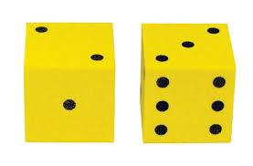
- Choose activity from colored sheets
- Complete number of reps/ seconds = die total
- Complete 1 activity from each color sheet
Red
1. Run or skip across the gym
2. Virtual Jump rope (pretend you have one!)
4. Jumping Jacks
5. Touch 5 different polyspots with your elbow
6. Skaters
7. Burpees
8. Ski jumps
Green
- Windmills
- High Knee Walk
- Swinging arm hugs
- Frankenstein walk
- Over the fence
- Carioca (lead w both legs)
- Side skips (lead with both legs)
- Cross country skiers

Blue
- Lunges (each leg)
- Squats
- Donkey Kicks (each leg)
- Bird Dog (each leg)
- Plank ups
- Pelvic lift (hold each one for 2 secs)
- Standing side leg raises (each leg)
Yellow
- Push ups
- Bear Crawl
- Crab Walk
- Plank
- Mountain Climbers
- Crunches
- Walk outs
- Triceps dips

The Money Game (Jennifer Higgins)
- Equipment Needs: paper money with a number 1-4 on the back; exercise sheets; equipment to complete exercise; hula hoops
- In the center of the playing area, put the paper money in containers or hoops.
- Set up hoops for each team around the outside of the playing area.
- Have students get into groups of 4-5 and sit by one of the hoops.
- On the go signal, one student at a time will go to the center and pick up one bill and bring it back to the group.
- Using the exercise sheet provided, the group must determine which exercise they must complete based on the denomination chosen and the number on the back of the bill.
- After the entire group has completed the exercise, the next student will go to the center and bring back another bill and the process gets repeated until there is no money left.
- At the end of the game, have each group add up how many dollars they earned.

Monkeys & Baboons
- Students are divided into two groups, the monkeys and the baboons
- The monkeys place a bandana in their waist band on the back for a tail and run around the room
- The baboons try to snatch the tails, if they do the baboon becomes a monkey and the monkey becomes the baboon

Mosquito Tag
- Need 4 cones, 3 noodles (1 per 15-20 students) set up cones to mark off 20x20 stride area
- Three taggers w/noodles try to freeze entire class.
- If tagged you must kneel down
- To be freed, two students have to Hi-10 above you and yell “OFF!” or any other type of bug repellant.
- Students can kill the mosquitoes by getting 8 students together (shoulder to shoulder) and at the same time clap their hands in unison as if they crushed the mosquito in their hands.
- If they don’t clap in unison, the mosquitoes live, and if they do three more students become the mosquitoes
- Mosquitoes love to tag people in line before they can clap

MOVATHON
  - This activity can easily turn into a fitness related activity with or without equipment.
  - The leader takes the group through a series of locomotor movements such as walking, running, crawling, galloping, sliding, and skipping as individuals and on command in groups of 2, 3, 4, etc.
  - When the leader says "stop" group members should stand quietly with their hands on their hips. As the group is asked to move in groups they may choose to hold hands or simply be close as they move.
These challenges will add social awareness and cooperation to the movement experience and establish another positive means for controlling students' actions

Movin’ It Routine
- Lively music
- Students should form in 4-5 lines equally spaced apart consisting of 6-7 students
- Teacher leads aerobic routine:
  - Jog in Place; jog on spot 16 times keeping in time to the music by clapping your hands
  - Jumping Cross-overs; place hands on hips and jump feet apart, then jump feet to cross each other. Alternate the front foot each time when crossing feet. Keep in time for 8 cross-overs
  - Twist Hops; extend arms sideways to shoulder level. Keep feet together as you twist your trunk from waist down. From side to side 8 times
  - Elbow to knee touches; hop on right foot while bringing the left knee up to touch right elbow. Switch and do left elbow to right knee. Repeat 8 times
  - Rocker Step; hop twice on left foot while bringing the right knee up and forward. Then hop twice on right foot bringing the left back. Repeat 8 times
  - Side Kicks; swing right leg to the right side while hopping twice on the left foot; the swing the left leg to the left side while hopping twice on the right foot. Repeat 8 times
  - Sprinter; drop down to front support position with one leg extended back and the other bent forward. Alternate leg positions for 8 times
- Repeat sequence until music is done

THE MR. MAN GAME (K-1)
- This is an easy warm-up involving no equipment. Say the name of a Mr. Man and children have to move like him.
- Mr. Slow - move slowly.
- Mr. Rush - move fast.
- Mr. Jelly - shake your whole body.
- Mr. Muddle - walk backwards.
- Mr. Bounce - bounce!
- Mr. Small - crouch and move.
- Mr. Strong - move flexing your muscles.
- Mr. Tall - stretch up and move

Multi-Shuffle Swamp Pass
- Students in groups of 6-8 each standing on 1 carpet square plus 2 or 3 extra for the group
- Students lined up except the last 2 students who shuffle forward until he/she is in the front, then they take the extra carpet square and pass it back to the next student at the end of the line
- Continue the sequence until group moves across the play area or everyone “shuffles” a designate number of times

Musical Fitness Dots Erika Buscaglia
- Grades K & Up
- Poly spots, posters
- Have one poly spot for each student
- On the signal, students begin to use a designated locomotor movement around the area
- When the music stops, students stand on the nearest spot and perform the exercise that corresponds with that color
- Give 12-20 seconds for each exercise and start the music again

Musical Islands Erika Buscaglia
Grades K – 5
- Hula hoops, music
- Students scattered throughout area
- Students gallop, skip, slide, etc. while the music is playing. When the music stops, everyone must step into a hoop. More than one student can be in a hoop
- Start with 15-20 hoops and eliminate hoops while music is playing

Musical Jump Rope
- Begin by placing all jump ropes in a straight row in the middle of the gym.
- Have students line up next to a rope.
- When the music begins the students must jog in a line around the jump ropes.
- When the music stops the person nearest a jump rope will begin jumping until the music begins again.
- When the music starts the students with the jump ropes lay them back on the ground and begin jogging again.
- Continue until everyone has had the opportunity to jump rope a few times.

Muscular Strength and Muscular Endurance Tag
- Equipment: Foam Balls, Dumbbells/Stretch Bands, cones
- Choose two students to be taggers. One is muscular endurance and the other is muscular strength.
- Give each of the taggers a foam ball.
- Allow the other students to scatter about the playing area.
- On the signal, the taggers try to tag the rest of the students.
- If the muscular endurance tagger tags someone, he she would call out, “Endurance”.
- The student tagged by the endurance tagger would then go to the side of the gym that was designated as the endurance side. He/she would run three times around the playing area
- A student tagged by the muscular strength tagger would move to the strength side of the gym, where he/she would try to perform bicep curls using enough stretch bands to make it impossible for him/her to complete more than eight repetitions.
Never Ending Relay Erika Buscaglia
Grades K & up
- One bucket or ring, one playground ball or basketball for each line
- Students line up in groups of 4
- On the signal the first student dribbles down to the bucket/ring, places the ball in the ring and performs an exercise (sit-ups, Trojan push-ups, crab kicks, etc.) picks the ball backup up and dribbles back to the next student in line.

FITNESS STATION IDEAS (Chad Triolet)
NOODLE CRUNCHES
- Students will find a partner and will move to the set of mats.
- One partner will lie on the mat and keep their feet off of the mat.
- The other partner will hold their feet down.
- On the side of the mat where the persons head lays, the teacher will place a hula hoop with 10 noodles in it.
- Behind the partner holding the feet, their will be a bucket.
- When the time begins, the student on the mat will take one noodlette at a time and sit-up and toss it into the bucket.
- When they have shot all 10, then the partners will switch.
NOODLE BUCKET RELAY
- Students will collect two noodle pieces out of a hula hoop at a time.
- They will then run to the opposite end of the gym and try to shoot each noodlette into the bucket.
- If they have a partner, when they return, their partner will get a chance to complete the task.
- The object is to see how many noodlettes they can get into the bucket.
NOODLE PUSH-UPS
- Place two poly spots on the floor about 3 inches apart.
- On one poly spot, stack 4-6 noodlettes.
- The object is to move the noodlettes onto the other poly spot one at a time while staying in push-up position.
- The students must alternate hands each time they move a noodlette over to the poly spot.
- This is a partner activity, once Partner A completes the task Partner B will take a turn.
- The activity continues until time expires.

Noodle Hockey
- 2-3 gator skin (or similar type) balls and enough noodles for each student.
- Students must keep both hands on the noodle
- Goals are two cones placed 6’ apart and at either end of a basketball court.
- Scoring can occur from the front or back of the goal, and play is not stopped by a goal.
- No players may kick a ball, including the goalies
- No checking, or carrying the ball
- Play for two minutes shifts

Number Scramble Erika Buscaglia
Grades K & up
- Deck of cards scattered on floor, face down
- On signal students move around area. When music stops students stand next to a card, pick it up, and perform a skill that number of times (hop on one foot, jump over line, shoulder touches, cab kicks, etc.)

Odds & Evens Erika Buscaglia
Grades K – 5
- Number cards (evens on one side, odds on the other)
- Scatter cards throughout area, divide class into two teams – odds & evens
- On the signal the odd team turns the cards so the odd number is up while the even team turns the cards so the even numbers are up.
- VARIATION – vowels & consonants. Vowel team turns up vowels while the consonant team turns up consonants

Olympic Country Tag
- Set up 20 x 20 area and students spread out in between the cones
- Select 2 students to be taggers with noodles
- Taggers run in the same direction as students to try to tag them with the noodle
- When tagged, the student has 4 seconds to name a country, if not they become the new tagger
- Can add another tagger or two to keep the activity moving

On a Roll (K & up) Thanks to Erika Buscaglia
- Give each student one die or a set of dice
- When the music starts, have the students use various locomotor movements around the area
- When the music stops, the student rolls the die and performs that number of a designated exercise. Students repeat until the music starts again
- After a few rolls of one die, roll two. Have students multiply the numbers, subtract largest from smallest number

One on One Moving Volleyball
- One 8’ or 9’ jump rope; a balloon, volley trainer, beachball, or gertie ball, etc
- Four students to a group, two holding the “net” (rope) and two students on opposite sides of the net.
- Play one on one volleyball over the short net, counting the number of hits the two students can strike in a row
- Once this is successful the two enders move around the area slowly.
- They can change from high to low, turn in a circle, walk together in all directions—the key is that they must talk
- After about 5 minutes, switch roles

1 vs. 1 Pirate Ball
- Divide the class into 2’s or 3’s and match groups to play against one another
- Set up a play areas about 20’ x 40’, enough to have all groups playing
- Divide each area in half and place a cone with a tennis ball on top at each end of the areas
- Players line up their groups at the end of the playing area opposite another group
- On signal, the first student from each group enters the playing area and has two options (which can change at any time)
  - First option is to play offense and try to get the other team’s tennis ball
  - The second option is to play defense and stop the other student from taking their ball by tagging him/her before they can get the ball
- If the ball is taken, the team that took it gets a point; replace the ball and play starts again with the next student in line.
- If a student tags another, both students return to their lines and high-5 the next student in line who continues the game
- Have the teams switch to play against other teams

One vs. Five Tag
      - Divide a large playing area in half with sidelines and end lines
      - Two teams are assigned to either side of the playing field. One team is the taggers (5 students for class of 30, 10 for class of 60) the other team is the players
      - Taggers need to be wearing pinnies
      - The object of the game is to make it to the opposite side of the area without being tagged, scoring a point for the team each time a student makes it across
      - If you make it across, you walk up the sideline out of play, and tag the teacher to register your score, then start back on their side to try again
      - If tagged you go to the other sideline and perform a quick exercise (3 jumping jacks, push-ups – sit ups etc.) then return to your side to continue
      - After one minute, allow the students (taggers & players) to strategize

Oogedy Boogedy Tag
- Purpose of Activity: To provide a fun way for students to practice their chasing, fleeing, dodging, and tagging skills.
- Prerequisites: Students should have had prior successful practice in moving safely through general space without running into anyone, as well as an introduction to the different skills for chasing, fleeing, and dodging (i.e., change pathways quickly to avoid a tagger; twist to avoid a tag; etc.).
- Suggested Grade Level: 1-2
- Materials Needed: foot longs or demi-noodles for tagging.
- First explain what an "oogedy boogedy" is: you shake your whole body while saying "oogedy boogedy". Practice it with the group a few times! Then explain the rules of the tag game as follows, and proceed to play.
- Pick three or four students to be "it"; these students hold the foot long noodle. On your "go" signal the game begins.
- The taggers then proceed to tag as many students as possible.
- If a student gets tagged, he or she goes to the center of the gym and does three "oogedy boogedies".
- After a short duration, have the students with the noodle hand it to another student who has not had it already. Make sure everyone knows who are the new "its", and begin play again!

Ostrich Nest
- Equipment; hula hoops (one for each group of 3-4 students plus one extra), tennis balls
- Place the hoops in a large circle formation with 3-4 students behind each hoop. One hoop is in the middle of the circle with tennis balls. There should be one more tennis balls than there are groups (10 groups = 11 balls)
- First student from each team starts by taking an “ostrich egg” from the center hoop (nest)
- They place that egg back in their hoop, and go to the end of their line
- Next student goes out to get an egg from the middle, however once all the “eggs” are gone form the center, students can steal eggs from other nests
- Students can not take an “egg” from a neighbor they can only take from groups away from them
- Game ends when a team gets three “eggs” in their nest and the team yells out “WE GOT THE EGGS!!”
- Remind students they can not guard their nest, no sliding or diving

Overload Tag
- 4-5 students as taggers holding foot long noodles
- When tagged students must look for others who have been tagged and then assume the push-up position next to another tagged student.
- When three tagged students are side by side in push-up position, they perform 5 Trojan push-ups, then they are all free to rejoin tag game

Over Under Around and Through
- Groups of 3 people, 2 of the 3 with hands joined (holding wrists, small rope, or use a juggling scarf between) and the third person acting as the “runner.”
- On “GO”, the runner must step over his/her partners hands run around and go under their hands, run all the way around the two partners, then step through the joined hands, the runner must start on the same side for each movement. Each partner then takes a turn being the “runner.” Once the group has this pattern established the following changes begin:
  - Race the other groups, sitting down when finished or how many times can you perform the routine in 20/30 seconds. (Ask students how they made faster/slower. What makes it easier, faster?) All three must complete the pattern for their group to be finished
  - Scramble the order, (ex. Around, over, through, under)
  - Hold up cards with words printed on them to change the order
  - Use sign language to give the instructions/order
  - Allow students to exit/enter on either side (should be faster)
  - Allow students to make up own order for speed, everyone must be a runner.

Oxygen Cycle
Suggested Grade Level: K-2
- Three objects, per student, which are small enough to carry in one hand. (i.e., beanbags); . Two big buckets or four small ones that will hold all the small objects.; Three large signs. One should say, "Mouth", one should say, "Heart", and one should say, "Muscle".;. About 30 cones.
- Students run clockwise around a track in the gym, pretending they are the blood that carries oxygen through the body.
- First of all, students go to the "mouth" station where they take three big breaths and pick up an object that represents oxygen (i.e., beanbag).
- Secondly, they run to the "heart" station and contract their whole body (see the explanation below), pretending to be a heart.
- Third, they run to the "muscle" station where they put their beanbag into a bucket and perform a designated exercise (i.e., 10 jumping jacks)
- Fourth, the students have "run out of oxygen" and must go back to the mouth to get more.
- Remind students that they must stay in the track because it is like the arteries in the body.
- Teach the students that when they exercise they begin breathing harder, and that when we breathe we take oxygen into our bodies. (Have everyone take three deep breaths.)
- Remind the students that when they exercise their heart beats faster, which makes the oxygen go through their whole body. (Have everyone simulate the heart pumping by having them stand with their arms up and then contract their whole body.
- An alternative to this is to have them lay on their back while they contract their whole body. Say, “Oxygen helps me exercise.”)
- Ask them if they can think of any examples of exercise. (They'll probably say jumping jacks, pushups, etc.) Then have everyone perform 5-10 of that particular exercise.
- After they understand what to do at each station, ask for a couple of volunteers to run the course so everyone can watch.
- You can vary the number of breaths they take at the mouth, the number of compressions at the "heart" station, the number or type of repetitions at the "muscle" station, or the type of movement to use when moving through the "artery" (the running path).
- Teaching extension for older children: As children understand how the blood flows within in their body, set up cones inside the "artery" to represent cholesterol. Cholesterol buildup makes it hard for the blood to flow freely through the arteries. Students cannot go through the cones or over them; they must go around them.
- Have the students spread out. Call out the words, "mouth", "heart" and "muscle" in random order, and when they hear the word they perform the activity for that station.

Partner Dice Scramble –
- One partner rolls a large foam die anywhere in the room.
- The other partner runs to it and does that many exercises (ex. Push-ups), then throws the die somewhere else for the other partner to chase.
- Use the die as a touch point for the push-up.

Partner Flag Grab
- Equipment; 1 flag or flag belt/student, 4 cones to mark off 20 x 20 area-depending on size of class
- Students get partners (if an odd number of student have one group work in 3’s)
- On signal, each person tries to take partners flag without losing their flag
- Group of three each tries to take each other’s flags
- (if an odd number of student have one group work in 3’s rotating the front person)
- (if an odd number of student have one group work in 3’s rotating the front person) B (if an odd number of student have one group work in 3’s rotating the front person)
Variation; play game in groups of three or four; have partners go against another set of partners (both partners would have to lose their flags for the others to win)

Partner Knee Bent Sit-Ups
- Student standing in pairs (away from other pairs), with one partner holding a ball.
- The music starts and the students begin moving around the area while passing the ball back and forth while waiting for the teacher’s directions
- After about 60 seconds, the music stops and the partner players sit down and face each other with their knee bent and begin chest passing the ball back and forth as they perform knee bent sit-ups
- After one pass, both students go back down, and back up in unison and chest pass the ball once, each time that they arrive in the up position
- After about 30 seconds, teacher signals students to stand and begin moving, tossing and catching.
- Use voice commands to get students to pass the ball in different ways while walking. Examples:
  - Hook shots
  - Low throws
  - Side arm throws
  - Other hand throws
  - High catch
  - Over the shoulder catch
  - Other hand shot put
  - Arc tossing
  - Highest point throws
  - Fancy toss
  - Roll it
  - Shot put
  - Jump shots
  - Low catches
  - Other hand hook shots
  - Chest passes
  - Overhead passes
  - Overhead catches

PARTNER MATH
  - Place the digits 0 through 9 on the floor in a straight line with 3 to 5 feet between each digit.
  - The row of digits will serve as a dividing line between players or groups of players. One player is on one side of 0 facing 9 and one player is on the other side of 0 facing 9.
  - The leader will call out a digit and the players will move to be beside that digit as quickly as they can. For example if the leader says "6" both players try to get beside 6 as quickly as they can staying on their side of the digits.
  - This is great for number recognition for younger players and math problems can be added to challenge older players. For instance 2 X 8 would require players to go to 1 and then to the 6.
  - This can be done by putting the digits in a circle and having players inside and outside and you may also put the digits on the wall and have the entire group move up and down the floor as you call out digits and problems. Sometimes I let them dribble a ball as we do this activity.

Partner Racetrack Fitness
- Equipment: cones, task cards with physical activity tasks fastened on cones
- Split group in half using a partner strategy
- Have students find a partner to begin activity (partner 1 jogs; partner 2 performs inner circle activity)
- Large circle/square is set up using 6-8 cones
- Inner circle includes the task card with several stationary health-related physical fitness activities
- Once activity begins, students switch on paused music (NOT when one lap is completed!) from jogging to inner circle activity and visa versa
- Students DO NOT need to go back to original partner!!
- When music stops, jogger stops and finds nearest cone and chooses next activity down the line…inner circle partner begins jogging

Partner Resistance Activities
- Equipment; task cards and cones for each resistance activity
- Partners spread around gym
- Students should be matched for strength and size
- Activities should be performed through the full range of motion for 8-12 sec.
- Partner providing resistance should give a “BEGIN” command and count the duration of the activity
- Each partner should perform 1 set the first time the activity is introduced and up to 2 sets later on
- Develop a task card that alternates between upper and lower body movements as well as large to small muscle groups
- Variation; Students create their own routine using teacher specified activities

Partner Run & Walk
- Objective: Aerobic endurance
- Equipment: Cones
Set-up: The cones are placed in a large oval.
- The students form pairs.
- The pairs of students are scattered around the outside of the oval (partners standing next to each other).
- On the signal to begin, Partner 1 begins running counter-clockwise around the outside of the oval, while Partner 2 begins walking in the same direction.
- Partner 1 remains running until she catches Partner 2.
- When this occurs, Partner 2 begins running and Partner 1 walks.
- The activity continues with the partners taking turns running and walking for the allotted time.
- Safety: Warn students to watch out for others as they run around the cones.

Passing Pizza Stretching Routines (if you don’t have pizzas, use Frisbees)
(John Smith)
Partners Standing Back to Back
  - Over and under
  - Reverse over and under
  - Side to side pizza passing
  - Reverse side to side pizza passing
  - Figure 8 side to side pizza passing
  - Reverse side to side figure 8 pizza passing
  - Extended (step away from partner) side to side figure 8 pizza passing
  - Over the shoulder pizza passing
  - One hand side to side pizza passing
  - One hand opposite side pizza passing

Group Pizza Passing Activities
- In a row of 3-5 passers, pass the pizzas over heads to the end of the line
- Pass the pizzas through the legs to the end of the line
- Alternate over and under to the end
- Pass the pizzas along the right side and back down the left side
- Pass alternating right and left side, weaving the line
- Pass the pizza down the line and get to the end before the pizza gets there
- Pass 2 pizzas over the shoulders at the same time, one down the right and one down the left
- Pass 2 pizzas along the hips both at the same time, one down the right and one down the left
- With each person alternating front and back, pass the pizzas down the line alternating over and under
- Pass several pizzas down the line using your elbows

Partner Knee Bent Sit-Ups
- Student standing in pairs (away from other pairs), with one partner holding a ball.
- The music starts and the students begin moving around the area while passing the ball back and forth while waiting for the teacher’s directions
- After about 60 seconds, the music stops and the partner players sit down and face each other with their knee bent and begin chest passing the ball back and forth as they perform knee bent sit-ups
- After one pass, both students go back down, and back up in unison and chest pass the ball once, each time that they arrive in the up position
- After about 30 seconds, teacher signals students to stand and begin moving, tossing and catching.
- Use voice commands to get students to pass the ball in different ways while walking. Examples:
  - Hook shots
  - Low throws
  - Side arm throws
  - Other hand throws
  - High catch
  - Over the shoulder catch
  - Other hand shot put
  - Arc tossing
  - Highest point throws
  - Fancy toss
  - Roll it
  - Shot put
  - Jump shots
  - Low catches
  - Other hand hook shots
  - Chest passes
  - Overhead passes
  - Overhead catches

Pass the Fat Tag
- Equipment needed; 4 cones (30 x 30 depending on class size), 1 bicycle inner tube/2 students 5 large sponges or noodles 1/10 students
- Students pair off and get inside a tube, (if no tubes, just link elbows)
- Chose 3-6 pairs to be it and give them the “fat” (sponge/noodle)
- If you have the fat you try to tag another partnership
- Once tagged, the partners must freeze to receive the sponge
- Now the have to get rid of the fat by tagging another partnership—there are no immediate tag backs
- At the end of designated time, 1 minute/round the students who have the fat must perform 10 jumping jacks while the rest do 5.
- Continue with 2-4 more rounds

Penguin Shuffle Erika Buscaglia
Grades K-2
- Each student has a beanbag and lines up along one side of the area
- Explain that the beanbag is a penguin egg and they must not break the egg
- Students place their egg on top of their feet. On the signal, students shuffle across the area without dropping their egg
- If their egg falls, they must jump over their egg 10X before continuing
- Variations:
  - Place egg on top of head
  - Crab walk with egg on stomach
  - Different exercises – Trojan push-ups, crab kicks, etc

Pickleball Relay
- Set up 1 row of 6 cones 3-4 feet apart at one end of the basketball court or other area.
- At the other end of the gym position 10 students in front of each cone.
- The first student in line will be equipped with a pickleball or other ball of similar size.
- On your signal the first student in line will dribble the ball to the cone, around the cone and back.
- As the student returns to the line the student hands off the pickleball to the next student in line and play continues until all the students in line have a turn at playing.
- Mishandling the dribble will cause the student to perform 3 push-ups before being allowed to continue.

Pickleball Tag
- Set up 5-6 areas of 8-10 cones in a large circle.
- Divide students into groups of 10-12 per circle.
- Place one student in the middle of the circle holding a pickleball, while the remainder of the students stand outside of the cones.
- On your signal the students outside the circle will run across the circle and the tagger will attempt to tag with the pickleball. The pickleball may not be thrown.
- Any student tagged becomes the “tagger” but must first perform a physical activity that the rest of the circle also performs

Pick Up the Pieces (Gr 1 and up)
- Need bins, poker chips, basketballs
- Scatter poker chips around the floor & place bins around the edges of the area.
- On the go signal, students begin to dribble their ball with one hand and pick up one poker chip with the other
- Students dribble to the corresponding bin to place the chip inside
- Repeat for a set time

Pirate Ball I
- Divide the class into four teams, give each team a set of pinnies
- Each team will be assigned four distinct objects such as 4 soccer balls, 4 pins, 4 bean bags, 4 footballs, etc
- Each team will also have a hula hoop in the center of their area for a holding space
- Divide the area into four equal spaces, one team assigned to each space where they cannot be tagged by another team
- Each team keeps one of their objects, the other three objects are placed in the other three team areas in the corner opposite their hoop
- When play begins, players may go into any space to get ONE object; it does not have to be their object either.
- If a player can get back to their area without being tagged, they place that object in the corner and go for another one
- If the player is tagged, they go to the hoop in that area and wait for one of your teammates to get to you without being tagged
- When a teammate gets to you, the two of you join hands, (link elbows), so that you are safe to return to your area. You must go back to your area before rejoining the action
- The object is to be the first team to get all four of their objects.

Pirate Ball II
- Divide the playing area in half and assign half the class to each end.
- Place five cones, with a tennis ball on top of each, at the end of the playing area
- The task is for each group to take all the tennis balls from the opposing team. Students can only take one ball at a time
- If tagged on the opposing team’s side, the tagged player goes to jail (the jail is only large enough to hold one student, so when another is tagged the first one is free to enter the game again
- If a ball is captured, the player has safe passage back to his/her side
- The captured ball is placed in a bucket back with the teams cones
- After crossing into the other team’s side, a student can choose to get his/her teams ball back or take a ball from the other team. Can only do one or the other once the student crosses into the other side.
- When a team captures all the other teams balls the game is over or you can set a time limit

Polar Bears & Crabs Erika Buscaglia
Grades K & up
- Divide the class in half; one half of the students are polar bears (Push-up position); & crabs (Crab walk position); the other half are the over/under group
- On the signal, the over/under group crawls under the polar bears and step over the crabs
- Once s a student goes under a polar bear or over a crab, the “animal” switches to the opposite “animal” (polar bears become crabs and crabs become polar bears)
- After 1 minute change roles

Popcorn
- Need container with 30 or more beanbags, or similar small object (Kooshballs)
- All the bean bags are in the container while students spread out in play area
- Choose 1 – 2 students to be the “popcorn makers”
- The object is for the students to make sure that the container always has at least one beanbag in it, while the popcorn makers throw beanbags out ONE AT A TIME ONLY!!!
- On teacher’s signal the popcorn makers begin tossing the beanbags out.
- Students return the bean bags one a time
- The popcorn makers can not block the return of any beanbag
- Variation; assign one or two students to be the only ones to return the bean bags to the container

Pump It Up With Paper Plates!
Suggested Grade Level: K-2
- Music; wide masking tape already stuck to walls (enough for one per student); one paper plate per student (plus extras if needed); and one yarn ball per student.
- Gym Set up: Spread out paper plates around the floor (lip up). Roll pieces of tape and stick on the walls, about waist high, throughout the gym. (Enough for each student, plus a few extras.)
- Intro: Students come in and stand beside a plate. Quickly explain to your students that they will be using paper plates today. Let them know that they can be creative at home with these activities. Remind them to take care of the plate and remember personal space.
- Activities:
  - Coffee Grinder Tag- Pick 2-3 taggers. If tagged, take your plate to the corner and do 1-2 coffee grinders. A Coffee Grinder is done by supporting your body with one arm. Hand on paper plate. Walk your legs around as the plate lets you spin. Change taggers periodically.
  - Paper Plate Boogie- Students follow the “aerobics instructor” through an aerobic routine using the paper plates. Pick some upbeat music and have fun. Lead the students with directional cues. Get your heart pumping! Check your heart rate after to see the effects!
  - Travel Time- Students travel through the gym to music and freeze with the heel on the center of the plate when the music stops. Try the elbow, knee, etc., and ask for a body part idea from a student. Try jumping over plates (I like to call them "mud puddles") as you move!
  - Target Practice: Ask students to stick their paper plate, lip up, on a piece of tape. Next, they get one yarn ball and freeze. Discuss “targets” and discuss “throwing.” When the music starts, students travel around the gym. When the music stops, they must go to the wall and put their yarn ball in the middle of a plate. This will be their target. Take 3-5 steps away and overhand/underhand throw to the target.
  - Statues- Students stand back to back with a partner. When they hear music, they move away from their partner. When the music stops, they find the same partner and form a statue using the paper plates as props. Try letting them change partners (2nd grade) each time.
Variations:
- Encourage them to lead an aerobics routine with paper plates to family members. They love it!
- Let the children decorate their plate with a favorite scene from a physical education class to hang on the gym wall!
- And/Or...
- Try... Targets with a Twist: Have colors or letters on the paper plates. Ask students to travel to the plates and hit the ones that spell their name, favorite sport, color, their age, etc.

Push Up Ball Fury
- Equipment; 1 to 3 softi-balls, tape to use as line markers
- 4-6 players on a team
- Each team forms a wall on the line, shoulder to shoulder, with their teammates (using the tape as a line marker).
- The two teams face each other with about 3-5 yards of distance between each team. Both teams get in a push up position.
- From the pushup position, their hands should be placed on the floor just in front of the line.
- Begin the game with one ball then add more to allow more students to be active in the game.
- The object of the game is to push the ball to the other team, in hopes of getting the ball to cross their line.
- Players have to support their body with one hand while trying to push the ball or stop the ball. (Encourage students to use whichever hand is closest to the ball).
- Students may take no more than a 10 second break (placing knees on the floor-modified pushup position). But they may not push the ball in this position. If they try to stop the ball while knees are on the floor-it is a point for the opposing team.
- Variations: Allow students to use the modified pushup position (knees on the floor).

Push-Up Challenges
- Students find a partner to work with, then work on upper arm strength by doing the following activities:
  - Standing face to face palms together, feet out away from each other (so that you are leaning on each other). Push-ups done so that heads come close together. How far apart can you and your partner get and still do the push-ups?
  - Partner patty cake- face your partner-Hi 5 right hand to right hand, left hand to left hand, etc., this can also be done in crab position, (foot to foot or hand to hand). Can you and your partner make up a routine?
  - Push-up hockey- One of you gets a bean bag, ball or any small object. Then, face your partner in push-up position about 5 feet apart and try to slide or roll the object between your partner’s two hands. Partner may stop it with one hand only.
  - Steal the Shuttlecock - Work in partners
    - Both partners are in the push-up position facing each other
    - Line 3-4 nylon shuttlecocks in between partners
    - Staying in push-up position, the object is to try to grab all the shuttlecocks and bring it to your side (shuttlecock must be standing)
    - You can reach over to your partner’s side and steal your partner’s shuttlecock

Quarter Tag/Catch
- Boundary is divided by 3/4 and 1/4 areas, going across the width of the gym. Put tape or polyspots on the floor to create an invisible wall that the students cannot pass through while playing the tag game. Choose 3 students to be Taggers.
- In the 3/4 area a regular tag game is played. If a student is tagged, they are given the magical ability to pass through the invisible wall
- Once on the 1/4 area of the gym, the student will need to get one ball and make 2-5 catches.
- Catches can be made with a bounce, without a bounce, or off a wall. After making the catches, the students place the ball back in the container and they can re-enter the tag game. Change the taggers every few minutes and after playing several games

Quick Dragon Ball
- Entire class scatters, two students have a 8 1/2” foam ball
- On teacher’s signal, the two students throw the ball to someone else, then they run up behind them placing their hands on the shoulders of the catcher. Catcher must wait for thrower(s) to line up behind them.
- As soon as the connection is made the catcher throw the ball to another student and the dragon continues to grow
- Which group will have the most students?

Quick Feet
- Each person with a poly spot. Poly spots will take the place of agility ladders in your class.
- All drills are for a set time. Start at 10 seconds and lengthen time as students become more conditioned.
- Part 1: “Skier” Feet together, stand next to spot. Jump sideways on to the spot; jump back to starting position.
- Part 2: “Bell” Feet together, stand behind spot. Jump forward on to the spot; jump backward to starting position.
- Part 3: “Double Skier” Feet together, stand next to spot. Jump sideways on to the spot; jump sideways to the far side of the spot; jump back on to the spot; jump back to starting position.
- Part 4: “Double Bell” Feet together, stand behind spot. Jump forward on to the spot; jump forward to the far side; jump backward on to the spot, then jump backward to starting position.
- Part 5: “Step Up” Feet together, stand behind spot. One foot steps on to the spot, followed by the second foot on to the spot. First steps back off the spot; second foot steps back of the spot to the starting position. (up-up-down-down)
- Part 6: “Double Up” Feet together, stand behind spot. One foot steps on to the spot, followed by the second foot on to the spot. First steps forward (to the far side); second foot follows to the far side. Repeat moving feet backward. (up-up-up-up-down-down-down- down)
- Part 7: “Switches” Start with one foot on the spot and the other foot off the spot. Jump and switch feet. One foot is always on the spot.
- Part 8: “Side Stepper” Feet together, stand by the spot. Inside foot steps on to the spot, followed by the outside on to the spot. Both feet are now on the spot at the same time. First foot steps off to the far side, followed by the second foot. Repeat back toward starting position. (on-on-over-over-on-on-over-over)
- Part 9: Perform above drills on one foot only. Try one drill on the dominant foot, followed by the non-dominant foot. Compare and contrast scores.
Part 10: Perform above drills (Part 1-8) in push-up position, moving hands instead of the feet.

RACE BASE
  - Divide the group into two teams. Each team will have a field base and a home plate.
- The batting team can put the ball into play by kicking, throwing, hitting of a tee or a pitch, and punting. This should be determined before the game is started so the fielding team will know what to expect.
  - As soon as the ball is put into play, the batting team follows the batter who leads them around their base in the field and back across their home plate. The fielding team follows the person with the ball across their field base and then to home plate. The team that crosses home plate first gets a point. Everyone must touch both bases. Play everyone bats and switch the teams.

Race Course
- Divide the class into groups of 4, each standing behind a cone in the center of the gym, facing, in relay formation, the sideline
- On the signal, the first student in the group begins to run the perimeter of the gym, while the remaining students in the line perform jumping jacks
- As the students are running the perimeter and performing jumping jacks, teacher calls out one of the following signals:
- Push-ups,
- Crunches
- Mountain climbers
- Crab kicks,
- Balance on one foot, switch
- Crab walk
- Plank
- After 15 seconds, give the “go” signal for students to return to their aerobic activity
- After completing one lap, the runner tags the hand of the second student who begins to run
- This rotation continues until everyone ahs had 2-3 turns as the runner
- Keep students rotating through this activity as quickly as possible; only give 1-2 challenge tasks be given for each lap

Rat Race
- Four cones and a lively music
- Set up cones to create a safe track for students to jog around
- Students are positioned outside the cones
- While music is playing the students jog around the “track”
- When the music stops, the “rats” (students) move forward only (not allowed to go against the flow of the rat race) to find a partner & sitting inside the cone track
- After 5 seconds (teacher can count off), any student without a partner does five jumping jacks (teacher can change the exercise for each stoppage of the music)

Relay Tag (Chip Candy)
- Line of three in a circle around the perimeter of the area
- Student 1 runs out, five seconds later second student runs out to tag number 1 student
- Once tagged, student 1 runs back and tags student 3, who then goes to chase number 2
- That way the rotation keeps going with a runner, a tagger, and a rester
- Can use Demi-noodles to tag with.

Rock, Paper, Scissors Tag
- Everyone is it
- On signal try to tag other students without being tagged
- If you get tagged, or you tag someone, play rock, paper, scissors.
- Person who wins gets up and rejoins game
- Person left goes to sideline and must perform an exercise--jump rope 10 times, do 5 push-ups, 5 curl ups, 10 jumping jacks, etc.
- If anyone wins 3 consecutive games, they yell “All ___(boys or girls) are free!” and those students get up and join the game

“ROLLER COASTER RIDE” – Song: “Palisades Park”
- Students stand beside their partners in a column of partners.
- This activity promotes students jogging rhythmically as well as doing abdominal/core work AND working cooperatively.
- For the first part of the song, have students follow YOU as you move through curving patterns in the activity space, simulating a roller coaster’s path.
- On your signal, all students sit (by their partner as if they were in a real roller coaster) and follow your moves. First, fasten safety belts. To simulate “ascending,” students lean back. To simulate “descending,” students lean forward. Encourage hands in the air, lateral leaning as they “take a corner,” as well as yelling (optional).
- Part B. Students lead a small group, perhaps even single seat roller coasters.

Rubber Band Mountain
- Grades K & up
- Foam balls, hoops, cones
- Students are in pairs. Each pair gets a hoop, ball, & cone
- Partners stand across from each other with a cone in the middle. One stands in the hoop and the other has the ball
- The partner with the ball bounces passes the ball over the cone to their partner. That partner must catch the ball while keeping at least one foot in the hoop at all times
- For each successful catch, the pair earns one point
- Switch places after 10 attempts

Rubber Chicken Activities*****************************************
Barnyard Tag
- Select 3-4 students to be taggers and wear red pinnies, they are the farmers
- Give out 4-6 chickens to other students
- Farmers try to catch the students, they are the chickens always getting out of the chicken coop
- When tagged the chicken must go to back to the chicken coop (a small coned area or behind a restraining line
- If a student is tagged while holding a rubber chicken they must drop the chicken and go to the coop
- Chickens in the coop can get out if they can catch a chicken thrown to them by a comrade chicken and then they are safe to return to the play area
- Remember to switch “farmers’

Caught with the Chicken
- Two students will be designated as taggers and will be given pinnies.
- Out of the remaining students 15 will receive a chicken.
- The taggers can only tag a student who has a chicken. To keep from getting tagged, the students must throw the chicken to a student who is in an open space and does not have a chicken.
- If the chicken is dropped while thrown, both the thrower and the student to whom the ball was thrown must do 5 jumping jacks.
- If a student with a chicken is tagged, they must also do 5 jumping jacks.
- Students cannot throw it back to the person who threw it to them. And taggers should be changed often.

Chicken A-La-King
- Select 4-6 students to be “chicken hawks” and have them wear red pinnies
- Select another 4-6 students to carry chickens- these are the “rulers” (Super-Chickens) of the barnyard
- The chicken hawks tag the rest of the students, they’re just little clucks
- When tagged by the chicken hawks, the little clucks have to freeze in a dead chicken pose
- Super Chickens come to the rescue and drop their rubber chicken into the hand of the dead chicken to bring them back to life
- The Super chicken now becomes a regular little cluck while the former dead chicken becomes a Super Chicken
Remember to switch the chicken hawks after one minute

Chicken Pox Tag
- Select 4-6 students to be taggers and give them a chicken (carrier of pox)
- To get rid of the chicken, tagger must tag another student with their free hand
- When taggers tags another student they drop the chicken and go
- Student who was tagged picks up chicken and is now it
- There are no tag backs

Chicken Soup:
- 5-6 students per group, each with a chicken.
- When the music starts, underhand or overhand (teacher choice) toss the chicken to someone else in the group (have students create a pattern so everyone gets a toss)
- When the music stops, the person holding the chicken performs jumping jacks, while the others in the group run to touch all four walls

Chuck the Chicken I
- Use 6-12 rubber chickens, (or tie knots in towels) depending on class size – equal to about a third of the class.
- Assign 2-3 students to be it. Have them wear pinnies.
- To be immune from a tag, a player must be grasping a bird.
- Since there are only 10 birds in a class of 30, there is much “flipping of the bird”
- Students can only hold one chicken in the hand at a time.
- In keeping with the name of the game, the chicken must be tossed, and the throw can not be made back and forth between paired players.
- When tagged the student must go to the “Chicken Kitchen” (a small designated area) and perform these fitness tasks- 3 push-ups, 3 sit-ups, and three jumping jacks.
- Can you keep your classmates from being tagged?

Chuck the Chicken II
- Use 6-12 rubber chickens, (or tie knots in towels) depending on class size – equal to about a third of the class.
- Assign 2-3 students to be it. Have them wear pinnies. (add more taggers if action is slow)
- To be immune from a tag, you can’t be holding a chicken
- If carrying a chicken, to avoid being tagged the student can chuck the chicken to another student
- HOWEVER, if a tagger picks up a chicken from the floor or intercepts a chicken, (chicken can not be taken from a student) ALL students being chased must stop and do three push ups
- When tagged the student must go to the “Chicken Kitchen” (a small designated area) and perform these fitness tasks- 3 push-ups, 3 sit-ups, and three jumping jacks
- Students must be carrying chicken in their hand and can only have one chicken
- Since there are only 10 birds in a class of 30, there is much “chucking the chicken”

FLEW THE COOP –
- 2-3 students try to complete 10 throws before the other team touches or intercepts the chicken
************************************************************************
Run the Colors Erika Buscaglia
Grades K – 5
- Multi-colored cones
- Place cones in a square/rectangle with each side a different color
- Have students walk all sides of the area except one, make that side the run side
- After a few times around the area, make a different side another locomotor movement (Blue – run, red – Skip, etc.)
- Eventually making all 4 sides different locomotor movements

Run the Numbers Erika Buscaglia
Grades K-4
- Cones, task cards (#1-10), number strips, music
- Set up cones in a circle (or other shape), with the task cards attached and facing the middle
- Students get in pairs and receive a number trip
- Each pair will run to the first number on their strip, then to the second, then to the third, etc. when finished one strip they exchange it for another
- Each pair does as many as possible
- Vary the locomotor movements

Scat!
- Spread the cones out over a large area one cone for each student
- One of the cones, the Scat Cone, should be placed by you.
- Place one more cones about five yards in front of the Scat cone.
- When you yell the word "Scat", everyone must then run to a different cone. At the same time, send the first person in the Scat line into the field, thus having one more student than there are cones.
- The student left without a cone comes to the Scat Cone for a rest.
- Allow the student who is first in the Scat line to call out “Scat!”

Shadow Tag:
- Equipment; 4 cones (20 x 20 depending on class size), optional spy type music.
- Students in pairs with one partner standing with back facing other partner, who stand one arms length away (if an odd number of student have one group work in 3’s rotating the front person)
- On teacher’s signal the front partner tries to get away from “shadow”
- After 20-30 seconds signal is sounded and the shadow can reach out and tag their partner, that partner has to perform 5 exercises (push-ups, sit ups, jumping jacks, etc)
- If the shadow can’t reach partner, then they do the exercises
- Partners switch roles and continue playing

Shark Attack
- Divide the class into groups of four
- Each group has four bases spread out into a square 20ft apart
- One student, (the shark), starts in the middle
- The other students are on a base and they try to move to any open base, or switch with another student
- If the shark tags a student off the base, they trade places
- Students must stay in the base lines or across the middle

Sharks:
- Equipment; 1 set of flags/student, 4 cones (30 X 30 depending on class size) with 2 cones marking mid-field at the sideline
- Choose 2 “sharks to be in the middle of the area.
- Teacher signals for all students to cross to the other side without losing their flags
- If your flag is pulled, you join the sharks
- The round ends when all students lose their flags and the last two students become the new sharks
- Variation; if playing with two flags, students become sharks after their second flag gets pulled

Shipwreck
This is a multidisciplinary game using marine terminology. The playing area is symbolic of a ship. The “captain” of the ship calls out the commands, and the students perform certain tasks. The game is fast moving and students are required to listen and follow directions. The last student to accomplish the task may be given demerits and after three be sent to the brig to perform 5 jumping jacks. But that is optional. The tasks are:
- Name the parts of the ship and directions - bow, port, starboard, stern, east, west, - all the students run to these areas/directions
- Hit the deck - students lie down flat
- Roll call - students form one long line and salute the captain
- To the crows nest - students pretend they are climbing a ladder
- Sharks - students get in a circle and hide their heads
- Anchors away - Students assume the bicycle exercise position
- Swab the deck - students make a swaying motion with arms and body
- Bring the anchor - students pretend they are pulling in an anchor
- Abandon ship - (man the oars) two people pretend they are rowing’
- Man overboard - one student on all fours, another places a foot on the lower back and looks for the missing person by placing hand over the brow to shade the sunshine
- Mates in the galley - groups of three sit and hold hands
- Inspection - Students form a line three or four
- Man the pumps - students drop to pushup position and do push ups
- Signal the tower - students move their arms in a flat waving gesture
- Shipwrecked - sit back and hook arms
- Rescued - stand up without unhooking arms
- Batten down the hatches - do sit ups

Selfie Tag (Chip Candy)
- In a confined area (half of a basketball court), play a simple game of tag, with 3 to 5 taggers.
- Taggers carry something (ex. A rubber chicken) to designate them as “it”, and are allowed to tag 3 people.
- On the third tag, the tagger tells that person that they are now it and they give them the chicken.
- Once tagged, you freeze in place, raise your hand, and make eye contact with 2 others who are also frozen.
- The three people must exit the game and take a “selfie” before re-entering the game.
- Use chalk board erasers/rubber chickens/deck rings as the cameras (or use actual cell phones/cameras and compile the pictures).

SEQUENCE JOGGING (Hal Cramer)
Grade Levels: K-8
- Equipment: Numbers 1 – 30 taped on wall, Cards with sequences of numbers written on them. You’ll need enough cards to have one for every two students., 4 cones, upbeat music
- Tape the numbers 1-30 randomly around the walls of the gymnasium.
- Use the cones to mark off a 12’ x 12’ area in the center of the gymnasium – or use a center circle painted on the floor.
- Students work with a partner. Partners begin in the marked-off center area of the gymnasium.
- Each pair of students begins with one card listing a sequence of numbers.
- When the music begins, one partner runs to the wall and touches the first number listed on his sequence card. He then returns to the center and high-fives his partner.
- The second partner runs to the wall and touches the second number listed on his sequence card and the pattern continues.
- Variations:
  - Vary the locomotor movement used to travel to the wall and back.
  - Make task cards that say, “Count by 1’s,” “Count by 2’s,” etc.
  - Make task cards that list math facts, such as, “2+2= ___,” “7-3= ___,” etc.
  - Begin with 26 letter cards taped to the wall. Partners begin with a list of vocabulary words and take turns running and touching the letters that spell the words.

Sit Up Relay (Chip Candy)
- The group (8-10 students) lies down with knees bent, heads to feet in one long line
- On go, the first student performs a sit up and slaps the next students hands, who sits up and slaps the next, etc
- Once the student is done their sit up, they run to the front to continue the line
- This continues with each student running to the front as fast as possible - making this a a team relay race

Site Word Madness (K-2) Thanks to Erika Buscaglia!
- Set of sight word cards, spots; place a set of sight word cards on the walls, scatter polyspots on the floor
- Students work in pairs; one is standing on a spot, while the other is holding a site word card.
- On the signal, the student on the spot begins to jog in place, while their partner with the word uses a locomotor movement to find their word on the wall. Once they find the word, he/she returns to the pile of words and selects another card to take back to their partner
- The partners then switch places and continue the activity

Sit up group juggling
- Group of 4-6.
- Each group has 2 objects as group sits up together they pass the objects in order determined before beginning.
- Then lie down & continue sit-ups.
- See if you can add 3 or more objects to toss

SMUGGLERS (k-2)
- Warm up game using colored hoops and colored beanbags.
- Scatter the hoops around the area in which you are working.
- Split the class in half - smugglers or 'goodies'. The goodies have a 30 second head start to place beanbags in their correct corresponding colored hoop.
- On the signal, the smugglers 'steal' the bean-bags from their correct hoops and place them incorrectly.
- The 'goodies' have to keep going to try and remedy the problem.

Snowball Strikes Erika Buscaglia
Grades K-2
- Snowball sheet, crayons, balloons, paddles, colored posters
- Place colored posters on the wall. Put crayons that correspond to the poster color at each of the posters
- Give each student a balloon & worksheet
- Students select a poster to start and complete the striking activity and then color in a snowball at the station.
- Students then move to another poster
- Striking activities:
  - Green – tap balloon from hand to hand 10X
  - Red – tap balloon with a paddle 10X
  - Blue – tap balloon as high as possible 10X
  - Yellow – tap the balloon with forehead 5X

SOFTI” BALL ACTIVITIES
- Objective: This is a great way to get students to exercise their entire body.
- Equipment: “Softi” balls, enough for each student

Each student receives a ball and asked to listen carefully to instructions.
1. Squeeze the ball between their hands and make “BRAINS”, then let ball resume shape.

2. Squeeze the ball under the arms and behind the back.
3. Sit down and lay on the ball on stomach and then the back.

4. Curls ups with the ball in hands and tap knees with the ball.
5. Push ups over the ball, squish it with their body.
6. Put the ball between the knees and squeeze.
7. Put the ball between the ankles, lay on your back, and lift legs up in the air.

Special Delivery Erika Buscaglia
Grades K-2
- Envelops (locomotor in address space, “stamp” in corner), Mr. Postman music
- Give half the students an envelop, the other half stays on the sideline doing jumping jacks, crab kicks, shoulder touch push-ups, etc.
- On the signal, students read the locomotor movement on the letter and perform the movement in the center of the area. When teacher says “Special Delivery!” students bring the letter to a student on the sideline
- Repeat, requesting that the envelops be delivered to a different student each time

Speed Fitness Bingo
- This is a great activity using a pre-made Activity Bingo Game (available from Flaghouse), or a homemade game.
- The set-up is teams of between 2 and 5 around the outside of a large circle.
- Each team should have one (or more...see variation below) Bingo card. All the fitness cards and the markers should be spread out in the middle of the circle face down. On “go”, the first person from each team runs in to retrieve a fitness card and a chip/marker and brings both back to the group.
- The team does the exercise on that card and if it is on their Bingo card, they cover that spot.
- The next person on the team returns the fitness card and brings a new card and a marker back.
- Continue the game until a team covers a line and yells BINGO! Remember...each card/exercise is done whether it is on the teams Bingo board or not. All cards should be replaced in the middle face down by a new player from the group each time.
- A chip is brought back each time and kept to be counted at the end of the game. The team with the most chips earns “hardest workers” bragging rights.
- A fun variation is to have the teams earn a Bingo board every time they complete a cooperative (everyone on the team connected) warm-up running lap at the start of class. If the team begins the Bingo round with three boards, they obviously must bring back three chips with each exercise card as the game progresses.

Spelling Pursuit Tag
Purpose of Event: To help reinforce students spelling abilities while working on chasing, fleeing and dodging skills.
Prerequisites: It helps if the students are familiar with spelling words being used so make sure to get past spelling lists from the classroom teacher.
Suggested Grade Level: 2-3
- Materials Needed: Spelling words written in advance onto 3x5 index cards/paper – one card per student. Enough yarn balls for 1/3 of the students in the class.
- As students enter the class, give them one index card with a spelling word written onto a 3 x 5 index card. (You should collaborate with your classroom teacher in advance to get their weekly spelling list or other spelling words the students need to practice.)
- Choose 1/3 of the class to get a yarn ball to use as a soft object for tagging. Students with yarn balls are also holding (or it could be folded to be put into a child's pocket or in their palm of their hand) the index card with the spelling word on it.
- Make sure the students are in good self-space and the taggers with the yarn balls hold up their hands showing this.
- Upon hearing the go signal, start the tag game by asking the children to walk (use other locomotor movements like sliding, skipping, etc. -- no need to have them run).
- When someone is tagged the two players stop and face each other. Each player then asks the other to spell their word (conceal word on card) and help each other as needed. After each player in the pair spells each other’s word correctly, the two players exchange cards and the yarn ball and continue on with the tag game. Play about 3-4 minutes.
- Variations:
  - You could move the kids who get tagged to a special spell checker section outside the tagging area.
- Assessment Ideas:
  - Teacher could monitor pairs of students practicing spelling words to check for accurate spelling and to facilitate feedback as needed.
- Teaching Suggestions:
  - Make sure you use the Back to the Wall teaching technique during this activity so you can make sure kids are safe and do not have them run as most kids need to practice other locomotor skills.

Spider Colony
- Boundary is basketball court or approximate size
- Select 2 taggers. Taggers must sit. From sitting position raise (crab walk position) and try to tag ants (other students)
- Ants are on all 4’s or bear crawl position (hands and feet; stomach towards the ground) and try to get away from spider
- If spider tags ant, the ant turns over and becomes a spider and tries to tag others
- Play until all are tagged or become spiders

Spinning Tops;
- Students in groups of 4-5
- Each group has a spinning top
- Each student takes a turn at spinning the top
- While top is spinning, students perform exercise chosen by spinner (either before or after spinning)
- Examples of exercises; jog in place, jumping jacks, jump rope, toss and catch object, do crab kicks/push-ups, jog around room, bounce a ball, sit-ups, hold a stretch, hold a balance, hop on one foot, etc.

Spot On! Fit is It! Erika Buscaglia
Grades 1 & up
- Poly spots
- Scatter poly spots in the middle of the play area
- Students stand with a partner outside of that area
- On the signal, one partner begins touching a designated number of spots with their foot (not stepping on the same spot twice). At the same time, their partner performs an exercise
- When the “spot” partner returns, the students switch places and repeat
- Stop the music at various times and change the number of spots to be touched and the exercise being performed
- Variation – use dice to determine the number

Squad Leader Challenges
- Equipment; depends on tasks, task cards for each group
- 3-5 students per squad
- Each squad receives a “Squad Leader Challenge” task card
- Students within the squad take turns acting as the squad leader
- Once a task is completed, a new squad leader reads the next task
- Squads will be performing different tasks through the gym based on the order of tasks
- Students start over if they complete all tasks before other groups
- Variations; Incorporate sport skills as tasks (e.g., Volleyball Scavenger Hunt); Allow squads, with teacher guidance (e.g., teacher provided specific options that students choose from, to develop their own routine

Square Dance Tag
- Set up cones (or a specified) space for boundaries. Pinnies or a tagging object for the taggers, and square dance music.
- Choose 2-4 students to be taggers
- While music is playing the taggers chase the other students
- When tagged, the student must stay frozen until another student “frees” them
- To unfreeze a student another student must perform a square dance skill with the frozen student. (Allemande right or left, elbow swing, do-si-do, etc.)
- Taggers can not tag a person if they are performing a square dance skill to free another student
- Variations; you can have the students perform a bow or curtsy before performing square dance skill to unfreeze a student; assign students to be “unfreezers” each student can be assign a different square dance skill; when students become proficient eliminate the last rule-taggers can tag “square dancers”

Stampede –
- Have the students all sit in a designated area in the gym (use the middle circle), and call it the coral.
- Choose 4 cowboys/cowgirls. They are given lassos (hula hoop) and sit in them and pretend to go to sleep.
- When the cowboys/cowgirls are sleeping, the teacher says, “stampede”. The horses gallop out of the circle (students in the circle), and run loose.
- The cowboys/cowgirls gallop after them and return them to the coral.
- This game can be found in movement with meaning.

Step Aerobics
- Beginner Pattern
- Basic Right
- Basic Left
- Wide Step
- Alternating Tap Downs
- Turn
- Tap Up/Tap Down
- Repeater Knee
- Repeater Heel Lift
- Repeater Leg Lift
- Alternating Tap Up
- Alternating Knee Lift
- Alternating Leg Lift
- Alternating Heel Lift
- Alternating Wide-Step Down
- Over the Top
- Straddle Down
- Alternating Tap Up/Straddle Down
- Across the top

Stinky Letter Stew Erika Buscaglia
Grades K-2
- Poem, large stew pot, chef hat, large spoon, apron, letters, grocery bags
- Scatter letters face down on the floor.
- Each student gets a plastic bag. Tell students we are going to make some stinky letter soup and we have to go to the store to get the ingredients.
- On the signal, the students use the set locomotor movement. On the stop signal, they pick up the nearest letter and put it in their bag
- Continue until all the letters are picked up. Then have students sit down and empty their bags, placing their letters in front of them.
- The chef the reads the Stinky Letter Recipe. As you call out the letters the students perform locomotor movement and place their letters into the pot
STINKY LETTER STEW

GALLOP If you have A, B, or C
Here’s what you do.
GALLOP to the pot
Put your letters in the stew!

SKIP If you have D, E, of F
It’s time for you to cook
SKIP to the pot
Come and have a look!

MARCH Those with G, H, or I
The only way we’ll eat
Is to MARCH to the pot
And turn up the heat

TIP TOE Come and take a look and see
If it’s J, K, L or M
TIP-TOE to the pot,
And put your letters in

RUN Now it’s time for letters
N, O, P
Is the stew ready?
RUN here and see

SLIDE Those that have the letters
Q, R, S, or T
Slide to the pot
If you’re hungry as can be

JUMP Will the letters be
Too tough to chew
JUMP here to taste
Letters U, V, W!

HOP Now X, Y, and Z
It’s time to have your fun!
HOP over here,
The stew is almost done!

PEE-EWE What’s that stinky smell?
Could it be our stew?
It sure smells yucky icky
Pee-Ewe, Pee-Ewe, Pee-Ewe!

Super-Hero Fitness
- Purpose of Activity: The purpose of this activity is to help the students associate exercises with the different health-related fitness components: cardiovascular fitness, flexibility and muscular strength/endurance.
- Prerequisites: Students have previously been taught what it means to have good cardiovascular fitness and muscular strength/endurance and to be flexible, along with why each component is important.
- Suggested Grade Level: K-2
- Materials Needed: 3-6 vests; optional: T-shirts imprinted with the letters F, M and C and/or capes for the Super-Heroes to wear
- Begin by telling the students how the Super-Heroes of the Universe have heard how the children on Earth watch too much TV, eat too much junk food and don't get enough exercise. They have decided to save the children by demonstrating how to get more exercise. The Super-Heroes are Kid Cardio, Fantastic Flex and Major Muscle.
- Choose 3 students to be the Super-Heroes. When the game starts, the Super-Heroes will try to tag the children from Earth in an effort to help them break away from the television.
- If a student is tagged by Kid Cardio (s)he must do an exercise for cardiovascular fitness before returning to the game.
- If a student is tagged by Fantastic Flex that student must perform a stretch
- When a student is tagged by Major Muscle (s)he must do a strength exercise.
- For younger students, a pre-designated exercise works well, such as jog 2 laps, V-sit Stretch or 5 curl-ups.
- The older students will be given index cards noting different exercises to perform. When the student gets tagged by Kid Cardio, (s)he goes to the teacher to get a pink card, performs the exercise and then returns the card to the teacher. The students will receive a blue card when tagged by Fantastic Flex and they will receive an orange card when tagged by Major Muscle.
- After a few minutes, switch Super-Heroes and start another round.
- Assessment Ideas:
- At the end of class, shout out a fitness component and see if the students can tell you an exercise that helps to improve the component.
- After you have played a few times, have the students choose their own appropriate exercise when they get tagged.

Sweatshop Hop
- Aerobic routine consisting of exercises that repeats itself for a desired number of times
- Station cards to use are:
  - Jog in place
  - Elbow to knee touches
  - Jumping crossovers
  - Twist hops
  - Rocker steps
  - Side kicks
  - Sprinter
  - Any other exercises you want to use

Switch And Rotate
- Groups of 5-6 students each standing in lines that face the same direction.
- On signal, the lines begin moving at a moderate rate of speed. The teacher gives movement commands such as “walk,” “jog,” “skip,” etc. and the lines begin moving.
- When the teacher says “switch,” the entire line does an about-face, making the last student in each line the new leader while the line moves in opposite direction.
- When the teacher say “rotate,” the line leaders rotate to the end of the lines, making the second student in each line the new leaders. The line does not change direction on rotate.
- The first minute or two should be spent walking and practicing so that everyone remembers the signals “switch” and “rotate.”

Tabatas –
- 20 seconds hard work, 10 seconds rest (8 times) followed by 1minute rest (5 minutes total)...
- Try it with running, jump rope, squats, push-ups (brutal), burpees (nasty), mountain climbers, Roman salute push-ups, punching bag, etc.

Tag Along
- Students walk or jog in group/squad formation.
- First person hands off a piece of equipment to the next person in line.
- When the equipment reaches the last person in line, that student jogs quickly to the front of the line and continues passing the equipment back.
- Variation; first person designates the locomotor skill/hand actions the group will mimic.
- Also you can make it a challenge by asking which group can get the most people to the front.

Tag the Tagger
- This can be used in any tag game where there is more than one tagger
- Designate one of the students whose job is to try and tag the taggers
- If a tagger is tagged, they become frozen
- Variations include:
  - The taggers remain frozen when tagged. The game is over when all taggers are frozen
  - Allow the taggers to unfreeze each other (makes for a longer game)
  - Give the taggers tagger a free pass. He/she may not be tagged…or not
  - Use a combination of these- for the first 2 minutes taggers can unfreeze, after 2 minutes they can’t unfreeze-same with the taggers tagger.

Team Bean Bag Fitness Stacking Relays:
- Students in groups of four and stand in the middle of the playing area.
- Two are facing one end of the area while the other two are facing the opposite direction.
- On the signal one pair runs to their end where there are beanbags next to upside down buckets.
- One partner then, in a push-up position, takes the beanbags one at a time and stacks them on top of the bucket. The other partner, also in a push-up position, takes the beanbags, one at a time off the bucket and stacks them next to the bucket.
- While the two teammates are performing that, the other two partners run down to the other side of the area and get into push-up position facing each other and perform low five push-ups while reciting the alphabet.
- When done the alphabet they return to the middle to wait for the other partners to return and the partners switch tasks.

Team Colors Tag;
- 4 – 6 sets of different colored pinnies
- Divide the class into 4-6 teams giving a set of pinnies to each team
- Each team (teacher can list exercises to choose from) decides what exercise other students will do when they tag them
- Listen for your color. Teacher will call a color and that team is it
- Teams will have 1 minute to tag as many students as they can
- Tagged students perform the exercise until the minute is up
- After 1 minute a new color is called
- Continue until every color has been called

Team Marathon
    - Students in groups of threes; if there are extra students, then have a couple groups of four
    - Each group will have a hoop with three of the following; basketballs & jump ropes
    - Each group will complete the following activities:
  - Run a lap
  - 25 jumps with a jump rope
  - Dribble a ball 50 times
  - 10 push-ups (can be modified)
  - 10 jump twists
  - Run a lap
  - 15 jumping jacks
  - Jump rope 25 times
  - Snap fingers 20 times
  - Run a lap
  - Walk across the area toe to toe then run back
  - Take a ball around your waist 15 times
  - Grapevine step 10 times (5 right, 5 left)
  - Give a high 5 to each team member
  - Punch up above head 20 times alternating right and left hand
  - Run a lap
  - 15 toe raises
  - Crawl through tunnel formed by others legs
  - Touch all four walls (if outside set up four 28” cones to touch)
  - Run a lap
  - 20 sit-ups (can be modified)
  - Flap chicken wing arms 15 times
  - Jump over rope 25 times
  - Jump rope 20 times
  - Bounce pass the ball around the team 7 times
  - Yell “we love PE” 3 times
  - Run a lap
  - Put all equipment back in the hoop

Team People Pass Relays:
- Divide students into two teams standing on opposite sides of the area.
- On the signal, both teams move across the area through the other team to the opposite side they started on.
- Team members begin clapping until all students are back on their line.
- Students can repeat using different locomotor movements; sliding, galloping, skipping, sprint, jogging, grapevine, etc.

Team Toss Tag
- Divide the gym into as many sections as there are members on a team. For example, use a team of six as taggers dividing the gym into six sections.
- Put a colored pinnie on each tagger. The taggers can not leave their section
- The other students can move anywhere they want in the gym.
- Taggers can only tag students in their section, and can only tag with the foam ball. The taggers have to work together, passing the ball to help each other tag students
- To begin, give two taggers a foam ball. As the students run to the other sections to avoid being tagged, the taggers must pass the ball to their teammate tagger in the other sections in order to tag a student.
- Once tagged, the student must “freeze”; in order to re-enter the game the student has to receive a hi-5 from another student.
Variations; add more or fewer tagger sections, add more balls, or use 4-6 students to free those who have been tagged imagine playing on a football/soccer field divided up and using footballs or other throwing objects.

Ten Second Fitness
            - Students spread out in area and find a line to stand behind
            - Front jumps; Give students ten seconds to see how many times they can jump forward and back across the line. After ten seconds ask them to try again to improve their score
            - Side jumps; Then have students stand beside the line. Another ten second for students to jump from side to side over the line as many times as they can. Try again to beat score
            - Scissors jumps; one foot forward over the line and other foot behind line (Toes pointing forward) Scissors jump back and forth for ten seconds. Try again to beat the score
            - Criss-Cross; feet apart with the line between the feet (feet and line are parallel). Jumping part and cross, apart and cross for ten seconds. Try again to beat score
            - Hand walkers; arm strength increased by this activity in push-up position with hands walking back and forth across the line for ten seconds. Try again to beat score

Three on Three Keep Away
- Each team attempts to complete ten consecutive passes before the object is intercepted or dropped
- Students bring four cones to set up small area 10’x10’ to play in
- The object may not be thrown to the same team member more than two consecutive times
- No body contact allowed
- The receiver of the pass may take three steps
- Change of possession for interceptions or the object touches the floor
- Variation; play two on two without the second rule

Three Player, Side Step Team Relays:
- Students in groups of three and stand in the center of the area side by side all facing the front.
- Students join hands and on the signal the teams slide sideways to the sideline where the end student touches the sideline and shouts go and then the team reverses direction going back to the opposite sideline.
- Step on 10 lines then stop in the center again.
- Have the students turn the other direction and race going lengthwise touching the sidelines 6 times

Three Spot Relay
- Set up 3 spots about 20’ apart in front of each line
- Assign a different task to be done at each spot such as jumping jacks, crab kicks, push cup variations, squats, etc.
- On signal first student runs to each spot and performs exercise, then returns to line and next student goes

Thirty-Three
- Students in groups of 3-4 each group with a paper and pencil used to add their numbers
- Set up hoops with a die inside
- Students take turns running down to die and rolling the die
- The task is for the group to roll the die in order to reach the number 33 first
- If a group rolls a one - their number reverts to zero and the group must perform a designated exercise
- Variations
    - Can use dice with a higher number to achieve and if they roll doubles - their number reverts to zero and they do a designated exercise
    - Have students roll the die from a plank position, crab position

TIC-TAC-STACK and Fitness (Todd K. Price)
- Grades: 3 and up, or modified to accommodate K to 2nd.
- Knowledge of each competitive stack required or you may modify this activity using the 3, 6, or 10 stacks.
- Tic-Tac score sheets, and objects as markers. Two stacks of cups for each team, stack mat with timer, but not required. A table for every 2 to 4 stackers, but not required, and one deck of playing cards per table.
- Each table or small area will have a tic-tac score card for every 2 stackers, deck of cards, and markers. (You may change what competitive stack or single stack you do according to your student’s ability when assigning a card suit to a stack).
- When a player turns over a playing card they will perform that stack, and then do a corresponding exercise the number of times on the card to win an X or O to place on the score card first.
- If there is a tie, then the “Cat” decides the win…. The “Cat” would be the stacker who wins the next stack on the next card that is turned over, getting the right to say, “Tic-Tac-Toe”. Here is an example:
- Hearts = 3-6-3 & Exercise; Sit-ups….A player turns over the 10 of hearts.
- On “GO” with timers running, both stackers up stack and down stack the 3-6-3, then they must do 10 bent-knee sit-ups.
- When done, they stop the timer. If the judge sees no faults, the stacker with the fastest time wins an X or O to place on the score card first.
- Repeat the step above letting the other stacker turn the card over.
- Here is a starter you can use, make sure each table has a list of what each suit stands for:
  - Hearts = 3-6-3 & Exercise; Sit-ups
  - Diamonds = 3-3-3 & Exercise; Jumping Jacks
  - Clubs = Cycle & Exercise; Jump Rope
  - Spades = Wild card, the stacker who lost the last round gets to choose which stack & Exercise; Line jumps.

Thunderstruck: (Credit Chris Tuck Bailey Bridge Middle Chesterfield Co, VA)
(AC/DC), Happy (Pharrell) & Flower (Moby)
- As a warm up pick two different fitness tasks. (jog in place and burpie) (crab walk position and push up position)
- Play the song Thunderstruck by AC/DC.
- Every time you hear the words ‘THUNDER’ you perform the opposite fitness task. Switch it up and do multiple activities throughout the song!
- Great as an activity break in the classroom!
- Happy: Plank position during the verse and then when the chorus comes on, sprint to the opposite side each time Happy is called out.
- Flower: Bring Sally up: Push-up position----Bring Sally down, plank position. Can also substitute push-ups, curl-ups, squats, etc.

TIC-TAC-TOE
- Dice, any markers
- Students sit at opposite ends of the playing area.
- Each student is given a die and a copy of a locomotor playing card.
- A tic-tac-toe game board and pieces are placed halfway between the players.
- On the “go” signal, each player rolls the die.
- The student compares the number on top of the die with the number on the playing card. The student performs the locomotor skill to the tic-tac-toe game board and places a game piece onto the board.
- The players run back and roll the die again. Play continues until someone scores a tic-tac-toe or it is determined the game is a draw.

Time Bomb (Chip Candy)
- Students in group of five begins in a circle with a ball
- the ball is passed/rolled/kicked/bounced around the circle while the music is on
- When the music stops, the student with the ball is frozen
- The rest of the group lines up behind the frozen student, then the ball is passed over their heads to the last student in the line
- Last student inline then runs to the front of the line, does three jumping jacks and sits down

Timed Scavenger Hunt for Fitness
- Scatter ten cones around a large area (soccer or football field preferable)
- At each cone place small equipment (easy for students to carry)
- Students will receive a card listing all the equipment
- Each student collect the objects one by one in the order listed on their task card, taking the object back to the teacher (in a marked area) before getting another object. (use hula hoops for object return – each object goes into specific hoop)
- Time the class. When the last student brings back the last object stop the clock.

True or False Tag
- Objective: Chasing; fleeing; quick thinking; cooperation.
- Equipment: Cones or markers.
- Class is divided into two groups and stand (or sit on the floor) facing each other, approximately 1 foot apart.
- One group is designated to be the “true” team and the other group is the “false” team.
- A safety line is marked on the floor or ground approximately 15-20 feet behind each group.
- Ask a question or gives a statement that is either true or false (e.g., the capital of California is Sacramento).
- If the statement or question is true, the true team (gets up and) runs to their safety line while the false team attempts to tag them.
- If the statement was false, the roles of the teams are reversed.
- A player gets a point for tagging the other player or for making it across the line without being tagged. Each player keeps his/her own score.
- Switch partners often.

TUNNEL TAG
  - Players move around the area trying not to get tagged. If a player gets tagged they stand with their legs spread wide and their hands on their hips.
  - Tagged players may get back into the game if someone who has not been tagged crawls through their legs. Make sure you have one-way traffic through the legs. Going in the front works best so everyone can see what happening.
  - Play rounds of 2 minutes and change "its" for each round. This game is most effective if played for about 6 to 8 minutes, which will give the group a pretty good aerobic challenge.

Turtle Tag
- Choose on student/ten to be it and give them on object to hold to designate them as taggers
- Play tag
- Only way to be safe from tagger is to lie on your back on the floor with hands and legs up in the air
- If tagged go to sideline, hop on each foot 5 times and reenter game

22 Skidoo
- Equipment- long noodles 2-3; cones to mark off play area (jail/safety lines)
- Set up a square jail in the middle of the area with 3-4 students in the jail, and establish safety lines around the perimeter.
- The object is to rescue the students in the jail by crossing the guard area and shaking a jailed student’s hand 22 times
- The student in jail is responsible for keeping his/her own handshake count. If a student has 16 shakes they cannot leave until they get 6 more shakes from a rescuer.
- If a rescuer is tagged below the knees, they must go to jail
- Stop every 3-4 minutes to change the jailers
- Rescuers may shake two jailed students at a time—but do not offer this rule to the students - see if they can figure this out on their own

Twins Tag
- Play on basketball court or designated area
- Pair with partner
- Select “It” team with noodle
- Everyone else should be paired and arm locked
- Once tagged, that team is now it and takes the noodle

UNO” Fitness (PE Central)
- Equipment Needs: Deck of “UNO” cards, colored signs with exercises; exercise cards
- Put piles of extra UNO cards in hoops in the corners of the playing area. Put up a sign with an exercise/skill for each of the UNO colors
- Give each student an UNO card to start. Using the following key, students will perform an exercise depending on the card:
  - Skip card: skip one lap around the gym
  - Reverse card: jog/walk one lap backwards around the gym
  - Draw 2 card: draw 2 cards from the regular UNO pile and perform the activity which corresponds to the card color using the number of repetitions indicated by the number of the card.
  - Wild Draw 4 card: draw 4 cards from the regular UNO deck and do all 4 activities
  - Wild Card: draw an exercise card from the wild card pile and perform the indicated exercise.
  - Number cards: go to the colored exercise card located in different areas of the gym and perform the exercise listed . The number on the card is the number of repetitions the student should perform the exercise.
- After performing the correct exercise, the student returns his card to the one of the hoops and chooses a new card. The game continues in this manner for a specified amount of time.

Veggie Tag
- Equipment; 3-4 old balls, 3-4 noodles
- Depending on class size, choose 3-4 students to be junk food taggers (old balls)
- Choose 3-4 students to be veggies (noodles)
- On signal students avoid being tagged by junk food
- If tagged they must squat down and yell, “I need my Veggies” with their hands raised up so the veggies can come over and free them by tagging their hand
- Change veggies and junk foods after 1 minute

Video Game Treasure Hunt
Suggested Grade Level: K-2
- Background music (optional) and a drum, tambourine, or other stop command.
- Before beginning the activity, talk with the students about video games. What are their favorites? What do almost all video games have in common? (They have a main character [hero or heroine] who must complete a task against opposition.) Discuss what types of opposition there are -- rivers, booby-trapped rooms, oil spills, etc.
- Let students know that today they will be moving in their very own live video game. They will be the main character/hero or heroine of their choice and they will have to accomplish their task, which they also get to decide (examples: finding lost or stolen treasure, saving the princess/finding the prince, or rescuing your teacher from aliens).
- But there is also opposition. Explain that to get to the princess or treasure, you must first pass through dangerous, booby-trapped rooms...and in the last one they will find their treasure or success!
- Explain that they will start on one side of the gym, and you will tell them what kind of room they are encountering.
- At the "go" signal, they will have to decide how to move safely across that room.
- When the drum/music signal stops, students will have to drop to the floor and freeze to see what the next room holds!
- Remind them that their way of moving may be different from someone else's, but that's ok, because every hero or heroine has their own way of doing things. Also, how long it takes them to get across the room is not important -- what is important is moving their best in that room, because if they don't, they can't make it across!
- Give students a moment to think of what their own task will be, without telling anyone.
- When they have their task in their head, they are to line up on the sideline of the gym (point to line), having some space between them and their neighbors.
- When all students have a space, give them their challenge and give the "go" signal.
- Once most students have made it across the space (either all the way if the space is small, or partway, if it is large), give the "freeze" signal (students drop and freeze in an "action" shape), getting ready to go through the next room (if space is small, have students turn and go back the way they came).
- Examples of challenges can be:
  - The room is full of water (students begin "swimming"); after a moment, tell them that sharks are after them! (Oh no! Swim faster!).
  - Room is filled with oil (slippery; slithery)
  - Cave filled with low ceilings (crawl or scoot)
  - Room filled with peanut butter (sticky situation)
  - Room with sleeping giant (tip toe quietly)
  - Over grown vines all over the room (reach and "swing")
  - The room is a maze (make sharp turns)
  - Cold room
  - Hot room
  - Spinning room
  - Room where they turn into robots
  - Nails on the floor
  - Room full of Jello
- As students move through the rooms, observe to see that they are indeed moving in the fashion which that room requires (for example, moving quietly in the "giant's" room; really reaching in the "vines" room).
- If necessary, have students freeze and pinpoint a few (not just one) students to demonstrate how they were moving in that room.
- Encourage students to think about how it would feel to move through jello, for example...how would one's arms...legs...body move through it? It may be helpful talking students through the different rooms in the beginning, in order for them to really get the "feeling" of each challenge.
- Once students have reached the end of the road, have them move (using the same movement, or perhaps running or skipping, for example) double time back through the rooms to get back out (call out the rooms they went through from the end backwards to the beginning; at each new room, they have to turn and go the other direction).
- Begin again, adding any new challenges or ideas in each room that come to mind! (Students can also be encouraged to think up new rooms/challenges!)
Assessment Ideas:
- Teacher Observation: During the activity, observe each student to see if he/she is using a movement appropriate to each room.
- Student Learning: Have students draw themselves/their character moving through their favorite room. Have them give them/their character a name, label what room it was, and how they moved through it. This is a good follow-up activity for the classroom. Post them on a bulletin board when done!

Waka Waka Workout (Jim DeLine)
- Students are in line squad formation. The student at the head of the line is the Exercise Leader.
- Use the music Waka Waka by the Tribute Band (but any upbeat music will do).
- The objective is for the exercise leader to create their own exercise, move, or dance (and it is fun to name it, i.e., Sara Slides, Jamie Jiggles, Paco Punches).
- Encourage kids to invent their own exercises as long as they are safe, and, doable for all, e.g., a back bend or the splits are great exercises, but not everyone can do them.
- You will need a signal for the Exercise Leader to change - a whistle or drum will do).
- On the change signal, the Exercise Leader passes to the right of their squad and takes the place at the back of their line.
- Everyone else moves forward one space and there is a new Exercise Leader.
- In the beginning, it is important to teach passing down the right hand side. It is a safety thing that is well worth taking the time to teach.

Wall Sit and Jump
- Do a 30 second wall sit, followed by 30 seconds of jump rope (aim for 5 mins.)

Warm Up Circle
- Summary: Warm up drill that focuses on throwing under pressure, breaking the mark, and cup-style defense.
- Description: To run this drill properly, you need about 14 players. 11 of the players are on offense and stand in a circle. The remaining 3 players are on defense and are in the center of the circle. The circle should be at least 30 feet across. These numbers are all adjustable depending on the number of participants you have.
- The goal of the drill is for the offense to keep completing passes between each other while the defense tries to force turnovers.
- Each player on the offense can throw to any other player on offense except for the two players closest to them on both sides.
- The defense is arranged with one player marking the disc and the other two playing a loose cup to try to poach passes across the circle.
- Hammers and bloopers over the heads of the defenders are not allowed.
- Players on the offense cannot run into the circle to catch a short throw, but they can run out of the circle to catch a long throw.
- Each set of defenders stays in for five minutes. If an incompletion occurs, the guilty party must do a lap around the circle.
- The strategy for the offense is to keep moving the disc as fast as possible to tire out the defenders. The defense must work hard to force incompletions.
- Variations. On a sunny day, some of the players may be facing into the sun on offense, making it very difficult to see the disc. These players may, when they commit a mistake and run a lap, play duck-duck-goose to try to steal another player's spot. They must tap each player yelling "duck" until they pick a "goose" then the "tapper" must sprint around the circle and steal the new position. If the "tapper" is touched by the "goose" before stealing the new position the "tapper" must resume his or her old position.

Watch It Tag
- Foam balls
- Game starts as a 2 vs 4 game
- The 2 are taggers
- Play within a confines area, the taggers pass a ball to each other trying to tag each of the other 4 students (dodgers)
- The taggers may not move with the ball.
- If tagged, the dodger switches roles with the tagger - establish rotation so each student becomes a tagger as well as a dodger
- Variations
    - When tagged, the dodger becomes an additional tagger. As the number of taggers grows the role of dodger becomes more challenging
    - Use different balls to pass
    - Change passing roles, so the dodgers are passing and the taggers are trying to tag the student with the ball

Water Tag
- Boundary is basketball court or approximate size
- Select 2 taggers with noodles
- When tagged, student must name a Brand of water within 3 seconds
- If student cannot name within 3 seconds, they take the noodle and become the tagger
- Examples of Brand water: Ozarka, Nestle, Arrowhead, Culligan, etc.
- Switch out taggers

Whistle Mixer Numbers Tag
- Students scattered throughout the playing area. 2-3 students holding tag objects.
- On signal, all students begin power walking in all directions in the designated area
- After 30-60 seconds, second signal and teacher calls out 2, 3, 4, 5, or 6. Students then need to get into correct groups according to the number called
- Taggers can tag any student who is moving around without a group, and hand them the tag object and move away from the new tagger
- After both taggers are in sight, the starting signal is given for all students to begin power walking again
Variation: groups can be formed in many ways. Example: back-to-back, locked arms, high-five position, star right or left, etc.

Wipe-Out (“Wipe-Out” music)
- Part A (verse) students move around the gym in specified locomotor movement.
- Part B (chorus/drums) students perform selected jumps to 4 and 8 count beats

Word Dribble Erika Buscaglia
Grades K & up
- Basketballs, check lists, word cards, pencils
- Students at one end of the area, each student with a ball and a checklist. The checklist has words that correspond to the word cards
- On the signal, students dribble the ball to the other end of the area, pick up card, read the word and replace the card, then dribble back to heir word list & check off the word if it is on their list
- Repeat
- Can use letters or pictures on cards for K-2

Y M C A
- Rhythmic run in place w/clap
- Side stretch 16 ct R – 16 ct L
- Trunk twist 16 ct R – 16 ct L
- Grapevine R & L (YMCA)
- Bounce with body twist 16 ct
- Push-ups 16 ct
- Crab kick 12 ct
- Grapevine R & L (YMCA)
- Curl-ups 12 ct
- Jumping jacks 16 ct
- Grapevine R & L (YMCA)
- Hop-kicks with clap
- Grapevine R & L (YMCA)

8 – 10 Minute Power & Fitness Activities
Touchdown:
- Divide class into 2 teams and position each team on the opposite ends of the area.
- One team is wearing pinnies for ID and every student has a flag tucked in the back of their pants.
- One team huddles with the teacher and places a penny in 6 of the student’s hands. All the huddled students close their hands tight and line up across the end line.
- The opposing team is also lined up along their end line not knowing who has the pennies.
- The goal of the defensive team is to pull the flags off opposing players to insure they have pulled the flags of the 6 players holding the “footballs” (Pennies).
- If a football-holding student crosses the goal line (the opposite side line) one touchdown is scored for the team.
- After a round the flags are returned to the students who lost them and the other team gets to huddle.

Crows & Cranes (lead up for Wizards, Elves, & Giants)
- Divide the class into two teams and position the teams in the middle of the area facing each other about three feet apart.
- One team is the Crows and the other is the Cranes.
- The boundary lines are 10 yards behind each team.
- The teacher signals by calling out either Crows or Cranes.
- Whichever team is called all the players from that team retreat as fast as they can behind their safety line.
- If they are tagged they must perform three push-ups (or join the other team).
- The team that’s tags students gets one point for every student tagged.

Crab Soccer Across One End of the Gym Floor with a Large Ball;
- Divide the students in to two teams.
- Everybody gets in a crab position and kicks the ball toward the other team’s end line.
- When ball crossed end line it’s a goal.

Time Bomb Relays:
- Students in teams of 6 standing in circles.
- One student is holding a basketball. On signal the student with the ball begins chest passing the ball to each student in the circle. (Students can create a pattern to pass the ball around to everyone)
- When the music stops the students in the circle line up behind the student with the ball and the ball is passed overhead to each student.
- The last student runs to the front and kneels on one knee to signal that their team is done.

Continuous Bowling:
- Divide class into 2 teams, one on opposite sides of the area.
- Place six pins on each end line. Each team begins with 6-7 balls.
- On the signal the two teams roll the balls into the opponent’s court attempting to knock down the other team’s pins.
- Opposing team retrieves the balls, run to center and bowl them back at the opponent’s pins.
- 3 points for each pin knocked down (pins can be reset after being knocked down) and 1 point for ball crossing the end line.
- Can play to 15 points.

12 -20 Minute Large Group Games
Four Station Steal the Bacon:
- Divide class into 8 teams and number students from 1-4. Have four “bacon’s” sitting on top of buckets in the middle of the area and each student with a flag.
- Call out number (1-4) and those students come out and attempt to either steal the bacon or catch their opponent stealing the bacon.
- Try to group the students ability-wise.

Partner Double Corner-Kick Soccer:
- Divide class into 4 teams for two separate games. 4 teams are lined up in a basketball-sized area with 2 teams on each lengthwise half of the court.
- On the signal first two students from each line come out and attempt to kick the ball across their opponent’s goal line.
- Students on the sides use their feet and bodies to stop the ball from crossing their goal line.
- After 2 -3 minutes of play rotate the players back to their teams and the next 2 students come out.
- Can add a one-pass rule before shooting.

Four-Sided, Big Beach Ball, Crab Soccer:
- Divide class into 4 teams; each team sits on one side of a square.
- Each student on the team has a number from 1-8.
- Teacher calls out 2 numbers and those students come out in crab position and attempt to kick the ball over, or through any team.
- Line players must stay on their knees and raise their hands up to block the ball.
- Any student who gets up to block ball results in their team getting a point.
- When the ball goes over or through a line that team gets a point.
- Team with the lowest number of points is the winner.

Stations with minimal equipment

Balance

Balance exercises
    - Stork
      - Positioning: standing with good posture,, thigh parallel to ground, heel under knee, toe up, arms at side,, shoulders back and not rounded
    - Balance boards
      - Positioning: good posture, knees and hips slightly flexed.
    - Balance pad
      - Positioning: good posture, knees and hips slightly flexed.
    - Balance Beam
      - Positioning: good posture OR athletic stance OR stork stand
B Ladders
1. Information about ladder
a. Lengths, types of ladders, set-up, rules, rhythm, patterns
b. Endurance/Stability Phase
1. Cues: active good posture, quiet feet, rhythm
2. Progressions: add length of ladder or # of reps, add patterns, increase speed, increase complexity.
c. Strength/Hypertrophy Phase
1. Progressions: add ballistic patterns, tempo changes, increase reps, increase speed, direction, resistance, or complexity
d. Power/Strength Phase (hopping, landing and more complex patterns)
1. Progressions: add tempo change. Increase reps, combine simple & more complex ladders, increase speed maintaining form.
2. Ladder exercises
a. 1. Walk on heels
2. Walk on toes
3. Tightrope
4. 1-in forward, run in forward
5. Forward 1-in run through
6. Forward 2-in run through
7. Lateral 2-in
8. Lateral 2-in skip a rung
9. Skips
10. Lateral half grapevine

b. 1. Lateral waddle steps
2. Forward 2-in, 1-out
3. Lateral 2-in, 2 out
4. Lateral 1-in, 2 out
5. Forward cross-step
6. Forward 2-in, 3-out (cha-cha-cha)
7. Lateral1-in Ali Shuffle
8. Lateral2-in Ali Shuffle

c. 1. Bunny Hops
2. Forward hop-scotch
3. Snake jumps
4. Slalom jumps
5. Forward Slalom hops
6. Lateral 2-in, 1-out up-down
7. Forward 3-in, 3-out shuffle
8. Lateral 180 degree slalom hops
9. Chimney hops

C. Body Weight Exercises
1. 3-6 position stork
2. Walking warrior
3. Balance circuit
4. Inchworm
5. Crabwalk
6. Bear walk
7. Push-Up walk

D Stability Balls
1. Information about stability balls and core training
a. Equipment selection & sizing
b. Initial learning-core setting exercises (pelvic clock; extremity movement; pelvic tilts; scapular retraction, protraction, elevation and depression)
c. Ball Walkout Balance Exercises:
i. Seated walkout to bridge
ii. Kneeling walkout to push up
iii. Seated walkout to supine incline
iv. Incline march
v. Seated walkout to supine flat
d. Teaching endurance/stability phase
i. Cues: walkout and hold; slow movements; focus on body control & position; proper form is critical
ii. Progressions: alter fulcrum to alter resistance; increase reps first, then increase complexity.
e. Strength/hypertrophy phase
i. Progressions: tempo changes in movements; increase fulcrum to increase resistance; decrease base of support; alter angles;
increase reps
f. Power/strength phase
i. Progressions: tempo changes with no momentum; increase
complexity of movement; add external resistance; alter angles

2. Stability Ball Core Strength Exercises
a. Bridges (supine hip position)
i. Shoulders & head supported by ball; knees bent at 90 degrees
ii. Flex hips & drop rear toward floor; pause; contract glutes to lift hips
b. Push-ups
i. Prone on ball with hands on floor & hips, thighs, or ankles on the ball
ii. Lower chest until elbows flexed to 90 degrees; pause; return to start (maintain neutral cervical and lumbar spine)
c. Supine trunk curl
i. Walk out to supine incline or supine flat position; ball under hips
ii. Contract abs, bringing rib to pelvis (30 degrees of flexion); pause; return
d. Super People (prone Opposition Arm/leg raise)
i. Prone on ball (ball under trunk or hips); toes & fingers touching floor
ii. Contract abs & glutes while lifting opposite arm & leg to horizontal; pause; return
e. Supine reverse trunk curls
i. Lie supine on the floor with heel grip on ball; hips flexed
90 degrees; arms extended
f. Prone back position
i. Prone on ball with ball under hips & trunk; toes touching the floor, feet wide; arms wrapped around ball or fingertips on the floor in front
ii. retract scapulae to initiate; extend back to horizontal; pause; return
g. Reverse bridge
i. Lie supine on floor with ankles on the ball; knees flexed; arms extended on floor
ii. Contract glutes & hamstrings, raising hips to full extension; hold; return
h. Lat pull
i. Prone on ball (ball under torso), feet in the air, arms extended forward out over head with hands in floor about shoulder width apart
ii. Extend shoulder-pull arms to ball until hands are under the shoulders; return
i. Wall squats
i. Standing with the ball pressed between the back & wall; feet 1-2 steps from wall
ii. Squat, flexing hips & knees until thighs are parallel to the floor; pause; press up through heels, extending hips knees; return; maintain “tall” chest

E. MEDICINE BALLS
1. Information about medicine ball training
a. equipment options and size/weight ranges
b. endurance/stability phase:
i. resistance ~ 2-3% body wt.; slow movements
ii. progressions; ROM first; increase reps; decrease base of support
c. Strength/power phase:
i. resistance ~ 5% body wt.
ii. progressions: increase resistance; decrease reps; increase sets; concentric movements
d. Power/Strength phase:
i. lighter weight-gradually increase
ii. progressions; faster movements; throw and catch; alter planes ball is thrown in
2. Medicine Ball Exercises
a. Exercises for Flexibility & Strength
1. Bend & reach- hold ball with both hands overhead; slowly bend forward rounding back, and reaching between your legs- repeat 6-12 X’s
2. Lateral Stretch- stand with ball in both hands overhead; bend from the waist to the left side & then to the right. Avoid ROM with any discomfort –repeat 6-12 X’s
3. Good Morning with ball behind head- holding ball behind head increase the load
4. Hi-Lo-Hi (trace happy face with ball) continue twisting until ball is above head height but inline with the body
5. Standing Torso Twist Low- stand in side lunge position, ball held out over front foot; pivot forward standing up, raise the ball overhead; pivot to the other side, repeat
6. Standing Torso Twist Middle- keep twisting as the ball is brought to the middle torso position
b. Solo Medicine ball exercises
1. Squat push press- hold in both hands close to chest; squat; extend up through heels, arms & legs together; push ball up overhead with small toss & catch
2. Wood chopper- hold in both hands, rotate left as you lower the ball to outside left thigh; keep arms straight as you extend your body while rotating up and diagonally; repeat on other side
3. Lunge-carrying ball- holding ball, step into a lunge keeping knee over foot, thigh parallel to the ground; hold 2 sec. and return to stand; repeat 6-10 X’s each leg
c. Partner Medicine Ball Exercises
1. Chest pass
2. 2 handed overhead pass
3. Scoop pass
4. Lunge pass

Core Stability/Dynamic Warm Up Activities
Little or No Equipment
- 1 legged toe touch (balance on one foot, bend at the waist, reach down and touch toes
- 1 legged toe touch with 3 (or 6) cup stacking
- 1 legged toe touch while dribbling a basketball
- forearm balance (push-up position balancing on the forearms not the hands)
- foot/hand balance (balance on one foot and one hand, opposite sides)
- Foot/hand balance (balance one foot and one hand same side)
- Star balance (balance on same side foot and hand and extended body parts up)

Balance Pods (“Jumbo Balance Dome” or “Ball Cushion”)
- Stand on two feet
- Stand on one foot; switch foot after 15 seconds
- Toss and catch a ball while standing; one or two feet
- Dribble a bal while standing; one or two feet
- Kneel on two knees
- Kneel on one knee; switch after 15 seconds
- V-sit (legs apart while sitting)
- Elevated V-sit (lift legs up either parallel or in a V)
- Sit and dribble a ball
- Toss and catch a ball with a partner while sitting
- Juggle scarves while standing or sitting

Dome Markers (Hard shell “Dome Markers” or “River Stones”)
- Balance with a body part on separate dome markers (1-5 markers)
- Balance on different body parts using 1-2 markers
- River Crossing #1; spread a number of markers across playing area, challenge the students to cross the playing area stepping only on the markers
- River Crossing #2; same as #1 but challenge the students to cross while stepping on only three colors (2 colors? 1 color?)

Agility Ladders
- Bounce in and out of every space
- Z bounce; bounce in and out to the side, back in and out to the opposite side
- Power bounce; bounce inside every 2 spaces (3 spaces?)
- High Knees #1; run inside spaces with knees high, 1 step in each space
- High Knees #2; run inside spaces with knees high, 2 steps in each space
- 2 Forward One back; bounce over two spaces, then back one space
- Try all the above with hopping
- Try jumping/running patterns while moving sideways

